Group 7

Bryan Tang, Casey Juergens, Vincent Lu

Conclusion Summary

For our project, we wanted to know if the Pokemon with the highest stats were the hardest to catch.

Pokemon By Type

We wanted to know the ratios of Pokemon type to the total amount of Pokemon. This way we can see which types are more prevalent and get an idea of the likelihood on what type of Pokemon we encounter on our journey. Notably, normal type Pokemon were the most common at 40.2%, so we can infer that normal type Pokemon would be the easiest to catch.

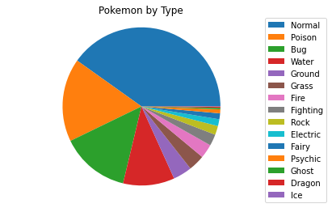

Question 1: Is there a relationship  between stats and capture rate?

Capture Rate vs Attack Level

In our findings, we noticed that the capture rate had a negative correlation with attack level. This is consistent with our hypothesis. The r-squared value is -.6266260700729032.  However, something interesting to note is that Magikarp had a 56% capture rate, which is the highest out of all pokemon.

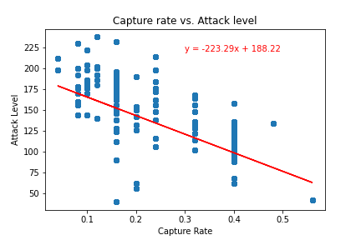

Capture Rate vs Stamina

There is a slight correlation between capture rate and stamina that supports our hypothesis. The r-squared value is -0.4863638544217492. Chansey had the highest stamina of all pokemon, but did not have the lowest capture rate.

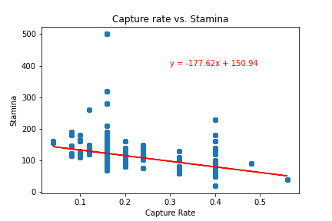

Capture Rate vs Defense

There is a significant correlation between capture rate and defense that supports our hypothesis, just like in the capture vs attack graph.  The r-squared value is -0.5835128937875973.

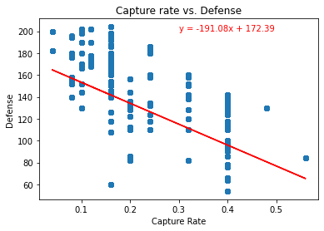

Question 2: Does Pokemon Type relate to Capture Rate?

Primary Type vs Average Spawn Chance

For the most part, spawn chance was directly correlated to the percentage of types compared to overall pokemon. The data for water pokemon may be skewed because water type pokemon are more likely to spawn near bodies of water, as well as having a chance to spawn inland.

Primary Type vs Average CP

From this data, we find that Ice type pokemon had the highest average CP, which should make them the hardest to catch. We also found that poison types had the lowest average CP.

Primary Type vs Capture Rate

Water type pokemon had the highest capture rate. This may be because water type pokemon spawn near water, and people who are near those locations get many more attempts at catching water type pokemon. Interestingly, fairy types have the lowest capture rate despite not having the highest CP.

Question 3: Is there a relationship between GeoData and Combat Power?

Gmaps lowest Spawn vs Geolocation

Although there are only 2 types of dragon type pokemon in the wild (Dratini and Dragonair), they appear more frequently due to environmental bonuses. These pokemon tend to appear near bodies of water. So even though dragon type pokemon have the lowest natural spawn chance, there is still a possibility of getting them by traveling near bodies of water. For those who don’t have access to these locations, it may be very difficult catching a dragon type!

Our hypothesis that pokemon with stronger stats were harder to catch proved to be only secondary to environmental bonuses. For example, water type pokemon had a higher chance to spawn near bodies of water, and dragon type pokemon also benefited from these bonuses. Even though the capture and spawn rates of dragon type pokemon were low, they had designated spawn cycles in certain environments. The stats of pokemon did correlate with the difficulty in catching them, but this was only secondary to their environment.