**Apply (SpidawebClient)**

**Project Overview**

**Mission and Scope**

* **What** **problem does this project address?**

This application enables user to access the open job positions, select and apply for job and check the application status through web based UIs.

* **What is the goal of this project?**

Acquire talents/resource efficiently.

* **What are the high-level assumptions or ground rules for the project?**

This project is consumes RESTful service api (<https://www.spidasoftware.com/apply/api>) provided by Spidaweb. This project is Java web project (J2EE) based on various open source apis like spring, maven, jersy etc.

* **What is not included in project?**

All the requirements are met. But focus is more on behavior rather than UI.

**Status**

* **What is the status of this project?**

This project is ready to submit.

**Implementation Notes:**

|  |  |
| --- | --- |
| **Implementation Type** | |
| Type of System | Web Service Client, Web Application |
| Programming Language | Java |
| Data Storage | N/A |
| UI Technologies | Spring MVC with JSP |
| Security | N/A |

**Quick Start Guide for developers:**

**Prerequisites:**

* Java JDK/JRE 1.7
* Apache Tomcat 6.0 or above
* Eclipse (any latest version with m2e plugin)
* GIT shell

**Procedure:**

* On GIT shell, navigate to the folder where you want to check out the project.
* Execute:$ *git clone* [*https://github.com/sustasuman/SpidawebClient.git*](https://github.com/sustasuman/SpidawebClient.git)
* On eclipse, right click on the Project Explorer > Import > Maven (Existing Maven Project) > Browse to the directory you checked out the project>Select SpidawebClient>check the pom.xml>next>Finish. Now we have project on eclipse.
* Right click the project> Run as> run on server (Make sure you have tomcat configured on eclipse).

**Quick Start Guide Users:**

**Prerequisites:**

* Any web browser.

**Procedure:**

* Go to home page. You will see the list of job that are available.

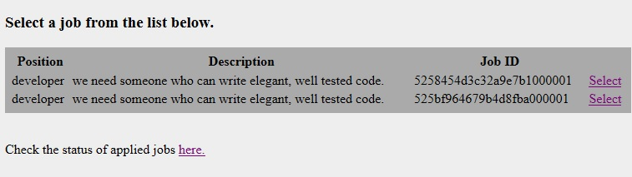

* Select a job that you want to apply.

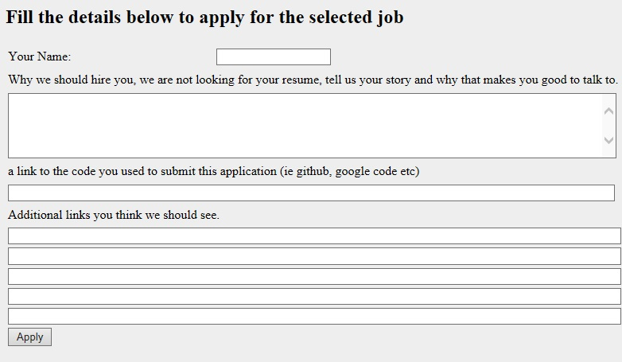

* Fill the form properly and click Apply.

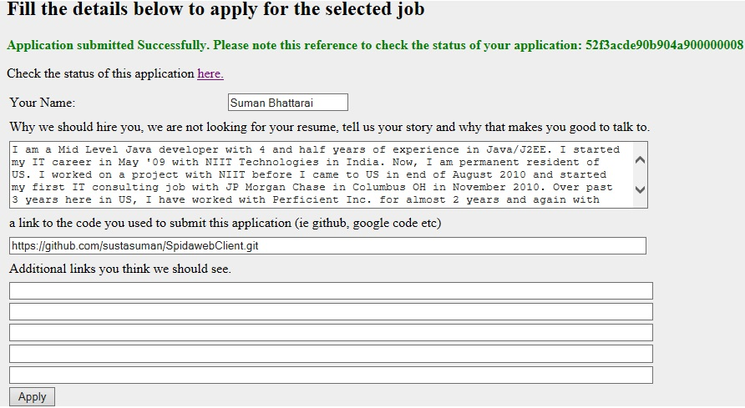

* Please note the application reference that can be used to check details of your application. To check your application click ‘here’.

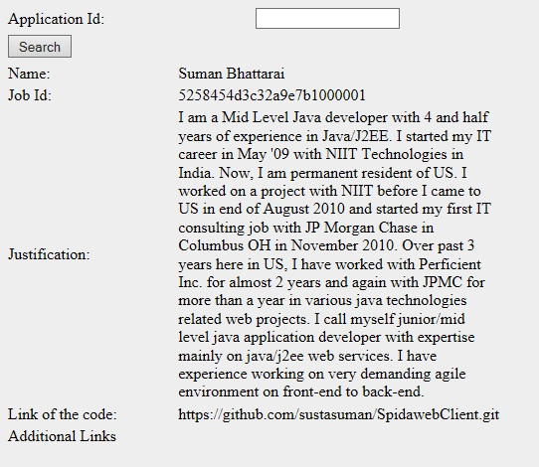

* You can use the same page to search other applications as well. You can directly navigate to this page from home page as well.