GridWorld – Special Focus
Save My Heart
Reg Hahne

This Special Focus GridWorld assignment will spotlight the development of a computer simulation that builds from the simple to the complex. As each level of the simulation is implemented, the Actors become more sophisticated in the ways in which they act.

The Actors in this simulation are

Heart – has the same characteristics as a Rock. It is a stationary item.
Bacteria – This Actor selects the shortest path to the Heart.
WhiteBloodCellCritter – interrupts the direct movement of the Bacteria to the Heart.

Level 0

The simulation at Level 0 contains two Actors…a Heart and a Bacteria.
The Bacteria’s goal is to infect the Heart by taking the shortest possible path to the Heart. The simulation ends when the Bacteria lands on a cell that is adjacent to the Heart, making the heart turn to the color BLACK. Once the Heart turns BLACK, the act method has completed its mission and the simulation ends.

Bacteria – The Bacteria knows the position of the Heart and moves in the shortest possible path towards the Heart.
Heart – The Heart does not move, but turns BLACK once the Bacteria is in an adjacent cell.

There are two main classes you will need to develop at this level of the simulation; the Heart and the Bacteria. Let’s focus on the Heart. The Heart extends Actor in a similar way that Rock extends Actor. As the heart is a stationary object, its coding is similar to that of a Rock.

Items for consideration:

- Change of color of the Heart to BLACK once it has been infected by the Bacteria.
- Use only one constructor (default) as the Heart’s color will always be RED at initial runtime.

Graph 0.1 shows initial location of the Heart and Bacteria prior to run. Graph 0.2 shows the location of the Bacteria after several moves towards the Heart. Graph 0.3 shows termination.
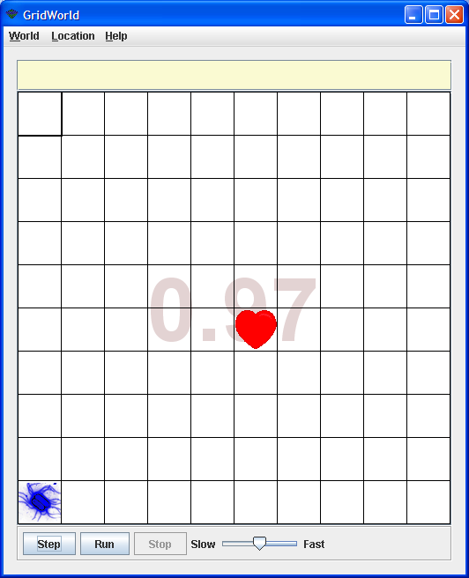
Graph 0.1

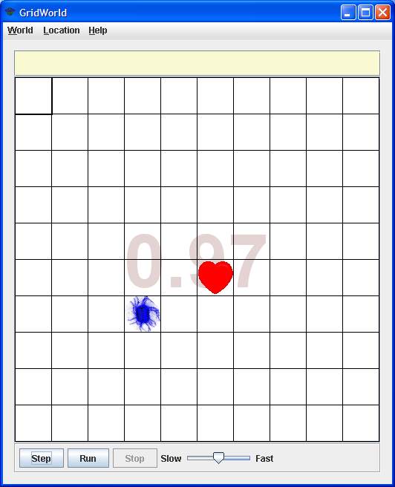
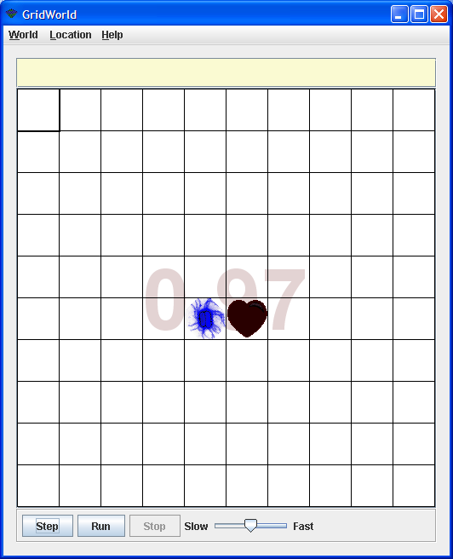

Graph 0.2
Graph 0.3

Once the Bacteria has come in contact with the Heart the Heart changes to BLACK, and the simulation ends.
Bacteria is our next responsibility. All Actors act, and Bacteria is an Actor, therefore the following will be encapsulated within Bacteria’s act method. Finding the location of the Heart for the Bacteria to attack and checking if the Bacteria has moved to a location adjacent to the Heart, terminating the simulation and turning the Heart BLACK will all be necessary.

Items for consideration:

- Set the constructor to an ugly “bacteria” color
- Find the location of the Heart
- Obtain locations around the Heart that could terminate the simulation
- How to move towards the Heart
- Termination

A suggested algorithm:

public void act()
{
// find Heart location
// making sure it’s not null
// get termination locations; those locations
// surrounding the Heart
// if (Heart not found) //not terminating
// set direction of the Bacteria
// make move towards the Heart
// else // terminated condition
// change Heart to the color BLACK
}

The Bacteria constructor should be simple to write. Because Bacteria is an Actor, its constructor can invoke the Actor’s setColor method, changing the color of the Bacteria to BLUE.

To find the location of the Heart you will need to create a method getHeartLocation that returns its location.

public Location getHeartLocation()

To do this you need to scan the entire grid creating a list of objects inhabiting locations. One way to do this is shown below,

int col, row = 0;
Location loc = null;
boolean found = false;
while (row < getGrid().getNumRows() && !found)
{
col = 0;
while (col < getGrid().getNumCols() && !found)
{
loc = new Location (row, col);
Actor a = getGrid().get(loc);
if (a != null && a instanceof Heart)
{
found = true;
}
col++;
}
row++;
}
return loc;

However, code such as this defeats the purpose of encapsulation and top-down design.
You should consider utilizing the Grid’s interface method getOccupiedLocations that allows you to acquire all the objects in the Grid. Then, use an enhanced for loop to traverse the array of objects, checking for a Heart.

for (Location loc : inhabitedLocations)
{
// check if loc is a Heart
}

Of course if the Heart is not found then return null.

Once the Heart has been located, you need to acquire a collection of locations that surround the Heart (possibly 8 in total). Create a list that will hold all the valid locations that are adjacent to the Heart. Once established, check to see if the Bacteria is in one of these locations. If it is, the Heart is set to BLACK and the act method is terminated.

public boolean checkForTermination
(ArrayList<Location> terminationLocations,
Location BacteriaLocation)

If the result of the test is false then the Bacteria will change direction towards the current location of the Heart and move one space forward. This will continue until the Bacteria is adjacent to the Heart.

Questions to Ponder

- Why does the simulation cease when a Bacteria is in a cell adjacent to the Heart?

- What other classes need to be imported?

- Why is it a good idea to set the direction of an Actor before making it move?
- Change program cessation from being “in a location next to the Heart” to being “in a location the same as the Heart,” in fact, removing the Heart. List the programming changes that need to be made, and then code your solution.
Level 1

The simulation at Level 1 contains three Actors: a Heart, a Bacteria and a WhiteBloodCellCritter.

The Bacteria’s goal is to infect the Heart by taking the shortest possible path to the Heart. The simulation ends (Heart turns BLACK) when the Bacteria lands on a cell that is adjacent to the Heart. This is similar to the situation for termination in Level 0. An additional skill that the Bacteria possesses is an ability to become aware of a WhiteBloodCellCritter and change direction.

WhiteBloodCellCritter – Moves randomly within a two cell range within a 5 x 5 cell grid with the Heart at its center.
Bacteria – The Bacteria knows the position of the Heart and moves in the shortest possible path towards it. In addition, the Bacteria can “see” two grid blocks in any direction from its current position. If the Bacteria is within two grid blocks of the WhiteBloodCellCritter the Bacteria moves one grid block in the opposite direction from the location of the WhiteBloodCellCritter.
Heart – The Heart does not move, but turns BLACK once the Bacteria is in an adjacent cell (as in Level 0).

Below are several phases of a graphical simulation demonstrating how the Bacteria and WhiteBloodCellCritter interact.
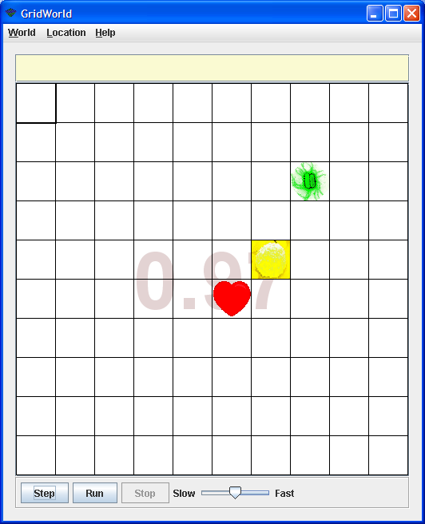
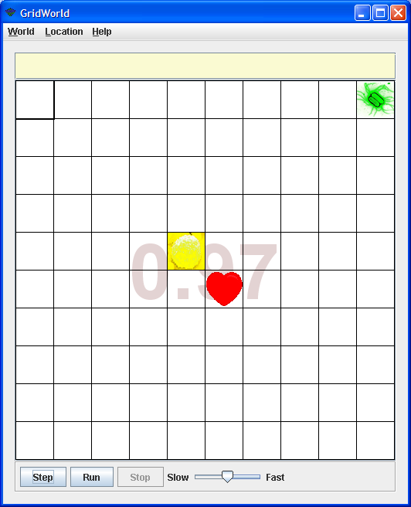
Graph 1.1
Graph 1.2

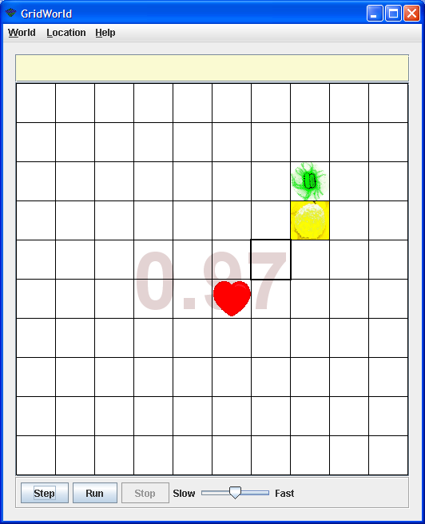
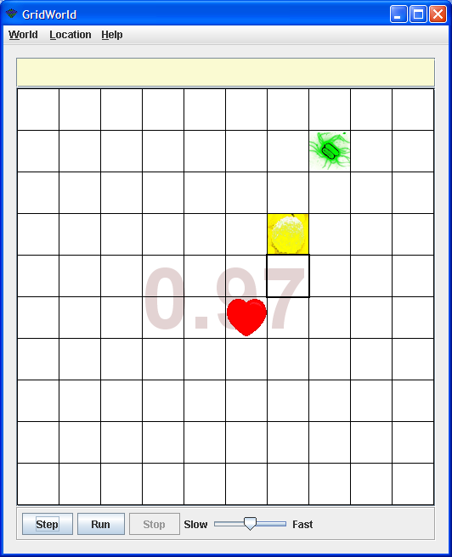

Graph 1.3
Graph 1.4

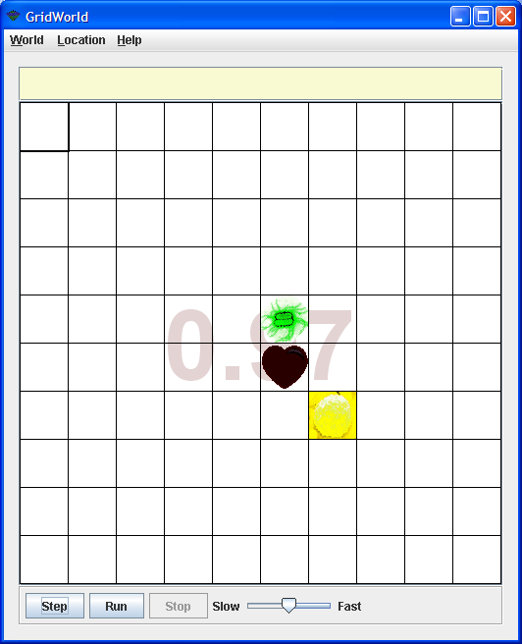
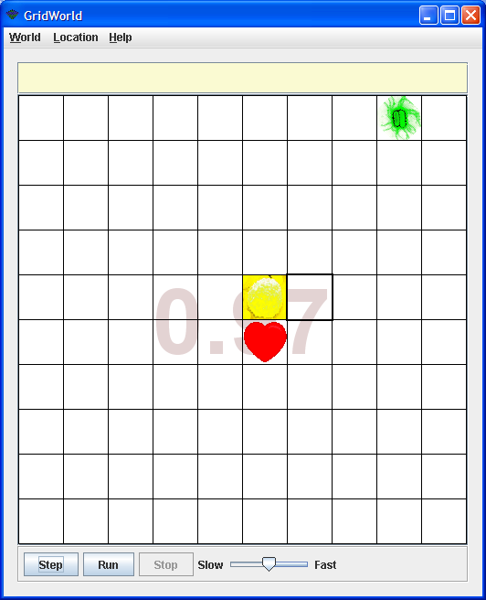

Graph 1.5
Graph 1.6

Graph 1.1 shows initial location of the Heart, Bacteria and WhiteBloodCellCritter prior to run. Graph 1.2 shows the location of the Heart, Bacteria and WhiteBloodCellCritter after two steps of the simulation. After many steps of the simulation Graph 1.3 shows the location of the Heart, Bacteria and WhiteBloodCellCritter. The resolution of this encounter is shown in Graph 1.4 and then Graph 1.5. Graph 1.6 shows termination.

Items for consideration:

There are three main classes to consider at this level of the simulation:
- The Heart will not change location.
- A new class, WhiteBloodCellCritter, needs to be created.
- The Bacteria will need to be modified to consider the position of the WhiteBloodCellCritter.

Let’s look at the creation of the WhiteBloodCellCritter class. A WhiteBloodCellCritter will be able to move within a 5 x 5 cell grid around the Heart. Graph 1.7 and Graph 1.8 show possible WhiteBloodCellCritter’s realm of movement.

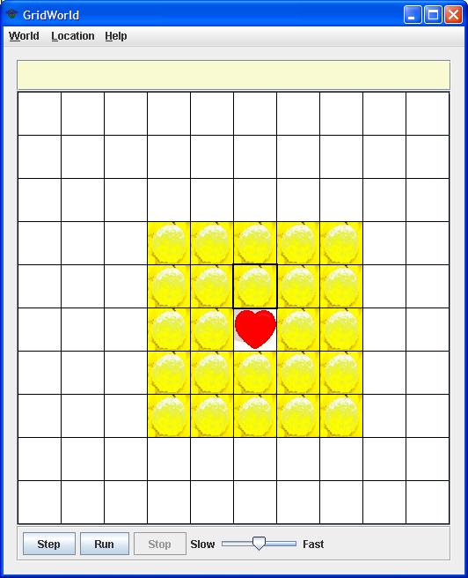
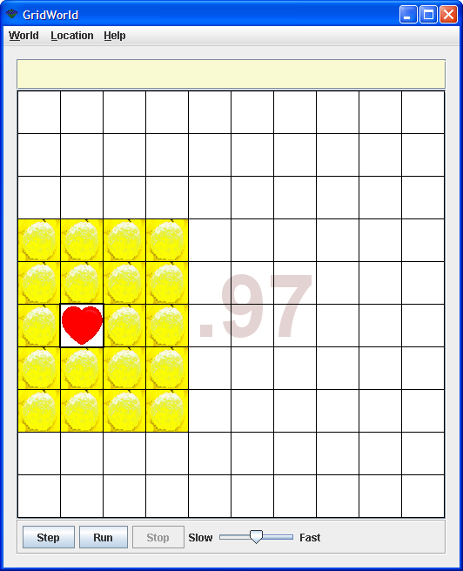
Graph 1.7
Graph 1.8
Because a WhiteBloodCellCritter is a Critter, its movement should be implemented by overriding the methods that are called by Critter’s act method. Remember the act method of the Critter class calls five other methods.

public void act()
{
if (getGrid() == null)
return;
ArrayList<Actor> actors = getActors();
processActors(actors);
ArrayList<Location> moveLocs = getMoveLocations();
Location loc = selectMoveLocation(moveLocs);
makeMove(loc);
}

The WhiteBloodCellCritter constructor should be simple. Because WhiteBloodCellCritter is a Critter and Critter is an Actor, the constructor can invoke the Actor’s setColor method, setting the color of a WhiteBloodCellCritter to YELLOW.

The getActors and processActors methods are implemented to do nothing.

The most intimidating method to write is getMoveLocations. This method returns an ArrayList of possible locations that the WhiteBloodCellCritter can legally move. Remember the restrictions placed upon the WhiteBloodCellCritter. Below is the method header and pseudo-code outlining a possible process.

public ArrayList<Location> getMoveLocations()
{
// get the empty adjacent cells
// remove locations that are outside its realm
// return the array
}

To obtain the empty locations, create an ArrayList of possible moves using the getEmptyAdjacentLocations method found in AbstractGrid. Once obtained, you will need to remove all the invalid locations. Method removeInvalidLocations outlines an implementation plan.

public ArrayList<Location> removeInvalidLocations
(ArrayList<Location> locations)
{
// make a new ArrayList
// place only valid items in this list
// need to check if locations are valid
}

This plan needs to remove locations that are outside of the realm of the WhiteBloodCellCritter’s movement. To do this requires the return of an ArrayList of valid locations. These valid locations depend on the location of the Heart. By using the getHeartLocation method from the Bacteria class, we will be able to process the current ArrayList, removing additional invalid locations and returning a list of possible valid locations to which the WhiteBloodCellCritter can move. To accomplish this task a method withinHeartRange needs to be developed.

public boolean withinHeartRange(Location loc,
Location heartLocation)
{
// returns true if loc is within a valid distance of
// the location of the Heart
}

Once getMoveLocations has returned the ArrayList of possible valid moves, the Critter’s selectMoveLocation and makeMove methods will be called.

Now you need to address the Bacteria and the new actions that it takes in relation to the location of the WhiteBloodCellCritter. There are several methods that the current Bacteria have, and some additional methods to write. It would be prudent to inherit all the current Bacteria methods and create a new class Bacteria1 which extends Bacteria.

public class Bacteria1 extends Bacteria

Items for consideration:

- Set the constructor to an ugly “Bacteria1” color
- Find the location of the Heart and WhiteBloodCellCritter
- Check to see if close to a WhiteBloodCellCritter
- Set reverse direction
- Move like a Bacteria

The Bacteria1 constructor should be simple. Because Bacteria1 is a Bacteria you can invoke the Bacteria constructor by using super to call the parent class’s constructor. Make sure you pass the color GREEN as a parameter in this call.

As before, the act method needs to be modified to accommodate these new requirements. This modification requires you to redesign Level 0 of the act method. Use the following steps in the redesign of your new act method.

public void act()
{
// find Heart and WhiteBloodCellCritter locations
// make sure neither is null
// check to see if close to a white blood cell
// if so next move is retreat
// move in the reverse direction
// else next move is attack
// move in the direction of the Heart
// but check for termination
}

Having already created the getHeartLocation method, modify it to create the getWhiteBloodCellLocation method. This can be accomplished by mimicking the getHeartLocation method found in the Bacteria class.

As you know, when a Bacteria1 discovers the existence of a WhiteBloodCellCritter, it moves in the opposite direction from the WhiteBloodCellCritter. To facilitate the discovery of the WhiteBloodCellCritter, the method closeToWhiteBloodCell needs to be created. Use the following header for this method:

public boolean closeToWhiteBloodCell()
{
// get the white blood cell location
// return true if detected a white blood cell
// else return false
}

To help detect a WhiteBloodCellCritter you will need to write the method getValidLocations that will return an ArrayList of valid locations that the Bacteria can search.

public ArrayList<Location> getValidLocations(Location bacteria)

Remember this area is a 5 x 5 cell grid surrounding the Bacteria1. Those valid locations need to be compared to the location of the WhiteBloodCellCritter and if within range move accordingly. This movement is in the reverse direction away from the WhiteBloodCellCritter. If no contact with a WhiteBloodCellCritter is discovered to be true, then the Bacteria11 moves like a regular Bacteria. This code can be found in Level 0 of the simulation.

Once the getMoveLocations has returned the ArrayList of possible valid moves, the Critter’s selectMoveLocation and makeMove methods will be called.
Questions to Ponder

- Why does the simulation appear not to work correctly for some situations? For example, looking at the simulations below one would think that termination should take effect on the next step, however it does not. What possible reasons could make your act method work in such a way? The following four simulation situations do not terminate correctly. How can this be corrected? List the steps needed to support your reason(s).
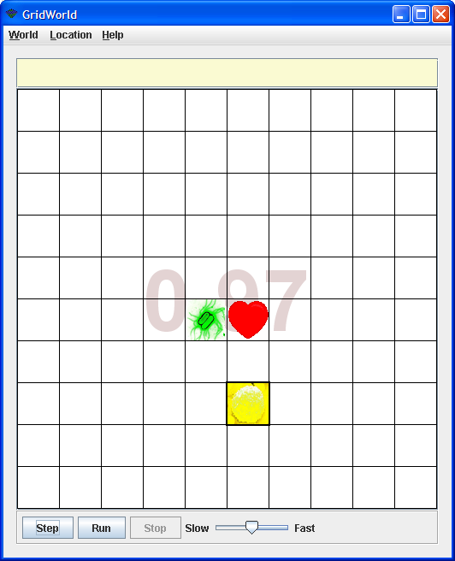
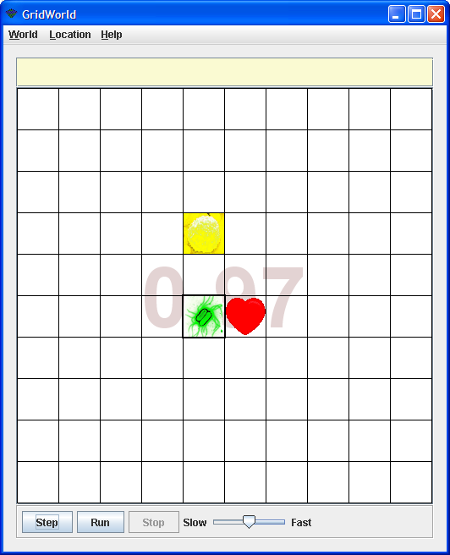

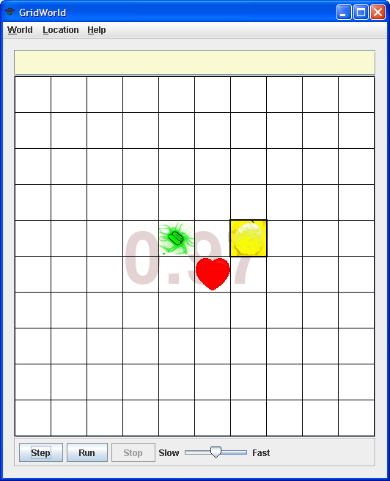
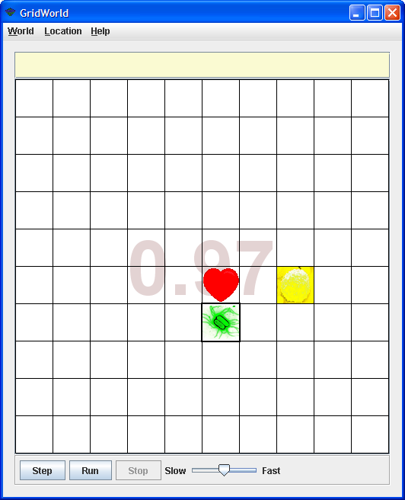

- Why does the following code not work?
for (Location loc : locations)
{
if (validLocation (loc, getHeartLocation()))
{
tempHold.add(temp);
}
}

- Why create a new array in removeInvalidLocations in the WhiteBloodCellCritter method?

- Once the Heart turns BLACK the simulation should end. Why does the simulation continue?

- Why is it a good idea to enlarge the grid size to 12 x 12? How can this be accomplished?
- (AB) Another way to implement a method to obtain valid locations is to modify the method getValidAdjacentLocations in AbstractGrid allowing the creation of a list of locations in the area within which the WhiteBloodCellCritter can move.

- (A or AB) See if you can develop another way to implement the way in which valid locations for the WhiteBloodCellCritter can be found.

Level 2

The simulation at Level 2 contains three Actors: a Heart, a Bacteria and a WhiteBloodCellCritter.

The Bacteria’s goal is to infect the Heart by taking the shortest possible path to the Heart. The simulation ends (heart turns BLACK) when the Bacteria lands on a cell that is adjacent to the Heart. This is similar to the situation to termination in Level 0. The Bacteria possesses an ability to become aware of a WhiteBloodCellCritter, and if so, changes direction. This situation existed in Level 1 of the simulation. In addition, the WhiteBloodCellCritter will attack (move towards) a Bacteria if the Bacteria is within a two-cell distance of a WhiteBloodCellCritter. This attack is represented by the WhiteBloodCellCritter moving in the direction of the Bacteria, but is unable to travel further than the two-cell distance limitation placed upon it in Level 1 of the simulation.

WhiteBloodCellCritter – Moves randomly within a two-cell range within a 5 x 5 cell grid with the Heart at its center. The WhiteBloodCellCritter can “see” two grid blocks in any direction from its current position. If the Bacteria is within two grid blocks of the WhiteBloodCellCritter the WhiteBloodCellCritter attacks the Bacteria by moving one grid block in the direction of the Bacteria.
Bacteria – The Bacteria knows the position of the Heart and moves in the shortest possible path towards it. In addition, the Bacteria can “see” two grid blocks in any direction from its current position. If the Bacteria is within two grid blocks of the WhiteBloodCellCritter the Bacteria moves one grid block in the opposite direction away from the location of the WhiteBloodCellCritter.
Heart – The Heart does not move, but turns BLACK once the Bacteria is in an adjacent cell.

Below are several phases of a graphical simulation demonstrating how the Heart, Bacteria and WhiteBloodCellCritter interact.
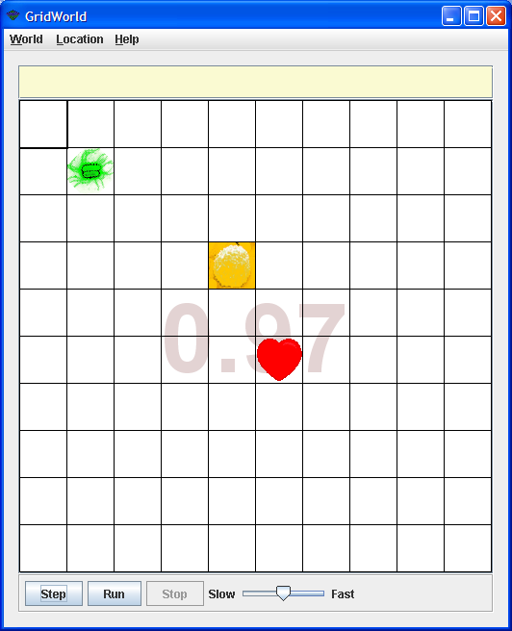
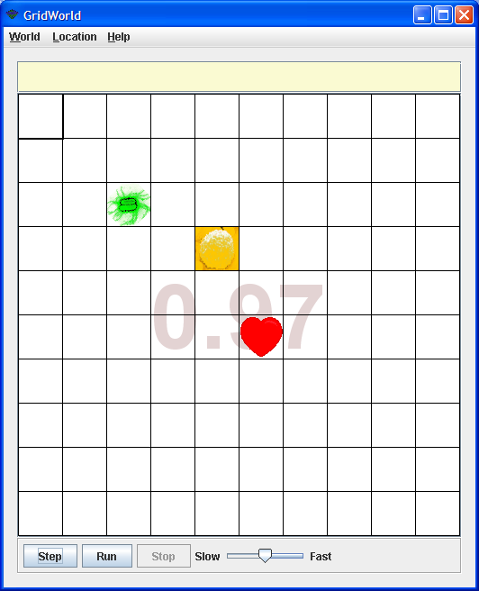
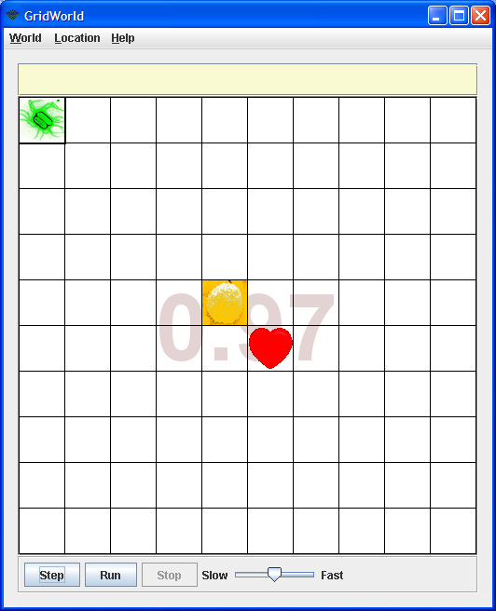
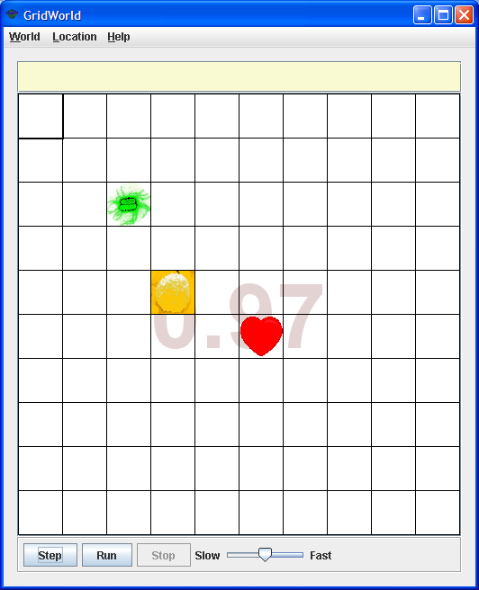
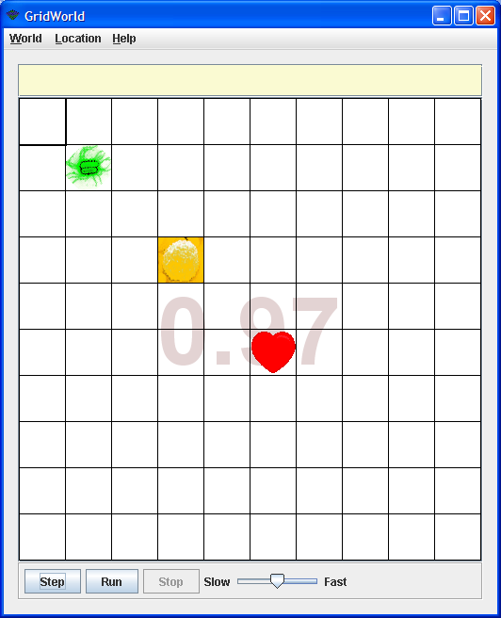
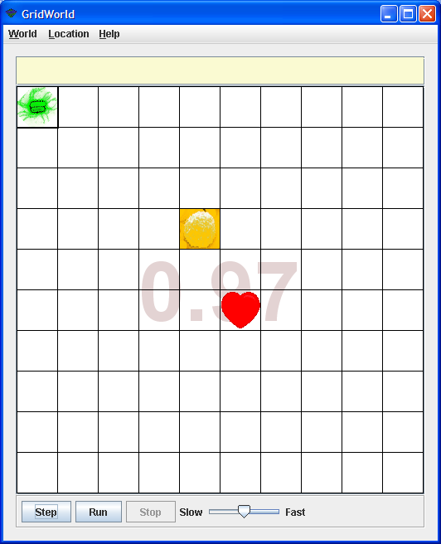
Graph 1.9
Graph 1.10
Graph 1.11
Graph 1.12
Graph 1.9 shows initial location of the Heart, Bacteria and WhiteBloodCellCritter prior to run. Graph 1.10 shows the location of the Heart, Bacteria and WhiteBloodCellCritter after two steps of the simulation. The resolution of this encounter is shown in Graph 1.11 and Graph 1.12.

Addressing the new actions of the WhiteBloodCellCritter reveals many similar traits from its Level 1 implementation. It would be prudent to utilize existing methods and write new ones for the additional responsibilities that the WhiteBloodCellCritter has been given. To do this, inherit all the current WhiteBloodCellCritter methods and create a new class WhiteBloodCellCritter2 which extends WhiteBloodCellCritter.

public class WhiteBloodCellCritter2 extends WhiteBloodCellCritter

Items for consideration:

- Set the constructor to an gentle “whiteBloodCellCritter2” color
- Find the location of the Heart and WhiteBloodCellCritter2
- Check to see if close to a Bacteria1
- Move in Bacteria1’s direction or move as in Level 1
- Move like a Bacteria

Because a WhiteBloodCellCritter2 is a Critter, its movement should be implemented by overriding the methods that are called by Critter’s act method. Remember the act method of the Critter class calls five other Critter methods.

public void act()
{
if (getGrid() == null)
return;
ArrayList<Actor> actors = getActors();
processActors(actors);
ArrayList<Location> moveLocs = getMoveLocations();
Location loc = selectMoveLocation(moveLocs);
makeMove(loc);
}

The WhiteBloodCellCritter2 constructor should be simple. Because WhiteBloodCellCritter2 is a WhiteBloodCellCritter and WhiteBloodCellCritter is an Actor, its constructor can invoke the Actor’s setColor method, setting the color of a WhiteBloodCellCritter2 to ORANGE.

WhiteBloodCellCritter’s getActors and processActors methods were implemented to do nothing, so we don’t need to override them here.

The most intimidating method to write is getMoveLocations. This method returns an ArrayList of possible locations that the WhiteBloodCellCritter2 can legally move. There are now two scenarios that the WhiteBloodCellCritter2 must take into account before movement takes place: when within range of a Bacteria1, or when not within range of a Bacteria1. When not within range of a Bacteria1 is the easier to code to write and is the same as that used for the WhiteBloodCellCritter2 in Level 1 of the simulation. When within range of a Bacteria1 there are more things to consider. Below is the method header and pseudo-code outlining a possible process.

public ArrayList<Location> getMoveLocations()
{
// if close to a Bacteria1
// find the direction toward the Bacteria1
// create an array of valid locations
// else
// get the empty adjacent cells
// remove locations that are outside its realm
// create an array of valid locations
// return the array
}

Let’s first look at what the WhiteBloodCellCritter2 will do if it moves within range of a Bacteria1, or if a Bacteria1 moves within range of a WhiteBloodCellCritter2. Either situation should produce similar results, i.e., the WhiteBloodCellCritter2’s next move being towards the Bacteria1.

If the WhiteBloodCellCritter2 is within range of a Bacteria1 the WhiteBloodCellCritter2 will find the direction from its location toward the Bacteria1. Writing a getBacteriaLocation method which is very similar to getHeartLocation is needed.

public Location getBacteriaLocation()

Once you have obtained its location the next step is to ascertain if the WhiteBloodCellCritter2 is within range of the Bacteria1. The method bacteriaDetected detects if the WhiteBloodCellCritter2 is within range of the Bacteria1.

public boolean bacteriaDetected(Location whiteBloodCell,
Location bacteria)

The next task is to find the valid locations the WhiteBloodCellCritter2 can move to, returning true if the location parameter is a valid location which then gets added to the moveLocs array. This can be overridden from Level1.

public boolean ValidLocation(Location loc)

If the WhiteBloodCellCritter2 is not within range of a Bacteria1 then it moves the same as it did in Level 1 of the simulation.

Once the getMoveLocations has returned the ArrayList of possible valid moves the Critter’s selectMoveLocation and makeMove methods will be called.
Questions to Ponder

- Think about other ways the Bacteria1 could move once it “sees” a WhiteBloodCellCritter2.

- How could you improve the chances of the Bacteria1 gaining quicker access to the Heart, or the WhiteBloodCellCritter2 defending the Heart?
Level 3
The simulation at Level 3 contains three Actors: a Heart, a Bacteria and a WhiteBloodCellCritter.

The Bacteria’s goal is to infect the Heart by taking the shortest possible path to the Heart. The simulation ends (heart turns BLACK) when the Bacteria lands on a cell that is adjacent to the Heart. This is similar to the situation for termination in Level 0. The Bacteria possesses an ability to become aware of a WhiteBloodCellCritter2, and if so, changes direction by a set pattern and deploys a decoy of itself, hoping that the WhiteBloodCellCritter2 will chase this new entity. This existed in Level 1 of the simulation. The WhiteBloodCellCritter2 will act as it did in Level 2 of the simulation.

WhiteBloodCellCritter – Moves randomly within a two-cell range; a 5 x 5 cell grid with the Heart at its center. The WhiteBloodCellCritter2 can “see” two grid blocks in any direction from its current position. If the Bacteria is within two grid blocks of the WhiteBloodCellCritter2 the WhiteBloodCellCritter2 attacks the Bacteria by moving one grid block in the direction of the Bacteria (as in Level 2).
Bacteria – The Bacteria knows the position of the Heart and moves in the shortest possible path towards it. In addition, the Bacteria can “see” two grid blocks in any direction from its current position. If the Bacteria is within two grid blocks of the WhiteBloodCellCritter2 the Bacteria moves in a predefined pattern in relationship to the WhiteBloodCellCritter2 while deploying a decoy of itself (as in Level 1).
Heart – The Heart does not move, but turns BLACK once the Bacteria is in an adjacent cell (as in previous levels).
Level 4 (AB extension)

Level 4 is similar to Level 3. The data structures used to simulate the game could be a PriorityQueue, Map or Set. In fact it would be interesting to analyze which is the best to use.

Level 5 (AB extension)

Level 5 implements many Bacteria and WhiteBloodCell Critters. A real challenge.

URL: http://www.sendspace.com/file/bjlqy1

