Mapping
-Reset the map.
-Make sure that the ADVANCE MODE, CONTINUOUS CLEANING, and the MULTI-FLOOR options are all enabled because if they are not turned ON before you send the Deebot to clean you will be having trouble completing the map or saving the map.
-Relocate the charging base. Charging docks should be placed properly to ensure proper charging of the unit. Here are some tips:
1. It needs to be put on a flat and dry place, leaning on the wall.
2. There should be NO obstacle within 0.5 meters at both the left and right sides of the charging dock and 1.5 meters in front.
3. Don't put the charging dock under sunshine.
4. Make sure it is away from any appliances that emit infrared signals such as television and remote controls.
5. Also, place the Deebot in the middle of the floor plan of your house, avoid placing it near/on the corners.
-Also, make sure that once the Deebot is already done creating a map for the first floor, you were able to save it. To save the map, follow the steps below:
1. For the Map Management to show on the app, make sure that the Deebot is on the charging base. Check for the picture of the icon below.
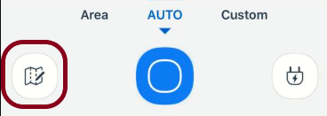
2. To save the app, click the icon below.

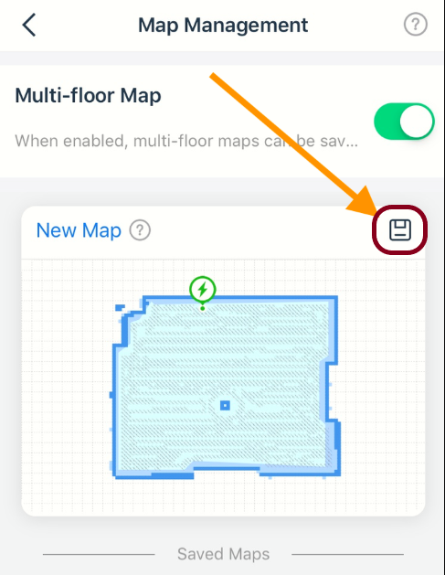
-After that, to create a second map, turn OFF the unit itself (lift the top cover, slide the red main power switch to the "O" symbol) then unplug the charging base. Put the Deebot and the charging base to your second floor. turn it back ON (slide the red main power switch to the "I" symbol) let the Deebot sit on the charging base for 30 minutes, and let it map the second floor then save it again.

Refresh the map

Sorry to hear that you are having trouble using the product, but no worries I'm here to help you figure out how to use the app perfectly!
Can you please try to manually place the Deebot back on the base then observe if your Deebot will speak like "I'm restoring the map please do not stand beside" or "I'm relocating"
After that, check your app again then press this one to refresh the map
