在 C/C++ 中，函数指针（function pointer）保存的只是函数在内存中的地址，它并不携带任何对象实例的信息。

在 C# 中，delegate 对象内部保存了两部分信息：

1. **方法指针**（指向方法在底层的入口）
2. **目标实例**（对于实例方法，保存了 this 引用；对于静态方法，目标实例为 null）

问大佬们一个问题，引用类型的get;set;只有替换引用类型本身才能触发set。那我对一个字典写get;set，想改其中的一个键值对触发set应该怎么做啊

自己写个方法，封装 dic[a]=val;

导入图片素材 全选图片设置图片为spriteAndUi没效果，单选某张图片先设置为默认，在设置为sprite

如果 Mesh Collider 仅使用网格，则可以在 **Import Settings** 中禁用 **Normals**，因为物理系统不需要它们

C#向下取整，cpp向上

推送显示

ssh: connect to host github.com port 22: Connection timed out

fatal: Could not read from remote repository.

改成443端口成功

ssh://git@ssh.github.com:443/susunqing/Remake-of-the-classic-game-.git、

拼接ui时（GameoverUi）在实现屏幕中间黑然后显示按钮功能时，发现按钮总是被缩放，查到panel被缩放，横向缩小，在建panel缩小导致，

解决：不要缩放panel而是改变他的宽度

IndexOutOfRangeException: Index was outside the bounds of the array. ScoreManager.ShowScore (UnityEngine.Vector3 position, System.Int32 score) (at Assets/Scripts/ScoreManager.cs:39) Pig.Dead () (at Assets/Pig.cs:14) Destructible.OnCollisionEnter2D (UnityEngine.Collision2D collision) (at Assets/Scripts/Destructible.cs:27)using System.Collections;

数组越界，ScoreManager脚本挂载在Gamanager上之后，pig上的没有移除，piginspect脚本没有赋值，导致数组为空。Debug发现数组为零，索引也是零

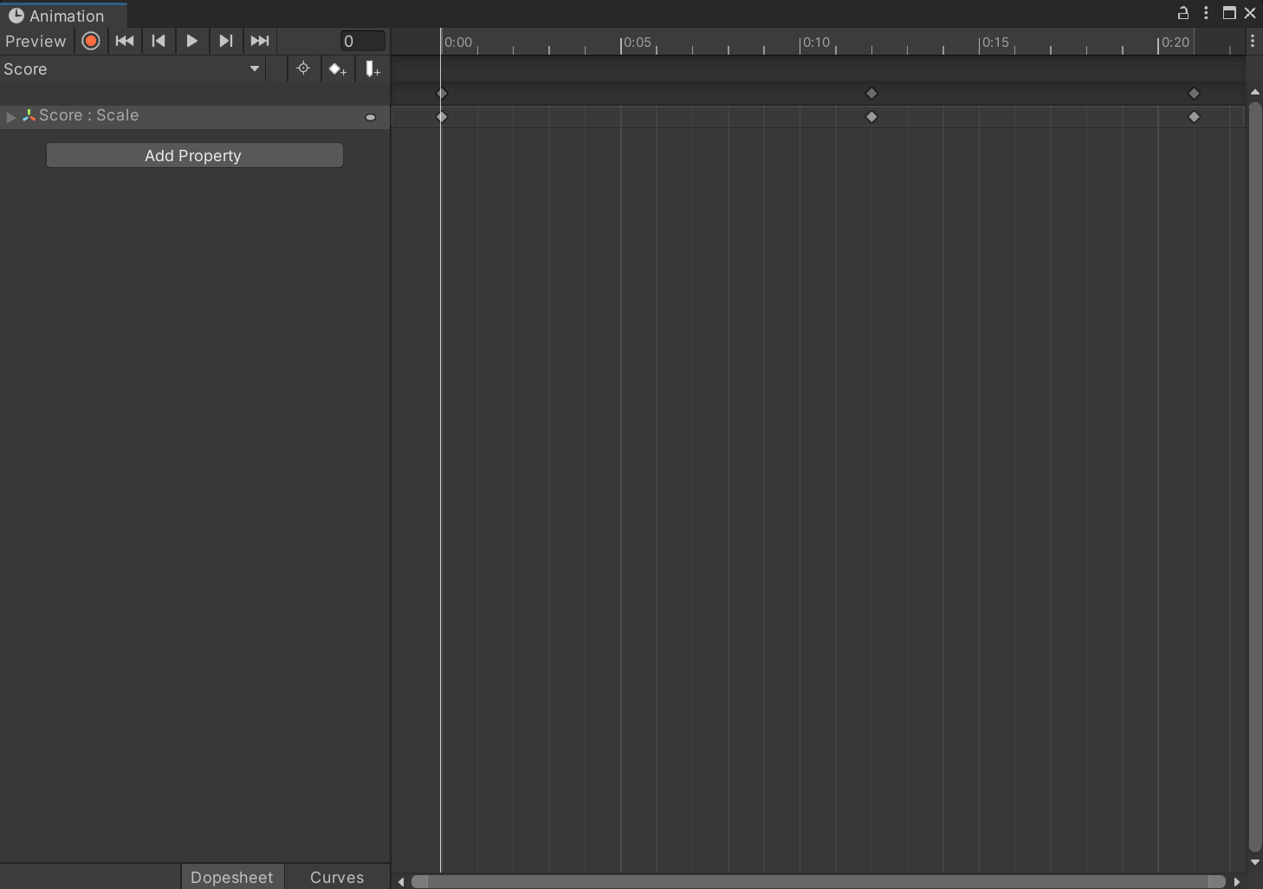

把分数预制体放到场景制作动画，制作完毕删除场景对象，没有应用，导致动画为空

NullReferenceException: Object reference not set to an instance of an object

UnityEditor.Graphs.AnimationStateMachine.Graph.GenerateConnectionKey (UnityEditor.Graphs.Node srcNode, UnityEditor.Graphs.Node dstNode) (at <43ab55752ae246bd8bf0084073d42e3b>:0)

UnityEditor.Graphs.AnimationStateMachine.Graph.GetEdgeInfo (UnityEditor.Graphs.Edge edge) (at <43ab55752ae246bd8bf0084073d42e3b>:0)

UnityEditor.Graphs.AnimationStateMachine.EdgeGUI.DoEdges () (at <43ab55752ae246bd8bf0084073d42e3b>:0)

UnityEditor.Graphs.AnimationStateMachine.GraphGUI.OnGraphGUI () (at <43ab55752ae246bd8bf0084073d42e3b>:0)

UnityEditor.Graphs.AnimatorControllerTool.StateMachineView (UnityEngine.Rect position, System.Single zoomLevel) (at <43ab55752ae246bd8bf0084073d42e3b>:0)

UnityEditor.Graphs.AnimatorControllerTool.DoGraph (UnityEngine.Rect graphRect, System.Single zoomLevel) (at <43ab55752ae246bd8bf0084073d42e3b>:0)

UnityEditor.Graphs.AnimatorControllerTool.<SetupGUI>b__143_12 () (at <43ab55752ae246bd8bf0084073d42e3b>:0)

UnityEditor.Graphs.AnimatorControllerTool.ScopedOnGUI (System.Action onGUIHandler) (at <43ab55752ae246bd8bf0084073d42e3b>:0)

UnityEditor.Graphs.AnimatorControllerTool.<SetupGUI>b__143_10 () (at <43ab55752ae246bd8bf0084073d42e3b>:0)

UnityEngine.UIElements.IMGUIContainer.DoOnGUI (UnityEngine.Event evt, UnityEngine.Matrix4x4 parentTransform, UnityEngine.Rect clippingRect, System.Boolean isComputingLayout, UnityEngine.Rect layoutSize, System.Action onGUIHandler, System.Boolean canAffectFocus) (at <8d75a2551d5249829e89d91a8d1df0f5>:0)

UnityEngine.UIElements.IMGUIContainer.HandleIMGUIEvent (UnityEngine.Event e, UnityEngine.Matrix4x4 worldTransform, UnityEngine.Rect clippingRect, System.Action onGUIHandler, System.Boolean canAffectFocus) (at <8d75a2551d5249829e89d91a8d1df0f5>:0)

UnityEngine.UIElements.IMGUIContainer.DoIMGUIRepaint () (at <8d75a2551d5249829e89d91a8d1df0f5>:0)

UnityEngine.UIElements.UIR.RenderChainCommand.ExecuteNonDrawMesh (UnityEngine.UIElements.UIR.DrawParams drawParams, System.Single pixelsPerPoint, System.Exception& immediateException) (at <8d75a2551d5249829e89d91a8d1df0f5>:0)

Rethrow as ImmediateModeException

UnityEngine.UIElements.UIR.RenderChain.Render () (at <8d75a2551d5249829e89d91a8d1df0f5>:0)

UnityEngine.UIElements.UIRRepaintUpdater.Update () (at <8d75a2551d5249829e89d91a8d1df0f5>:0)

UnityEngine.UIElements.VisualTreeUpdater.UpdateVisualTreePhase (UnityEngine.UIElements.VisualTreeUpdatePhase phase) (at <8d75a2551d5249829e89d91a8d1df0f5>:0)

UnityEngine.UIElements.Panel.UpdateForRepaint () (at <8d75a2551d5249829e89d91a8d1df0f5>:0)

UnityEngine.UIElements.Panel.Repaint (UnityEngine.Event e) (at <8d75a2551d5249829e89d91a8d1df0f5>:0)

UnityEngine.UIElements.UIElementsUtility.DoDispatch (UnityEngine.UIElements.BaseVisualElementPanel panel) (at <8d75a2551d5249829e89d91a8d1df0f5>:0)

UnityEngine.UIElements.UIElementsUtility.UnityEngine.UIElements.IUIElementsUtility.ProcessEvent (System.Int32 instanceID, System.IntPtr nativeEventPtr, System.Boolean& eventHandled) (at <8d75a2551d5249829e89d91a8d1df0f5>:0)

UnityEngine.UIElements.UIEventRegistration.ProcessEvent (System.Int32 instanceID, System.IntPtr nativeEventPtr) (at <8d75a2551d5249829e89d91a8d1df0f5>:0)

UnityEngine.UIElements.UIEventRegistration+<>c.<.cctor>b__1_2 (System.Int32 i, System.IntPtr ptr) (at <8d75a2551d5249829e89d91a8d1df0f5>:0)

UnityEngine.GUIUtility.ProcessEvent (System.Int32 instanceID, System.IntPtr nativeEventPtr, System.Boolean& result) (at <23559c5aae9d498788134bf893312194>:0)