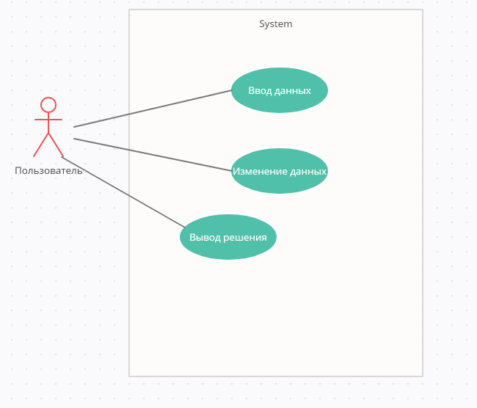Диаграмма вариантов пользования:

Диаграмма последовательности:  
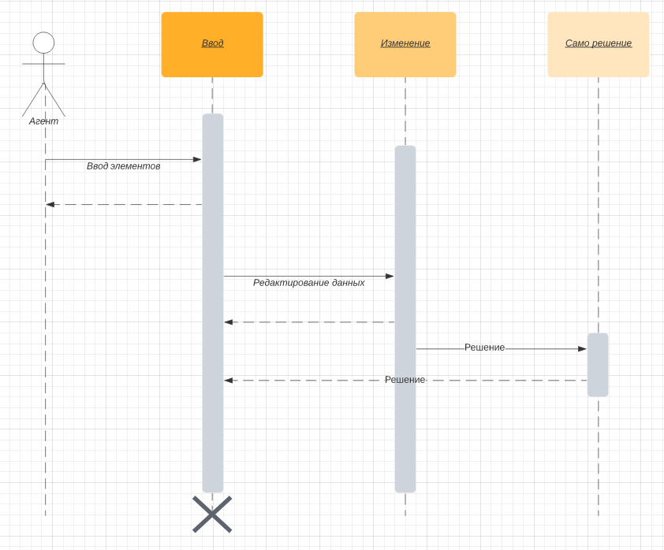

Диаграмма состояний :  
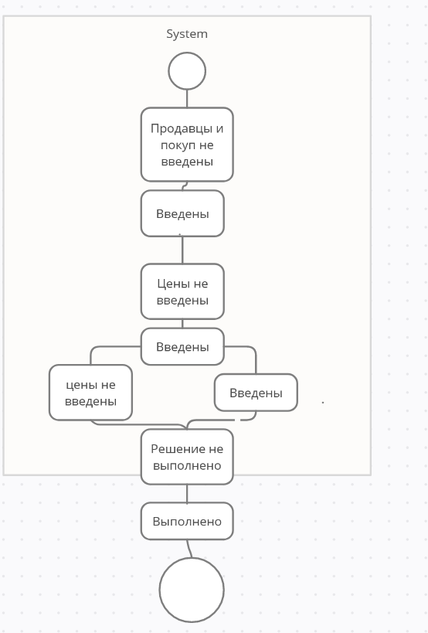

Решение:

|  |  |  |  |  |
| --- | --- | --- | --- | --- |
| bk  ai | 45 | 15 | 22 | 20 |
| 25 | 9 | 5 | 3 | 10 |
| 55 | 6 | 3 | 8 | 2 |
| 22 | 3 | 8 | 4 | 7 |

|  |  |  |  |  |
| --- | --- | --- | --- | --- |
| bk  ai | 45 | 15 | 22 | 20 |
| (-)25 | 9(25) | 5 | 3 | 10 |
| 55 | 6 | 3 | 8 | 2 |
| 22 | 3 | 8 | 4 | 7 |

|  |  |  |  |  |
| --- | --- | --- | --- | --- |
| bk  ai | 45 | 15 | 22 | 20 |
| (-)25 | 9(25) | 5 | 3 | 10 |
| (-)55 | 6(20) | 3(15) | 8(20) | 2 |
| (-)22 | 3 | 8 | 4(2) | 7(20) |

F=9*25+6*20+3*15+8*20+4*2+7*20=698 у.д.е