10 machine

Reliable Broadcast

E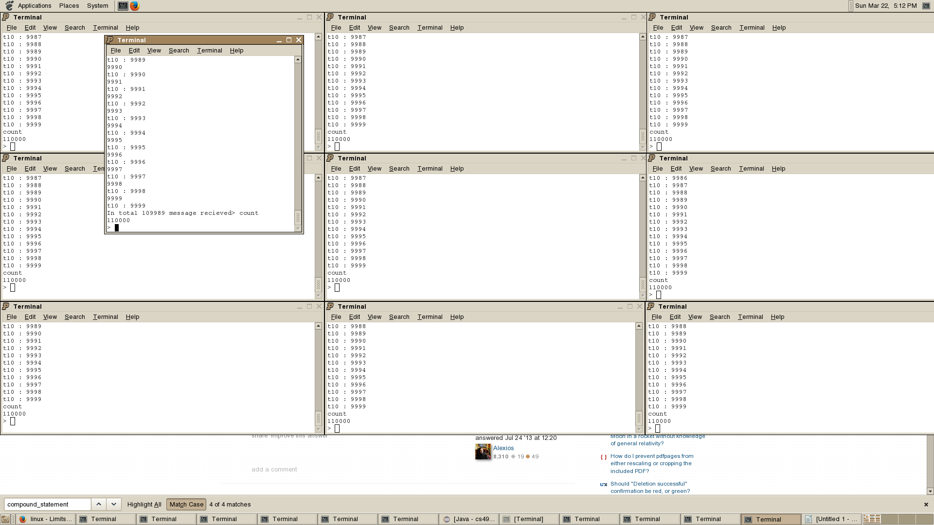ach client receive 110000 messages.

The sender initially says only 109989 because the work on other thread haven't finished yet.

FIFO Broadcast

Each client receive 103487 messages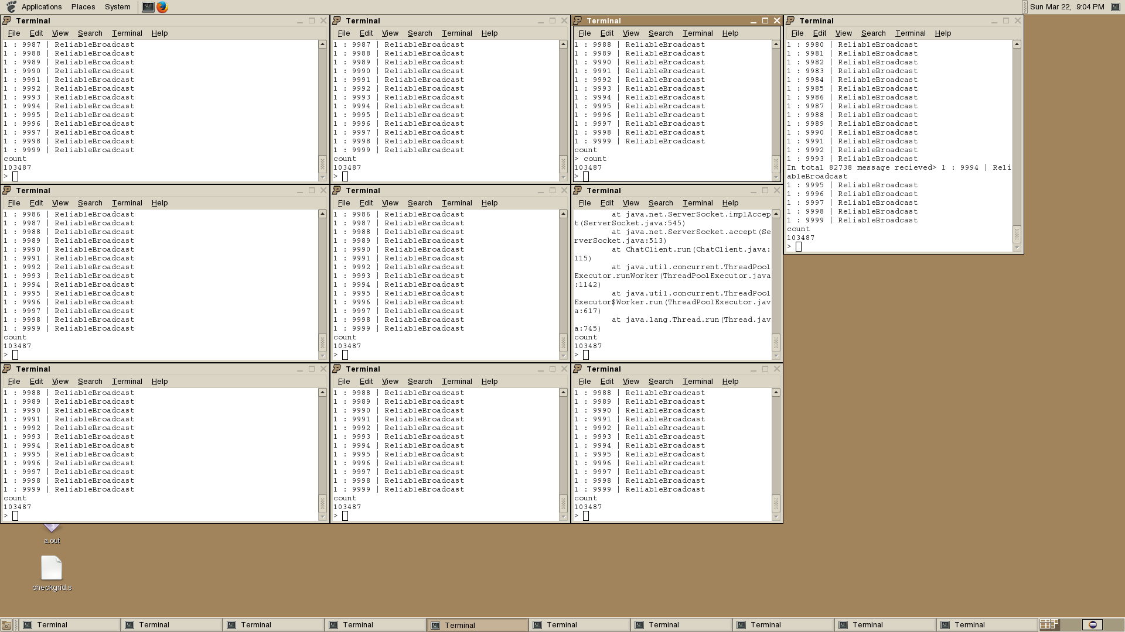

Should be 110000 but one of the client get Too many open files error...

5 machine

Reliable Broadcast

Running two on one machine just stuck and not working.

After delivering about 20 messages, it takes a really long time for it to deliver the next for some reason.