Development, Temporal Validation, and External Validation of Non-invasive Machine Learning Models for Screening Undiagnosed Hypertension
[Author names to be completed]
[Affiliations to be completed]
Corresponding Author:
[Name, degrees, department, institution, postal address, phone, email to be completed]

Abstract
Background: Undiagnosed hypertension is often asymptomatic and contributes to cardiovascular and premature mortality. Models excluding blood pressure and laboratory predictors may help prioritize adults for confirmatory blood pressure measurement.
Objective: The study developed, temporally validated, and externally validated non-invasive machine learning models for screening undiagnosed hypertension among adults.
Methods: Models were developed using Korea National Health and Nutrition Examination Survey (KNHANES) 2014-2020 data from adults aged 19 years or older. Undiagnosed hypertension was defined as measured systolic blood pressure >=140 mmHg or diastolic blood pressure >=90 mmHg among adults without self-reported diagnosed hypertension or antihypertensive medication use. Predictors excluded blood pressure, hypertension diagnosis or treatment, laboratory, and outcome-derived variables. Five-fold cross-validation used fold-internal multiple imputation, preprocessing, and tuning. Frozen models were validated without retraining in KNHANES 2021-2022 and pooled Health Survey for England (HSE) 2018, 2019, 2021, and 2022.
Results: The final integrated, male-specific, and female-specific models all used extreme gradient boosting (XGBoost). Development out-of-fold area under the receiver operating characteristic curve (AUROC) values were 0.757, 0.714, and 0.778, respectively. Temporal validation AUROCs were 0.746, 0.722, and 0.756. The pooled HSE external validation cohort included 8,718 participants, 1,420 events, and an event rate of 16.3%. External AUROCs were 0.720 (95% confidence interval [CI] 0.707-0.733), 0.671 (95% CI 0.651-0.692), and 0.746 (95% CI 0.729-0.762), respectively. At frozen sensitivity-priority thresholds, external sensitivities were 0.924, 0.894, and 0.926, with referral rates of 68.5%, 72.4%, and 63.5%, indicating a substantial screen-positive burden alongside high sensitivity.
Conclusions: The models showed moderate discrimination, driven substantially by age with limited within-age-band discrimination among older adults, although the non-invasive predictor set added discrimination beyond age alone, particularly for the male-specific model. Temporal degradation was limited, and external discrimination in England was retained. Integrated and female-specific models showed better external transportability than the male-specific model. The models are screening-prioritization tools, not diagnostic replacements.
Keywords: undiagnosed hypertension; machine learning; non-invasive screening; external validation; XGBoost

Introduction
Hypertension remains one of the most important modifiable determinants of cardiovascular, cerebrovascular, renal, and premature mortality worldwide. In a pooled analysis of 1201 population-representative studies including 104 million participants, the number of adults aged 30-79 years with hypertension doubled between 1990 and 2019, reaching approximately 1.28 billion people, while detection, treatment, and control remained incomplete in many regions [1]. Contemporary reviews similarly emphasize high hypertension prevalence across income settings and uneven global progress in treatment and control [2]. Elevated blood pressure has been estimated to account for 7.6 million premature deaths and 92 million disability-adjusted life-years worldwide, and an individual participant meta-analysis has shown a continuous relationship between usual blood pressure and vascular mortality without clear evidence of a threshold down to approximately 115/75 mmHg [3,4]. Large-scale cohort evidence further links higher blood pressure to a broad spectrum of cardiovascular outcomes, supporting earlier identification of adults with elevated blood pressure before complications occur [5].
Clinical guidelines define hypertension using measured systolic and diastolic blood pressure thresholds and recommend timely detection, confirmation, and management to reduce cardiovascular risk [6]. The US Preventive Services Task Force recommends screening adults for hypertension with office blood pressure measurement and obtaining measurements outside the clinical setting for diagnostic confirmation before starting treatment, reflecting the need to separate initial detection from definitive diagnosis [7]. The updated evidence review supporting the recommendation highlights both the public health value of screening and the limitations of relying on a single office measurement, including white-coat and masked hypertension [8]. Population-based screening models should therefore be positioned as tools to prioritize confirmatory blood pressure measurement rather than as stand-alone diagnostic substitutes.
South Korea provides a particularly relevant setting for developing a non-invasive screening model because national health surveys include standardized health interviews, examination data, and repeated blood pressure measurements. The Korea Hypertension Fact Sheet 2018 reported more than 11 million Korean adults with hypertension, while awareness, treatment, and control improved substantially but plateaued after earlier gains [9]. Korea National Health and Nutrition Examination Survey (KNHANES)-based analyses have similarly shown hypertension prevalence near 30% among Korean adults aged 30 years or older, with suboptimal management particularly among younger adults and men [10]. Additional KNHANES studies focused on young adults indicate low awareness, treatment, and control in the age group, underscoring the need for screening approaches able to identify elevated-risk individuals before entering sustained clinical care [11].
A non-invasive model is attractive because many predictors associated with hypertension risk can be collected without blood testing or clinical instrumentation beyond routine anthropometry and pulse assessment. Prospective meta-analysis has demonstrated continuous increases in hypertension risk with higher body mass index, waist circumference, waist-to-hip ratio, waist-to-height ratio, and weight gain [12]. Family history is also informative: screened cohort data show a graded association between the number of family members with hypertension and prevalent hypertension after adjustment for conventional risk factors [13]. Behavioral predictors are similarly relevant, with cohort meta-analyses showing lower hypertension risk with higher recreational physical activity, positive dose-response associations between alcohol intake and blood pressure, and increased incident hypertension risk among current smokers in longitudinal population data [14-16]. Diabetes and resting heart rate provide additional non-invasive or minimally invasive cardiometabolic signals, as type 2 diabetes has been linked to hypertension and resting heart rate has shown a positive dose-response association with incident hypertension in prospective studies [17,18].
Social determinants of health may improve screening models by capturing upstream differences in exposure, access, and risk accumulation incompletely represented by conventional biomedical variables. A meta-analysis reported higher hypertension risk among people with lower socioeconomic status, especially lower educational attainment [19]. A recent systematic review further summarized evidence linking education, income, health care access, neighborhood characteristics, and social context with hypertension prevalence and control [20]. Food insecurity, although more heterogeneous in the association with directly measured blood pressure than with self-reported hypertension, remains a plausible social risk marker because food insecurity co-occurs with poorer diet quality, chronic stress, and barriers to preventive care [21]. Incorporating social determinant variables may therefore help a screening model reflect the social and behavioral context of undiagnosed hypertension, while cross-country and cross-survey transportability still requires careful evaluation.
Machine learning has been increasingly applied to hypertension prediction, but prior work has often focused on incident hypertension rather than current undiagnosed hypertension, used electronic health records or laboratory-rich health checkup data, or included blood pressure itself as a dominant predictor. For example, an extreme gradient boosting (XGBoost) model using statewide electronic health record data prospectively predicted one-year incident hypertension with high discrimination, and an artificial neural network study using NHANES data demonstrated the feasibility of data-driven hypertension classification from population survey features [22,23]. A recent study using regular health checkup data from South Korea and Japan achieved strong incident hypertension prediction, but the most important features included systolic and diastolic blood pressure and laboratory variables, making the feature set unsuitable for screening currently undiagnosed hypertension without outcome-defining blood pressure measurements [24]. Prior studies support the promise of machine learning while also highlighting a remaining need for models explicitly avoiding outcome leakage, using practically obtainable non-invasive predictors, and testing generalizability beyond the development survey.
Transparent development and validation are essential for prediction models intended for clinical or public health screening. The Transparent Reporting of a multivariable prediction model for Individual Prognosis or Diagnosis plus Artificial Intelligence (TRIPOD+AI) statement emphasizes clear reporting of eligibility criteria, predictor definitions, outcome definitions, missing-data handling, model specification, validation, and performance metrics [25]. Methodological literature also stresses evaluation beyond discrimination to include calibration and clinical usefulness, because a model with acceptable area under the receiver operating characteristic curve (AUROC) may still be poorly calibrated or unhelpful at clinically relevant risk thresholds [26,27]. Accordingly, a screening model for undiagnosed hypertension should be evaluated using temporally separated validation, external validation, calibration assessment, threshold-specific sensitivity and specificity, referral burden, and decision curve analysis.
Therefore, the study aimed to develop, temporally validate, and externally validate non-invasive machine learning models for screening undiagnosed hypertension among adults. Using KNHANES 2014-2020 as the development dataset, KNHANES 2021-2022 as a temporal validation dataset, and an independent external population survey for transportability testing, the analysis compared integrated and sex-specific models, evaluated calibration and threshold performance, and assessed whether non-invasive demographic, anthropometric, health behavior, social determinant, family history, and heart-rate predictors can identify adults warranting confirmatory blood pressure measurement. Health Survey for England (HSE) validation was intended not as a simple performance replication exercise, but as an assessment of transportability across different countries and survey systems.

Methods
Study Design and Data Sources
The investigation was a model development, temporal validation, and external validation study using repeated cross-sectional health survey data. Model development used KNHANES 2014-2020 [28]. Temporal validation used KNHANES 2021-2022. External validation used HSE 2018, 2019, 2021, and 2022 pooled into a harmonized participant-level dataset. In the manuscript, non-invasive refers to models excluding systolic or diastolic blood pressure measurements, hypertension diagnosis or treatment variables, laboratory predictors, or outcome-derived variables as predictors; routinely measured anthropometry, heart rate, questionnaire variables, and social determinant variables were allowed. The reporting structure follows the TRIPOD+AI statement [25] (Multimedia Appendix 2), emphasizing eligibility criteria, outcome and predictor definitions, missing-data handling, model specification, validation, and performance metrics [25,29]. The end-to-end analytic workflow is summarized in Figure 1.
Figure 1. Data source, cohort construction, and modeling pipeline for development, temporal validation, and external validation.
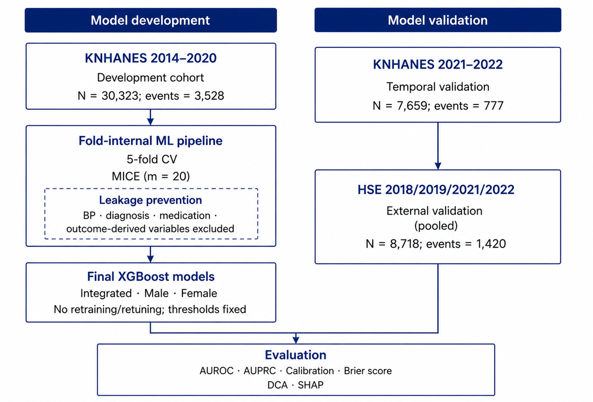
Three analysis populations were defined before model development began, as part of the study’s internal analysis plan rather than a formally registered protocol: an integrated model including both sexes, a male-specific model, and a female-specific model. Sex was included as a predictor only in the integrated model and was not included in the sex-specific models.
Study Population
For KNHANES development and temporal validation, adults aged 19 years or older were eligible. Participants were excluded if currently pregnant, had missing final systolic or diastolic blood pressure measurements, reported physician-diagnosed hypertension, used antihypertensive medication, had indeterminate hypertension diagnosis or medication status, or had more than 50% participant-level missingness across candidate predictors. The KNHANES development cohort exclusion flow is provided in Table S2 in Multimedia Appendix 1.
For HSE external validation, exact age was not available in the accessible public/EUL data. Therefore, the adult criterion was implemented using the 5-year age-band variable as age 20 years or older. The difference represented a data-driven harmonization constraint and protocol deviation from the KNHANES age criterion of 19 years or older, caused by the unavailability of exact age in the accessible HSE files. Conceptually equivalent exclusions were applied for missing blood pressure measurement, self-reported physician-diagnosed high blood pressure, prescribed blood pressure medication use, and pregnancy where available.
Outcome Definition
The primary outcome was undiagnosed hypertension. In KNHANES, participants were classified as having undiagnosed hypertension if measured systolic blood pressure was >=140 mmHg or measured diastolic blood pressure was >=90 mmHg, with no self-reported physician-diagnosed hypertension and no antihypertensive medication use. The threshold and screening frame align with commonly used adult hypertension screening and management recommendations [6,30].
In HSE external validation, the outcome was defined using a harmonized outcome definition based on valid mean Omron systolic and diastolic blood pressure variables, applying the same blood pressure threshold of systolic blood pressure >=140 mmHg or diastolic blood pressure >=90 mmHg after excluding participants with self-reported physician-diagnosed high blood pressure or prescribed blood pressure medication use. Because HSE diagnosis and medication questions were not identical to KNHANES items, the outcome was treated as harmonized rather than identical. This harmonization could bias external performance estimates in either direction if diagnosis or medication reporting differed systematically between surveys.
Predictors
The final primary predictor set was fixed as Core+SDOH+HR before external validation. Integrated models used 19 predictors: age, sex, body mass index, waist circumference, heart rate, physician-diagnosed diabetes, aerobic activity, self-rated health, activity limitation, family history of hypertension, current smoking, alcohol drinking frequency, usual drinking amount, binge drinking, education level, household income quartile, employment status, marital status, and food security status. Sex-specific models used the same predictors except sex. Predictor selection followed the risk-factor evidence summarized in the Introduction. Predictor definitions and KNHANES source variables are provided in Table S1 in Multimedia Appendix 1.
Systolic blood pressure, diastolic blood pressure, repeated blood pressure measurements, hypertension diagnosis variables, antihypertensive medication variables, and any outcome-derived variables were not used as predictors.
Model Development, Final Refit, and Freezing
The development pipeline used 5-fold stratified group cross-validation in KNHANES 2014-2020. Groups were defined by survey year and primary sampling unit, and the outcome was used for stratification. Within each outer fold, multiple imputation by chained equations (MICE) with m=20 [31] was fit only in the outer training fold and applied to the corresponding outer validation fold, consistent with recommended practice for handling missing data in prediction-model development [32]. Development sample size (30,323 participants, 3,528 events) exceeded minimum requirements for a 19-predictor binary prediction model [33,34], corresponding to approximately 186 events per predictor for the integrated model, 109 for the male-specific model, and 87 for the female-specific model (18 predictors, sex excluded), well above conventional minimum event-per-predictor guidance. Predictor missingness before imputation is provided in Table S3 in Multimedia Appendix 1. Scaling, one-hot encoding, and other preprocessing steps were fit only in the training fold and then applied to validation data, following leakage-control principles for prediction-model development and evaluation [32,35].
The candidate algorithms in the primary pipeline were logistic regression, least absolute shrinkage and selection operator (LASSO), elastic net, random forest, XGBoost, light gradient boosting machine (LightGBM), and adaptive boosting (AdaBoost). Hyperparameter tuning was performed within the outer training fold using inner cross-validation. The outer validation fold was used only for out-of-fold evaluation. A non-invasive Hypertension Index Model benchmark was also evaluated on the same cohort and folds, but the benchmark was not eligible for final model selection.
Out-of-fold predictions from all five validation folds were combined to evaluate discrimination, calibration, threshold performance, and decision curve analysis. After development model comparison, the final predictor set was frozen as Core+SDOH+HR, and the best single model by development out-of-fold AUROC in KNHANES 2014-2020 was selected for each analysis population. The final primary model selected for each analysis population was XGBoost according to the frozen primary manifest and bundle quality control. Each final model was refit on the full KNHANES 2014-2020 development cohort using MICE m=20 and selected hyperparameters. No retraining, retuning, recalibration, variable selection, or threshold resetting was performed in temporal or external validation. Final frozen model specifications are shown in Table 1.
For each candidate, logistic recalibration was fitted to the pooled development out-of-fold predictions using the logit of the uncalibrated probability as the predictor. The fitted intercept and slope were then applied to the same predictions. Development post-calibration estimates therefore describe apparent fit of the calibration step, rather than an independent evaluation of that step. Uncalibrated out-of-fold and post-calibration results are reported separately in Tables S11 and S12 in Multimedia Appendix 1. The development-fitted calibrator for each selected model was frozen and applied without refitting in temporal and external validation.
HSE Harmonization
HSE external validation used pooled data from 2018, 2019, 2021, and 2022 [36]. Predictor and outcome harmonization rules are provided in Table S5 in Multimedia Appendix 1. Blood pressure protocol evidence supported right-arm cuff placement, a rest period before measurement, and three Omron readings with intervals between readings. Valid mean systolic and diastolic blood pressure variables were used for outcome definition, consistent with measurement-quality guidance emphasizing standardized cuff-based blood pressure assessment [37-39].
Key harmonization limitations were documented before interpreting external validation. Exact age was unavailable and was represented by 5-year age-band midpoints. Family history of hypertension and food security status were unavailable in HSE and were retained as all-missing predictors handled by the frozen development-fitted imputation and preprocessing pipeline. The schema-preserving approach maintained compatibility with the frozen model but could attenuate external transportability. Aerobic activity, alcohol amount, and binge drinking required harmonization or proxy definitions in some years. Predictor missingness in the pooled HSE input is provided in Table S6 in Multimedia Appendix 1. HSE 2021 had a reduced valid blood pressure measurement subset; this reduction coincided with the pandemic period, although changes in survey mode or respondent composition cannot be excluded as contributing factors. The HSE harmonization decisions and limitations are summarized in Table 2.
Statistical Analysis
Discrimination was evaluated using AUROC and the area under the precision-recall curve (AUPRC). Calibration was evaluated using Brier score, calibration intercept, calibration slope, and calibration curves [26]. Clinical utility was evaluated using decision curve analysis across threshold probabilities of 0.05 to 0.30 [27]; in this context, “treat” corresponds to recommending confirmatory blood pressure measurement rather than initiating antihypertensive treatment, and the evaluated threshold range was selected to span the observed event rates across analysis populations and plausible referral-threshold preferences for a low-cost, low-risk confirmatory test. Threshold performance was summarized using sensitivity, specificity, positive predictive value, negative predictive value, balanced accuracy, and referral rate at frozen development thresholds. Confidence intervals (CIs) for validation AUROC and AUPRC were estimated using 2000 bootstrap resamples in the analysis pipeline. Exploratory HSE subgroup AUROC 95% CIs were estimated with 2000 participant-level bootstrap resamples. Selection associated with blood pressure availability was assessed descriptively by comparing age-group and sex distributions among age-eligible HSE participants with unavailable versus available valid blood pressure measurements and the final external-validation cohort; no formal hypothesis tests were performed (Table S14 in Multimedia Appendix 1).
Sensitivity Analyses
A prediction-only sensitivity analysis in the KNHANES 2021-2022 temporal cohort compared the original model inputs with a copy in which family history of hypertension was set to missing for every participant. The same participants, outcomes, remaining predictors, and frozen preprocessing, imputation, model, and calibration components were used in both conditions. AUROC and Brier score were compared descriptively; no model updating or threshold resetting was performed (Table S13 in Multimedia Appendix 1).
A joint harmonization sensitivity analysis extended this comparison by additionally setting food security status to missing, discretizing age to HSE-style 5-year band midpoints, and restricting to participants aged 20 years or older, to estimate how much of the temporal-to-external AUROC gap was attributable to these harmonization constraints versus other transportability factors (Table S17 in Multimedia Appendix 1).
A population-weighted sensitivity analysis was conducted for pooled HSE external validation using the HSE nurse-visit survey weight, without retraining the frozen models. Weighted event rate, referral rate, threshold-based metrics, and AUROC were compared with the unweighted estimates reported in Tables 3 and 4, with 95% CIs from a cluster bootstrap resampling HSE primary sampling units (Table S15 in Multimedia Appendix 1).
An age-only sensitivity analysis compared development out-of-fold discrimination of an unpenalized logistic regression using only age (plus sex for the integrated model) against the frozen primary models, using the same development participants and cross-validation folds (Table S16 in Multimedia Appendix 1).
Model interpretation used TreeSHAP values [40] from the frozen XGBoost models. Shapley additive explanations (SHAP) values were grouped back to original predictors for interpretation, and partial dependence plots were generated for age, body mass index, and waist circumference. Interpretability analyses were descriptive and were not used to refit or change the models.
Ethical Considerations
This study used secondary analysis of existing, de-identified survey data and did not involve new contact with participants. KNHANES data are released by the Korea Disease Control and Prevention Agency for approved secondary research use, with participant consent for secondary scientific use of de-identified data obtained at the time of original data collection. HSE data were obtained from the UK Data Service under an End User License that permits secondary analysis of de-identified survey data for approved research purposes. No identifiable personal information was accessed at any stage of the analysis. [Author input needed: institutional review board determination for this secondary analysis — either the institution name and exemption approval number, or the basis for the determination that review was not required.]
Table 1. Frozen final model specification.
Model set | KNHANESª development N^{b} | Events^{b} | Event rate^{b} | Variable set | Algorithm | Frozen sensitivity threshold
Integrated | 30,323 | 3,528 | 11.6% | Core+SDOH+HR | XGBoost^{c} | 0.1062
Male | 13,088 | 1,966 | 15.0% | Core+SDOH+HR | XGBoost | 0.1205
Female | 17,235 | 1,562 | 9.1% | Core+SDOH+HR | XGBoost | 0.0870
ªKNHANES: Korea National Health and Nutrition Examination Survey.
^{b}Values are counts or proportions unless otherwise indicated.
^{c}XGBoost: extreme gradient boosting.

Table 2. Health Survey for England (HSE) predictor harmonization and limitations.
Predictor domain | HSEª implementation | Mapping class^{b} | Limitation or handling
Age | 5-year age band midpoint | Proxy | Exact age unavailable; age-band midpoint used and adult eligibility set to 20 years or older.
Sex | Reported sex | Direct | Used for integrated model and sex-specific subsetting.
BMI^{c}/waist | Measured anthropometrics | Direct/harmonized | Units harmonized to kg/m2 and cm.
Heart rate | Mean of available pulse readings | Harmonized | Constructed from available pulse measures to approximate KNHANES^{d} heart rate.
Diabetes diagnosis | Self-reported doctor diagnosis | Direct | Question wording was clinically comparable.
Physical activity | Survey activity items | Proxy/harmonized | Aerobic activity required cross-survey rule mapping.
Alcohol variables | Frequency/amount/binge items | Proxy/harmonized | Binge drinking and usual amount required HSE-specific response harmonization.
Family history of hypertension | No acceptable item identified | Not available | Retained as all missing and handled by frozen development-fitted imputation.
Food security | No acceptable item identified | Not available | Retained as all missing and handled by frozen development-fitted imputation.
SDOH^{e} | Education, income, employment, marital status | Harmonized | Categories mapped before prediction; no validation-driven recoding was performed.
ªHSE: Health Survey for England.
^{b}Mapping classes were finalized before external prediction; no validation-driven recoding was performed.
^{c}BMI: body mass index.
^{d}KNHANES: Korea National Health and Nutrition Examination Survey.
^{e}SDOH: social determinants of health.

Results
Development Cohort and Final Models
The KNHANES 2014-2020 development cohort included 30,323 adults in the integrated analysis, with 3,528 events of undiagnosed hypertension. The male-specific analysis included 13,088 men with 1,966 events, and the female-specific analysis included 17,235 women with 1,562 events. The KNHANES 2021-2022 temporal validation cohort included 7,659 adults, with 777 events of undiagnosed hypertension. The final frozen primary models used XGBoost for all three analysis populations.
Development, Temporal Validation, and External Validation Performance
In development out-of-fold evaluation, AUROC values were 0.757 for the integrated model, 0.714 for the male-specific model, and 0.778 for the female-specific model. In KNHANES 2021-2022 temporal validation, AUROC values were 0.746, 0.722, and 0.756, respectively. Compared with development out-of-fold estimates, temporal AUROC changed by -0.011 for the integrated model, +0.008 for the male-specific model, and -0.022 for the female-specific model. Before logistic recalibration, development OOF calibration intercepts/slopes were 0.0028/1.0020, -0.0526/0.9650, and 0.0003/0.9984 for the integrated, male-specific, and female-specific models, respectively (Table S12 in Multimedia Appendix 1).
The pooled HSE external validation cohort included 8,718 participants after exclusions, with 1,420 events of undiagnosed hypertension. The male-specific cohort included 3,646 men with 701 events, and the female-specific cohort included 5,072 women with 719 events. In pooled HSE external validation, AUROC values were 0.720 (95% CI 0.707-0.733), 0.671 (95% CI 0.651-0.692), and 0.746 (95% CI 0.729-0.762), respectively. External AUROC was lower than development out-of-fold AUROC by 0.037, 0.043, and 0.032, respectively. Full discrimination and calibration estimates are summarized in Table 3, and ROC and calibration curves are shown in Figures 2 and 3.
Table 3. Development, temporal validation, and external validation discrimination and calibration.
Dataset | Model set | AUROCª (95% CI)^{b} | AUPRC^{c} | Brier | Cal.^{d} intercept | Cal. slope
Dev OOF^{e,f} | Integrated | 0.757 | 0.269 | 0.094 | 0.000 | 1.000
Dev OOF | Male | 0.714 | 0.289 | 0.118 | 0.001 | 1.001
Dev OOF | Female | 0.778 | 0.228 | 0.076 | 0.000 | 1.000
Temporal | Integrated | 0.746 (0.730-0.761) | 0.231 (0.208-0.259) | 0.085 | -0.209 | 1.018
Temporal | Male | 0.722 (0.698-0.745) | 0.269 (0.237-0.308) | 0.106 | -0.151 | 1.048
Temporal | Female | 0.756 (0.734-0.778) | 0.180 (0.156-0.213) | 0.070 | -0.435 | 0.900
HSE^{g} pooled | Integrated | 0.720 (0.707-0.733) | 0.301 (0.281-0.324) | 0.126 | 0.020 | 1.047
HSE pooled | Male | 0.671 (0.651-0.692) | 0.312 (0.283-0.345) | 0.147 | -0.167 | 0.854
HSE pooled | Female | 0.746 (0.729-0.762) | 0.271 (0.248-0.299) | 0.111 | 0.065 | 1.055
ªAUROC: area under the receiver operating characteristic curve.
^{b}CI: confidence interval.
^{c}AUPRC: area under the precision-recall curve.
^{d}Cal.: calibration.
^{e}Development Brier scores and calibration estimates were evaluated after logistic recalibration on the same pooled OOF predictions used to fit the calibrator and represent apparent calibration-step performance. Uncalibrated OOF values are reported in Table S12 in Multimedia Appendix 1. Temporal and external estimates use the frozen calibrator; 95% CIs are reported for validation AUROC/AUPRC.
^{f}OOF: out-of-fold.
^{g}HSE: Health Survey for England.

Figure 2. Receiver operating characteristic curves for the frozen primary extreme gradient boosting (XGBoost) models in development out-of-fold evaluation, Korea National Health and Nutrition Examination Survey (KNHANES) 2021-2022 temporal validation, and Health Survey for England (HSE) pooled external validation.
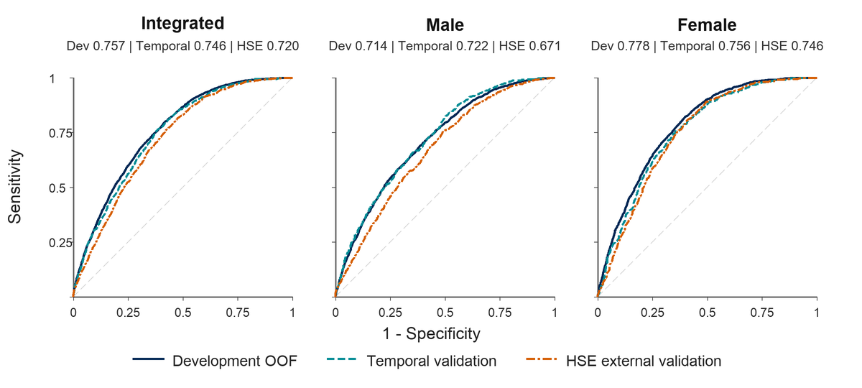

Threshold Performance and Decision Curve Analysis
At sensitivity-priority thresholds frozen from development out-of-fold predictions, temporal validation sensitivity was 0.840 for the integrated model, 0.845 for the male-specific model, and 0.817 for the female-specific model. In pooled HSE external validation, sensitivity at the same threshold type was higher: 0.924, 0.894, and 0.926, respectively, with referral rates of 0.685, 0.724, and 0.635, respectively.
Decision curve analysis in pooled HSE external validation showed positive mean net benefit across threshold probabilities of 0.05 to 0.30: 0.053 for the integrated model, 0.065 for the male-specific model, and 0.044 for the female-specific model. Across key threshold probabilities, the models generally provided higher net benefit than treating all participants as screen-positive or treating none as screen-positive. The male-specific model had the highest mean net benefit despite the lowest AUROC, indicating that threshold-based clinical utility and rank discrimination did not move in parallel for this model, partly because event rate and threshold placement affect net benefit independently of discrimination. Threshold metrics are summarized in Table 4, and the decision curves are shown in Figure 4.
Table 4. Frozen sensitivity-priority threshold performance.
Dataset | Model set | Thresh.ª | Cutoff | Sens.^{b} | Spec.^{c} | PPV^{d} | NPVe | Referral
Temporal | Integrated | Sensitivity | 0.1062 | 0.840 | 0.530 | 0.168 | 0.967 | 0.507
Temporal | Male | Sensitivity | 0.1205 | 0.845 | 0.469 | 0.193 | 0.953 | 0.572
Temporal | Female | Sensitivity | 0.0870 | 0.817 | 0.571 | 0.142 | 0.973 | 0.460
HSE^{f} pooled | Integrated | Sensitivity | 0.1062 | 0.924 | 0.362 | 0.220 | 0.961 | 0.685
HSE pooled | Male | Sensitivity | 0.1205 | 0.894 | 0.316 | 0.237 | 0.926 | 0.724
HSE pooled | Female | Sensitivity | 0.0870 | 0.926 | 0.413 | 0.207 | 0.971 | 0.635
ªSensitivity-priority thresholds were frozen from development out-of-fold (OOF) predictions and applied without resetting.
^{b}Sens.: sensitivity.
^{c}Spec.: specificity.
^{d}PPV: positive predictive value.
^{e}NPV: negative predictive value.
^{f}HSE: Health Survey for England.

Figure 3. Calibration curves for the frozen primary models in pooled Health Survey for England (HSE) external validation.
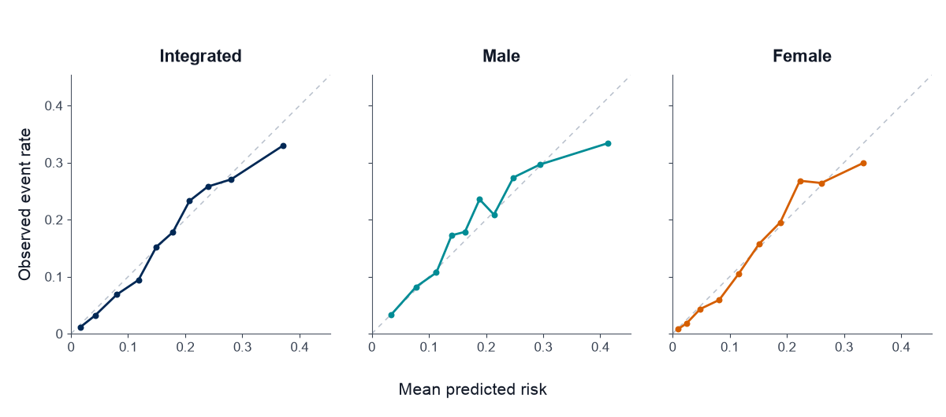
Figure 4. Decision curve analysis for the frozen primary models in pooled Health Survey for England (HSE) external validation.
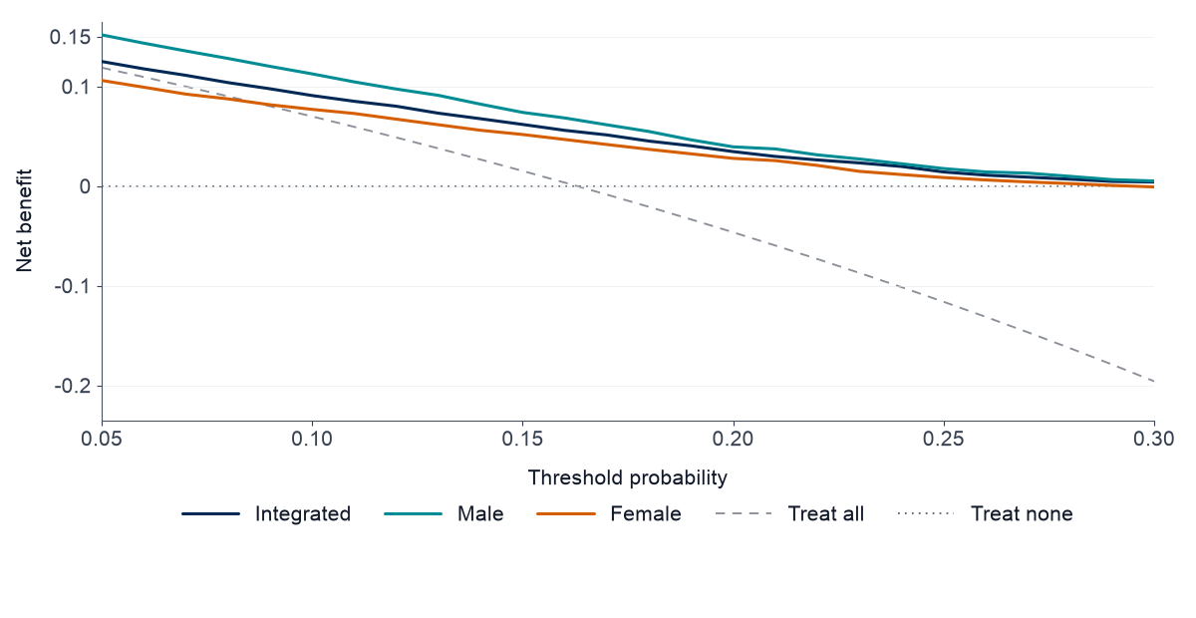

Year-Specific External Validation and Prediction Quality Control
Year-specific HSE external validation showed higher discrimination in 2018 and 2019 than in 2021 and 2022. Integrated-model AUROC values were 0.734 in 2018, 0.742 in 2019, 0.694 in 2021, and 0.688 in 2022. The corresponding male-specific AUROC values were 0.686, 0.708, 0.613, and 0.638; female-specific AUROC values were 0.760, 0.757, 0.744, and 0.710. The lower 2021 and 2022 estimates were consistent with the reduced valid blood pressure measurement subset described in the harmonization assessment, which coincided with the pandemic period but may also reflect other survey-mode or respondent-composition changes.
Prediction quality control showed no missing predictions, no out-of-range predictions, and matched transformed feature schemas for integrated, male-specific, and female-specific HSE validation. Family history of hypertension and food security status were all-missing in HSE; unavailable variables were retained as missing rather than replaced by unverified proxy variables. The pooled HSE cohort flow is presented in the main text, and year-specific external validation metrics are provided in Table S7 in Multimedia Appendix 1. In the temporal-cohort sensitivity analysis, setting family history of hypertension to missing changed AUROC from 0.7455 to 0.7447 for the integrated model, from 0.7220 to 0.7211 for the male-specific model, and from 0.7563 to 0.7556 for the female-specific model. Brier scores changed only slightly (Table S13 in Multimedia Appendix 1). A joint harmonization sensitivity analysis, which additionally set food security status to missing, discretized age to HSE-style 5-year band midpoints, and restricted to participants aged 20 years or older, changed AUROC by -0.0000 for the integrated model, +0.0011 for the male-specific model, and -0.0012 for the female-specific model relative to the same age-restricted temporal cohort, accounting for approximately 0%, a negative share, and 15% of the respective temporal-to-external AUROC gaps (Table S17 in Multimedia Appendix 1). Among 28,889 age-eligible HSE participants with valid sex, 16,302 (56.4%) lacked valid blood pressure measurements, 12,587 had valid measurements, and 8,718 entered final external validation. The group with valid measurements had a larger proportion aged 65 years or older than the group without valid measurements (36.3% vs 27.0%), whereas the male proportion was similar (44.6% vs 45.3%); the final cohort included 23.9% aged 65 years or older after the remaining prespecified exclusions (Table S14 in Multimedia Appendix 1). Subgroup AUROCs with 95% bootstrap CIs, including estimates for the White and Non-White ethnicity strata, are reported in Table S8 in Multimedia Appendix 1; given the small non-White subgroup sizes (N=418-989) and correspondingly wide confidence intervals, these ethnicity-stratified estimates should be interpreted as descriptive and hypothesis-generating rather than as evidence for or against differential model performance by ethnicity.
Table 5. Health Survey for England (HSE) cohort construction flow.
Stepª | Remaining N | Excluded N
Raw HSE^{b} 2018/2019/2021/2022 records | 36,791 | -
Age 20 years or older by 5-year age band | 28,889 | 7,902
Valid sex | 28,889 | 0
Valid systolic and diastolic blood pressure | 12,587 | 16,302
Known high blood pressure diagnosis status | 12,583 | 4
No self-reported diagnosed high blood pressure | 8,988 | 3,595
Antihypertensive medication determinable | 8,988 | 0
No prescribed blood pressure medication use | 8,718 | 270
Pregnancy exclusion applied | 8,718 | 0
ªRows are sequential exclusion steps applied to the pooled HSE external validation cohort.
^{b}HSE: Health Survey for England.
Benchmark and Interpretability
Among the seven candidate algorithms evaluated with the primary predictor set, XGBoost had the highest development OOF AUROC in each analysis population. Corresponding logistic regression AUROCs were 0.7502, 0.7105, and 0.7768 for the integrated, male-specific, and female-specific models, respectively; the XGBoost increments were 0.0069, 0.0034, and 0.0012. Candidate AUROC, AUPRC, and Brier scores are reported in Table S11 in Multimedia Appendix 1.
Compared with the non-invasive Hypertension Index Model benchmark, the primary model showed higher development out-of-fold AUROC in all three analysis populations. The AUROC difference was 0.015 (95% CI 0.011 to 0.020; P<.001) for the integrated model, 0.015 (95% CI 0.008 to 0.022; P<.001) for the male-specific model, and 0.005 (95% CI 0.000 to 0.010; P=.06) for the female-specific model. Benchmark comparisons are provided in Table S9 in Multimedia Appendix 1.
In a population-weighted sensitivity analysis of pooled HSE external validation, weighted AUROC was higher than the corresponding unweighted estimate for all three analysis populations (integrated 0.744, male 0.707, female 0.769), and weighted referral rate was lower than the unweighted estimate by 7.8 to 9.3 percentage points, with 95% CIs from a cluster bootstrap overlapping only narrowly with the unweighted AUROC CIs in Table 3 (Table S15 in Multimedia Appendix 1).
An age-only model achieved lower development OOF AUROC than the primary models by 0.076 for the integrated model, 0.126 for the male-specific model, and 0.044 for the female-specific model, indicating that the non-invasive predictor set added discrimination beyond age alone, most notably for the male-specific model (Table S16 in Multimedia Appendix 1).
In grouped SHAP analyses, age was the highest-ranked predictor in all three models. In the integrated model, the top predictors by mean absolute grouped SHAP were age, waist circumference, body mass index, family history of hypertension, sex, alcohol drinking frequency, binge drinking, heart rate, usual drinking amount, and education level. In men, body mass index and heart rate ranked more prominently; in women, age, family history of hypertension, body mass index, waist circumference, and education level ranked highly. Ranked SHAP variables are provided in Table S10 in Multimedia Appendix 1, and the grouped SHAP beeswarm plot is shown in Figure 5.
Figure 5. Beeswarm plot of grouped Shapley additive explanations (SHAP) values for the final integrated extreme gradient boosting (XGBoost) model. Points represent participant-level grouped SHAP contributions for the highest-ranked predictors.
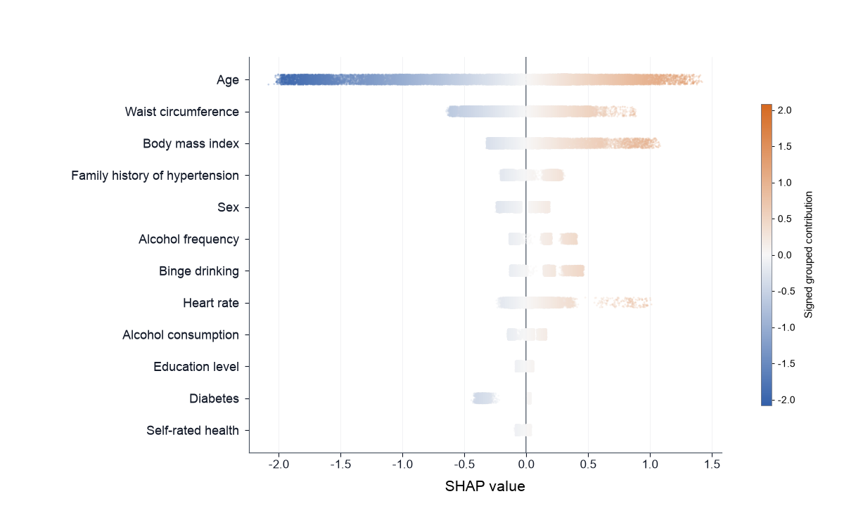

Discussion
Principal Findings
The study developed and validated non-invasive machine learning models for screening undiagnosed hypertension among adults. The models were trained without using blood pressure measurements, laboratory predictors, hypertension diagnosis variables, antihypertensive medication variables, or outcome-derived variables as predictors. The final XGBoost models showed moderate discrimination in development out-of-fold evaluation, limited degradation in later KNHANES temporal validation, and attenuated but retained discrimination in HSE external validation. This pattern, discrimination holding up across a later domestic survey wave and then declining but remaining above chance in an independent country, is the pattern expected of a genuine screening signal rather than of a model that memorized development-cohort idiosyncrasies [35], and it supports interpreting the non-invasive predictor set as carrying real information about undiagnosed hypertension rather than artifacts specific to KNHANES 2014-2020.
The female-specific model showed the highest discrimination across development and external validation. The male-specific model consistently showed lower AUROC, suggesting greater difficulty distinguishing undiagnosed hypertension among men using the available non-invasive predictors alone or incomplete capture of important male-specific determinants by the survey variables. However, decision curve analysis in HSE showed competitive or higher threshold-based net benefit for the male-specific model across much of the evaluated threshold range, underscoring that AUROC and clinical utility can diverge when event rates and operating thresholds differ. This divergence is not circular: AUROC quantifies rank-based discrimination independent of any single threshold, whereas net benefit is threshold- and prevalence-dependent; the male-specific model's external AUROC of 0.671 is accordingly reported and interpreted as a genuine, below-conventional-threshold discrimination result, not one offset by its net-benefit performance. Sex differences in hypertension pathophysiology, symptom recognition, and health-care-seeking behavior are well documented and may contribute to differential detectability of undiagnosed hypertension by sex [41], and cross-national survey data have similarly reported sex-specific gaps in hypertension awareness, treatment, and control that vary by country and health system [42]. Future models may require additional behavioral, occupational, medication-use, or longitudinal predictors to improve discrimination in men. Pending such improvements, the female-specific and integrated models are the more defensible choice for discrimination-based ranking, whereas the male-specific model's competitive net benefit indicates it remains clinically useful for threshold-based referral decisions despite its lower AUROC. The integrated model performed between the sex-specific models and may be useful when a single population-level screening model is preferred.
Comparison With Prior Work
The present study differs from many previous hypertension prediction studies because the target was current undiagnosed hypertension, not future incident hypertension. Prior work has shown strong performance for incident hypertension prediction when electronic health records, health checkup data, laboratory values, or systolic and diastolic blood pressure are available [22-24]. In contrast, the present models intentionally excluded blood pressure, laboratory, and hypertension-related variables to preserve a screening-prioritization role rather than serving as diagnostic or near-diagnostic models. This distinction matters for translational purposes: incident-hypertension models are typically positioned for risk stratification over a future time horizon, whereas the present models are positioned to prompt confirmatory measurement for hypertension that may already be present but undetected, a use case with a shorter and more directly actionable time horizon for the individual adult. This distinction is relevant because machine learning algorithms have not consistently outperformed simpler regression-based approaches for clinical prediction, underscoring the importance of validating discrimination, calibration, and clinical utility rather than assuming an advantage from algorithm complexity alone [43]. The small OOF AUROC increments over logistic regression in the present analysis support reporting the selected XGBoost models alongside simpler comparators, without assuming a clinically important advantage from algorithm complexity alone. XGBoost was nonetheless retained as the primary model rather than reporting logistic regression as co-primary because SHAP-based interpretation of the tree-based model supported transparent, consistent predictor rankings across analysis populations (Interpretability); the near-equivalent discrimination of logistic regression indicates that a simpler, directly interpretable linear model would be a reasonable alternative for implementations that prioritize coefficient-level transparency over SHAP-based explanation.
The emphasis on temporal validation, external validation, calibration, decision curve analysis, and transparent reporting is consistent with contemporary prediction-model recommendations [26,27,29]. The use of HSE as an external validation dataset provided a conservative transportability test across countries, survey systems, and measurement conditions [36].
Clinical Interpretation
The models should not be interpreted as diagnostic substitutes for blood pressure measurement [7,8]. Instead, first-stage screening prioritization is the appropriate use case for identifying adults warranting confirmatory blood pressure assessment. The screening-prioritization interpretation is important because the models deliberately avoid using the measurements defining the outcome.
Because blood pressure measurement is inexpensive and already recommended for all adults in many health systems [7,8], the clinical value of a non-invasive model is greatest where routine in-person blood pressure measurement is not readily available at first contact: for example, remote or community-based outreach without on-site measurement equipment, population-level pre-screening from self-reported survey or digital-intake data before a clinical visit is scheduled, or prioritization of limited confirmatory-measurement capacity in resource-constrained screening programs. In these settings, the models are intended to prompt confirmatory blood pressure measurement rather than to replace it.
The frozen sensitivity-priority thresholds produced high sensitivity in both temporal and external validation, with substantial referral rates. In pooled HSE external validation, referral rates were 68.5% for the integrated model, 72.4% for the male-specific model, and 63.5% for the female-specific model. Referral rates should be interpreted as the practical trade-off between high sensitivity and additional confirmatory blood pressure measurement burden [8,44]. Such trade-offs may be acceptable in settings where blood pressure measurement is low-cost and low-risk, but threshold choice should be aligned with local screening capacity and implementation context. In quantitative terms, the frozen thresholds would direct confirmatory blood pressure measurement to 63.5% to 72.4% of adults rather than the entire population (68.5% to 60.7% for the integrated model under unweighted and weighted estimates, respectively), a reduction in confirmatory-measurement volume of approximately 27% to 45% across the three models and both weighting schemes relative to universal measurement while retaining 85.7% to 92.6% sensitivity; whether this reduction justifies the residual missed cases and implementation costs depends on local measurement capacity and was not evaluated as a formal cost-effectiveness analysis in this study. Because referral rate and sensitivity move together at a fixed threshold, no single frozen threshold is optimal for every deployment setting; screening programs with constrained confirmatory-measurement capacity may instead consider the Youden-optimal operating point reported in Table S4 in Multimedia Appendix 1, accepting lower sensitivity in exchange for a smaller referral burden.
Population weighting further suggested that the unweighted referral-rate estimates may be conservative: weighted referral rates were 7.8 to 9.3 percentage points lower than the unweighted estimates across the three models, while weighted AUROC was correspondingly higher, indicating that survey-representative referral burden may be somewhat lower than the unweighted estimates imply (Table S15 in Multimedia Appendix 1).
External Validation and Transportability
External validation in HSE showed lower AUROC than development and temporal validation, particularly in men. The performance drop is methodologically plausible because HSE differed from KNHANES in country, population composition, survey protocol, age representation, predictor availability, and pandemic-era data collection, including differences in the screening and diagnostic threshold conventions applied across health systems [30,44]. Family history of hypertension and food security status were unavailable in HSE and were retained as missing rather than replaced by convenience proxies. Alcohol and physical activity variables also required harmonization or proxy definitions in some years. A joint harmonization sensitivity analysis applying the HSE-style constraints (age discretized to 5-year band midpoints, family history of hypertension and food security status set to fully missing, and age restricted to 20 years or older) to the same Korean temporal-validation cohort, using the frozen models and calibrators, found that these harmonization constraints explained approximately 0% of the AUROC gap between temporal and external validation for the integrated model, a negative share for the male-specific model, and approximately 15% for the female-specific model (Table S17 in Multimedia Appendix 1). This finding indicates that most of the external AUROC decline reflects genuine cross-country transportability differences rather than an artifact of the harmonization constraints themselves.
The HSE validation should therefore be interpreted primarily as evidence of genuine cross-country transportability limits, conducted under real-world cross-survey harmonization constraints that contributed little to the observed decline. The results support retained ranking performance, especially in women and in pre-pandemic HSE years, but do not imply full interchangeability between Korean and English survey settings. Because the HSE outcome was harmonized rather than identical, external validation should be interpreted as a transportability assessment under realistic measurement differences rather than as a pure replication of the KNHANES outcome. The moderate sample size of several HSE year-specific and subgroup strata, reflected in the width of the corresponding confidence intervals, is consistent with methodological guidance indicating that external validation studies require samples considerably larger than commonly assumed to estimate discrimination precisely [45]; the pooled HSE cohort was accordingly treated as the primary external estimate, with year-specific and subgroup analyses reported as secondary, hypothesis-generating checks rather than as independently powered validations (Table S8 in Multimedia Appendix 1). The lower 2021 and 2022 year-specific discrimination is consistent with this sample-size and measurement-mode explanation rather than with a general decline in transportability, because survey-mode changes coinciding with the pandemic period reduced the valid blood pressure measurement subset and may have altered the composition of participants with complete outcome ascertainment. Excluding the 2021 subgroup, which had the highest BMI missingness (76.9%; Table S5 in Multimedia Appendix 1) and coincided with pandemic-era survey-mode changes, changed pooled external AUROC by less than 0.008 for all three models (0.7204 to 0.7244 for the integrated model, 0.6727 to 0.6805 for the male-specific model, and 0.7443 to 0.7430 for the female-specific model), indicating that 2021 alone does not substantially drive the pooled external result or the male-specific model's below-0.7 external AUROC.
Interpretability
SHAP analyses supported the clinical plausibility of the fitted models. Age, body mass index, waist circumference, family history of hypertension, alcohol-related variables, and heart rate showed higher grouped SHAP contributions in model prediction, an ordering that parallels established, independently replicated risk factors for hypertension [12-18] rather than survey artifacts specific to this development cohort. The prominence of anthropometric and cardiometabolic predictors over social determinant and behavioral predictors in grouped SHAP rankings is also consistent with the modest incremental contribution of social determinant variables observed during predictor-set selection, and suggests that anthropometric and family-history information carries most of the non-invasive predictive signal for this outcome. The SHAP findings are broadly consistent with established hypertension risk factors, but diabetes diagnosis showed a predominantly negative grouped SHAP contribution, a pattern plausibly reflecting greater clinical contact and diagnosis among adults with diabetes rather than a lower biological relationship between diabetes and elevated blood pressure. This finding illustrates that predictors may capture detection and health-care-contact patterns in an undiagnosed-hypertension outcome, and SHAP and partial dependence analyses should therefore be interpreted as summaries of model behavior rather than causal estimates.
Although age was the highest-ranked predictor in grouped SHAP analyses, an age-only sensitivity analysis showed that the full non-invasive predictor set added discrimination beyond age alone, with development OOF AUROC increments of 0.076 for the integrated model, 0.126 for the male-specific model, and 0.044 for the female-specific model (Table S16 in Multimedia Appendix 1). This pattern is consistent with the age-stratified subgroup findings (Table S8 in Multimedia Appendix 1), in which within-age-band discrimination was attenuated for all models, particularly among older adults. Taken together, these findings indicate that age is the single most informative non-invasive predictor but that the remaining predictors, especially anthropometric, behavioral, and family-history variables, provide additional discrimination that age alone does not capture, most clearly for the male-specific model. A plausible explanation is that age itself is a strong prior for undiagnosed hypertension risk in this population, so that once age is known, the remaining non-invasive predictors carry comparatively little additional information within a narrow age band; this effect would be expected to be most pronounced in the oldest stratum, where age-related risk is already high and more uniform across individuals, consistent with the near-chance within-age-band AUROC (0.549-0.553) observed in adults 65 years or older despite this stratum having the highest event rate (approximately 30%) and therefore the greatest undiagnosed-hypertension burden.
Implementation Considerations
Interpretable artificial intelligence tools are increasingly proposed as clinical decision support for conditions with substantial underdiagnosis, but translation from a validated model to routine practice requires more than favorable discrimination and calibration [46]. The frozen models reported here output a calibrated probability accompanied by SHAP-based individual contributions, intended to support a single, low-stakes action (recommending confirmatory blood pressure measurement) rather than an autonomous diagnostic or treatment decision. This design choice keeps a clinician or screening program in the decision loop and may limit exposure to the alert-fatigue and automation-bias risks that have been described for interpretable artificial intelligence decision support in other acute and chronic care settings [46]. Realizing this design in practice would still require prospective evaluation of workflow integration, referral capacity, and user trust before the frozen models could be considered ready for use beyond the present development and validation cohorts.
Strengths and Limitations
Major strengths include the use of a nationally representative development dataset, strict leakage prevention with fold-internal imputation and preprocessing following established leakage-control principles for prediction-model development [32,35], sex-specific modeling, final model freezing before validation, temporal validation, external validation in an independent country-level survey, evaluation beyond AUROC, frozen threshold assessment, decision curve analysis, and model interpretation.
The study also has several limitations, spanning outcome measurement, predictor harmonization, model scope, and participant selection. Regarding outcome measurement, the outcome was based on survey-measured blood pressure at a single examination rather than repeated clinical visits or ambulatory monitoring, and single-visit office measurement is known to classify some adults differently than multi-visit or out-of-office protocols [47]. In a systematic review using 24-hour ambulatory monitoring as the reference standard, single-visit office measurement had a sensitivity of 51% and specificity of 88% for hypertension [48], indicating that survey-based single-measurement classification, including the positive predictive values reported here, may not generalize directly to ambulatory-confirmed diagnoses. Measurement protocols and survey conditions, assessed against standardized cuff-based blood pressure measurement-quality guidance [37,38], differed between KNHANES and HSE.
Regarding predictor harmonization, exact age was unavailable in the accessible HSE data, requiring use of age-band midpoints and an external validation criterion of age 20 years or older. Family history of hypertension and food security status were unavailable in HSE and handled as all-missing external predictors by the frozen development-fitted imputation pipeline. The all-missing handling approach preserved the frozen input schema; the joint harmonization sensitivity analysis (Table S17 in Multimedia Appendix 1) suggested this approach did not substantially weaken transportability, but it does not establish the true external availability of family history of hypertension or food security status. An alternative design could have excluded these two variables entirely and frozen a 17-predictor model as primary. This study retained the 19-predictor schema because both variables were genuinely available and informative in the KNHANES development and temporal-validation cohorts (family history ranked among the higher-contribution predictors in grouped SHAP analyses; Table S10 in Multimedia Appendix 1) and because the sensitivity analysis above indicated their absence explained little of the external AUROC gap; a 17-predictor alternative was not fit and would be a reasonable direction for future work. Physical activity and alcohol-related variables required proxy harmonization in some HSE years, and HSE external validation was restricted to participants with valid blood pressure measurement.
Regarding model scope, the survey predictor sets did not capture some sex-specific clinical or social determinants that may explain undiagnosed hypertension in men [41], and the frozen models were not re-optimized for any subgroup after freezing; therefore, subgroup and year-specific estimates should be read as descriptive rather than as separately validated models. Development post-calibration estimates were evaluated on the same pooled OOF predictions used to fit the calibrator and may be optimistic for that step; uncalibrated OOF and independent temporal and external validation estimates provide complementary assessments.
Regarding participant selection, because 16,302 of 28,889 age-eligible HSE participants lacked valid blood pressure measurements, external validation may also be affected by outcome-availability selection. The descriptive age-group and sex comparison in Table S14 does not exclude selection related to unmeasured characteristics.

Conclusions
Non-invasive XGBoost-based models developed in KNHANES 2014-2020 showed moderate discrimination for undiagnosed hypertension and maintained broadly similar performance in KNHANES 2021-2022 temporal validation. Discrimination was driven substantially by age, with limited within-age-band discrimination among older adults, but the non-invasive predictor set added meaningful discrimination beyond age alone, particularly in the male-specific model. In HSE external validation, discrimination was attenuated but remained clinically interpretable, particularly for the integrated and female-specific models. Better transportability was observed for the integrated and female-specific models than for the male-specific model. The frozen models may be useful as first-stage screening-prioritization tools to identify adults warranting confirmatory blood pressure measurement, rather than as diagnostic substitutes. Further validation in additional population-based surveys and implementation studies is warranted before clinical deployment.
Acknowledgments
The authors thank the participants, field investigators, and survey teams of the Korea National Health and Nutrition Examination Survey and the Health Survey for England. Funding information will be completed before journal submission. Author and institutional details can be completed in the unblinded submission file if required by the journal.
Data Availability
KNHANES data are available through the Korea Disease Control and Prevention Agency data access system. Health Survey for England data are available through the UK Data Service subject to applicable end-user license and data-use conditions. Derived analytic code, trained model objects, and nonidentifiable summary tables are available from the corresponding author upon reasonable request, subject to applicable survey data-use restrictions.
Authors' Contributions
Author contributions will be completed after author order and roles are finalized.
Conflicts of Interest
The authors declare no competing interests.
Multimedia Appendix 1
Supplementary methods, predictor definitions, harmonization rules, cohort flow details, model-development quality control, additional calibration and decision-curve results, and interpretability outputs.
Multimedia Appendix 2
TRIPOD+AI checklist.

References
1. NCD Risk Factor Collaboration (NCD-RisC). Worldwide trends in hypertension prevalence and progress in treatment and control from 1990 to 2019: a pooled analysis of 1201 population-representative studies with 104 million participants. Lancet. Sep 11, 2021;398(10304):957-980. [doi: 10.1016/S0140-6736(21)01330-1] [Medline: 34450083]
2. Mills KT, Stefanescu A, He J. The global epidemiology of hypertension. Nat Rev Nephrol. Apr 2020;16(4):223-237. [doi: 10.1038/s41581-019-0244-2] [Medline: 32024986]
3. Lawes CMM, Vander Hoorn S, Rodgers A; International Society of Hypertension. Global burden of blood-pressure-related disease, 2001. Lancet. May 3, 2008;371(9623):1513-1518. [doi: 10.1016/S0140-6736(08)60655-8] [Medline: 18456100]
4. Lewington S, Clarke R, Qizilbash N, Peto R, Collins R; Prospective Studies Collaboration. Age-specific relevance of usual blood pressure to vascular mortality: a meta-analysis of individual data for one million adults in 61 prospective studies. Lancet. Dec 14, 2002;360(9349):1903-1913. [doi: 10.1016/s0140-6736(02)11911-8] [Medline: 12493255]
5. Rapsomaniki E, Timmis A, George J, et al. Blood pressure and incidence of twelve cardiovascular diseases: lifetime risks, healthy life-years lost, and age-specific associations in 1.25 million people. Lancet. May 31, 2014;383(9932):1899-1911. [doi: 10.1016/S0140-6736(14)60685-1] [Medline: 24881994]
6. Whelton PK, Carey RM, Aronow WS, et al. 2017 ACC/AHA/AAPA/ABC/ACPM/AGS/APhA/ASH/ASPC/NMA/PCNA guideline for the prevention, detection, evaluation, and management of high blood pressure in adults. Circulation. Oct 23, 2018;138(17):e484-e594. [doi: 10.1161/CIR.0000000000000596] [Medline: 30354654]
7. US Preventive Services Task Force; Krist AH, Davidson KW, et al. Screening for hypertension in adults: US Preventive Services Task Force reaffirmation recommendation statement. JAMA. Apr 27, 2021;325(16):1650-1656. [doi: 10.1001/jama.2021.4987] [Medline: 33904861]
8. Guirguis-Blake JM, Evans CV, Webber EM, Coppola EL, Perdue LA, Weyrich MS. Screening for hypertension in adults: updated evidence report and systematic review for the US Preventive Services Task Force. JAMA. Apr 27, 2021;325(16):1657-1669. [doi: 10.1001/jama.2020.21669] [Medline: 33904862]
9. Korean Society Hypertension (KSH); Hypertension Epidemiology Research Working Group; Kim HC, Cho MC. Korea hypertension fact sheet 2018. Clin Hypertens. 2018;24:13. [doi: 10.1186/s40885-018-0098-0] [Medline: 30288297]
10. Kang SH, Kim SH, Cho JH, et al. Prevalence, awareness, treatment, and control of hypertension in Korea. Sci Rep. Jul 29, 2019;9(1):10970. [doi: 10.1038/s41598-019-46965-4] [Medline: 31358791]
11. Jeon YW, Kim HC. Factors associated with awareness, treatment, and control rate of hypertension among Korean young adults aged 30-49 years. Korean Circ J. Dec 2020;50(12):1077-1091. [doi: 10.4070/kcj.2020.0208] [Medline: 32975054]
12. Jayedi A, Rashidy-Pour A, Khorshidi M, Shab-Bidar S. Body mass index, abdominal adiposity, weight gain and risk of developing hypertension: a systematic review and dose-response meta-analysis of more than 2.3 million participants. Obes Rev. May 2018;19(5):654-667. [doi: 10.1111/obr.12656] [Medline: 29334692]
13. Tozawa M, Oshiro S, Iseki C, et al. Family history of hypertension and blood pressure in a screened cohort. Hypertens Res. Mar 2001;24(2):93-98. [doi: 10.1291/hypres.24.93] [Medline: 11325080]
14. Huai P, Xun H, Reilly KH, Wang Y, Ma W, Xi B. Physical activity and risk of hypertension: a meta-analysis of prospective cohort studies. Hypertension. Dec 2013;62(6):1021-1026. [doi: 10.1161/HYPERTENSIONAHA.113.01965] [Medline: 24082054]
15. Di Federico S, Filippini T, Whelton PK, et al. Alcohol intake and blood pressure levels: a dose-response meta-analysis of nonexperimental cohort studies. Hypertension. Oct 2023;80(10):1961-1969. [doi: 10.1161/HYPERTENSIONAHA.123.21224] [Medline: 37522179]
16. Kaplan RC, Baldoni PL, Strizich G, et al. Current smoking raises risk of incident hypertension: Hispanic Community Health Study-Study of Latinos. Am J Hypertens. Mar 11, 2021;34(2):190-197. [doi: 10.1093/ajh/hpaa152] [Medline: 32968788]
17. Sun D, Zhou T, Heianza Y, et al. Type 2 diabetes and hypertension. Circ Res. Mar 15, 2019;124(6):930-937. [doi: 10.1161/CIRCRESAHA.118.314487] [Medline: 30646822]
18. Shi Y, Zhou W, Liu X, et al. Resting heart rate and the risk of hypertension and heart failure: a dose-response meta-analysis of prospective studies. J Hypertens. May 2018;36(5):995-1004. [doi: 10.1097/HJH.0000000000001627] [Medline: 29176508]
19. Leng B, Jin Y, Li G, Chen L, Jin N. Socioeconomic status and hypertension: a meta-analysis. J Hypertens. Feb 2015;33(2):221-229. [doi: 10.1097/HJH.0000000000000428] [Medline: 25479029]
20. Metlock FE, Hinneh T, Benjasirisan C, et al. Impact of social determinants of health on hypertension outcomes: a systematic review. Hypertension. Aug 2024;81(8):1675-1700. [doi: 10.1161/HYPERTENSIONAHA.123.22571] [Medline: 38887955]
21. Beltran S, Pharel M, Montgomery CT, Lopez-Hinojosa IJ, Arenas DJ, DeLisser HM. Food insecurity and hypertension: a systematic review and meta-analysis. PLoS One. 2020;15(11):e0241628. [doi: 10.1371/journal.pone.0241628] [Medline: 33201873]
22. Ye C, Fu T, Hao S, et al. Prediction of incident hypertension within the next year: prospective study using statewide electronic health records and machine learning. J Med Internet Res. Jan 30, 2018;20(1):e22. [doi: 10.2196/jmir.9268] [Medline: 29382633]
23. Lopez-Martinez F, Nunez-Valdez ER, Gonzalez Crespo R, Garcia-Diaz V. An artificial neural network approach for predicting hypertension using NHANES data. Sci Rep. Jun 30, 2020;10(1):10620. [doi: 10.1038/s41598-020-67640-z] [Medline: 32606434]
24. Hwang SH, Lee H, Lee JH, et al. Machine learning-based prediction for incident hypertension based on regular health checkup data: derivation and validation in 2 independent nationwide cohorts in South Korea and Japan. J Med Internet Res. Nov 5, 2024;26:e52794. [doi: 10.2196/52794] [Medline: 39499554]
25. Collins GS, Moons KGM, Dhiman P, et al. TRIPOD+AI statement: updated guidance for reporting clinical prediction models that use regression or machine learning methods. BMJ. Apr 16, 2024;385:e078378. [doi: 10.1136/bmj-2023-078378] [Medline: 38626948]
26. Huang Y, Li W, Macheret F, Gabriel RA, Ohno-Machado L. A tutorial on calibration measurements and calibration models for clinical prediction models. J Am Med Inform Assoc. Apr 1, 2020;27(4):621-633. [doi: 10.1093/jamia/ocz228] [Medline: 32106284]
27. Vickers AJ, Elkin EB. Decision curve analysis: a novel method for evaluating prediction models. Med Decis Making. Nov-Dec 2006;26(6):565-574. [doi: 10.1177/0272989X06295361] [Medline: 17099194]
28. Kweon S, Kim Y, Jang MJ, et al. Data resource profile: the Korea National Health and Nutrition Examination Survey. Int J Epidemiol. Feb 2014;43(1):69-77. [doi: 10.1093/ije/dyt228] [Medline: 24585853]
29. Collins GS, Reitsma JB, Altman DG, Moons KGM. Transparent reporting of a multivariable prediction model for individual prognosis or diagnosis (TRIPOD): the TRIPOD statement. Ann Intern Med. Jan 6, 2015;162(1):55-63. [doi: 10.7326/M14-0697] [Medline: 25560714]
30. Williams B, Mancia G, Spiering W, et al. 2018 ESC/ESH Guidelines for the management of arterial hypertension. Eur Heart J. Sep 1, 2018;39(33):3021-3104. [doi: 10.1093/eurheartj/ehy339] [Medline: 30165516]
31. White IR, Royston P, Wood AM. Multiple imputation using chained equations: issues and guidance for practice. Stat Med. Feb 20, 2011;30(4):377-399. [doi: 10.1002/sim.4067] [Medline: 21225900]
32. Moons KG, Donders RA, Stijnen T, Harrell FE Jr. Using the outcome for imputation of missing predictor values was preferred. J Clin Epidemiol. Oct 2006;59(10):1092-1101. [doi: 10.1016/j.jclinepi.2006.01.009] [Medline: 16980150]
33. Riley RD, Ensor J, Snell KIE, et al. Calculating the sample size required for developing a clinical prediction model. BMJ. Mar 18, 2020;368:m441. [doi: 10.1136/bmj.m441] [Medline: 32188600]
34. van Smeden M, Moons KGM, de Groot JAH, et al. Sample size for binary logistic prediction models: beyond events per variable criteria. Stat Methods Med Res. Aug 2019;28(8):2455-2474. [doi: 10.1177/0962280218784726] [Medline: 29966490]
35. Steyerberg EW, Vergouwe Y. Towards better clinical prediction models: seven steps for development and an ABCD for validation. Eur Heart J. Aug 1, 2014;35(29):1925-1931. [doi: 10.1093/eurheartj/ehu207] [Medline: 24898551]
36. Mindell J, Biddulph JP, Hirani V, et al. Cohort profile: the health survey for England. Int J Epidemiol. Dec 2012;41(6):1585-1593. [doi: 10.1093/ije/dyr199] [Medline: 22253315]
37. Muntner P, Shimbo D, Carey RM, et al. Measurement of blood pressure in humans: a scientific statement from the American Heart Association. Hypertension. May 2019;73(5):e35-e66. [doi: 10.1161/HYP.0000000000000087] [Medline: 30827125]
38. Kallioinen N, Hill A, Horswill MS, Ward HE, Watson MO. Sources of inaccuracy in the measurement of adult patients' resting blood pressure in clinical settings: a systematic review. J Hypertens. Mar 2017;35(3):421-441. [doi: 10.1097/HJH.0000000000001197] [Medline: 27977471]
39. Myers MG, Godwin M, Dawes M, et al. Conventional versus automated measurement of blood pressure in primary care patients with systolic hypertension: randomised parallel design controlled trial. BMJ. Feb 7, 2011;342:d286. [doi: 10.1136/bmj.d286] [Medline: 21300709]
40. Lundberg SM, Erion G, Chen H, et al. From local explanations to global understanding with explainable AI for trees. Nat Mach Intell. Jan 2020;2(1):56-67. [doi: 10.1038/s42256-019-0138-9] [Medline: 32607472]
41. Ramirez LA, Sullivan JC. Sex differences in hypertension: where we have been and where we are going. Am J Hypertens. Nov 13, 2018;31(12):1247-1254. [doi: 10.1093/ajh/hpy148] [Medline: 30299518]
42. Santosa A, Zhang Y, Weinehall L, et al. Gender differences and determinants of prevalence, awareness, treatment and control of hypertension among adults in China and Sweden. BMC Public Health. Nov 23, 2020;20(1):1763. [doi: 10.1186/s12889-020-09862-4] [Medline: 33228600]
43. Christodoulou E, Ma J, Collins GS, Steyerberg EW, Verbakel JY, Van Calster B. A systematic review shows no performance benefit of machine learning over logistic regression for clinical prediction models. J Clin Epidemiol. Jun 2019;110:12-22. [doi: 10.1016/j.jclinepi.2019.02.004] [Medline: 30763612]
44. Piper MA, Evans CV, Burda BU, Margolis KL, O'Connor E, Whitlock EP. Diagnostic and predictive accuracy of blood pressure screening methods with consideration of rescreening intervals: a systematic review for the US Preventive Services Task Force. Ann Intern Med. Feb 3, 2015;162(3):192-204. [doi: 10.7326/M14-1539] [Medline: 25531400]
45. Riley RD, Snell KIE, Archer L, et al. Evaluation of clinical prediction models (part 3): calculating the sample size required for an external validation study. BMJ. Jan 22, 2024;384:e074821. [doi: 10.1136/bmj-2023-074821] [Medline: 38253388]
46. Ibraheem M, Khalil M, Khalil S, Contreras H, Azar J. Early clinical decision support using interpretable artificial intelligence in acute illness (sepsis and infection): A systematic review and meta-analysis. Int J Med Inform. Nov 1, 2026;220:106629. [doi: 10.1016/j.ijmedinf.2026.106629] [Medline: 42480414]
47. Sanchez Bacaicoa M, Rico S, Gullon A, et al. Automated office blood pressure measurements in waiting room or isolated room for diagnosis and phenotyping of hypertension. J Am Heart Assoc. Oct 21, 2025;14(20):e038011. [doi: 10.1161/JAHA.124.038011] [Medline: 41085208]
48. Viera AJ, Yano Y, Lin FC, et al. Does this adult patient have hypertension?: the rational clinical examination systematic review. JAMA. Jul 27, 2021;326(4):339-347. [doi: 10.1001/jama.2021.4533] [Medline: 34313682]

Abbreviations
AdaBoost: adaptive boosting
AUPRC: area under the precision-recall curve
AUROC: area under the receiver operating characteristic curve
BMI: body mass index
CI: confidence interval
HSE: Health Survey for England
KNHANES: Korea National Health and Nutrition Examination Survey
LASSO: least absolute shrinkage and selection operator
LightGBM: light gradient boosting machine
MICE: multiple imputation by chained equations
NPV: negative predictive value
OOF: out-of-fold
PPV: positive predictive value
SDOH: social determinants of health
SHAP: Shapley additive explanations
TRIPOD+AI: Transparent Reporting of a multivariable prediction model for Individual Prognosis or Diagnosis plus Artificial Intelligence
XGBoost: extreme gradient boosting

