LABORATORY RECORD
Course: Full Stack Web Development
Course Code: 23CM4121
Experiment No.: 1
Student Name: D. Suswetha
Roll No.: A24126552079
Date: 30-08-2026

TITLE
Design and Implementation of Static College Webpage Using HTML5 Formatting, Tables, Lists, and Forms

AIM
To develop a static college webpage for ABC Engineering College utilizing HTML5 text formatting tags, superscripts, subscripts, lists, structured tables, hyperlinks, images, and contact form inputs.

OBJECTIVE
The objectives of this experiment are:
- To practice document structuring with HTML5.
- To apply text formatting tags (bold, italic, underline, sup, sub).
- To construct ordered and unordered lists for academic courses and facilities.
- To create structured tables displaying student academic details.
- To implement a contact form with text, email, gender radio buttons, and submit action.

THEORY
HTML5 is the backbone of web development. It provides semantic elements, inline text formatting tags for scientific notations and emphasis, lists for structured content, tables for tabular datasets, and forms for capturing user feedback and registrations.
Application Flow:
HTML5 Structure -> Text Formatting & Lists -> Student Table -> Image & Links -> Contact Form

ALGORITHM / PROCEDURE
- Create an HTML5 document with title 'Static Webpage'.
- Display college heading and introductory paragraph with bold, italic, and underline tags.
- Format chemical formula (H■O) and mathematical formula (X²) using sub and sup.
- Build an ordered list (<ol>) for courses and an unordered list (<ul>) for facilities.
- Construct a border table with headers: Roll No, Name, Branch, and populate rows.
- Embed an image tag and an external hyperlink with target='_blank'.
- Implement a contact form containing name, email, gender radio buttons, and a submit button.
- Verify web page rendering and form inputs in browser.

PROGRAM
index.html
<!DOCTYPE html>
<html>
<head>
<title>Static Webpage</title>
</head>
<body> <h1>ABC Engineering College</h1>
<p> Welcome to our <b>College Website</b>.
We provide <i>Quality Education</i> in <u>Engineering</u>.
</p>
<p>
Formula: X<sup>2</sup><br>
Water: H<sub>2</sub>O
</p>
<h2>Courses</h2>
<ol>
<li>CSE</li>
<li>ECE</li>
<li>EEE</li>
</ol>
<h2>Facilities</h2>
<ul>
<li>Library</li>
<li>Hostel</li>
<li>Sports</li>
</ul>
<h2>Student Details</h2>
<table border="1">
<tr>
<th>Roll No</th>
<th>Name</th>
<th>Branch</th>
</tr>
<tr>
<td>101</td>
<td>suresh</td>
<td>CSE</td>
</tr>
<tr>
<td>102</td>
<td>Rahul</td>
<td>ECE</td>
</tr>
</table>
<br> <img src="college_logo.png" alt="College Logo" width="150">
<br><br> <a href="https://www.google.com" target="_blank">Visit Google</a>
<hr>
<h2>Contact Form</h2>
<form>
Name:
<input type="text"><br><br>
Email:
<input type="email"><br><br>
Gender:
<input type="radio" name="gender"> Male
<input type="radio" name="gender"> Female
<br><br> <input type="submit" value="Submit">
</form>
</body>
</html>

CODE EXPLANATION
Code / Syntax | Explanation
<b>, <i>, <u> | Applies bold, italic, and underline styling to text.
<sup>, <sub> | Renders text above (superscript X²) or below (subscript H■O) normal baseline.
<ol>, <ul>, <li> | Creates numbered and bulleted lists for courses and campus facilities.
<table border='1'> | Defines a structured table with visible cell borders.
<input type='radio' name='gender'> | Radio button group ensuring mutual exclusivity of gender choice.
<a href='...' target='_blank'> | Hyperlink opening destination URL in a new browser tab.

TEST CASES AND EXECUTION DATA
The experiment was executed with the following test cases to verify functionality:
Test Case | Input / Action | Expected Result | Actual Result | Status
TC-01 | Heading & Formatting | Inspect college description | Bold, italic, and underline styles render correctly | Pass
TC-02 | Formulas Rendering | Check formulas | X² and H■O render with sup and sub | Pass
TC-03 | Courses & Facilities Lists | Check lists section | Courses displayed as 1,2,3;  Facilities as bullet points | Pass
TC-04 | Student Details Table | Inspect table structure | Table displays Roll No, Name,  Branch rows | Pass
TC-05 | Contact Form | Fill form & Submit | Form inputs accept text, email, and radio selection | Pass

OUTPUT
Output 1: Static College Webpage with Formatting, Lists, Table and Contact Form
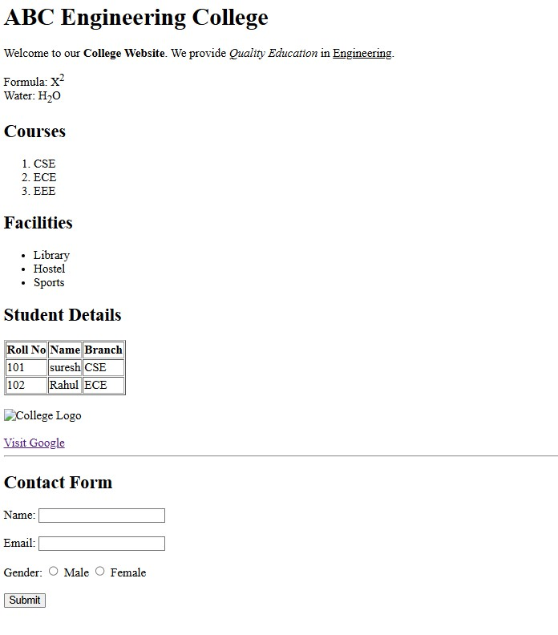
10
. RESULT
Thus, the static college webpage demonstrating HTML5 formatting, lists, tables, and contact form was successfully designed, implemented, and verified.

