LABORATORY RECORD
Course: Full Stack Web Development
Course Code: 23CM4121
Experiment No.: 2
Student Name: D. Suswetha
Roll No.: A24126552079
Date: 30-08-2026

TITLE
Webpage Styling with External CSS3, Linear Gradients, Navigation Bar & Flexbox

AIM
To structure and style a multi-card webpage using external CSS3 stylesheets, linear gradients, responsive navigation bars, flexbox card grid layout, box shadows, and button hover transitions.

OBJECTIVE
The objectives of this experiment are:
- To link external CSS3 stylesheets to HTML5 documents.
- To apply multi-color linear gradients and text shadows on headers.
- To style a dark navigation bar with interactive hover color changes.
- To implement responsive flexbox card layout with borders and shadows.
- To create button hover color transitions.

THEORY
External CSS separates document structure from visual presentation. CSS3 provides linear gradients, Flexbox for flexible horizontal/vertical alignment (display: flex, justify-content, gap), box shadows for modern UI depth, and pseudo-classes (:hover) for interactive transitions.
Application Flow:
HTML5 Structure -> External CSS Linking -> Gradient Header & Nav -> Flexbox Container -> Card Styling & Hover Effects

ALGORITHM / PROCEDURE
- Create index.html and link external style.css using <link rel='stylesheet'>.
- Style header with linear-gradient(to right, #0066cc, #8000ff) and text shadow.
- Style navigation bar with dark background and yellow link hover color.
- Implement .container with display: flex, justify-content: center, and gap: 20px.
- Style .card with white background, rounded border, padding, and box shadow.
- Style buttons with green background and red hover color transition.
- Style footer with dark background.
- Verify styling and responsive layout across different screen sizes.

PROGRAM

index.html
<!DOCTYPE html>
<html lang="en">
<head>
<meta charset="UTF-8">
<meta name="viewport" content="width=device-width, initial-scale=1.0">
<title>My Styled Webpage</title>
<link rel="stylesheet" href="style.css">
</head>
<body>
<header>
<h1>My Styled Webpage</h1>
</header>
<nav>
<a href="#">Home</a>
<a href="#">About</a>
<a href="#">Services</a>
<a href="#">Contact</a>
</nav>
<section class="container">
<div class="card">
<h2>HTML5</h2> <p>HTML5 is used to create the structure of web pages.</p> <button>Read More</button>
</div>
<div class="card">
<h2>CSS3</h2>
<p>CSS3 is used to style web pages and improve appearance.</p>
<button>Read More</button>
</div>
<div class="card">
<h2>Web Design</h2> <p>HTML and CSS together create beautiful web applications.</p> <button>Read More</button>
</div>
</section>
<footer>
<p>© 2026 My Styled Webpage</p>
</footer>
</body>
</html>

style.css
body{ margin:0; font-family:Arial,sans-serif; background:#f2f2f2; }
header{ background:linear-gradient(to right,#0066cc,#8000ff); color:white; text-align:center; padding:20px; text-shadow:2px 2px 5px gray; }
nav{ background:#333; text-align:center; padding:15px; }
nav a{ color:white; text-decoration:none; margin:20px; font-size:18px; }
nav a:hover{ color:yellow; }
.container{ display:flex; justify-content:center; gap:20px; margin:30px; }
.card{ background:white; width:250px; padding:20px; border:2px solid gray; border-radius:15px; text-align:center; box-shadow:5px 5px 10px gray; }
button{ background:green; color:white; border:none; padding:10px 15px; border-radius:5px; cursor:pointer; }
button:hover{ background:red; }
footer{ background:black; color:white; text-align:center; padding:15px; margin-top:20px;
}

CODE EXPLANATION
Code / Syntax | Explanation
<link rel='stylesheet' href='style.css'> | Links the external CSS stylesheet to the HTML document.
background: linear-gradient(to right,  #0066cc, #8000ff) | Creates a two-color horizontal gradient background on the header.
nav a:hover { color: yellow; } | Changes link font color to yellow on mouse hover.
display: flex; justify-content: center; gap:  20px; | Flexbox container centering child cards with 20px uniform gap.
border-radius: 15px; box-shadow: 5px 5px  10px gray; | Rounds card corners and adds realistic drop shadows.
button:hover { background: red; } | Transitions button color from green to red upon mouse hover.

TEST CASES AND EXECUTION DATA
The experiment was executed with the following test cases to verify functionality:
Test Case | Input / Action | Expected Result | Actual Result | Status
TC-01 | CSS Linkage | Open styled page | Header gradient and typography applied correctly | Pass
TC-02 | Nav Hover State | Hover over nav links | Link color turns yellow on hover | Pass
TC-03 | Flexbox Cards Alignment | Inspect cards container | Three cards aligned in a centered row with 20px gap | Pass
TC-04 | Card Box Shadow | Inspect cards | Cards render 15px rounded corners and box shadows | Pass
TC-05 | Button Hover Effect | Hover over 'Read More' | Button color transitions from green to red | Pass

OUTPUT

Output 1: Styled Webpage with Gradient Header, Navigation, and Flexbox Cards
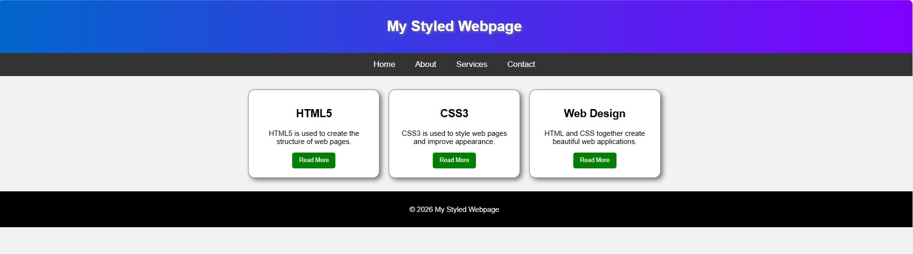

RESULT
Thus, external CSS3 styling with linear gradients, navigation bar hover effects, and flexbox card layout was successfully implemented and verified.

