LABORATORY RECORD
Course: Full Stack Web Development
Course Code: 23CM4121
Experiment No.: 4
Student Name: D. Suswetha
Roll No.: A24126552079
Date: 30-08-2026

TITLE
Development of a Dynamic Web Application with Live Clock, Task Manager, and Dynamic Theme Switching

AIM
To develop an interactive dynamic webpage combining real-time digital clock updates (setInterval), personalized greeting generation, dynamic task list management, and live background theme switching using JavaScript DOM manipulation.

OBJECTIVE
The objectives of this experiment are:
- To build multi-feature interactive web pages with HTML, CSS, and JavaScript.
- To implement real-time timers in JavaScript using setInterval().
- To read user input dynamically and update DOM text nodes.
- To dynamically create and append HTML list elements.
- To manipulate CSS inline styles dynamically for theme switching.

THEORY
Dynamic web applications update UI content in real time without full page reloads.
JavaScript provides timing events like setInterval() to execute code periodically (e.g. clock).
DOM manipulation functions (document.getElementById, createElement, appendChild) enable runtime element insertion, and style manipulation (document.body.style.background) allows live visual customization.
Application Flow:
HTML5 UI Cards -> User Actions / Timers -> JavaScript DOM Handlers -> Dynamic Content & Theme Update

ALGORITHM / PROCEDURE
- Create index.html with gradient background and header.
- Create four styled card sections: Welcome Message, Live Clock, Task Manager, and Colour Theme.
- Implement welcome() function to capture input name and display 'Welcome <Name>'.
- Implement clock() function using new Date().toLocaleTimeString() and run periodically using setInterval(clock, 1000).
- Implement addTask() function to dynamically create <li> elements and append to <ul id='list'>.
- Implement blue(), green(), and dark() functions updating document.body.style.background with gradient themes.
- Open in web browser and verify all dynamic features.

PROGRAM
index.html
<!DOCTYPE html>
<html>
<head>
<title>Dynamic Webpage</title>
<style> *{margin:0;padding:0;box-sizing:border-box} body{ font-family:Arial; background:linear-gradient(135deg,#4facfe,#00f2fe); min-height:100vh; } header{ background:#222;color:white;text-align:center;padding:20px; } .container{ width:95%;max-width:1200px;margin:20px auto; } .card{ background:white;padding:35px;min-height:200px; margin-bottom:20px;border-radius:15px; box-shadow:0 5px 15px #555; } input{ padding:12px;width:65%;margin:15px 0; } button{ padding:10px 15px;border:0;border-radius:5px; background:#007bff;color:white;cursor:pointer; } button:hover{background:#0056b3} #clock{font-size:35px;margin-top:25px} li{margin:8px;padding:8px;background:#eee} </style>
</head>
<body>
<header>
<h1>Dynamic Webpage</h1>
<p>Using HTML, CSS and JavaScript</p>
</header>
<div class="container">
<div class="card">
<h2>Welcome</h2>
<input id="name" placeholder="Enter your name"> <button onclick="welcome()">Submit</button>
<p id="msg"></p>
</div>
<div class="card">
<h2>Live Clock</h2>
<p id="clock"></p>
</div>
<div class="card">
<h2>Task Manager</h2>
<input id="task" placeholder="Enter task">
<button onclick="addTask()">Add</button>
<ul id="list"></ul>
</div>
<div class="card">
<h2>Colour Theme</h2>
<button onclick="blue()">Blue</button>
<button onclick="green()">Green</button> <button onclick="dark()">Dark</button>
</div>
</div>
<script> function welcome(){ let n=document.getElementById("name").value; document.getElementById("msg").innerHTML="Welcome "+n; }
function clock(){ document.getElementById("clock").innerHTML= new Date().toLocaleTimeString(); } setInterval(clock,1000);clock();
function addTask(){ let t=document.getElementById("task").value; if(t!=""){ let li=document.createElement("li"); li.innerHTML=t; document.getElementById("list").appendChild(li); } }
function blue(){ document.body.style.background= "linear-gradient(135deg,#4facfe,#00f2fe)"; } function green(){ document.body.style.background= "linear-gradient(135deg,#43e97b,#38f9d7)"; } function dark(){ document.body.style.background= "linear-gradient(135deg,#232526,#414345)";
}
</script>
</body>
</html>

CODE EXPLANATION
Code / Syntax | Explanation
document.getElementById('msg').innerHTM  L = ... | Dynamically updates paragraph text with personalized welcome greeting.
new Date().toLocaleTimeString() | Retrieves current system time formatted as HH:MM:SS.
setInterval(clock, 1000) | Executes the clock function every 1000 milliseconds (1 second) continuously.
document.createElement('li') | Creates a new list item element for task manager.
document.getElementById('list').appendChil d(li) | Appends the new task item to the task list container.
document.body.style.background = '...' | Dynamically changes the document background linear gradient theme at runtime.

TEST CASES AND EXECUTION DATA
The experiment was executed with the following test cases to verify functionality:
Test Case | Input / Action | Expected Result | Actual Result | Status
TC-01 | Welcome Greeting | Enter name & click Submit | Displays 'Welcome <Name>' dynamically | Pass
TC-02 | Live Digital Clock | Observe clock card | Clock displays current time and ticks every second | Pass
TC-03 | Task Manager | Enter task & click Add | Task is added as a list item in the task card | Pass
TC-04 | Blue Theme | Click 'Blue' button | Page background updates to blue linear gradient | Pass
TC-05 | Green Theme | Click 'Green' button | Page background updates to green linear gradient | Pass
TC-06 | Dark Theme | Click 'Dark' button | Page background updates to dark linear gradient | Pass

OUTPUT
Output 1: Dynamic Webpage with Live Clock, Task Manager, and Theme Switcher
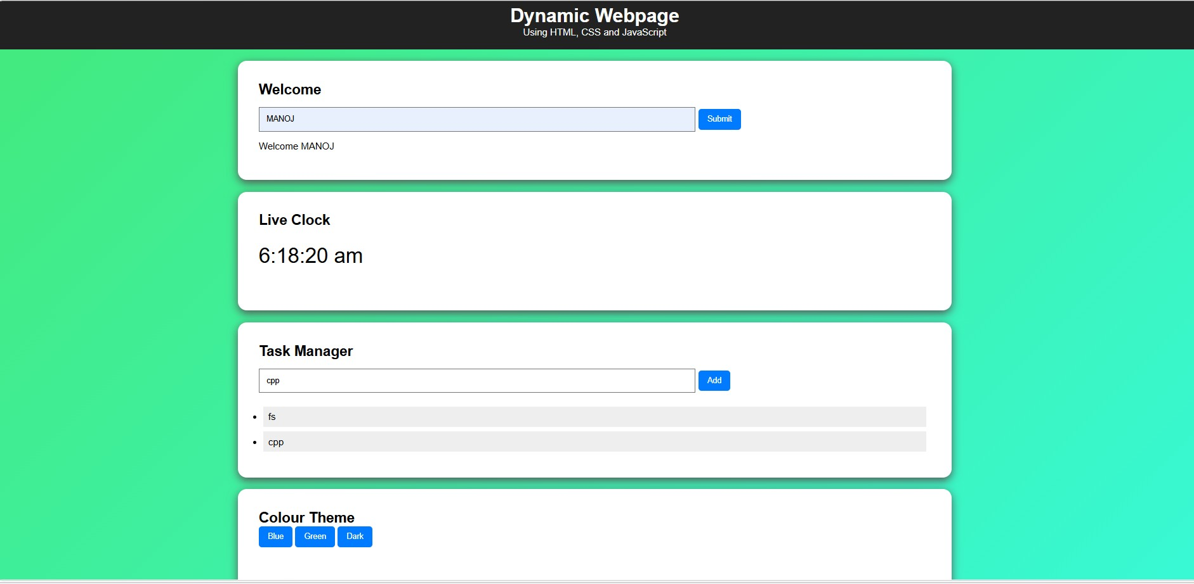

RESULT
Thus, the dynamic web application with real-time digital clock, personalized greeting, task manager, and dynamic theme switching was successfully developed and verified across all test cases.

