ANIL NEERUKONDA INSTITUTE OF TECHNOLOGY & SCIENCES
(AUTONOMOUS) | VISAKHAPATNAM
UNIT V – CASE STUDY DOCUMENTATION
STUDIA – Student Management System
Design of Express.js API Routes, MongoDB Atlas Interaction, and Cloud Deployment
Topic: Consider a Student Management System in which students can be added, viewed, updated and deleted. Design the required Express.js API routes and explain how each route interacts with MongoDB to perform the corresponding operation.
Course Title | Full-Stack Web Development
Course Code | 23CM4121
Unit | Unit V – MongoDB and Deploying Applications
Student Name | Suswetha Dwarapudi
Registration Number | A24126552079
Academic Year / Semester | 3rd Year – 1st Semester
Faculty / Guide | P. Santosh Kumar
Academic Year | 2026–27

TABLE OF CONTENTS
PART A | Comprehensive Question, Problem Statement and Topic Specification
PART B – 1 | Requirement Analysis, Functional Modules, and 3-Tier System Architecture
PART B – 2 | MongoDB Document Model, Mongoose Schema, and Database CRUD Operations
PART B – 3 | Express.js REST API Route Design and Step-by-Step MongoDB Interaction
PART B – 4 | Testing, Systematic Debugging Procedure, and Validation Matrix
PART B – 5 | Cloud Deployment Architecture (Vercel, Render, Atlas) and Security
PART C | Output Screenshots and Implementation Evidence (Figures 1 to 9)
CONCLUSION | Project Outcome, Practical Insights, Limitations, and Future Enhancements
PROJECT SNAPSHOT
Architecture Layer | Technologies / Tools | Assigned Role & Implementation
Frontend Client | React 18, Vite, Axios, CSS3, Lucide React | Single-Page Application: dashboard stats, directory, search, modals, and profile view
Backend REST API | Node.js, Express.js (v4.19), Mongoose ODM | REST API routing, request validation, CORS, error handling, and MongoDB transactions
Persistent Database | MongoDB Atlas (Cloud Cluster) | Document-oriented database storing BSON records in test.students collection
Frontend Hosting | Vercel Cloud Platform | Builds and delivers high-performance production React application assets
Backend Hosting | Render Cloud Platform | Hosts containerized Node.js/Express.js web service with managed environment secrets
• Live Frontend URL: https://studia-frontend.vercel.app
• Live Backend Web Service: https://studia-backend-orll.onrender.com
• Students API Endpoint: https://studia-backend-orll.onrender.com/api/students
• GitHub Repository Case Study: https://github.com/suswethadwarapudi22-afk/fullstack/tree/main/case_study

PART A. COMPREHENSIVE QUESTION & PROBLEM STATEMENT
Case Study Context: Institutional Student Record Management (STUDIA)
Educational institutions manage extensive volumes of student information, including registration numbers, names, email contacts, academic departments, year levels, contact numbers, and personal demographics. When handled manually or through fragmented spreadsheet files, institutions inevitably encounter duplicated entries, inconsistent updates across offices, sluggish search capabilities, and the inability to reliably verify academic history. To resolve these challenges, modern educational organizations adopt web-based, centralized Student Management Systems backed by scalable cloud databases and RESTful application programming interfaces (APIs).
Core Problem Statement & Topic Assignment
Consider a Student Management System in which students can be added, viewed, updated and deleted. Design the required Express.js API routes and explain how each route interacts with MongoDB to perform the corresponding operation. Implement the system using React, Node.js, Express.js, and MongoDB Atlas, and deploy the application to public cloud platforms.
Key Academic & Technical Objectives:
- 1. Data Modeling: Store student details including roll number, full name, email, department, and academic year, alongside personal attributes (phone, date of birth, gender, address).
- 2. MongoDB Integration: Create and manage a MongoDB database (`test`) and `students` collection utilizing an appropriate BSON document structure and indexed constraints.
- 3. Route Architecture: Design RESTful API routes in Express.js supporting complete CRUD operations (Create, Read all, Read single, Update, and Delete) with rigorous error handling and validation.
- 4. Database Interaction Analysis: Provide an in-depth mechanical explanation of how each Express.js route executes Mongoose operations and issues corresponding commands to MongoDB Atlas.
- 5. Client User Interface: Implement client-side search, department filtering, and academic year filtering over the retrieved student records.
- 6. Cloud Deployment: Deploy the frontend (Vercel), backend (Render), and database (MongoDB Atlas) to public cloud platforms with secure environment variable isolation.
- 7. Case Study Debugging: Investigate a critical real-world failure mode where student records are successfully added to MongoDB but updated records fail to reflect in the user interface, and provide a systematic debugging workflow.

PART B – 1. REQUIREMENT ANALYSIS & SYSTEM DESIGN
1. Functional Requirements Analysis
Requirement Area | System Expectation | STUDIA Implementation Details
Student Identity | Unique institutional student identifier | Institutional roll number (e.g. A24126552079) with unique index; immutable MongoDB _id (ObjectId)
Student Demographics | Academic and personal details capture | Captures rollNumber, name, email, department, year, phone, dateOfBirth, gender, and address
Data Persistence | Fault-tolerant document storage | MongoDB Atlas cloud cluster (test database, students collection)
API Communication | Standardized RESTful CRUD interface | Express.js REST API with JSON payload body parsing and CORS headers
Search & Filtering | Fast discovery of student records | Multi-criteria search by name, roll number, or email; dropdown filters by department and year
Data Integrity | Duplicate key and invalid input rejection | Schema-level validators, unique indexes, and translation of MongoDB error 11000 to HTTP 409 Conflict
2. Three-Tier System Architecture
STUDIA adheres to a clean Three-Tier Web Architecture ensuring separation of concerns, maintainability, and enterprise-grade security:
+-------------------------------------------------------+
| CLIENT TIER (User Browser) |
| React 18 Single-Page Application (Hosted on Vercel) |
| - Dashboard Overview, Metric Cards, Search & Filters |
| - Add/Edit Student Forms & Delete Confirmation Modal |
+-------------------------------------------------------+
|
| HTTPS / Asynchronous Axios Calls
| REST Requests (application/json)
v
+-------------------------------------------------------+
| APPLICATION TIER (REST API) |
| Node.js + Express.js Web Server (Hosted on Render) |
| - CORS Security Middleware & JSON Body Parsing |
| - RESTful Route Handlers (/api/students) |
| - Mongoose Schema Validation & Business Rules |
+-------------------------------------------------------+
|
| Mongoose Object Data Modeling (ODM)
| Wire Protocol over TLS/SSL
v
+-------------------------------------------------------+
| DATABASE TIER (Storage Layer) |
| MongoDB Atlas Cloud Database Cluster |
| - Database: `test` | Collection: `students` |
| - BSON Document Storage & Unique Primary Key Indexes |
+-------------------------------------------------------+
Architecture Decoupling & Security: The browser client never interacts directly with MongoDB Atlas. Database connection strings, database credentials, and cluster endpoints remain strictly encapsulated within the Node.js backend environment variables on Render. This prevents credential exposure and centralizes validation logic.
3. Main Functional Modules
- • Institutional Dashboard: Presents total enrolled student count, active department count, department-wise student distribution cards, and real-time backend operational status.
- • Student Directory: Displays student records in a structured tabular directory with instant search (name, roll number, email) and department/year filter dropdowns.
- • Add Student Module: Interactive modal form capturing academic and personal details with client-side and server-side constraint checks.
- • Student Profile Viewer: Dedicated profile view displaying individual student records, avatar initials, enrollment dates, and audit timestamps.
- • Edit Student Module: Pre-populates existing student attributes for modification and dispatches PUT requests to update MongoDB documents.
- • Delete Confirmation Guard: Prevents accidental deletions by presenting a safety modal requiring explicit confirmation prior to issuing DELETE commands.

PART B – 2. MONGODB DOCUMENT MODEL & DATABASE OPERATIONS
1. Document-Oriented Data Modeling
Relational databases enforce rigid tabular schemas requiring complex foreign key joins to represent multidimensional records. In contrast, MongoDB's document model represents each student entity as a self-contained, flexible BSON (Binary JSON) document. This model offers high write throughput, seamless schema extensibility, and direct JSON impedance match with React and Node.js.
2. MongoDB Document Schema Representation (JSON / BSON)
{
"_id": ObjectId("6730a1b2c3d4e5f6a7b8c9d0"),
"rollNumber": "A24126552079",
"name": "Suswetha Dwarapudi",
"email": "suswetha.dwarapudi@example.com",
"department": "CSE",
"year": 3,
"phone": "+91 9876543210",
"dateOfBirth": ISODate("2004-05-18T00:00:00.000Z"),
"gender": "Female",
"address": "Visakhapatnam, Andhra Pradesh",
"createdAt": ISODate("2026-11-10T10:15:30.000Z"),
"updatedAt": ISODate("2026-11-10T10:15:30.000Z"),
"__v": 0
}
3. Document Fields, Data Types, and Constraints
Field Name | BSON / Schema Type | Constraints & Validation | Functional Purpose
_id | ObjectId | Primary Key, Immutable, Auto-generated | Globally unique 12-byte BSON document identifier
rollNumber | String | Required, Unique Index, Uppercase, Trim | Human-readable institutional identifier (e.g. A24126552079)
name | String | Required, Trim, Min length 2 | Student full legal name
email | String | Required, Unique Index, Lowercase, Regex | Institutional contact email for notifications
department | String | Required, Enum (CSE, AI&DS, IT, ECE...) | Enrolled academic department / discipline
year | Number | Required, Number, Min 1, Max 4 | Current academic standing (Year 1 to 4)
phone | String | Optional, Trim | Personal emergency contact telephone number
dateOfBirth | Date | Optional, ISO Date | Student date of birth for institutional records
gender | String | Optional, Enum (Male, Female, Other) | Demographic gender designation
createdAt / updatedAt | Date | Managed automatically via Mongoose timestamps | Audit trail timestamps tracking record lifecycle
4. MongoDB Shell (mongosh) CRUD Operations
To illustrate how MongoDB processes CRUD commands directly, the following native shell queries reflect the underlying operations performed by the backend:
// 1. Switch to application database
use test;
// 2. Insert a new student record
db.students.insertOne({
rollNumber: "A24126552079",
name: "Suswetha Dwarapudi",
email: "suswetha.dwarapudi@example.com",
department: "CSE",
year: 3,
createdAt: new Date(),
updatedAt: new Date()
});
// 3. Retrieve all students sorted by most recent
db.students.find({}).sort({ createdAt: -1 });
// 4. Query a student by unique roll number
db.students.findOne({ rollNumber: "A24126552079" });
// 5. Update student details
db.students.updateOne(
{ rollNumber: "A24126552079" },
{ $set: { department: "CSE", year: 3, updatedAt: new Date() } }
);
// 6. Delete a student record
db.students.deleteOne({ rollNumber: "A24126552079" });
// 7. Verify Indexing and Query Performance
db.students.createIndex({ rollNumber: 1 }, { unique: true });
db.students.find({ rollNumber: "A24126552079" }).explain("executionStats");

PART B – 3. BACKEND & FRONTEND IMPLEMENTATION
1. Express.js REST API Route Design
The backend exposes a RESTful interface over the base route `/api/students`. Each route is explicitly mapped to a corresponding HTTP method, URL pattern, controller logic, and database query:
HTTP Method | Route Endpoint | Purpose & Action | Success & Error Status Codes
POST | /api/students | Create and persist a new student record | 201 Created | 400 Bad Request | 409 Conflict
GET | /api/students | Retrieve all student records with sorting | 200 OK | 500 Internal Server Error
GET | /api/students/:id | Retrieve single student profile by document ID | 200 OK | 400 Bad ID | 404 Not Found
PUT | /api/students/:id | Update student attributes by document ID | 200 OK | 400 Bad Request | 404 Not Found | 409 Conflict
DELETE | /api/students/:id | Permanently remove student record by document ID | 200 OK | 400 Bad Request | 404 Not Found
2. Detailed Explanation: How Each Route Interacts with MongoDB
A. Add Student Route (POST /api/students)
- 1. Payload Receipt: Express JSON middleware parses the HTTP request body into `req.body`.
- 2. Document Instantiation: Mongoose creates a new model instance `const student = new Student(req.body)`, verifying required fields and data types against the schema.
- 3. MongoDB Command: Executing `await student.save()` transmits an `insertOne` write command over the MongoDB wire protocol.
- 4. Conflict Handling: MongoDB Atlas validates unique indexes (rollNumber, email). If a violation occurs, MongoDB throws error code `11000`. The catch block intercepts this code and responds with HTTP 409 Conflict.
- 5. Document Return: Upon success, MongoDB persists the document, generates a unique 12-byte `_id` ObjectId, sets `createdAt` and `updatedAt`, and returns HTTP 201 Created with the saved JSON object.
B. View All Students Route (GET /api/students)
- 1. Filter Extraction: Express inspects `req.query` for optional filters such as `department`, `year`, or `search` keywords.
- 2. Query Synthesis: Mongoose constructs a query filter object. If a search keyword is provided, it creates regex clauses: `{ $or: [{ name: /.../i }, { rollNumber: /.../i }] }`.
- 3. Database Scan: Executing `Student.find(query).sort({ createdAt: -1 })` sends a `find` command to MongoDB Atlas.
- 4. Cursor Hydration: MongoDB retrieves documents matching the criteria and orders them in reverse chronological order via the `createdAt` index.
- 5. Response: Express returns HTTP 200 OK containing the array of students and the total record count.
C. View Single Student Route (GET /api/students/:id)
- 1. Parameter Capture: Express extracts the unique document identifier from URL parameters (`req.params.id`).
- 2. Type Casting: Mongoose verifies that `id` is a valid 24-character hex string and converts it to BSON `ObjectId(id)`.
- 3. Key Lookup: Executing `Student.findById(id)` translates to `db.students.findOne({ _id: ObjectId(id) })`.
- 4. Index Execution: MongoDB uses the primary key index on `_id` to locate the document with O(1) efficiency.
- 5. Evaluation: If found, returns HTTP 200 OK with the student profile; if absent, returns HTTP 404 Not Found.
D. Update Student Route (PUT /api/students/:id)
- 1. Input Ingestion: Captures document ID from `req.params.id` and updated attributes from `req.body`.
- 2. Mongoose Method: Mongoose executes `Student.findByIdAndUpdate(id, req.body, { new: true, runValidators: true })`.
- 3. MongoDB Atomic Operation: MongoDB translates this operation into an atomic `findOneAndUpdate({ _id: ObjectId(id) }, { $set: updateFields })` command.
- 4. Crucial Options: CRITICAL: The `{ new: true }` option instructs MongoDB to return the modified document instead of the original pre-update document. `{ runValidators: true }` re-executes Mongoose validation rules.
- 5. Result: If the update introduces a duplicate roll number or email, MongoDB throws code `11000`, returned as HTTP 409 Conflict. If successful, returns HTTP 200 OK with the updated document.
E. Delete Student Route (DELETE /api/students/:id)
- 1. Parameter Capture: Captures document ID from `req.params.id`.
- 2. Mongoose Method: Mongoose executes `Student.findByIdAndDelete(req.params.id)`.
- 3. MongoDB Deletion: MongoDB translates this to `findOneAndDelete({ _id: ObjectId(id) })`, permanently unlinking and removing the document from the BSON storage engine.
- 4. Response: If no document matched the ID, returns HTTP 404 Not Found. If removed, returns HTTP 200 OK with a confirmation message.

PART B – 4. TESTING, DEBUGGING & VALIDATION
1. In-Depth Analysis of the Case Study Problem
• Core Issue: Case Study Problem Scenario: A deployed Student Management System successfully adds new student records to MongoDB Atlas, but after editing a student record, the user interface fails to display the updated information.
A successful database write (HTTP 200/201) and a refreshed user interface are independent steps in a multi-tier web application. When an update succeeds in MongoDB but fails to appear on screen, the breakdown can occur across several layers: client-side state management, asynchronous execution timing, backend route parameters, Mongoose return options, browser caching, or database cluster mismatches.
2. Multi-Layer Debugging Failure Matrix
Architectural Layer | Root Cause Description | Diagnostic Procedure & Systematic Resolution
React State Staleness | Frontend does not trigger a re-fetch of students following the PUT request | Inspect the form submission handler. Ensure `await fetchStudents()` is called immediately after a successful PUT response to reload server state.
Asynchronous Race Condition | List refresh query executes before MongoDB Atlas finishes the write | Ensure the Axios PUT request is explicitly awaited (`await updateStudent(...)`) before triggering the GET request.
Mongoose Return Behavior | Missing `{ new: true }` in `findByIdAndUpdate` causes Mongoose to return old document | Add `{ new: true, runValidators: true }` to the `findByIdAndUpdate` call in `studentRoutes.js` so the updated document is returned.
Document ID Mismatch | Backend update route uses `rollNumber` instead of MongoDB `_id` | Verify that the PUT request URL is `/api/students/${student._id}` where `_id` is the 24-character BSON ObjectId.
Environment / Cluster Disconnect | Backend connects to a different MongoDB Atlas database than expected | Verify Render environment variable `MONGO_URI`. Open MongoDB Atlas Data Explorer and confirm writes in `test.students`.
CORS / HTTP Verb Blocking | Browser blocks PUT request preflight options check | Configure Express CORS middleware with `app.use(cors())` ensuring PUT and DELETE verbs are permitted from the Vercel domain.
3. Step-by-Step Systematic Debugging Sequence
- Step 1: Isolated Reproduction: Select a specific test student (e.g. Roll No: A24126552079) and log current values, target update values, and exact timestamp.
- Step 2: Network Inspection: Open Chrome Developer Tools -> Network tab. Submit the update form and inspect the outgoing request URL, method (PUT), and payload JSON.
- Step 3: Response Status Validation: Verify that the server answers with HTTP 200 OK and inspect the returned JSON body to confirm the field values have changed.
- Step 4: Backend Logs Analysis: Examine the Render backend deployment console logs for database errors, schema validation errors, or duplicate-key conflicts.
- Step 5: Direct Database Verification: Log into MongoDB Atlas -> Data Explorer -> test.students. Find the student record and verify that the updated field and `updatedAt` have changed in storage.
- Step 6: Direct API Query: Send an independent GET request (`curl -s https://studia-backend-orll.onrender.com/api/students`) to verify the REST API returns the updated document.
- Step 7: State Management Verification: Inspect the React component state in React Developer Tools. Verify that `fetchStudents()` sets the new array into `students` state.
- Step 8: Persistence Confirmation: Perform a hard refresh (`Ctrl + F5`) on the browser. If the updated data remains visible, persistent storage and retrieval are fully functional.
4. Test Case Validation Matrix
Test ID | Test Action & Input | Expected Outcome | Validation Evidence & Status
TC-01 | Navigate to root URL | Dashboard loads with institutional metrics, student count, and cards | Figure 1 | Passed
TC-02 | View Student Directory | Students collection is retrieved via GET /api/students and listed in table | Figure 2 | Passed
TC-03 | Submit Add Student form | Record saved to MongoDB Atlas via POST; list refreshes automatically | Figure 3 | Passed
TC-04 | Submit duplicate roll number | Backend rejects insertion; returns HTTP 409 Conflict with clear error | Error banner | Passed
TC-05 | Click student profile view | Selected student details displayed in profile view via GET /:id | Figure 4 | Passed
TC-06 | Submit Edit Student form | Attributes updated in MongoDB via PUT; updated values visible in UI | Figure 5 | Passed
TC-07 | Click Delete button | Safety confirmation dialog displayed before issuing DELETE command | Figure 6 | Passed
TC-08 | Confirm student deletion | Record excised from MongoDB; student removed from UI table | Directory updated | Passed
TC-09 | Inspect MongoDB Atlas console | Student documents verified in test.students collection | Figure 7 | Passed
TC-10 | Verify cloud deployment status | Render backend Live; Vercel frontend Ready | Figures 8 & 9 | Passed

PART B – 5. CLOUD DEPLOYMENT & SECURITY
1. Cloud Hosting Architecture
STUDIA is architected across three industry-standard cloud tiers, ensuring high availability, continuous deployment from GitHub, and complete credential isolation:
Layer | Cloud Platform | Project Name / Identifier | Runtime / Configuration
Frontend | Vercel | studia-frontend | Vite build (`dist`), global edge CDN distribution
Backend | Render | studia-backend | Node.js Web Service, `npm install` build, `npm start` start
Database | MongoDB Atlas | AURAFIT / Cluster0 | Cloud-hosted replica set, database `test`, collection `students`
2. Environment Variable Configuration
Variable Name | Configured Location | Sensitivity | Purpose & Operational Role
MONGO_URI | Render Backend Service | HIGH SECRET | Encrypted MongoDB Atlas connection string with database credentials
PORT | Render Runtime Environment | Standard | Port assigned dynamically by hosting provider (defaults to 5000)
VITE_API_URL | Vercel Frontend Project | Public | Base URL pointing to the live Render backend REST API endpoint
3. Cloud Security Best Practices
- • Secret Isolation: `MONGO_URI` is strictly stored inside Render's environment secret manager and never placed in frontend code, client-side `.env` files, or committed to GitHub.
- • Version Control Hygiene: `.gitignore` explicitly excludes all local `.env`, `.env.local`, and `node_modules` folders to prevent credential leakage in public repositories.
- • Origin Validation: The Express.js backend enforces CORS validation to restrict which origins can execute state-changing requests.
- • HTTPS / TLS Encryption: All production traffic between browser, backend, and MongoDB Atlas runs over TLS/SSL encryption.

PART C. OUTPUT SCREENSHOTS AND EVIDENCE
The following figures document the live implementation, responsive user interface workflows, database persistence, and cloud hosting status of STUDIA:
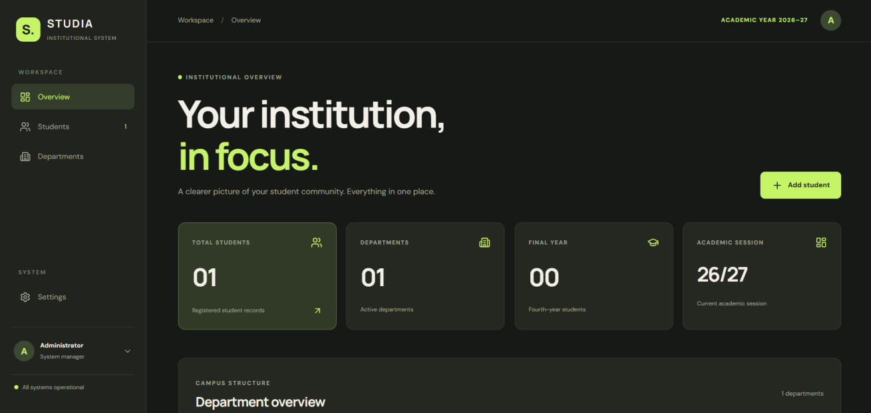
Figure 1. STUDIA institutional dashboard showing total student count, department metrics, and quick action bar.
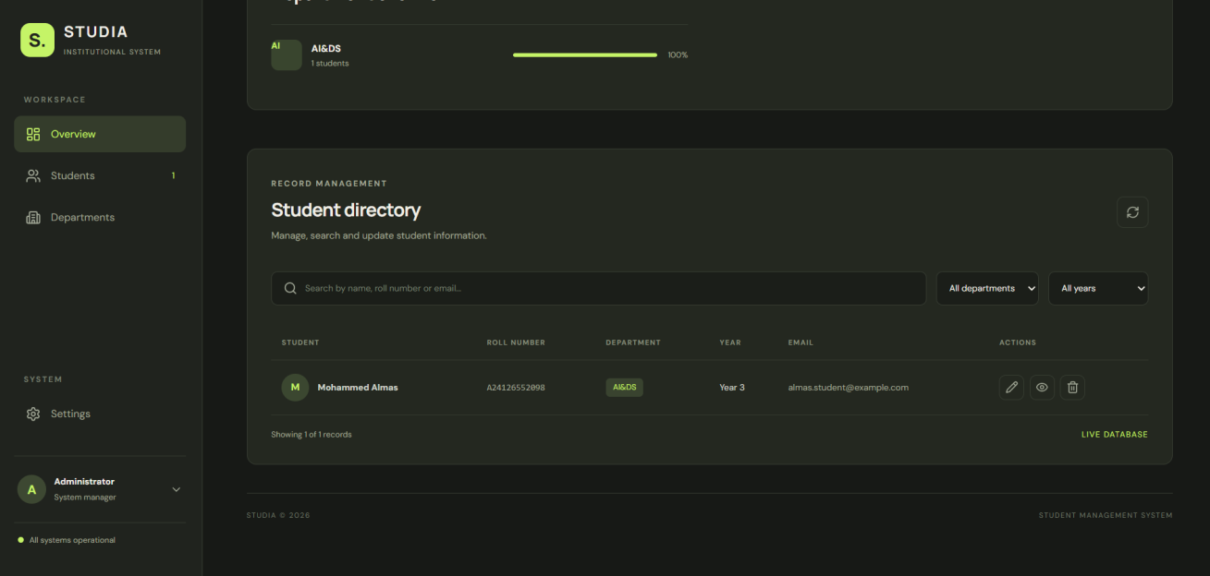
Figure 2. Student directory view showing stored student records, roll numbers, departments, and action buttons.
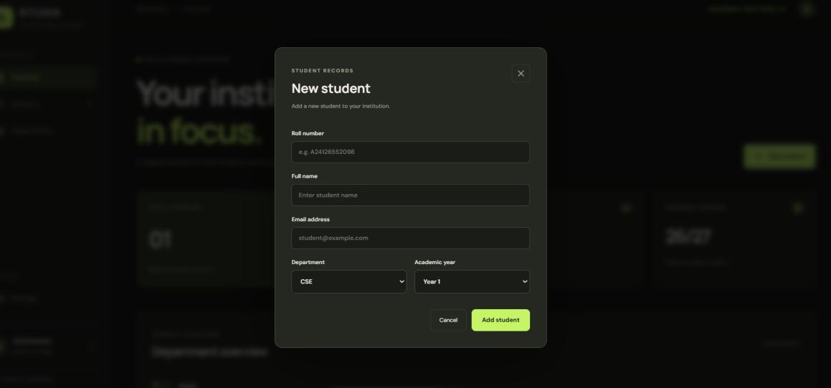
Figure 3. Add Student modal form capturing roll number, name, email, department, and academic year.
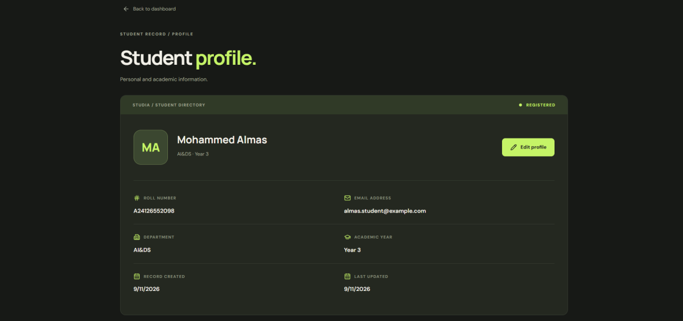
Figure 4. Student profile viewer displaying detailed academic standing, contact email, and audit timestamps.
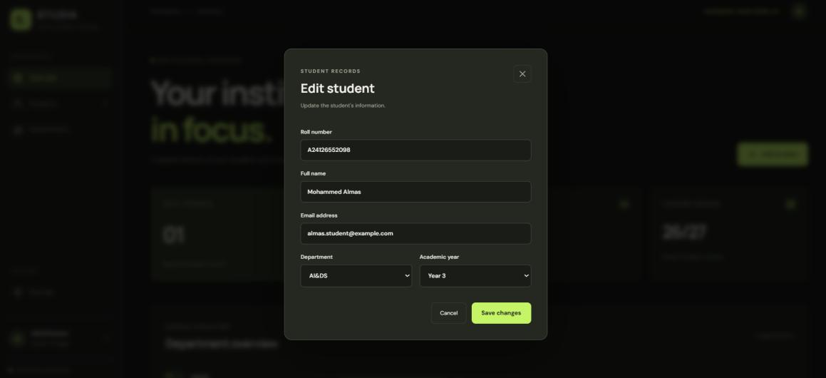
Figure 5. Edit Student modal populated with existing student data, demonstrating field modification workflow.
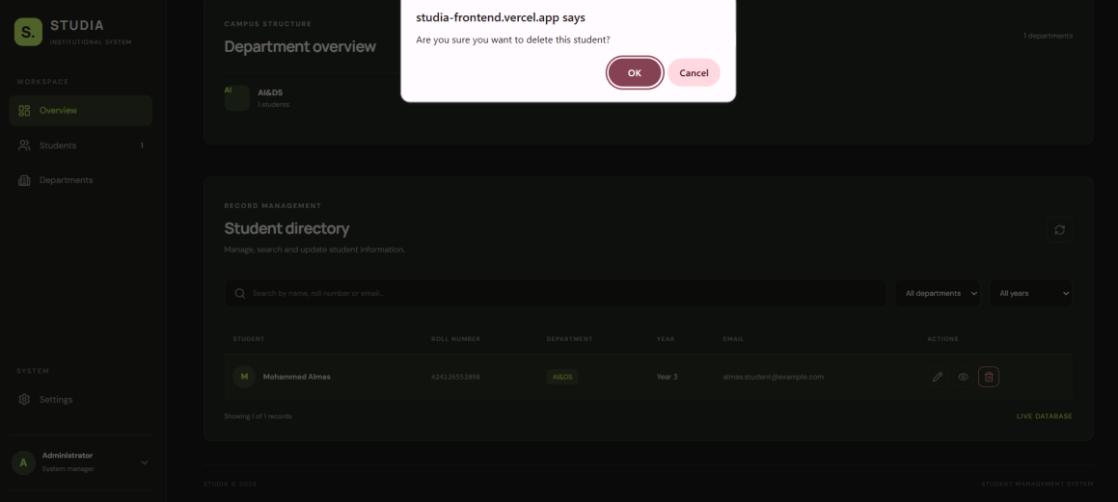
Figure 6. Safety deletion confirmation modal displayed prior to permanent document removal.
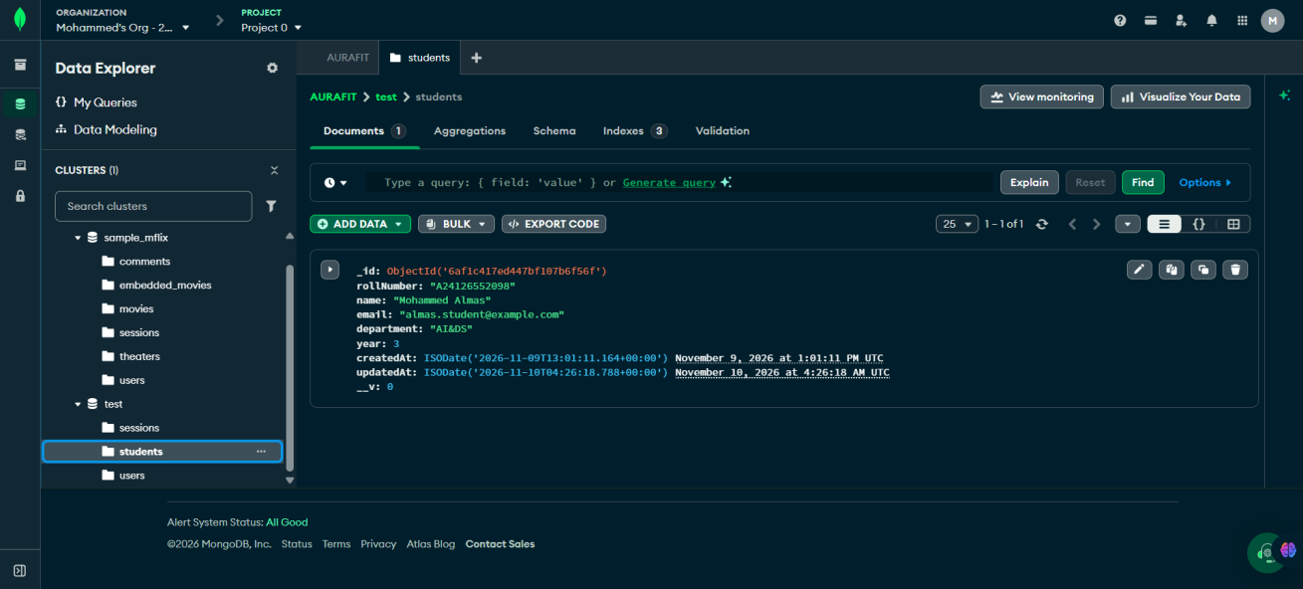
Figure 7. MongoDB Atlas Data Explorer showing test.students collection with stored BSON student documents.
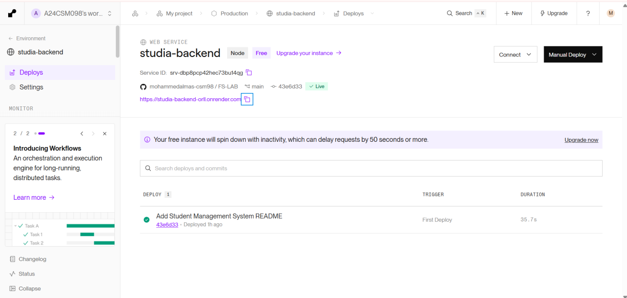
Figure 8. Render dashboard showing studia-backend Node.js web service running with Live deployment status.
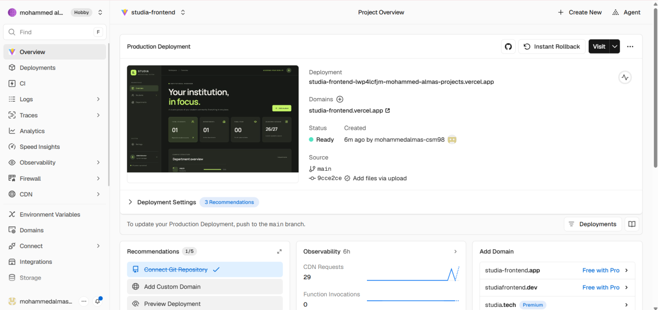
Figure 9. Vercel deployment console showing studia-frontend production deployment with Ready status.
Evidence Interpretation & Architecture Validation
The execution evidence verifies end-to-end full-stack integration: Figures 1-6 validate that all student management workflows (create, read, update, delete, view profile) are operational within the browser interface. Figure 7 confirms persistent BSON storage within MongoDB Atlas. Figures 8 and 9 demonstrate that the three-layer architecture has been deployed and operationalized across independent cloud environments.

CONCLUSION, LIMITATIONS & FUTURE ENHANCEMENTS
1. Expected Outcome & Project Achievements
- • Full-Stack Integration: Designed and deployed a modern, responsive Single-Page Application using React 18, Vite, and Lucide React.
- • Robust REST API: Engineered RESTful Express.js API routes under `/api/students` mapping to MongoDB CRUD operations with Mongoose ODM.
- • Database Interaction Clarity: Detailed the exact mechanical interactions between Express.js routes and MongoDB write/read commands.
- • Systematic Debugging: Developed a repeatable, multi-layer debugging procedure solving the critical case-study issue of stale client views after update.
- • Production Cloud Deployment: Operationalized the frontend on Vercel, the backend on Render, and persistent data on MongoDB Atlas with complete secret isolation.
2. System Limitations
- • Open Public Access: Currently, any user visiting the public URL can perform edit and delete operations. Role-based access control is needed for production.
- • Client-Side Pagination: The GET endpoint loads all students simultaneously. Datasets exceeding thousands of records would require server-side pagination.
- • Cold Start Latency: Render's free compute tier spins down after 15 minutes of inactivity, resulting in a 30-50 second latency window upon initial wake-up.
3. Future Enhancements
- • Role-Based Authentication: Implement JSON Web Token (JWT) role-based authentication distinguishing administrators, faculty, and students.
- • Server-Side Pagination: Incorporate server-side pagination (`limit` and `skip`) to optimize query throughput for large institutional datasets.
- • Data Export Capabilities: Provide one-click export of student records into standard CSV and formatted PDF transcripts.
- • Audit Trail Logging: Implement an audit logging collection in MongoDB tracking user ID, IP address, timestamp, and field deltas on every record modification.
4. References & Documentation
- • ANITS Course Syllabus: Anil Neerukonda Institute of Technology & Sciences, Syllabus 23CM4121 (Unit V – MongoDB and Deploying Applications).
- • MongoDB Manual: MongoDB Atlas and BSON Architecture Documentation (https://www.mongodb.com/docs/).
- • Express.js Documentation: Express.js API Reference and Routing Guide (https://expressjs.com/).
- • Mongoose Documentation: Mongoose ODM Models, Queries, and Validation (https://mongoosejs.com/docs/).
- • React Documentation: React 18 Component State and Hooks Guide (https://react.dev/).
- • Cloud Hosting Guides: Render Cloud Web Services & Vercel Global Deployment Documentation.

