Zappy Cheat Sheet

Logging in
The username is “ginkgo”, and the password is “hackdna”

If you plug in the machine without any network, it may take a couple minutes to boot as it searches for a network host. If you continue to encounter troubles booting without network, try plugging it into an active Ethernet port.

Preparing the run
There is an Excel-like icon on the left side of the screen. Double click it to open a spreadsheet editor.



Open the template at /home/ginkgo/zappy/test.csv

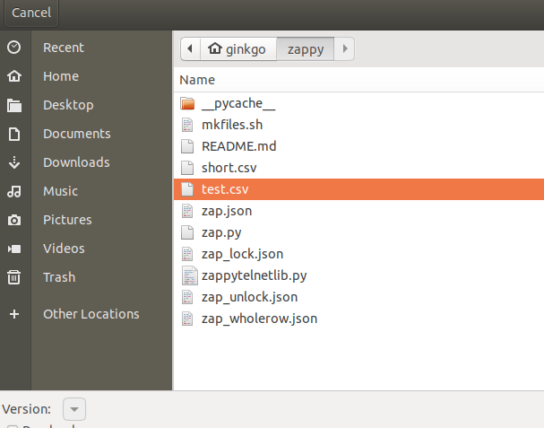

You can edit the file and save it in the zappy directory as a csv. For the rest of this manual, we assume the name of your file is simply “test.csv”, but replace it with the respective file name whenever you see it.

Dry run
Before doing your biology, check your settings with a dry run. Click on the “terminal” icon on the left to start the terminal.
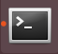

Run the command

cd zappy

To change to the directory of the control program, then run the command

./zap.py -c test.csv -d

Where you replace “test.csv” with the name of your CSV file, in order to dry-run the CSV file and make sure there are no typos.

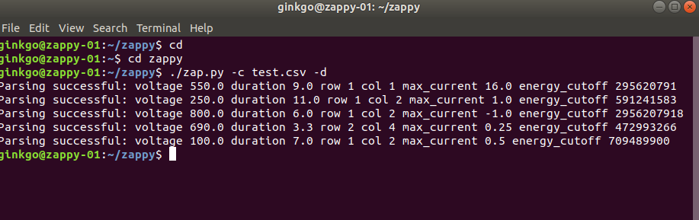

Installing the plate
Before you can use zappy, you have to install and lock the plate. In order to do this, first place a plate on top of the electroporation array. Then, lock the plate in place using the following command:

./zap.py -f zap_lock.json

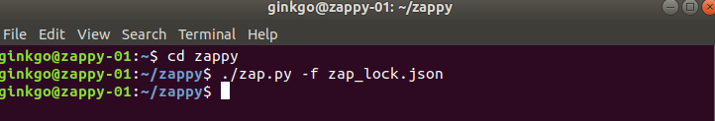
The screen on the front should say “Lock: success” on the bottom if all went well, and the cams will have rotated to the left.

Doing the Experiment

Before you start to load your pipettes, type in the following command, but do not hit enter

./zap.py -c test.csv

The moment you hit enter, the command will execute. Below is what the command looks like before you do the experiment.

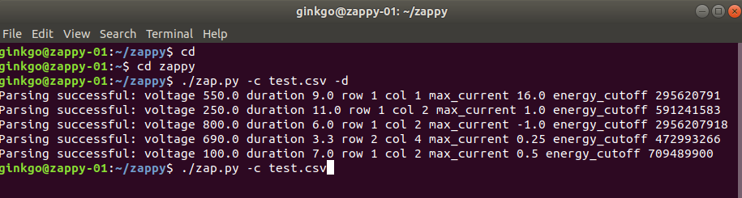

Once your pipettes are loaded into the correct row (and column if using a single channel pipette), hit enter on the keyboard. There will be one beep per electroporation. The beeps will stop when the process is done.

Below is what the screen looks like after the experiment is done.

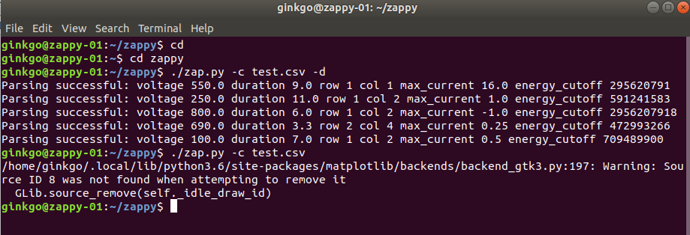
It’s safe to ignore the random python error that comes out after the command is run.

Cleaning up

Once you’re done with the experiment, you need to remove and dispose of the plate. Do this by running the unlock command:

./zap.py -f zap_unlock.json

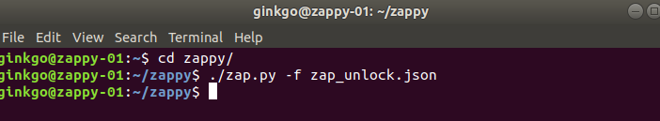
The screen should read “Unlock: success” on the bottom, and the cams will have rotated to the right, freeing up the plate to be removed.

Log files

There are log files that are put into ~/zap-logs/. Every run that is done is stored in that directory with a timestamp.

Shutting down

To shut down the system, use the “I/O” icon in the top right and select the I/O icon in the drop down and click through until the system shuts down. Once the system is powered off you can safely unplug it.

