**AWS Lambda Solutions Implementation Documentation**

**Project Overview**

This document details the implementation of two AWS Lambda functions:

1. Number Addition Function
2. S3 File Storage Function

**Basic configuration**

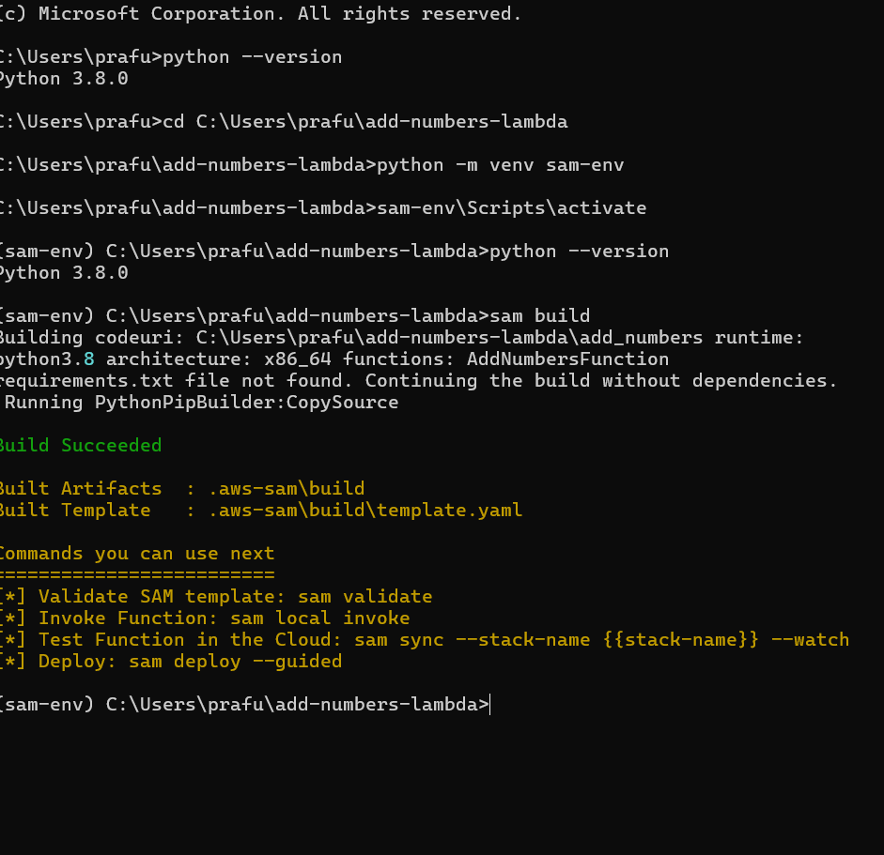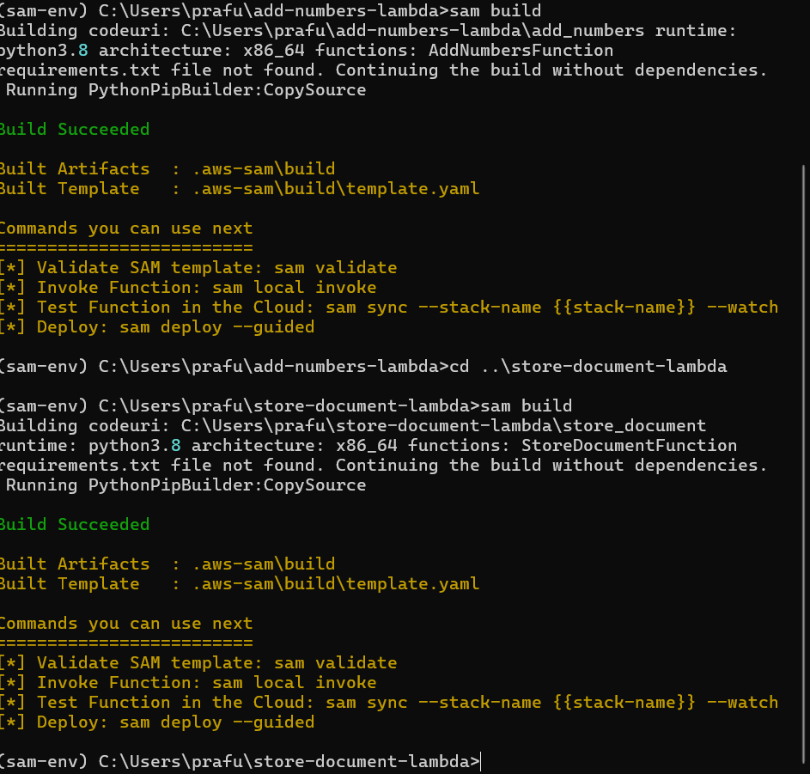

**1. Number Addition Lambda Function**

**Function Details**

* **Function Name:** AddNumbersFunction
* **Runtime:** Python 3.12

**Implementation**

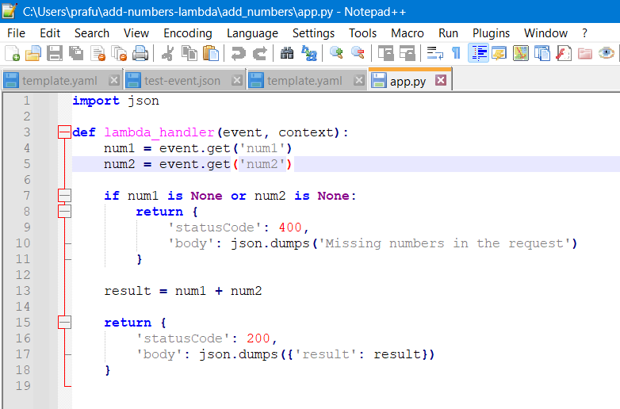

**Testing Evidence**

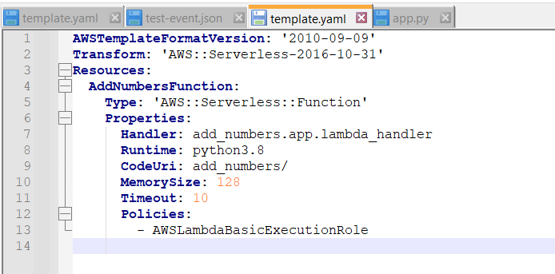

**Test Input:**

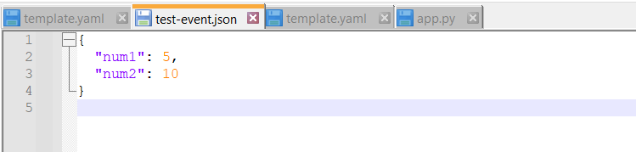

**Output:**

{

"statusCode": 200,

"body": {

"result": 8,

"message": "Successfully added 5 and 3"

}

}

1. **S3 File Storage Lambda Function**

**Function Details**

* **Function Name:** StoreFileS3Function
* **Runtime:** Python 3.12
* **S3 Bucket:** [Your Bucket Name]
* **ARN:** [Your Function ARN]
* **Region:** [Your Region]

**Implementation**

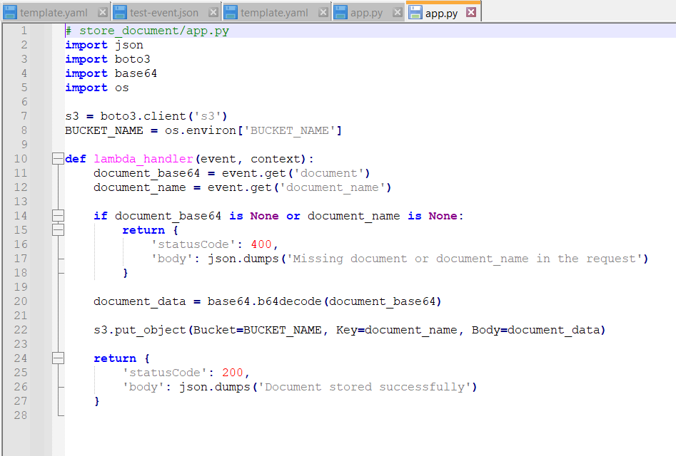

**IAM Role Configuration**

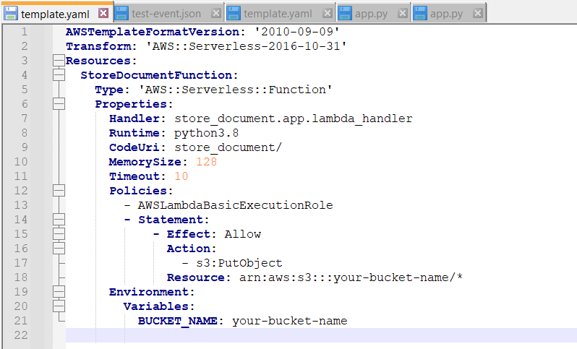

**Testing Evidence**

**Test Input:**

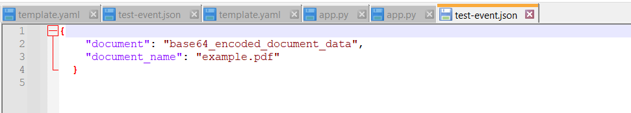

**Output:**

{

"statusCode": 200,

"body": {

"message": "File test.pdf successfully uploaded to S3",

"location": "s3://your-bucket-name/test.pdf",

"presigned_url": "https://your-bucket-name.s3.amazonaws.com/..."

}

}

**Access and Security**

* Both functions implement appropriate error handling
* S3 function generates temporary presigned URLs for secure file access
* IAM roles follow principle of least privilege
* All data transmission is encrypted in transit

**Contact Information**

For technical queries or support:

* Prafull Sutar
* Prafullsutar77@gmail.com
* 8888995423