
Replayer
User Manual

Overview
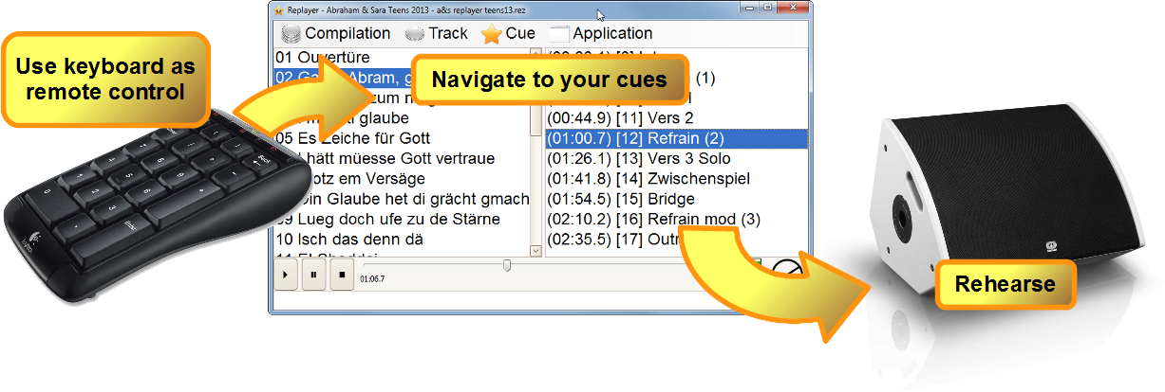
Replayer is a free media player for use during rehearsals with playback music. It's main feature is fast navigation to predefined cues in the playback media.

Notions
- A cue is a named moment in time in a track.
- A track consists of a media file and any amount of cues for that.
- A compilation is an ordered set of tracks.

Download
Download directly from the GitHub repository at https://github.com/suterma/Replayer/releases

Installation
No installation is necessary. Just copy the Replayer.exe file on the desktop or any other location you desire. Start it with a double-click.

Getting started with compilations
If the folder, from which Replayer is started, already contains a compilation, it is loaded.
Or you use the demo compilation from the project page at https://github.com/suterma/Replayer/raw/master/SOURCE/TestCompilations/Demo%20Compilation%20Featuring%20Lidija%20Roos.rez
Otherwise, you create your own compilation using the wizard via “Compilation/Create new...” in the menu.
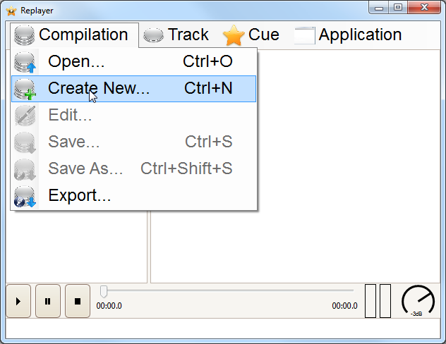Illustration 1: Creating a new compilation from the menu

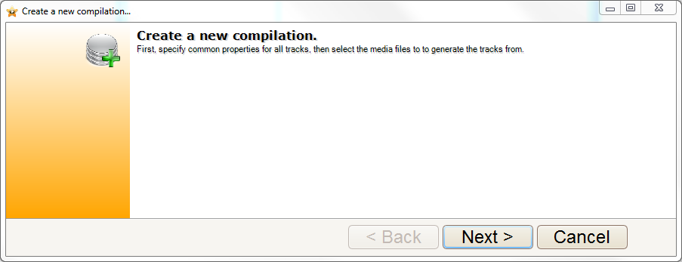Illustration 2: The wizard for creating a new compilation

On the next pages, create your compilation. You will be able to change and add stuff as needed.
The last loaded compilation is automatically loaded again at the next application start-up.

Navigation
To navigate to a specific cue point, you have 2 options:

Using the mouse
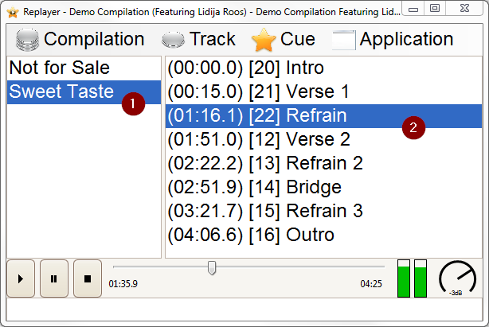
- In the list of tracks, select the one you like to rehearse.
- In the presented list of available cues, select the desired cues by a click..
- By hitting the ENTER key or by double-click, playing starts at this cue.

Using the keyboard
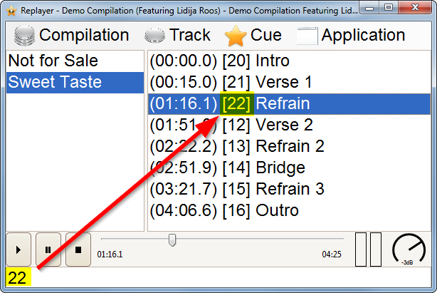
- By directly entering the shortcut key combination (shown in is square brackets) terminated by ENTER, you can navigate directly to the desired cue.
- By hitting the ENTER key again, playback will start.

Keyboard Shortcuts
All frequently used actions are available via specific shortcut keys. For convenience, most of them are all available from the numeric keypad.
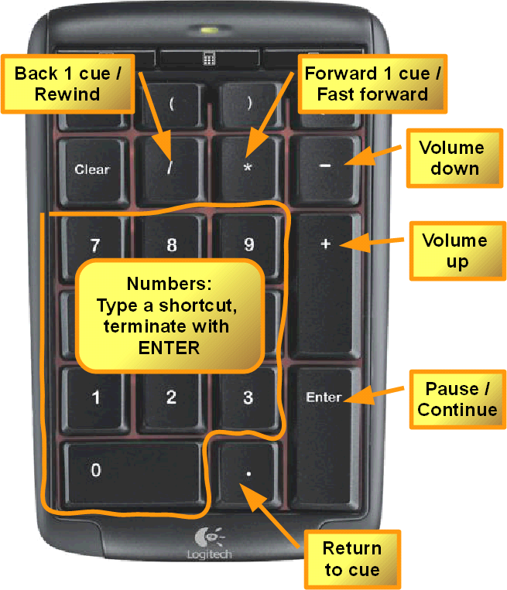Illustration 3: Shortcuts on a numeric keypad

Editing items
To add cues, simply hit F12 while playing.

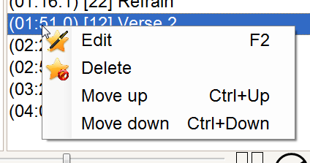
To modify the properties of the compilation itself, use Compilation/Edit. To modify a track or a cue, right-click on the item in question and select Edit from the context menu.

Compilation types

XML compilations (*.rex)
This type of compilation contains a list of tracks with their cue points. Each track refers to an external media file on the local file system. The content of the media file is not part of the compilation.

ZIP compilation (*.rez)
This type is a ZIP archive (as a single file), containing an XML compilation plus the complete set of referenced media files. This allows distributing ready-to-use compilations as a single file.

Compatibility
The current version allows the opening of compilations of *.zip type, which are zipped compilations of the 0.2.8 beta and later releases.

Converting a compilation
Disclaimer: You are responsible for respecting the eventual copyright of the distributed media files. The author of Replayer denies all responsibilities for eventual copyright infringement.

Save As...
In Compilation/Save as... in the application menu, you may choose to save the current compilation to another file or into another type of compilation. Replayer converts and saves the current compilation into the chosen type as necessary.

Export
Replayer supports exporting to a quirli web-page, which is a browser version of Replayer. See https://quir.li/ for more information.

Deployment
To deploy your compilation for rehearsals, just provide the compilation along with a copy of Replayer.EXE. Upon first use on a new computer, Replayer automatically loads the first compilation in the same directory.

Command Line arguments
You can define a specific compilation to load at startup:

Replayer mycompilation.rez

Bug reports
Please report any bugs and feature requests on the GitHub Issues page or via replayer@codeministry.ch.

License
Replayer is licensed to you under the GNU General Public License v3.0.

Credits
Icons: Everaldo Coelho, http://www.everaldo.com/crystal/
Zip Library: SharpzipLib, http://icsharpcode.github.io/SharpZipLib/
Audio Library: NAudio, https://github.com/naudio/NAudio
Exception Message, IDE, Framwork: Microsoft
UI controls: DevExpress, http://www.devexpress.com/
Templating Engine: DotLiquid, http://dotliquidmarkup.org/

