
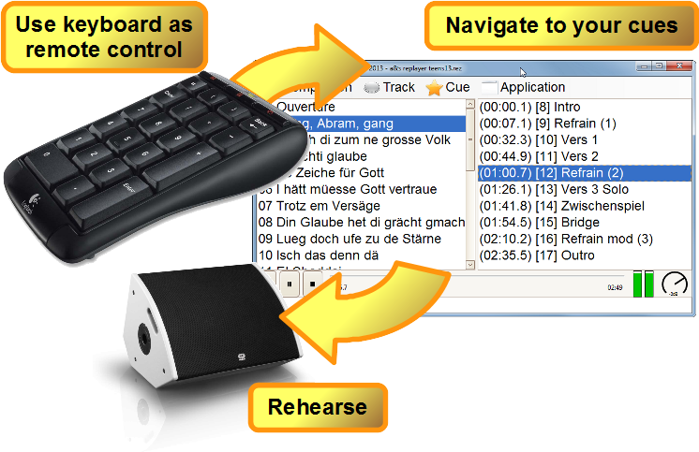
Replayer Version 1.7.0
Replayer is a free, cue-based media player for rehearsals with playback music. By the click of a button, Replayer starts to play at predefined times in the audio file.

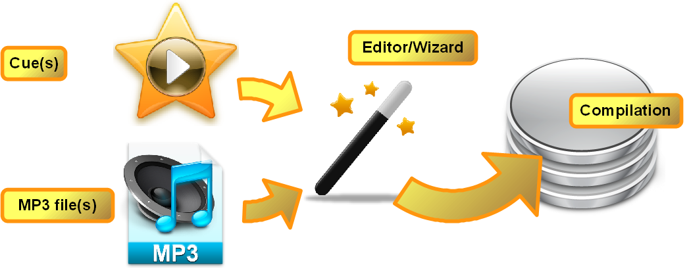
Getting started
First, you create a compilation of tracks and cues once, using a wizard from within Replayer.

Rehearse
Then, using Replayer and your laptop computer, you can rehearse any portion of your set with ease.

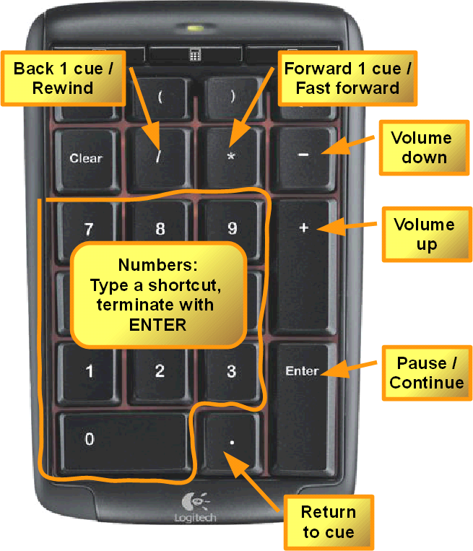
Fast
Use the navigation features on the numeric keypad.

Get your free copy today from https://replayer.app

