Table of Contents
1.Thesis: Analysation 1
1.1.Existing Solution 1
1.1.1.Existing solution (spare) 1
1.1.2.Existing solution in use 1
2.SRS: Stakeholders 5
2.1.Ralf Lange (Measurement Technician) as user 5
2.1.1.Wishes 5
2.2.Tools 5
3.Master Thesis: Design guidelines for the Presentation 5
4.TODO 6
4.1.SRS 6
4.2.Preproject 6
4.3.Thesis Work 6
4.4.General 6
5.Notes 6
6.Master Thesis:Optimisations 6
7.Master Thesis: Extensions 7
7.1.Sensors (Positioning providers) 7
7.1.1.Optical stop recognition 7
7.1.2.Optical landmark recognition 7
7.1.3.Optical speed measurements 7

Thesis: Analysation

Existing Solution

Existing solution (spare)
The solution currently in use is a custom-built unit, consisting of a single-axis accelerometer, a laser-gyro, a microcontroller and additional hardware to provide data over a serial RS-232 connection. A USB hub and USB-to RS-232 is also built-in for convenience, but it is not used for the navigation itself.
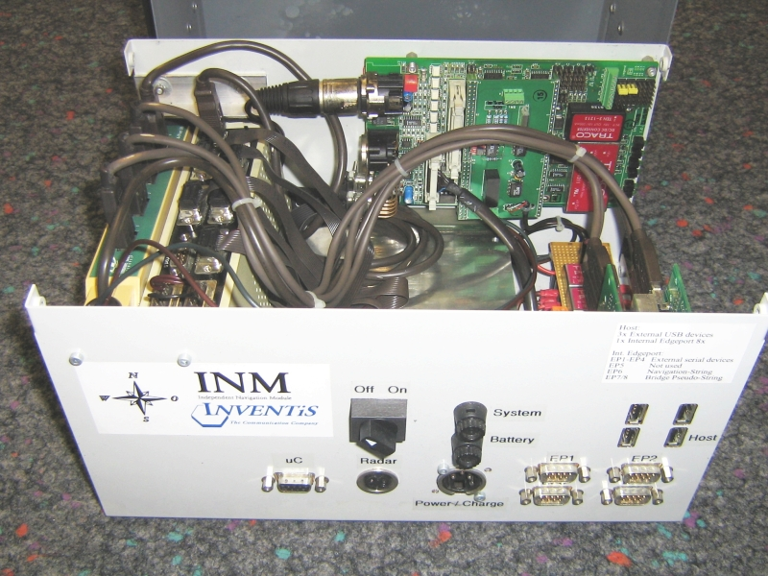Illustration 1: Existing inertial navigation system
The system has no possibility to provide an initial position. The output is raw accelerometer data, at a rate of about 100 samples per second.

SRS: Stakeholders

Ralf Lange (Measurement Technician) as user

Wishes
- Possibility to make comments during the measurement also for the UMTS version of the measurement software. (Does not apply to this master thesis)
- Possibility to revoke multiple event markers also for a longer period than 5 seconds. (Will probably be impossible with the solution from the master thesis, because it should be real-time).
- Possibility to add, delete or change event markers in the predefined set. This would be useful to keep the set up to date.
- Better USB Hub. The current hub sometimes has dropouts. This is probably due to the fact that the Laptop is connected only to 12VDC whereas the it is specified to be connected to 16VDC

Tools
GIS PLANET NAVIGATOR
Navigator is a stand-alone application for real time GPS navigation in Google Earth, and it's free. It supports USB and COM (bluetooth) connection. And it can simultaneously use more than one GPS receiver.
http://blog.geoblogspot.com/2008/09/navigator-101.html

Illustration 2: The Navigatior software, showing a l ive GPS position report form a device in Google Earth
The data transfer into Google Earth works via a simple KML file with a Link entry. The Linked file gets updated by the Navigator every second, and Google Earth is advised by the Link entry's property to refetch the file every second. This introduces a considerable delay of the shown position with regard to on the GPS device reports at a given point in time. This delay is about 3 to 5 seconds.
To evaluate the precision of a single fix reported by the GPS device, this single GPS fix should be written in the file and not updated anymore, until this fix is shown in Google Earth.

Master Thesis: Design guidelines for the Presentation
- No empty white slides
- Clearly show the context of the thesis. Point out the content of the thesis itself.
- sharp final point/gag
- avoid abbreviations and technical terms or explain!
- Give overview over the used technologies and methods.
- few words, more pictures
- Structured, although continuous sequence of the slides
- A nice pictures of symbol at the start and as icon
- only few, wisely used animation
- Probably use metaphers, if applicable (example classical concert showing how things work together)
- in bullet lists, dont use whole sentences
- use light colours (soft contrast, that does not stress the eye)
- Use the common visual elements (also repeated over slides) where applicable, eg. in structure diagrams.

Bibliography
-CPLX01: , Managed Wifi API, ,
-NICO01: Nicomsoft, Advanced WiFi-Manager , ,http://www.nicomsoft.com/wifiman/advanced.htm
-NETS01: Marius Milner, stumbler dot net, ,http://www.stumbler.net/
-PLLB01: Anthony LaMarca, Yatin Chawathe, Sunny Consolvo, Jeffrey Hightower, IanSmith, James Scott, Tim Sohn, James Howard, Jeff Hughes, Fred Potter, JasonTabert, Pauline Powledge, Gaetano Borriello, Bill Schilit, Place Lab: Device Positioning Using Radio Beacons inthe Wild, ,http://placelab.org/publications/pubs/pervasive-placelab-2005-final.pdf

TODO

Allgemein
- The student delivers a schedule together with the SRS until 14.11.2008
- The next project review meeting takes place on the 11.11.2008
- The student discusses and defines the confidentiality level with the company.
Evtl. Volle Dok and Experte und nur Teildok an SWS (Vertraulicher Teil auslagern)
- Erste Iteration der Systemarchitektur erstellen.
- Zeitplan erstellen

SRS
Phasen machen für GPS, Inertial und Erweiterungen
Am Schluss prüfen: Messbare Anforderungen formulieren
Anforderunge prioorisieren
SRS ist auch Werbung für's Projekt
Der Leser soll das Projekt verstanden haben

Design
Every Provider has a n Extrapolator, that extrapolates the position estimat from this provider in the time domain to the current time.
CurrentBestEstimate is a Singleton containing/providing the current best estimate. This is also the data that is outputted each second.

Implementation
Implementation: StormSource Software will release version 1.3 of its GPS.NET Global Positioning SDK next week. The SDK will assist developers with writing GPS-enabled applications for the .NET Compact Framework for mobile applications to perform any GPS-related task.

General
Add bibliographic database to openoffice.org. Describe the WLAN campaign in the S3.
Transfer notes from Handy to this doc.!!
Each sensor has a singleton containing the latest data and the status information

Notes
Probably use .NET Datasources for the positioning data providing.
Design: Use every resource, that is available only once as a service (Or ev. As Singlton). Eg. Database, GPS, Inertial navigation, WIFI,...
Use Entity Framwork instead of linq for database access.
Design: Define Positioning source, Positioning processors. Each source may have a processor, that enhances the signal. There is a storage for the most recent fix. The output is defined in an interface “Position outputter” or similar.

[10.1.2] Inertial, Acceleration and Heading sensors
An excellent summary technical report on this area can be found at:
[34]CMU-RI-TR-94-15 (compressed)
_Modern Inertial and Satellite Navigation_ by Alonzo Kelly, May 1994.
Inertial measurement includes such devices as accelerometers, gyros,
and devices for measuring orientation or acceleration of moving
vehicles. Accelerometers are devices for measuring the rate of change
in velocity and can provide estimations of distance or be used to
detect high forces.

From Placelab: For more information on the intricacies and
advantages of using probabilistic Bayesian filters in location systems, see Hightower
et al. [5] and Patterson et al. [9].

