Solaiyappan, Chenniappan (Cognizant)

[Email address]

Abstract

HEDIS Operating Environment – Fly like BIRDS

Claimpshere user experience

Strive for Perfection, No matter how hard it is

Contents

**Cockpit** 2

**Qbuilder** 10

Cohort Explorer 11

**Clinical+ V10** 13

MRRA 15

# **Cockpit**

1. **Self Review & Peer Review Checklist:**

Member which has….

Is this grammatically right ?

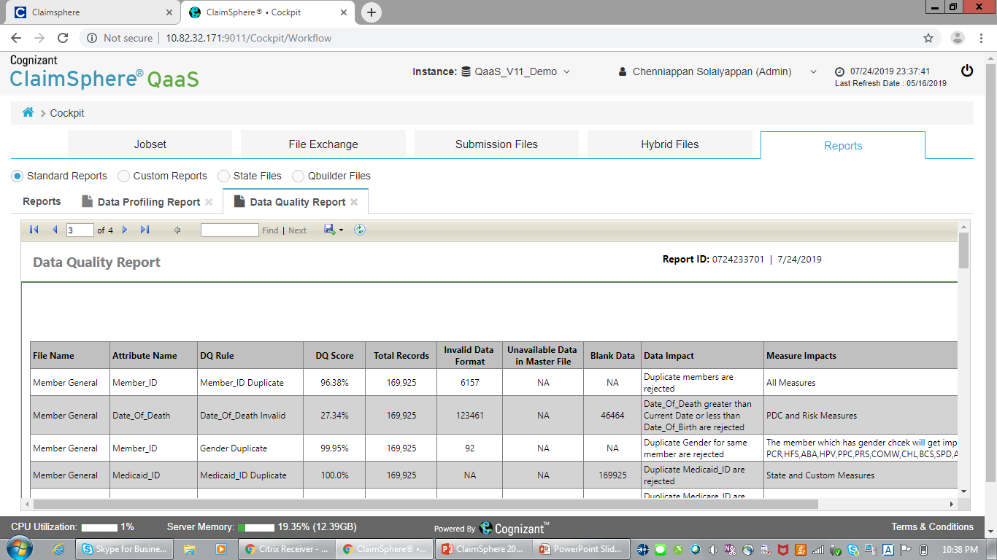

1. Lets fix the report name and it doesn’t make sense to have one report as Data Quality report but the context had Data Load Statistics, whereas the other report is named as Data Load Statistics.

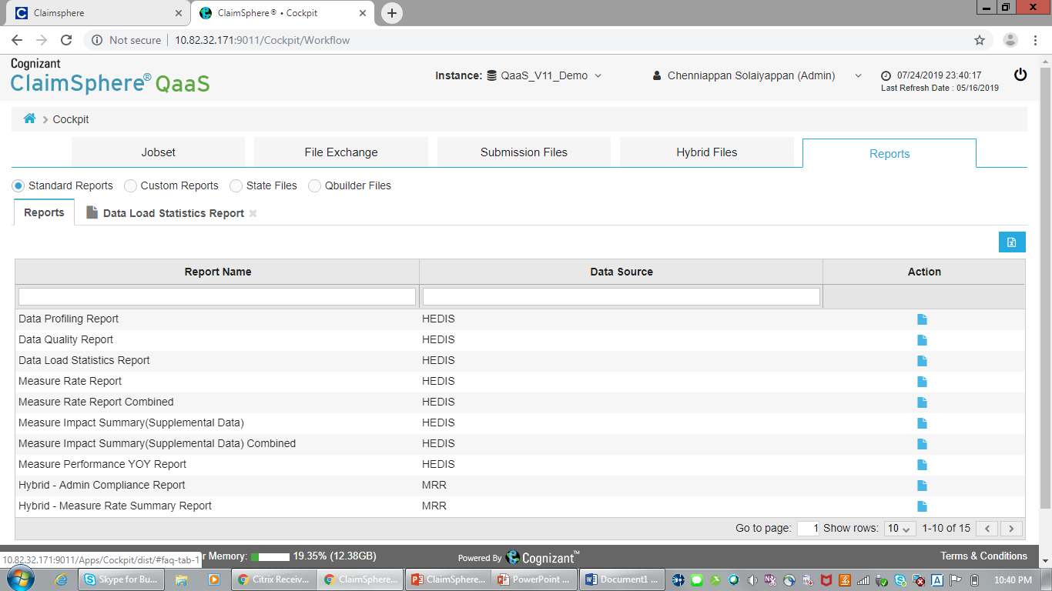

1. This report must display the variance but Year 2018 rate is missing:

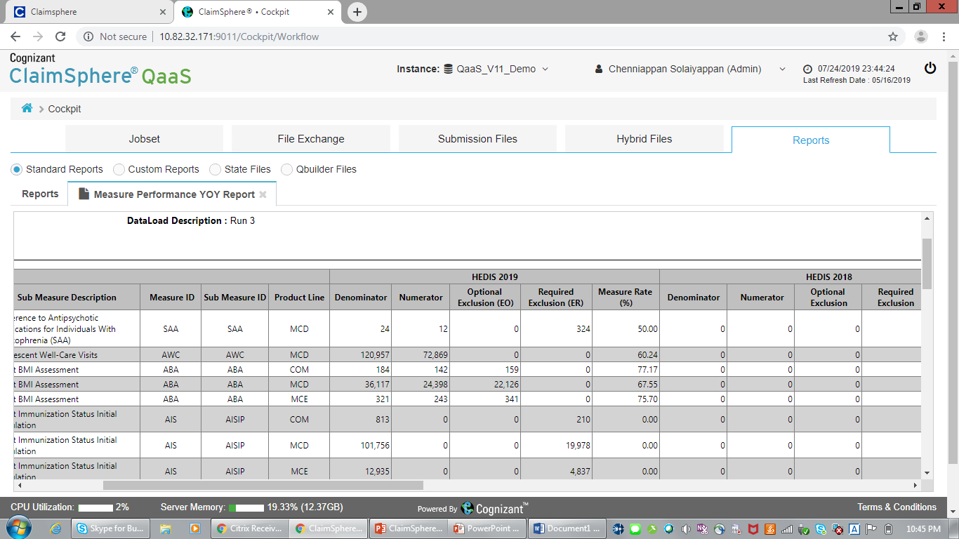

1. Error Occurred

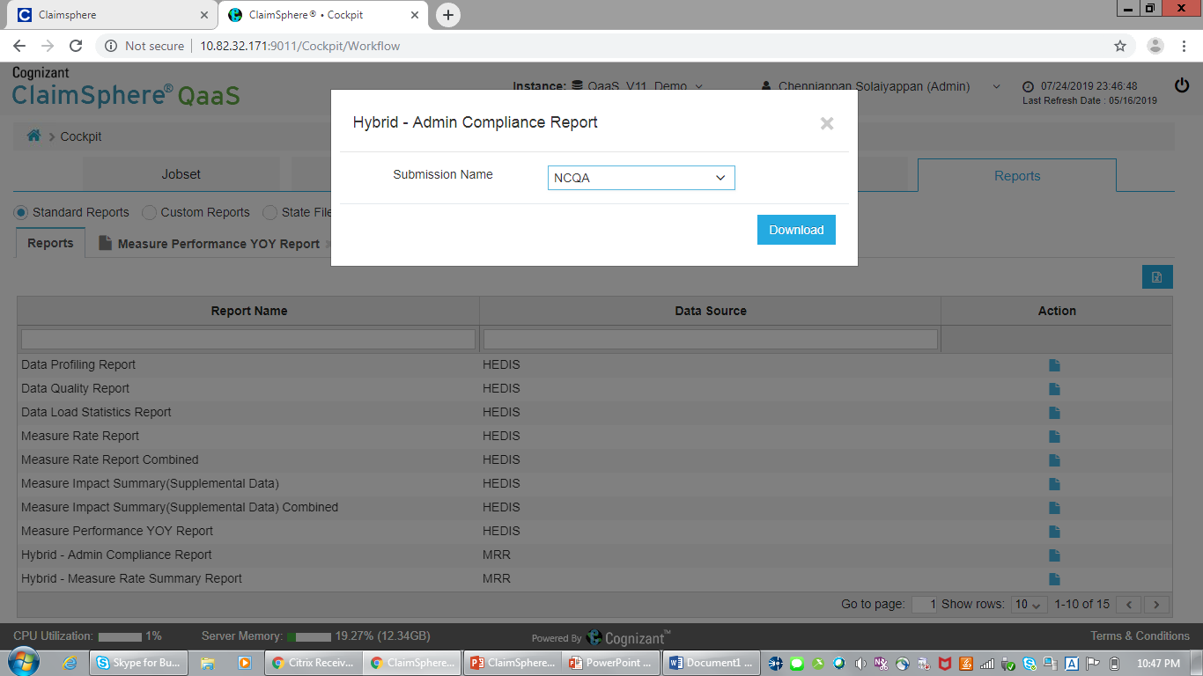

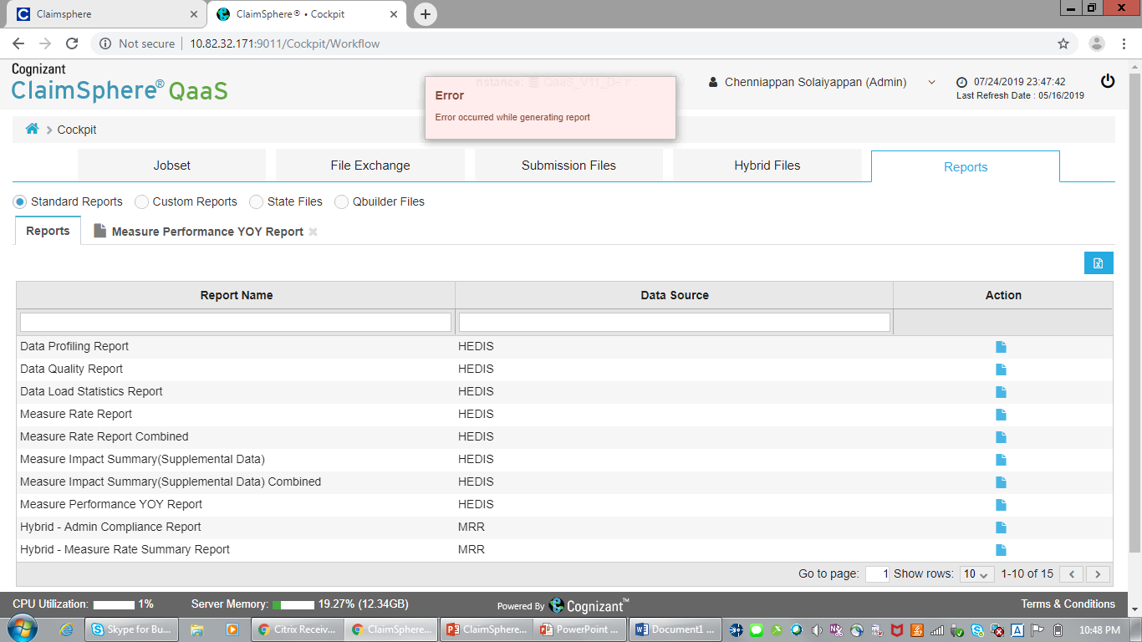

1. Can I get the Report catalogue with description and usage, for those reports available in Cockpit.
2. Measure Cloning – Look and feel needs to be improved: 10SP

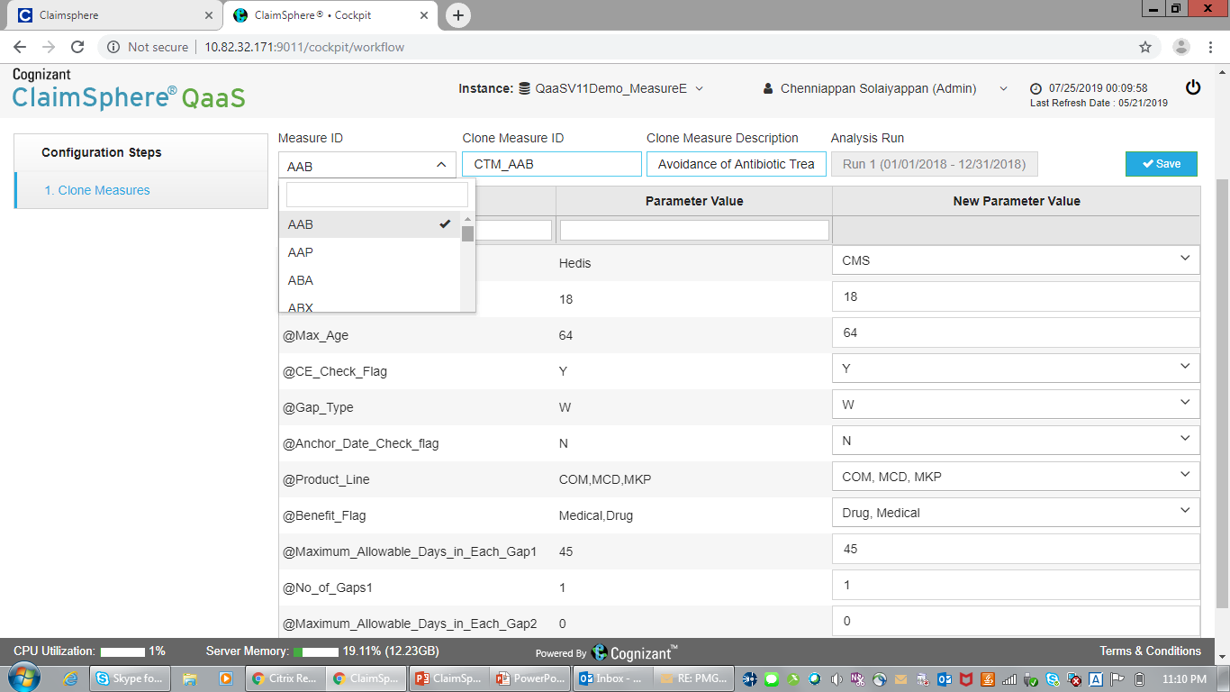

1. Why don’t I see all the measures listed in Cockpit for editing the measure parameters

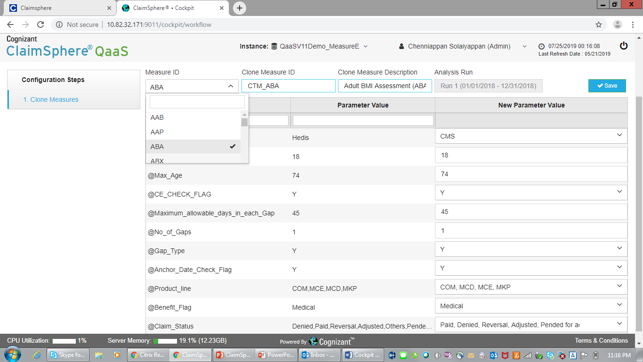

1. Widgets are not sequenced by the flow: Why ?

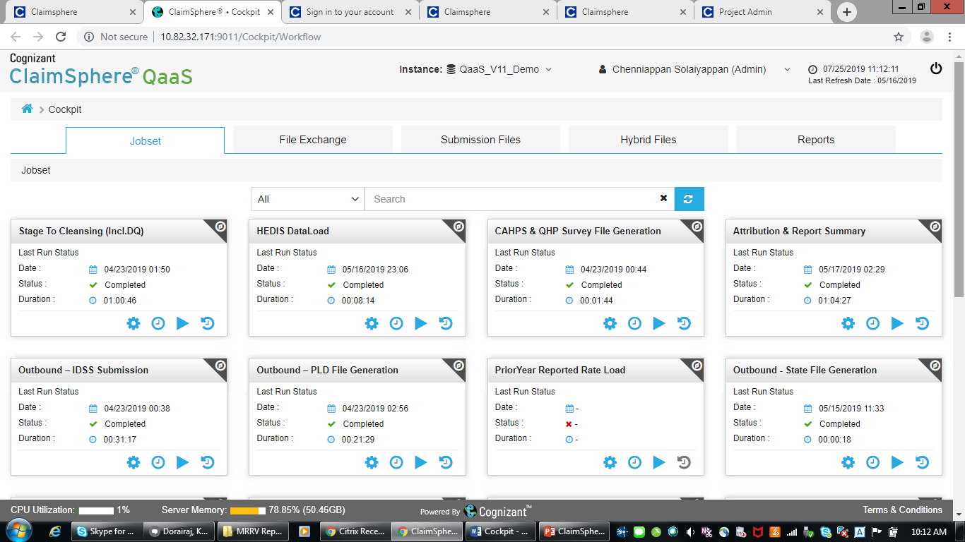

1. Home icon is taking me out of Cockpit. Why ? 1SP

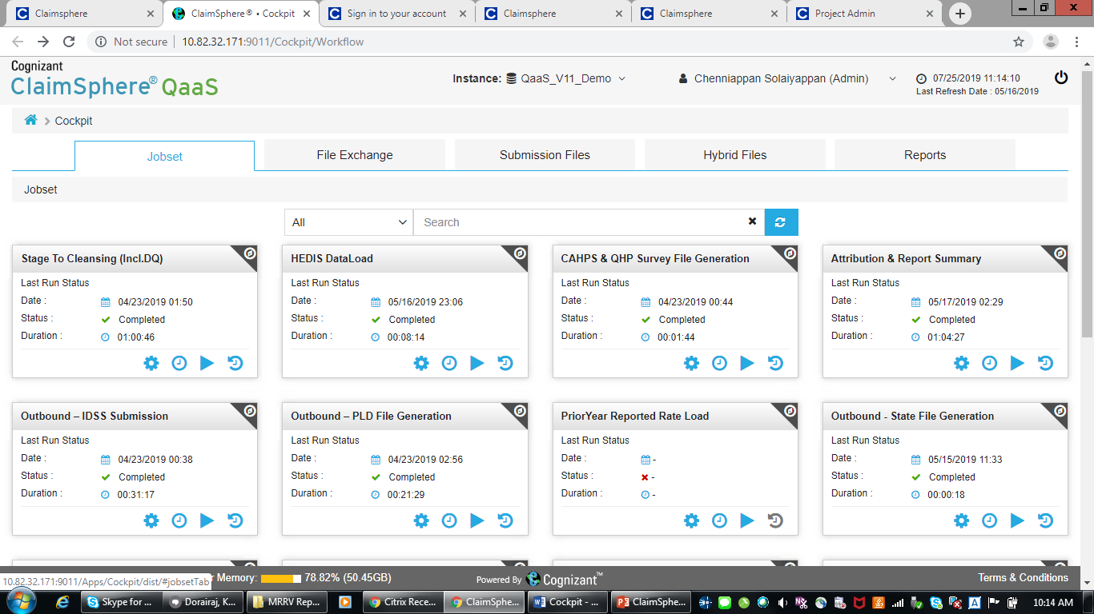

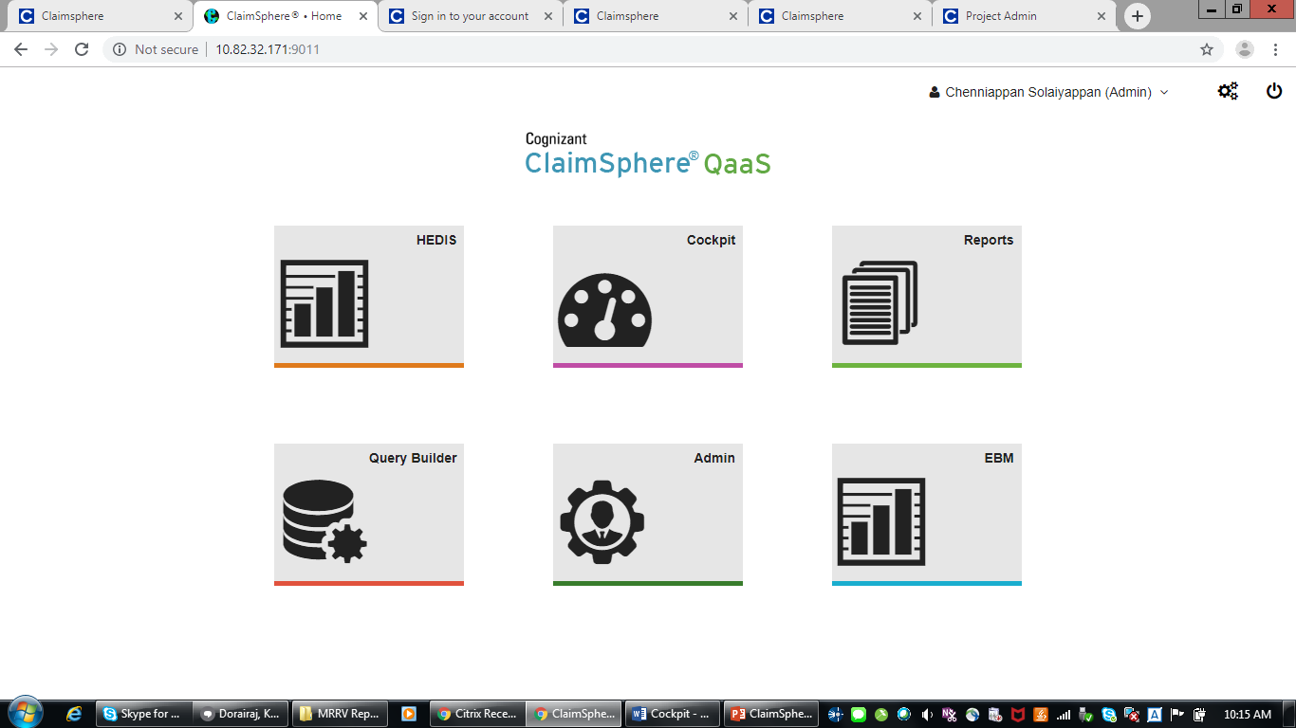

1. What is the elapse time of each report ?

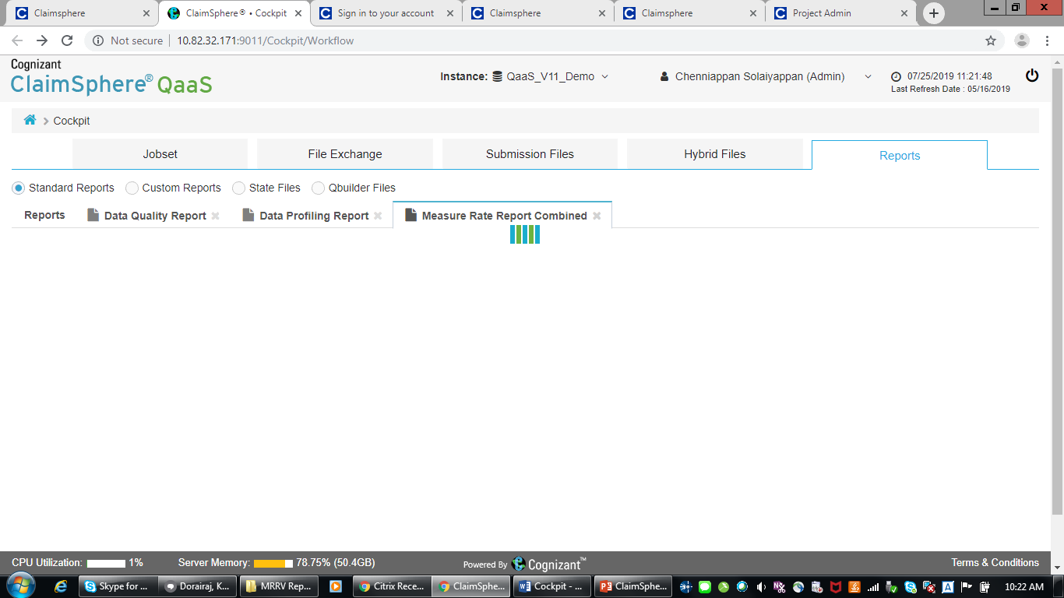

1. Look and feel is not professional.

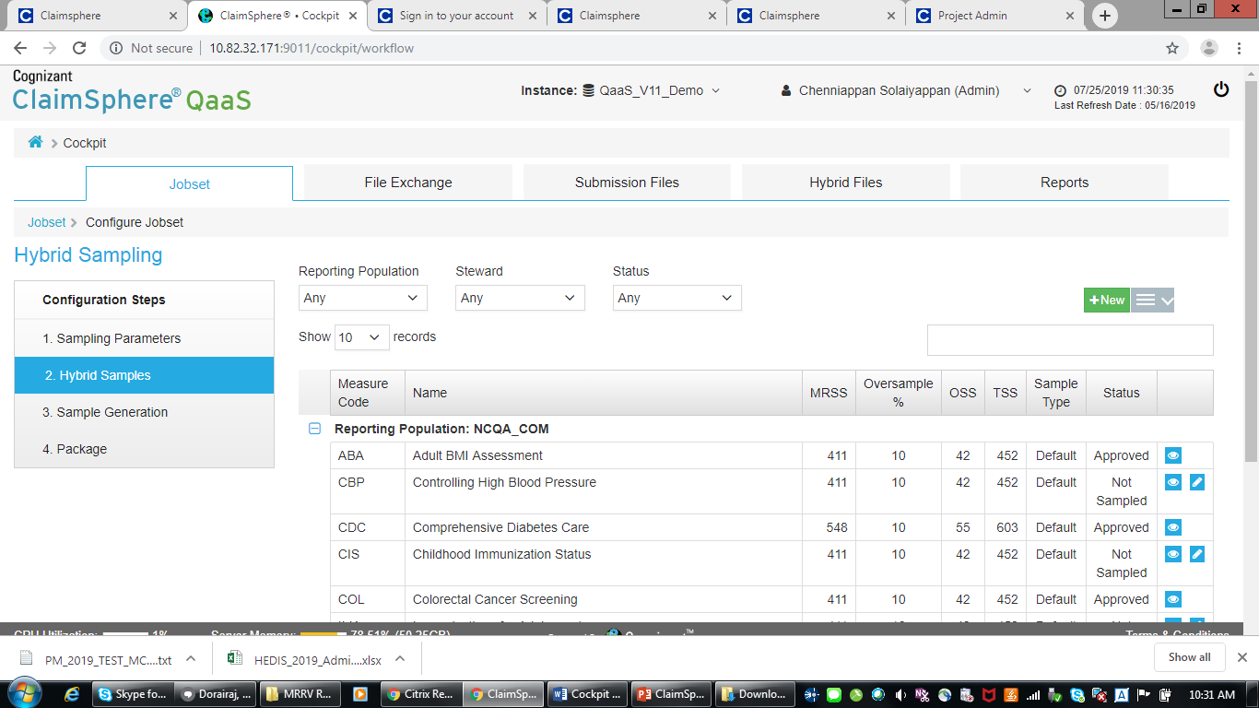

1. Why do we have to confirm. Pl remove the confirmation to avoid a mouse click.

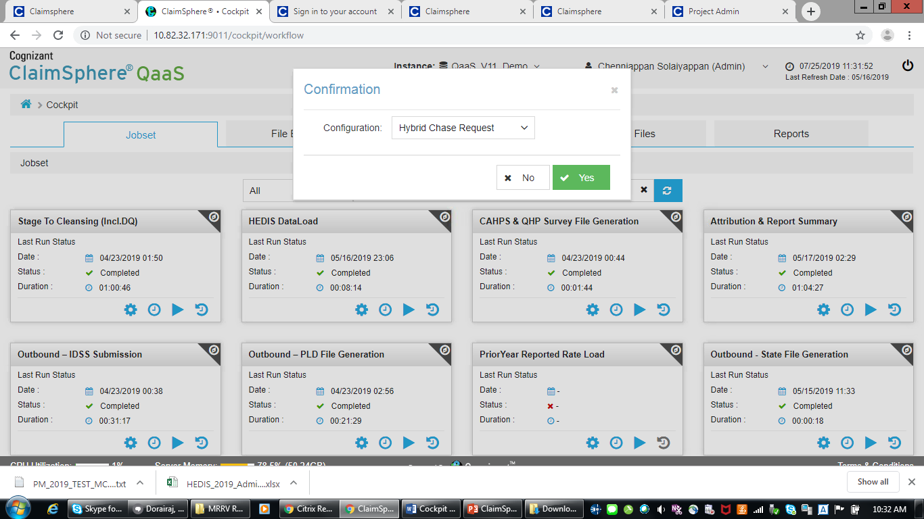

1. Chase response and Data Quality are blank.

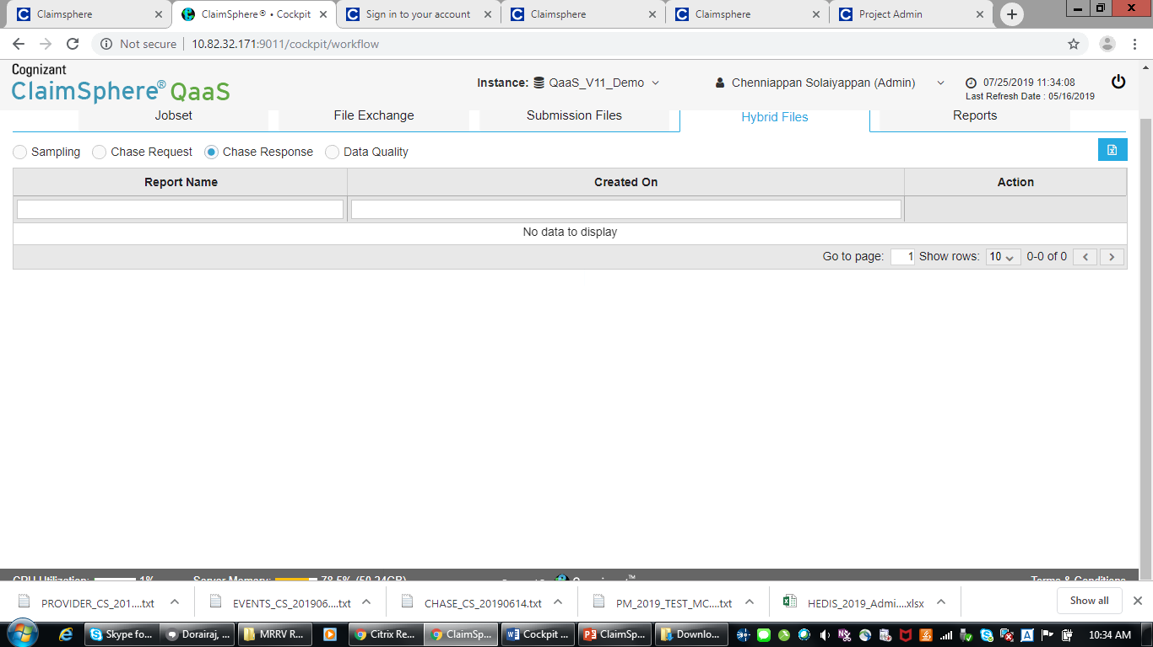

1. **Measure Stewards 🡨 Steward cannot be plural**
2. **Hedis cannot be mixed case, its an acronym, all uppercase:**

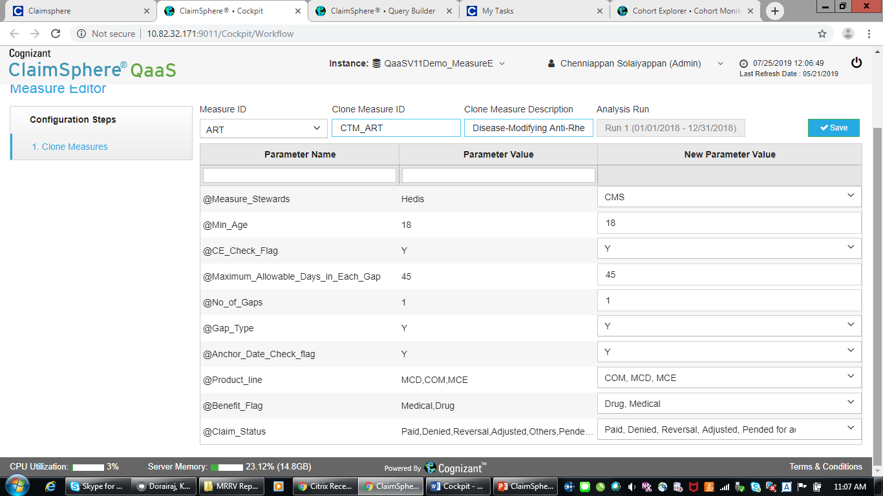

# **Qbuilder**

1. Every query and the folder name must be reviewed for naming convention. How can you name a query as “NDC…” within ICD10 folder ? ICD and NDC are two different terminology.

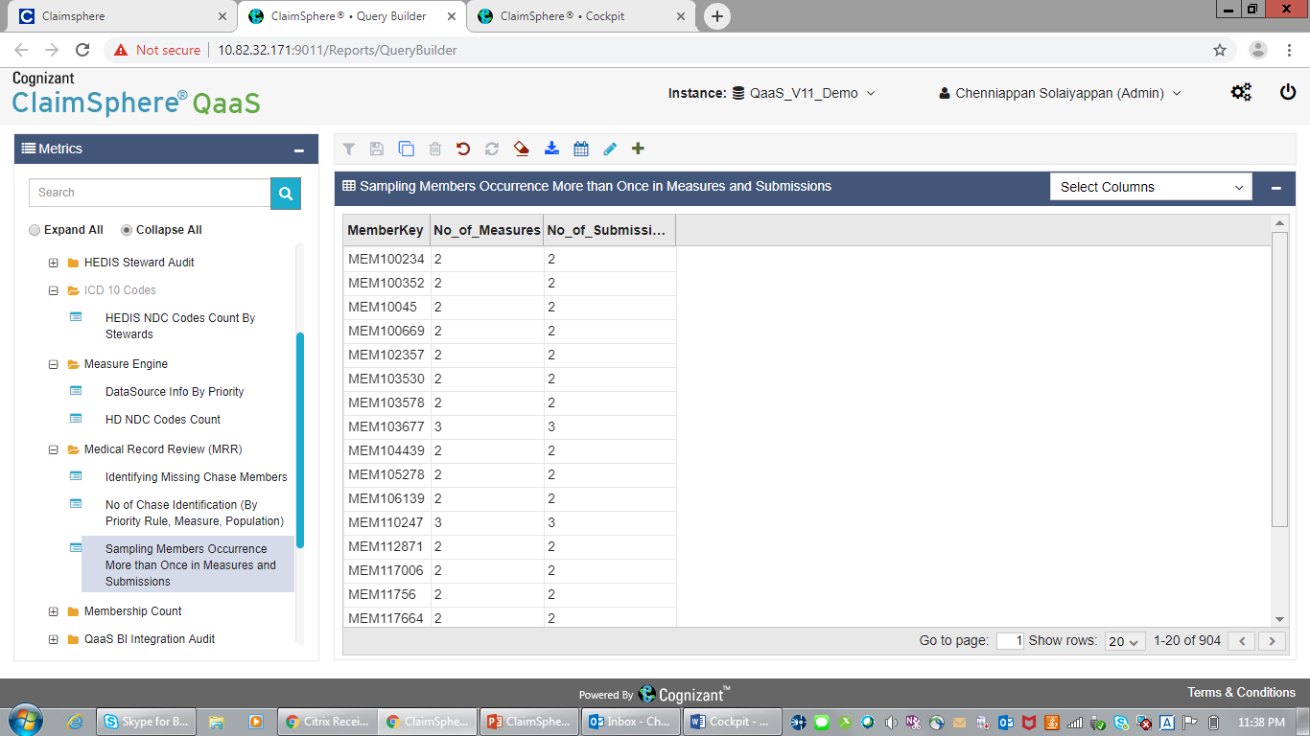

# Cohort Explorer

1. Someone had created a “Gender” Cohort in a private mode. This needs to be avoided thru proper guidance.

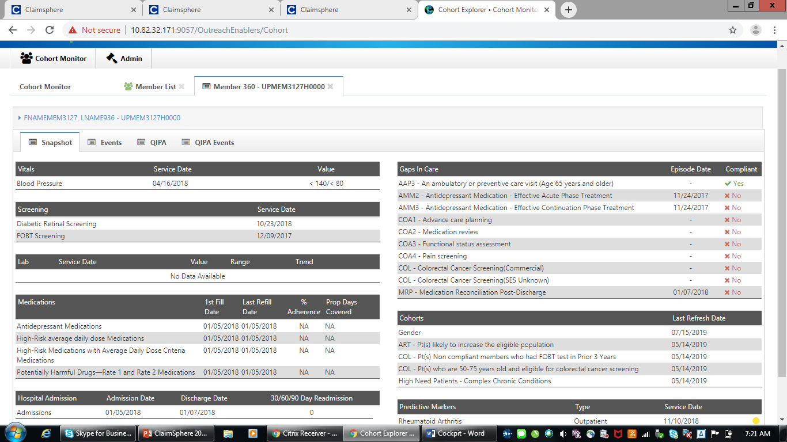

1. Dementia for 2 year old !

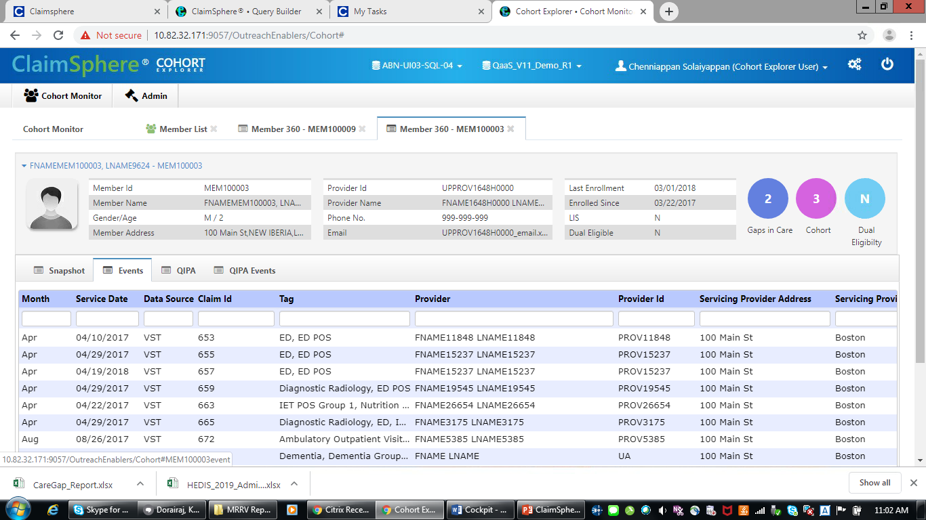

# **Clinical+ V10**

1. Overall summary report, what is the meaning of Perf Rank 2 ?

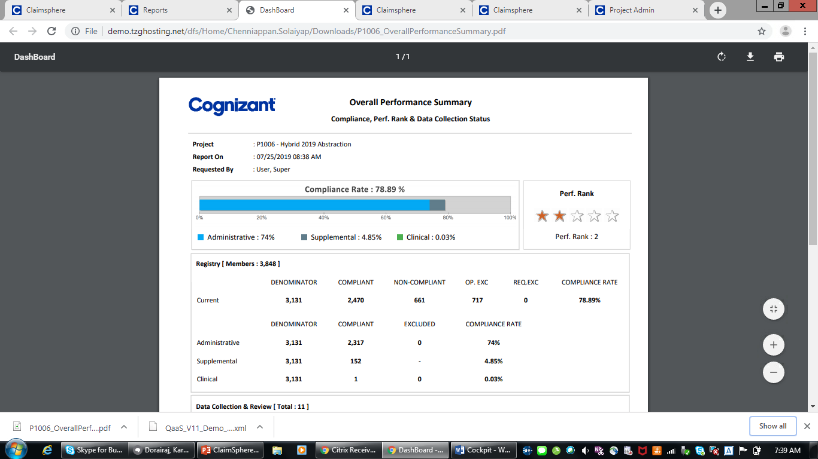

1. Why do we have IESD data in ABA in Clinical+ v10 ?

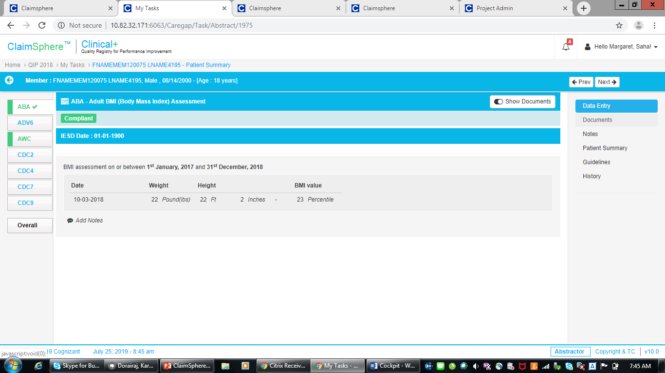

1. User Saha and Nancy are missing in v11
2. Why do I have to scroll down to click “Start Abstraction” ?

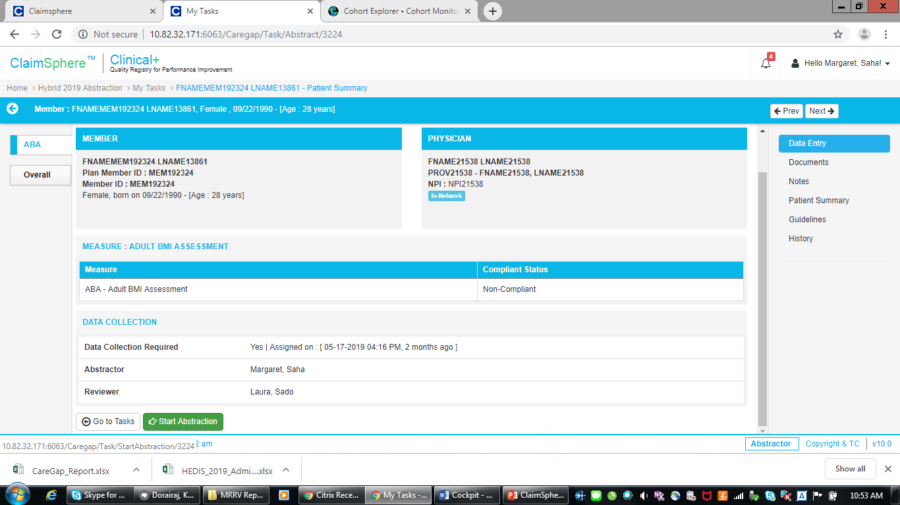

# MRRA

1. Is the error message is correct ?

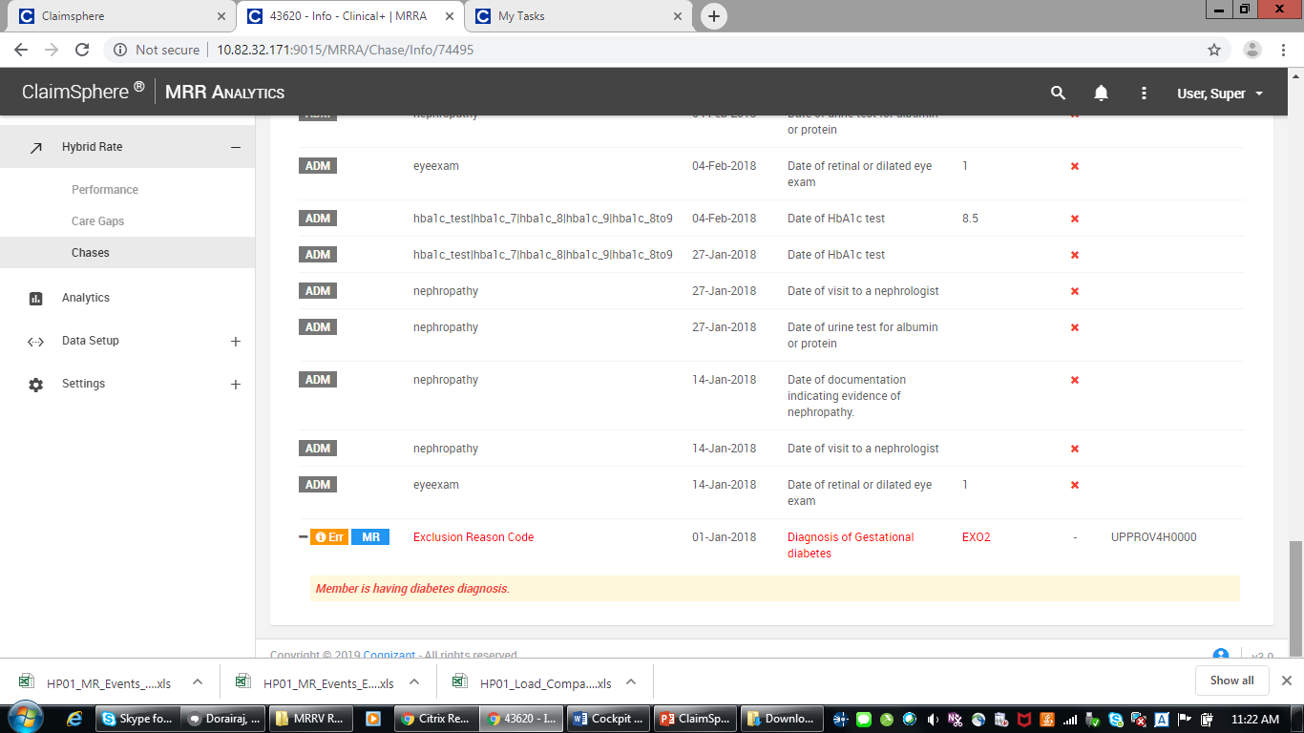

1. It will be a good design if you have Measure-wise Summary Dashboard, rather than, jumping straight into raw data.