SaaS Sales, Discount and Profitability: Analysis Report
1.Summary
Across 9,994 order lines (revenue 2,297,201), the company earned 286,397 in profit at a 12.5% margin, and 18.7% of lines lost money. Lines discounted above 20% lost 135,376 in total, and 89% to 100% of them were loss-making. One product, Marketing Suite, lost money overall. Profit is concentrated: the top 10 customers account for 27% of it.
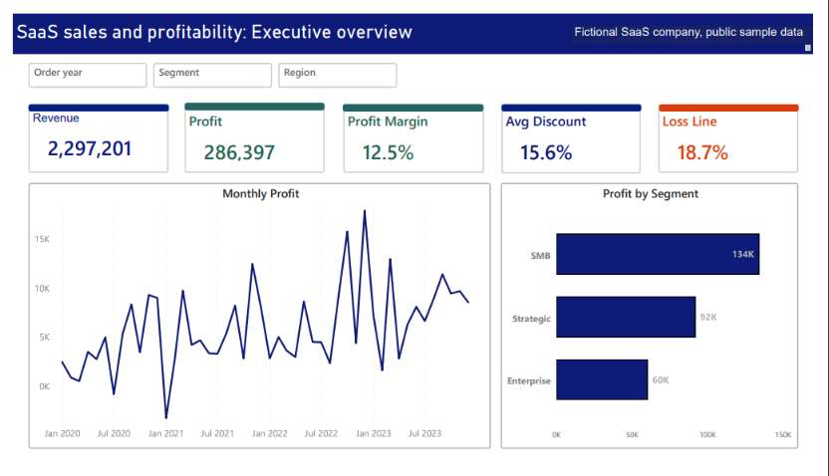
Figure 1: Executive overview dashboard
2. Data and method
The data is a public SaaS sales sample for a fictional company. I cleaned it in Excel and SQL, tested the discount effect in Python, and built a four-page Power BI dashboard. Methods: correlation, a test comparing discount tiers, a regression of profit on discount, and a decision tree on profit or loss.
Data source: Amazon AWS SaaS Sales Dataset (Kaggle, nnthanh101), a fictitious B2B SaaS company.

3. Findings
Finding 1: Discounts above 20% destroy profit.
Loss-making lines were 0% at no discount, 4.3% at 1-10%, 14.0% at 11-20%, 91.6% at 21-30%, 88.8% at 31-40% and 100% at 40%+. The 0% tier earned 321,000 in profit, while the three tiers above 20% lost 10,000, 25,000 and 100,000 (135,376 in total).
Statistical support: discount and profit are negatively correlated (Pearson r = -0.22, Spearman ρ = -0.54, both p < 0.001). A Kruskal-Wallis test shows profit differs across discount tiers (H = 3,660, p < 0.001). In a linear regression, each 10-point rise in discount is linked to a fall of about 25 in profit per order line (R² = 0.048), so discount alone explains little of the straight-line variation, and the damage is concentrated above 20%. A decision tree splits at a 25% discount, consistent with the tier results above.
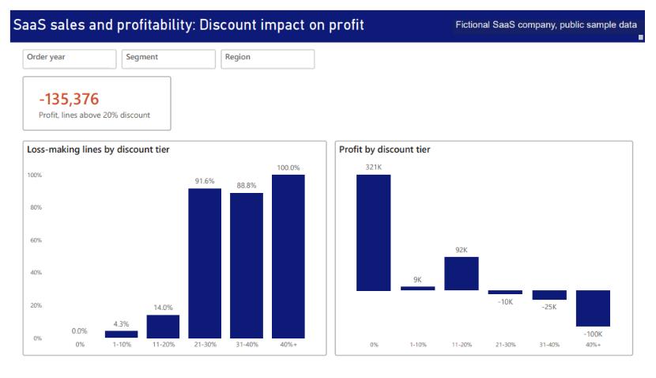
Figure 2: Discount Impact on Profit
Finding 2: Product profitability differs sharply.
Marketing Suite is the only loss-making product (-3,473, margin -3.0%), driven by its SMB segment (-4,436). Alchemy earns the most (55,618, margin 37.2%). ContactMatcher (margin 3.0%, average discount 35.3%) and Big OI Database (margin 1.8%, average discount 30.6%) have the thinnest margins and the heaviest discounts. SaaS Connector Pack - Gold earns a 42.3% margin at an 8.0% average discount.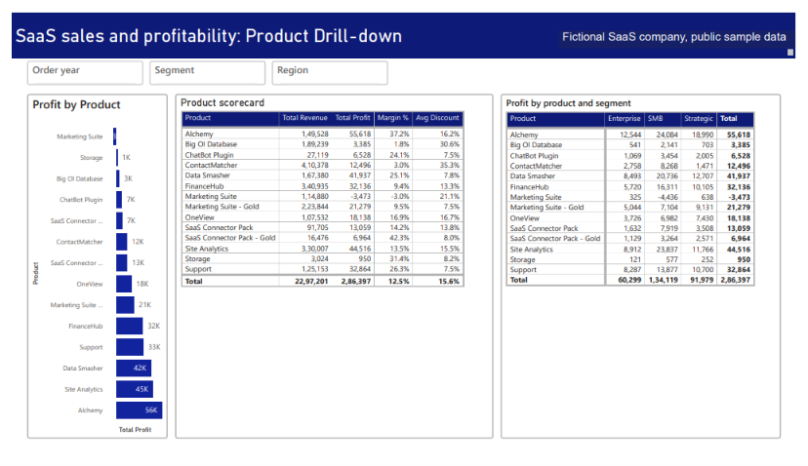
Figure 3: Product Drill-Down
Finding 3: Segments and customers.
SMB earns 134,119 (47% of profit), Strategic 91,979 (32%) and Enterprise 60,299 (21%). The top 10 customers earn 77,437 (27%). The bottom 10 customers all lost money, 9,381 in total, led by Allstate at -2,796. There are 99 customers, with 2,893 profit per customer.
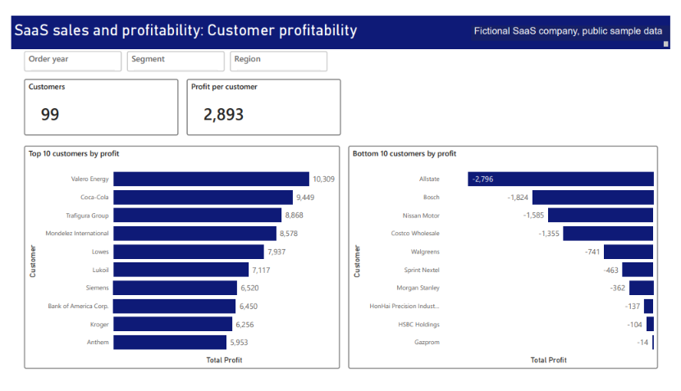
Figure 4: Customer Profitability
Finding 4: Monthly profit is volatile.
Monthly profit ranges from about -3,000 to about 18,000, so single months should not be read as a trend.

4. Recommendations
- Require approval for any discount above 20%.
- Scenario: capping discounts at 20% would affect 1,393 order lines. If all of them still sold at the higher price, profit would rise from 286,397 to about 505,588 (+219,191). If none of them sold, profit would still be about 421,773, because those lines lost 135,376 in total. The real outcome depends on how customers respond, and the loss of other business is not modelled. This is a scenario built on historical relationships, not a forecast.
- Review Marketing Suite pricing, and the discounting on Contact Matcher and Big OI Database.
- Review terms for the 10 loss-making customers.
- Use the dashboard in the monthly MIS pack.
5. Limitations
Sample data for a fictional company. The discount and profit link is an association, not proof of cause. Retention is not reported because every customer repeats.

