#YPOOOGQOG  
The *Ain-i-Akbari* is the third volume of the *Akbarnama* containing information regarding Akbar's reign in the form of, what would be called in modern times, administration reports, statistical compilations, or gazetteers. It contains the áín (i.e., mode of governing) of Emperor Akbar, and is, in fact, the administration report and statistical Return of his government. The first volume of the *Akbarnama*contains the history of [Timur](https://en.wikipedia.org/wiki/Timur" \o "Timur)'s family and the reigns of [Babar](https://en.wikipedia.org/wiki/Babur), the Súr kings, and [Humayun](https://en.wikipedia.org/wiki/Humayun" \o "Humayun). The second volume is devoted to the detailed history of the nearly forty-six years of the Akbar's reign. Since it was written around 1590, it also contains details of [Hindu](https://en.wikipedia.org/wiki/Hindu) beliefs and practices as well as a [history of India](https://en.wikipedia.org/wiki/History_of_India).[[3]](https://en.wikipedia.org/wiki/Ain-i-Akbari#cite_note-Blochmann-3)[[4]](https://en.wikipedia.org/wiki/Ain-i-Akbari#cite_note-4)

The *Ain-i-Akbari* is itself divided into five books. The first book deals with the imperial household, and the second with the servants of the emperor, the military and civil services. The third book deals with the imperial administration, containing the regulations for the judicial and executive departments. The fourth book contains information about Hindu philosophy, science, social customs and literature. The fifth book contains sayings of Akbar,[[3]](https://en.wikipedia.org/wiki/Ain-i-Akbari" \l "cite_note-Blochmann-3) along with an account of the ancestry and biography of the author.

## Volumes[[edit](https://en.wikipedia.org/w/index.php?title=Ain-i-Akbari&action=edit&section=2" \o "Edit section: Volumes)]

**Volume 1**

The volume has a total of 90 ‘Ain’ or Regulations dealing and describing the different segments of administration and occupations at that time. The various ains include the one on the imperial mint, its workmen and their process of refining and extracting gold and silver, the [dirham](https://en.wikipedia.org/wiki/Dirham) and the [dinar](https://en.wikipedia.org/wiki/Dinar) etc. There are also portions dedicated to the Imperial [harem](https://en.wikipedia.org/wiki/Harem) (ain 15), the royal seals (ain 20), the imperial kitchen (ain 23) and its recipes and the rules relating to the days of abstinence (ain 26). The volume contains a detailed description of the trade/ business of items like fruits, vegetables, perfumes, carpets etc. and also of art and painting. Ain-i-Akbari is an excellent resource to know more about the maintenance of an army as large as Akbar’s. Ain 35 onwards deals with the use and maintenance of [artillery](https://en.wikipedia.org/wiki/Artillery), upkeep and branding of royal horses, camels, mules and elephants, describing even the detail of the food given to the animals. The volume also has regulations pertaining to the wages of labourers, estimates of house building etc.[[5]](https://en.wikipedia.org/wiki/Ain-i-Akbari#cite_note-bol-5)

**Volume 2**

The second book treats of the servants of the throne, the military and civil services, and the attendants at court whose literary genius or musical skill receives a great deal of encouragement from the emperor, and who in their turn reflect a brilliant light on the government.

**Volume 3**

The third book is entirely devoted to regulations for the judicial and executive departments, the establishment of a new and more practical era, the survey of the land, the tribal divisions, and the rent-roll of the great Finance minister.

**Volume 4**

The fourth book treats of the social condition and literary activity, especially in philosophy and law, of the Hindus, who form the bulk of the population, and in whose political advancement the emperor saw the guarantee of the stability of his realm. There are also a few chapters on the foreign invaders of India, on distinguished travellers, and on Muhammadan saints and the sects to which they respectively belong.

**Volume 5**

The fifth book contains the moral sentences and epigrammatical sayings, observations, and rules of wisdom of the emperor, which Abulfazl has gathered as the disciple gathers the sayings of the master.

## Important Ains[[edit](https://en.wikipedia.org/w/index.php?title=Ain-i-Akbari&action=edit&section=3" \o "Edit section: Important Ains)]

**The Muster of Man (Ain 76 Book 1 )**  
The business which Akbar Majesty transacts is multifarious. A large number of men were appointed on the days assembly of expenditure was announced. Their merits are inquired into and the coin of knowledge passes the current. Some pray his majesty to remove religious doubt; other again seek his advice for settling a worldly matter; other want medicines for their cure. Like these many other requests were made. The salaries of large number of men from [Iran](https://en.wikipedia.org/wiki/Iran), [Turkey](https://en.wikipedia.org/wiki/Turkey), [Europe](https://en.wikipedia.org/wiki/Europe), [Hindustan](https://en.wikipedia.org/wiki/Hindustan) and [Kashmir](https://en.wikipedia.org/wiki/Kashmir) are fixed in a manner described below, and the men themselves are taken before His Majesty by the paymasters. Formerly it had been custom for man to come with horses and accoutrements; but now only men appointed to the post of Ahadi were allowed to bring horses. The salary is proposed by the officer who bring them, which is then increased or decreased, though it is generally increased; for the market of His Majesty is never dull. The number of men brought before His Majesty depends on number of men available. Every Monday all such horsemen are mustered as were left from the preceding week. With the view of increasing army and zeal of officers, His Majesty gives to each who brings horsemen, a present of two dams for each horsemen.

**Regulation regarding education (Ain 25 Book 2)**  
His Majesty orders that every school boy must learn to write the letters of the [alphabet](https://en.wikipedia.org/wiki/Alphabet) first and then learn to trace their several forms. he ought to learn the shape and name of each letter, which may be done on two days, after which the boy should proceed to write joined letter. They may be practised for a week after which boy should learn some prose and poetry by heart, and then commit to memory some verses to the praise of God, or moral sentences, each written separately. Care is to be taken that he learns everything by himself but the teacher must assist him a little.

## Translations[[edit](https://en.wikipedia.org/w/index.php?title=Ain-i-Akbari&action=edit&section=4" \o "Edit section: Translations)]

The original Persian text was translated into English in three volumes. The first volume, translated by [Heinrich Blochmann](https://en.wikipedia.org/wiki/Heinrich_Blochmann) (1873) consisted of Books I and II. The second volume, translated by Colonel Henry Sullivan Jarrett (1891), consisted of Book III. The third volume, also translated by Jarrett (1896), consisted of Books IV and V. These three volumes were published by the [Asiatic Society](https://en.wikipedia.org/wiki/Asiatic_Society) of [Bengal](https://en.wikipedia.org/wiki/Bengal), [Calcutta](https://en.wikipedia.org/wiki/Calcutta) as a part of their *Bibliotheca Indica* series.[[3]](https://en.wikipedia.org/wiki/Ain-i-Akbari#cite_note-Blochmann-3)[[6]](https://en.wikipedia.org/wiki/Ain-i-Akbari#cite_note-6)[[7]](https://en.wikipedia.org/wiki/Ain-i-Akbari#cite_note-7)

* [](https://www.biography.com/)
* [**PEOPLE**](https://www.biography.com/people)
* [**NOSTALGIA**](https://www.biography.com/news/section/nostalgia)
* [**CELEBRITY**](https://www.biography.com/news/section/celebrity)
* [**HISTORY & CULTURE**](https://www.biography.com/news/section/history-and-culture)
* [**WOMEN'S HISTORY**](https://www.biography.com/tag/womens-history)
* [**CRIME & SCANDAL**](https://www.biography.com/news/section/crime-and-scandal)
* [**VIDEO**](https://www.biography.com/tag/video)
* [**HIP HOP**](https://www.biography.com/people/groups/hip-hop-rap)
* [Subscribe to Newsletter](http://biography.us3.list-manage.com/subscribe?u=ea133f9673650b0ae52db7875&id=ec4b64e320)
* [About](http://www.biography.com/page/about)

[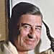](https://www.biography.com/people/dr-seuss-9479638)

[**BIOGRAPHY**](https://www.biography.com/people/dr-seuss-9479638)

## [Dr. Seuss](https://www.biography.com/people/dr-seuss-9479638)

[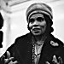](https://www.biography.com/news/marian-anderson-lincoln-memorial-concert)

[**HISTORY & CULTURE**](https://www.biography.com/news/section/history-and-culture)

## [Marian Anderson: A Voice That Broke Barriers](https://www.biography.com/news/marian-anderson-lincoln-memorial-concert)

* [**PEOPLE**](https://www.biography.com/people)
* [**NOSTALGIA**](https://www.biography.com/news/section/nostalgia)
* [**CELEBRITY**](https://www.biography.com/news/section/celebrity)
* [**HISTORY & CULTURE**](https://www.biography.com/news/section/history-and-culture)
* [**WOMEN'S HISTORY**](https://www.biography.com/tag/womens-history)
* [**CRIME & SCANDAL**](https://www.biography.com/news/section/crime-and-scandal)
* [**VIDEO**](https://www.biography.com/tag/video)
* [**HIP HOP**](https://www.biography.com/people/groups/hip-hop-rap)
* [**HOME**](https://www.biography.com/)

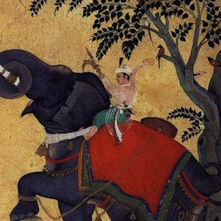

## QUICK FACTS

**NAME**

Akbar the Great

**OCCUPATION**

[Emperor](https://www.biography.com/people/groups/royalty-emperors-and-emperesses-male)

**BIRTH DATE**

[October 15](https://www.biography.com/people/groups/born-on-october-15), [1542](https://www.biography.com/people/groups/born-1542)

**DEATH DATE**

c. [October 27](https://www.biography.com/people/groups/died-on-october-27), [1605](https://www.biography.com/people/groups/died-1605)

**PLACE OF BIRTH**

[Umarkot, Sindh](https://www.biography.com/people/groups/birth-city-umarkot-sindh), [India](https://www.biography.com/people/groups/born-in-india)

**PLACE OF DEATH**

[Agra](https://www.biography.com/people/groups/death-city-agra), [India](https://www.biography.com/people/groups/died-in-india)

**AKA**

Akbar the Great

**FULL NAME**

Ab al-Fat Jall al-Dn Muammad Akbar

* [CITE THIS PAGE](https://www.biography.com/)

## IN THESE GROUPS

* [FAMOUS EMPERORS](https://www.biography.com/people/groups/royalty-emperors-and-emperesses-male)
* [FAMOUS PEOPLE WHO DIED IN INDIA](https://www.biography.com/people/groups/died-in-india)
* [FAMOUS GOVERNMENT](https://www.biography.com/people/groups/government)
* [FAMOUS PEOPLE BORN IN INDIA](https://www.biography.com/people/groups/born-in-india)

Show All Groups

# Akbar the Great Biography

Emperor(1542–c. 1605)

* **320**

**SHARES**

Akbar the Great, Muslim emperor of India, established a sprawling kingdom through military conquests, but is known for his policy of religious tolerance.

## Synopsis

Born on October 15, 1542 in Umarkot, India, and enthroned at age 14, Akbar the Great began his military conquests under the tutelage of a regent before claiming imperial power and expanding the Mughal Empire. Known as much for his inclusive leadership style as for his war mongering, Akbar ushered in an era of religious tolerance and appreciation for the arts. Akbar the Great died in 1605.

## Early Life

The conditions of Akbar's birth in Umarkot, Sindh, India on October 15, 1542, gave no indication that he would be a great leader. Though Akbar was a direct descendent of Ghengis Khan, and his grandfather Babur was the first emperor of the Mughal dynasty, his father, Humayun, had been driven from the throne by Sher Shah Suri. He was impoverished and in exile when Akbar was born.

Humayun managed to regain power in 1555, but ruled only a few months before he died, leaving Akbar to succeed him at just 14 years old. The kingdom Akbar inherited was little more than a collection of frail fiefs. Under the regency of Bairam Khan, however, Akbar achieved relative stability in the region. Most notably, Khan won control of northern India from the Afghans and successfully led the army against the Hindu king Hemu at the Second Battle of Panipat. In spite of this loyal service, when Akbar came of age in March of 1560, he dismissed Bairam Khan and took full control of the government.

## Expanding the Empire

Akbar was a cunning general, and he continued his military expansion throughout his reign. By the time he died, his empire extended to Afghanistan in the north, Sindh in the west, Bengal in the east, and the Godavari River in the south.Akbar’s success in creating his empire was as much a result of his ability to earn the loyalty of his conquered people as it was of his ability to conquer them. He allied himself with the defeated Rajput rulers, and rather than demanding a high “tribute tax” and leaving them to rule their territories unsupervised, he created a system of central government, integrating them into his administration. Akbar was known for rewarding talent, loyalty, and intellect, regardless of ethnic background or religious practice. In addition to compiling an able administration, this practice brought stability to his dynasty by establishing a base of loyalty to Akbar that was greater than that of any one religion.

Beyond military conciliation, he appealed to the Rajput people by ruling in a spirit of cooperation and tolerance. He did not force India’s majority Hindu population to convert to Islam; he accommodated them instead, abolishing the poll tax on non-Muslims, translating Hindu literature and participating in Hindu festivals.

Akbar also formed powerful matrimonial alliances. When he married Hindu princesses—including Jodha Bai, the eldest daughter of the house of Jaipur, as well princesses of Bikaner and Jaisalmer—their fathers and brothers became members of his court and were elevated to the same status as his Muslim fathers- and brothers-in-law. While marrying off the daughters of conquered Hindu leaders to Muslim royalty was not a new practice, it had always been viewed as a humiliation. By elevating the status of the princesses’ families, Akbar removed this stigma among all but the most orthodox Hindu sects.

## Administration

In 1574 Akbar revised his tax system, separating revenue collection from military administration. Each subah, or governor, was responsible for maintaining order in his region, while a separate tax collector collected property taxes and sent them to the capital. This created checks and balances in each region, since the individuals with the money had no troops, and the troops had no money, and all were dependent on the central government. The central government then doled out fixed salaries to both military and civilian personnel according to rank.

## Religion

Akbar was religiously curious. He regularly participated in the festivals of other faiths, and in 1575 in Fatehpur Sikri—a walled city that Akbar had designed in the Persian style—he built a temple (ibadat-khana) where he frequently hosted scholars from other religions, including Hindus, Zoroastrians, Christians, yogis, and Muslims of other sects. He allowed the Jesuits to construct a church at Agra, and discouraged the slaughter of cattle out of respect for Hindu custom. Not everyone appreciated these forays into multiculturalism, however, and many called him a heretic.

In 1579, a mazhar, or declaration, was issued that granted Akbar the authority to interpret religious law, superseding the authority of the mullahs. This became known as the “Infallibility Decree,” and it furthered Akbar’s ability to create an interreligious and multicultural state. In 1582 he established a new cult, the Din-i-Ilahi (“divine faith”), which combined elements of many religions, including Islam, Hinduism and Zoroastrianism. The faith centered around Akbar as a prophet or spiritual leader, but it did not procure many converts and died with Akbar.

## Patronage of the Arts

Unlike his father, Humayun, and grandfather Babur, Akbar was not a poet or diarist, and many have speculated that he was illiterate. Nonetheless, he appreciated the arts, culture and intellectual discourse, and cultivated them throughout the empire. Akbar is known for ushering in the Mughal style of architecture, which combined elements of Islamic, Persian and Hindu design, and sponsored some of the best and brightest minds of the era—including poets, musicians, artists, philosophers and engineers—in his courts at Delhi, Agra and Fatehpur Sikri.

Some of Akbar's more well-known courtiers are his navaratna, or "nine gems." They served to both advise and entertain Akbar, and included Abul Fazl, Akbar's biographer, who chronicled his reign in the three-volume book "Akbarnama"; Abul Faizi, a poet and scholar as well as Abul Fazl's brother; Miyan Tansen, a singer and musician; Raja Birbal, the court jester; Raja Todar Mal, Akbar's  minister of finance; Raja Man Singh, a celebrated lieutenant; Abdul Rahim Khan-I-Khana, a poet; and Fagir Aziao-Din and Mullah Do Piaza, who were both advisors.

## Death and Succession

Akbar died in 1605. Some sources say Akbar became fatally ill with dysentery, while others cite a possible poisoning, likely traced to Akbar's son Jahangir. Many favored Jahangir’s eldest son, Khusrau, to succeed Akbar as emperor, but Jahangir forcefully ascended days after Akbar's death.

## Fact Check

We strive for accuracy and fairness. If you see something that doesn't look right, [contact us](https://www.biography.com/page/contact-us)!

## Citation Information

### Article Title

Akbar the Great Biography

### Author

### Website Name

The Biography.com website

### URL

<https://www.biography.com/people/akbar-the-great-9178163>

### Access Date

{{$root.currentTime | date:'MMMM d, yyyy'}}

### Publisher

A&E Television Networks

### Last Updated

April 2, 2014

### Original Published Date

n/a

* **320**

**SHARES**

# BIO NEWSLETTER

Sign up to receive updates from BIO and A+E Networks.

Top of Form

SUBSCRIBE

Bottom of Form

# MORE STORIES FROM BIO

[[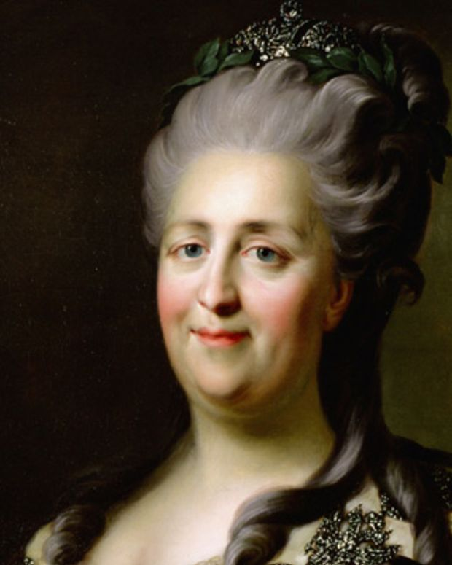](https://www.biography.com/people/catherine-ii-9241622)](https://www.biography.com/people/catherine-ii-9241622)

[**BIOGRAPHY**](https://www.biography.com/people/catherine-ii-9241622)

## [Catherine the Great](https://www.biography.com/people/catherine-ii-9241622)

* **EMPEROR**

**(1729–1796)**

[[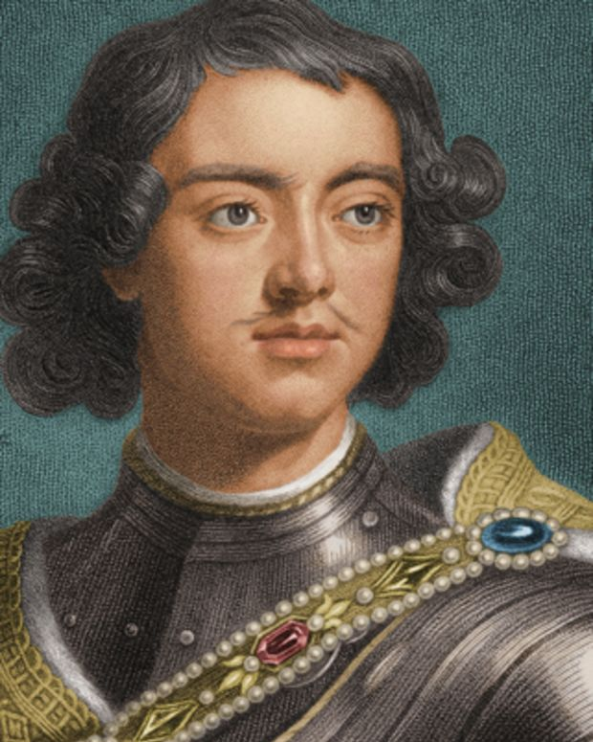](https://www.biography.com/people/peter-the-great-9542228)](https://www.biography.com/people/peter-the-great-9542228)

[**BIOGRAPHY**](https://www.biography.com/people/peter-the-great-9542228)

## [Peter the Great](https://www.biography.com/people/peter-the-great-9542228)

* **TSAR/TSARINA**

**(1672–1725)**

[[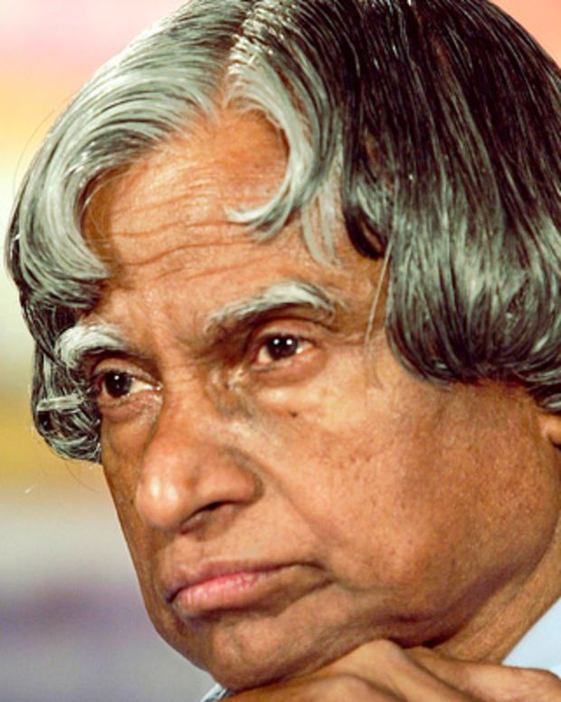](https://www.biography.com/people/apj-abdul-kalam-39325)](https://www.biography.com/people/apj-abdul-kalam-39325)

[**BIOGRAPHY**](https://www.biography.com/people/apj-abdul-kalam-39325)

## [A.P.J. Abdul Kalam](https://www.biography.com/people/apj-abdul-kalam-39325)

* **ENGINEER, SCIENTIST, PRESIDENT (NON-U.S.)**

**(1931–2015)**

* [About](https://www.biography.com/page/about)
* [Contact Us](https://www.biography.com/page/contact-us)
* [Advertise](http://www.saymedia.com/advertising)
* [Privacy](http://www.aenetworks.com/privacy)
* [Terms of Use](http://www.aenetworks.com/terms)
* [Copyright Policy](http://www.aenetworks.com/copyright)
* [Ad Choices](http://www.aenetworks.com/adchoices)

© 2018 Bio and the Bio logo are registered trademarks of A&E Television Networks, LLC.

**Abu'l-Fath Jalal-ud-din Muhammad Akbar**[[7]](https://en.wikipedia.org/wiki/Akbar#cite_note-Britannica-8) (15 October 1542[[a]](https://en.wikipedia.org/wiki/Akbar#cite_note-birth-4)– 27 October 1605[[10]](https://en.wikipedia.org/wiki/Akbar#cite_note-iranicaonline1-11)[[11]](https://en.wikipedia.org/wiki/Akbar#cite_note-12)), popularly known as **Akbar I**(IPA: [[əkbər]](https://en.wikipedia.org/wiki/Help:IPA/Hindi_and_Urdu), literally "the great")[[12]](https://en.wikipedia.org/wiki/Akbar#cite_note-time-13) was the third [Mughal emperor](https://en.wikipedia.org/wiki/Mughal_emperors), who reigned from 1556 to 1605. Akbar succeeded his father, [Humayun](https://en.wikipedia.org/wiki/Humayun" \o "Humayun), under a regent, [Bairam Khan](https://en.wikipedia.org/wiki/Bairam_Khan" \o "Bairam Khan), who helped the young emperor expand and consolidate Mughal domains in India. A strong personality and a successful general, Akbar gradually enlarged the Mughal Empire to include nearly all of the [Indian Subcontinent](https://en.wikipedia.org/wiki/Indian_Subcontinent) north of the [Godavari](https://en.wikipedia.org/wiki/Godavari) river. His power and influence, however, extended over the entire country because of Mughal military, political, cultural, and economic dominance. To unify the vast Mughal state, Akbar established a centralised system of administration throughout his empire and adopted a policy of conciliating conquered rulers through marriage and diplomacy. To preserve peace and order in a religiously and culturally diverse empire, he adopted policies that won him the support of his non-Muslim subjects. Eschewing tribal bonds and Islamic state identity, Akbar strove to unite far-flung lands of his realm through loyalty, expressed through an [Indo-Persian culture](https://en.wikipedia.org/wiki/Indo-Persian_culture), to himself as an emperor who had near-divine status.

Mughal India developed a strong and stable economy, leading to commercial expansion and greater patronage of culture. Akbar himself was a patron of art and culture. He was fond of literature, and created a library of over 24,000 volumes written in [Sanskrit](https://en.wikipedia.org/wiki/Sanskrit), [Urdu](https://en.wikipedia.org/wiki/Urdu), [Persian](https://en.wikipedia.org/wiki/Persian_language), [Greek](https://en.wikipedia.org/wiki/Greek_language), [Latin](https://en.wikipedia.org/wiki/Latin_language), [Arabic](https://en.wikipedia.org/wiki/Arabic_language) and [Kashmiri](https://en.wikipedia.org/wiki/Kashmiri_language), staffed by many scholars, translators, artists, [calligraphers](https://en.wikipedia.org/wiki/Calligraphers), scribes, bookbinders and readers. Akbar also established the library of Fatehpur Sikri exclusively for women,[[13]](https://en.wikipedia.org/wiki/Akbar" \l "cite_note-FOOTNOTEWiegandDavis1994271-14) and he decreed that schools for the education of both Muslims and Hindus should be established throughout the realm. Holy men of many faiths, poets, architects, and artisans adorned his court from all over the world for study and discussion. Akbar's courts at [Delhi](https://en.wikipedia.org/wiki/Delhi), [Agra](https://en.wikipedia.org/wiki/Agra), and [Fatehpur Sikri](https://en.wikipedia.org/wiki/Fatehpur_Sikri" \o "Fatehpur Sikri) became centres of the arts, letters, and learning. Perso-Islamic culture began to merge and blend with indigenous Indian elements, and a distinct Indo-Persian culture emerged characterized by Mughal style arts, [painting](https://en.wikipedia.org/wiki/Mughal_painting), and [architecture](https://en.wikipedia.org/wiki/Mughal_architecture). Disillusioned with orthodox Islam and perhaps hoping to bring about religious unity within his empire, Akbar promulgated [Din-i-Ilahi](https://en.wikipedia.org/wiki/Din-i-Ilahi), a syncretic creed derived mainly from [Islam](https://en.wikipedia.org/wiki/Islam" \o "Islam)and [Hinduism](https://en.wikipedia.org/wiki/Hinduism) as well as some parts of [Zoroastrianism](https://en.wikipedia.org/wiki/Zoroastrianism) and [Christianity](https://en.wikipedia.org/wiki/Christianity). A simple, monotheistic cult, tolerant in outlook, it centered on Akbar as a prophet, for which he drew the ire of the [ulema](https://en.wikipedia.org/wiki/Ulema" \o "Ulema) and orthodox Muslims. Many of his courtiers followed Din-i-Ilahi as their religion as well, as many believed that Akbar was a prophet. One famous courtier who followed this blended religion was [Birbal](https://en.wikipedia.org/wiki/Birbal" \o "Birbal).[*[citation needed](https://en.wikipedia.org/wiki/Wikipedia:Citation_needed" \o "Wikipedia:Citation needed)*]

Akbar's reign significantly influenced the course of Indian history. During his rule, the Mughal empire tripled in size and wealth. He created a powerful military system and instituted effective political and social reforms. By abolishing the [sectarian tax](https://en.wikipedia.org/wiki/Jizya) on non-Muslims and appointing them to high civil and military posts, he was the first Mughal ruler to win the trust and loyalty of the native subjects. He had [Sanskrit literature](https://en.wikipedia.org/wiki/Sanskrit_literature) translated, participated in native festivals, realising that a stable empire depended on the co-operation and good-will of his subjects. Thus, the foundations for a multicultural empire under Mughal rule were laid during his reign. Akbar was succeeded as emperor by his son, Prince Salim later known as Jahangir.

## History of Akbar the great

Akbar the Great was born on 14 October 1542, at the Rajput Fortress of Umerkot in Sindh. He was the son of Humayun and his wife Hamida Banu Begum. Akbar was born at a time when his parents were in exile.

Akbar spent his entire childhood learning how to fight and hunt. He had no interest in learning how to read and write. However, Akbar was the only Moghul Emperor who was illiterate and still had a penchant for knowledge.

Akbar was made king at the age of 13, after the death of his father. Akbar was with Bairam Khan at the time of his father’s passing and Bairam was made Regent, as Akbar was too young. On many occasions Bairam led campaigns on Akbar’s behalf to expand the kingdom.

Hemu, the Hindu minister of an Afghan Prince, Adil Shah, was waiting for a chance to defeat Akbar. Hemu attacked the kingdom of Delhi and emerged victorious, crowning himself ruler of Delhi.

## Second Battle of Panipat

Akbar launched a scathing attack in the Second Battle of Panipat. The two armies fought valiantly and it seemed as the Moghuls were fighting a losing battle until an arrow hit Hemu’s eye and he fainted. Hemu’s men thought that he was dead and put down their weapons, accepting defeat. Akbar became king again.

As Akbar grew older, he won many more battles and added more regions to his kingdom, stretching from the Indo-Ganges Basin to Kashmir and Afghanistan, all the way down to Bengal in the east and part of Deccan in the south.

### Religious policies of Akbar

Although Akbar was a young king, he was a shrewd and organised. He got rid of all his ministers who he felt were too ambitious and were looking to covet his position. He removed restrictions on religions and allowed his people to practice the religion of their choice, without having to fear for their life.

Akbar was fair to his people and abolished unfair taxes on non-Muslims. He also played an important role in bringing in social reforms such as the abolishment of child marriage, permission for widows to re-marry and the removal of bans to build [Hindu temples.](http://mocomi.com/golden-temple/)

Although illiterate, Akbar was surrounded by scholars such as Birbal, Abul Fazl and Tansen who were all part of the Nine Gems or Navaratnas. Akbar took keen interest in religion, music, painting, poetry and philosophy.

He had a huge collecting of books and manuscripts and was also the owner of a number of artworks from across the region. His biggest accomplishment however, lay in architecture. He built great structures like the Jama Masjid that stands tall even today. He even built a palace for his wife close to [the Hawa Mahal.](http://mocomi.com/hawa-mahal/)

Akbar fathered three sons, Jahangir, Murad and Daniyal. Jahangir was the only surviving son as the other two died very young. [Jahangir](http://mocomi.com/jahangir/) and Akbar did not share a very good relationship and were at constant logger-heads with each other.

### Death of the emperor Akbar

In 1605, Akbar fell very ill and died a slow death. He had managed to bring parts of East, West, North as well as South India under his rule. Akbar’s rule is greatly noted for the wealth of learning and culture that existed in his time. He was also admired for his bravery and wisdom.