Week 2: 1.2 Exercises: Charts

Shani Kumar

9/13/2020

## Week 2: 1.2 Exercises: Charts

You need to submit 3 bar charts, 3 stacked bar charts, 3 pie charts, and 3 donut charts using Tableau or PowerBI, Python and R using the data from the link below (the link will download a zipped folder containing three data files.) You may also use your own datasets if you wish. You can also submit using D3 if you choose – but it is not required. You can choose which library to use in Python or R, documentation is provided to help you decide and as you start to play around in the libraries, you will decide which you prefer.

**Data source** We are using dataset from [Data Source URL](https://content.bellevue.edu/cst/dsc/640/datasets/ex1-2.zip) file.

## Issue Approve Disapprove None  
## 1 Race Relations 52 38 10  
## 2 Education 49 40 11  
## 3 Terrorism 48 45 7  
## 4 Energy Policy 47 42 11  
## 5 Foreign Affairs 44 48 8  
## 6 Environment 43 51 6

### Data structure:

## 'data.frame': 13 obs. of 4 variables:  
## $ Issue : chr "Race Relations" "Education" "Terrorism" "Energy Policy" ...  
## $ Approve : num 52 49 48 47 44 43 41 41 40 38 ...  
## $ Disapprove: num 38 40 45 42 48 51 53 54 57 59 ...  
## $ None : num 10 11 7 11 8 6 6 5 3 3 ...

### Construct Charts:

**Bar Chart**

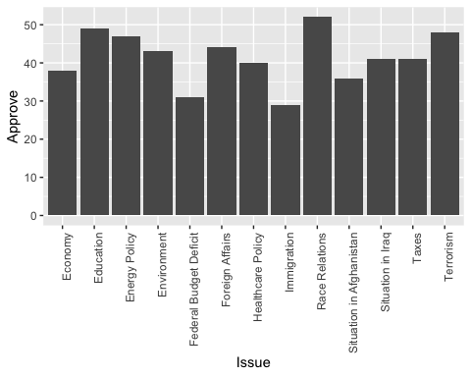

**Stacked Bar Chart**

Used melt to tranform dataset

## Using Issue as id variables

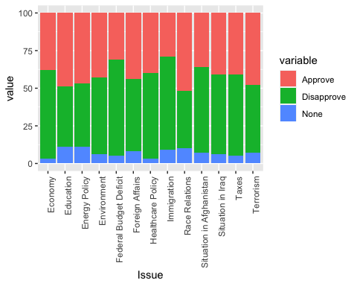

**Pie Chart : Issue Approve Rating**

To put the labels in the center of pies, I used cumsum(Approve) - 0.5*Approve as label position.

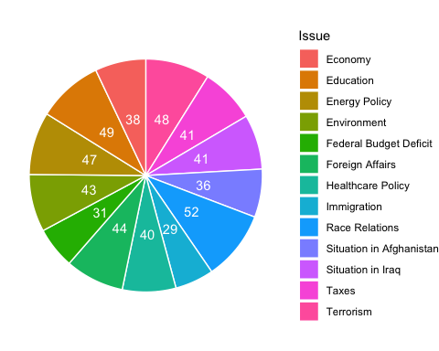

**Donut Chart : Issue Disapprove Rating**

To put the labels in the center of pies, I used cumsum(Disapprove) - 0.5*Disapprove as label position.

