Week 3-4: Exercises: Line Charts & Step Charts

Shani Kumar

## Week 3-4: Exercises: Charts

You need to submit 3 line charts and 3 step charts using Tableau or PowerBI, Python and R using the data below (or your own datasets). You can also submit using D3, though not required. You can choose which library to use in Python or R, documentation is provided to help you decide and as you start to play around in the libraries, you will decide which you prefer.

**Data source** We are using dataset from [Data Source URL](https://content.bellevue.edu/cst/dsc/640/datasets/ex2-2.zip) file.

## Year Population  
## 1 1960 3028654024  
## 2 1961 3068356747  
## 3 1962 3121963107  
## 4 1963 3187471383  
## 5 1964 3253112403  
## 6 1965 3320396924

### Data structure:

## 'data.frame': 50 obs. of 2 variables:  
## $ Year : num 1960 1961 1962 1963 1964 ...  
## $ Population: num 3.03e+09 3.07e+09 3.12e+09 3.19e+09 3.25e+09 ...

### Construct Charts:

**Line Chart**

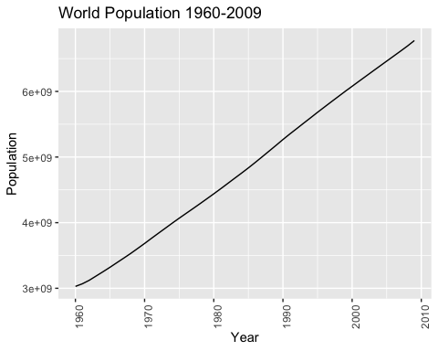

**Step Chart**

