Week 9-10: Prepare - Heat maps, Spatial charts, and Contour charts

Shani Kumar

## Exercises: Charts

You need to submit 3 heat maps, 3 spatial charts and 3 contour charts using Tableau or PowerBI, Python and R using the data below (or your own datasets). You can also use D3. You can choose which library to use in Python or R, documentation is provided to help you decide and as you start to play around in the libraries, you will decide which you prefer.

**Data source** We are using dataset from [Data Source URL](https://content.bellevue.edu/cst/dsc/640/datasets/ex5-2.zip) file.

## Address City State Zip.Code Latitude Longitude  
## 1 1205 N. Memorial Parkway Huntsville Alabama 35801-5930 34.74309 -86.60096  
## 2 3650 Galleria Circle Hoover Alabama 35244-2346 33.37765 -86.81242  
## 3 8251 Eastchase Parkway Montgomery Alabama 36117 32.36389 -86.15088  
## 4 5225 Commercial Boulevard Juneau Alaska 99801-7210 58.35920 -134.48300  
## 5 330 West Dimond Blvd Anchorage Alaska 99515-1950 61.14327 -149.88422  
## 6 4125 DeBarr Road Anchorage Alaska 99508-3115 61.21081 -149.80434

## Name G MIN PTS FGM FGA FGP FTM FTA FTP X3PM X3PA X3PP ORB  
## 1 Dwyane Wade 79 38.6 30.2 10.8 22.0 0.491 7.5 9.8 0.765 1.1 3.5 0.317 1.1  
## 2 LeBron James 81 37.7 28.4 9.7 19.9 0.489 7.3 9.4 0.780 1.6 4.7 0.344 1.3  
## 3 Kobe Bryant 82 36.2 26.8 9.8 20.9 0.467 5.9 6.9 0.856 1.4 4.1 0.351 1.1  
## 4 Dirk Nowitzki 81 37.7 25.9 9.6 20.0 0.479 6.0 6.7 0.890 0.8 2.1 0.359 1.1  
## 5 Danny Granger 67 36.2 25.8 8.5 19.1 0.447 6.0 6.9 0.878 2.7 6.7 0.404 0.7  
## 6 Kevin Durant 74 39.0 25.3 8.9 18.8 0.476 6.1 7.1 0.863 1.3 3.1 0.422 1.0  
## DRB TRB AST STL BLK TO PF  
## 1 3.9 5.0 7.5 2.2 1.3 3.4 2.3  
## 2 6.3 7.6 7.2 1.7 1.1 3.0 1.7  
## 3 4.1 5.2 4.9 1.5 0.5 2.6 2.3  
## 4 7.3 8.4 2.4 0.8 0.8 1.9 2.2  
## 5 4.4 5.1 2.7 1.0 1.4 2.5 3.1  
## 6 5.5 6.5 2.8 1.3 0.7 3.0 1.8

### Data structure:

## 'data.frame': 417 obs. of 6 variables:  
## $ Address : Factor w/ 416 levels "1 Industrial Lane",..: 49 255 387 316 243 276 269 268 341 124 ...  
## $ City : Factor w/ 369 levels "Albany","Albuquerque",..: 139 137 210 147 7 7 256 330 330 117 ...  
## $ State : Factor w/ 40 levels "Alabama","Alaska",..: 1 1 1 2 2 2 3 3 3 3 ...  
## $ Zip.Code : Factor w/ 415 levels "01089-4672","01923-1014",..: 115 114 116 415 414 413 239 238 237 235 ...  
## $ Latitude : num 34.7 33.4 32.4 58.4 61.1 ...  
## $ Longitude: num -86.6 -86.8 -86.2 -134.5 -149.9 ...

## 'data.frame': 50 obs. of 21 variables:  
## $ Name: Factor w/ 50 levels "Al Harrington ",..: 21 31 29 19 15 27 28 2 13 9 ...  
## $ G : int 79 81 82 81 67 74 51 50 78 66 ...  
## $ MIN : num 38.6 37.7 36.2 37.7 36.2 39 38.2 36.6 38.5 34.5 ...  
## $ PTS : num 30.2 28.4 26.8 25.9 25.8 25.3 24.6 23.1 22.8 22.8 ...  
## $ FGM : num 10.8 9.7 9.8 9.6 8.5 8.9 6.7 9.7 8.1 8.1 ...  
## $ FGA : num 22 19.9 20.9 20 19.1 18.8 15.9 19.5 16.1 18.3 ...  
## $ FGP : num 0.491 0.489 0.467 0.479 0.447 0.476 0.42 0.497 0.503 0.443 ...  
## $ FTM : num 7.5 7.3 5.9 6 6 6.1 9 3.7 5.8 5.6 ...  
## $ FTA : num 9.8 9.4 6.9 6.7 6.9 7.1 10.3 5 6.7 7.1 ...  
## $ FTP : num 0.765 0.78 0.856 0.89 0.878 0.863 0.867 0.738 0.868 0.793 ...  
## $ X3PM: num 1.1 1.6 1.4 0.8 2.7 1.3 2.3 0 0.8 1 ...  
## $ X3PA: num 3.5 4.7 4.1 2.1 6.7 3.1 5.4 0.1 2.3 2.6 ...  
## $ X3PP: num 0.317 0.344 0.351 0.359 0.404 0.422 0.415 0 0.364 0.371 ...  
## $ ORB : num 1.1 1.3 1.1 1.1 0.7 1 0.6 3.4 0.9 1.6 ...  
## $ DRB : num 3.9 6.3 4.1 7.3 4.4 5.5 3 7.5 4.7 5.2 ...  
## $ TRB : num 5 7.6 5.2 8.4 5.1 6.5 3.6 11 5.5 6.8 ...  
## $ AST : num 7.5 7.2 4.9 2.4 2.7 2.8 2.7 1.6 11 3.4 ...  
## $ STL : num 2.2 1.7 1.5 0.8 1 1.3 1.2 0.8 2.8 1.1 ...  
## $ BLK : num 1.3 1.1 0.5 0.8 1.4 0.7 0.2 1.7 0.1 0.4 ...  
## $ TO : num 3.4 3 2.6 1.9 2.5 3 2.9 1.8 3 3 ...  
## $ PF : num 2.3 1.7 2.3 2.2 3.1 1.8 2.3 2.8 2.7 3 ...

### Construct Charts:

**Heat Map**

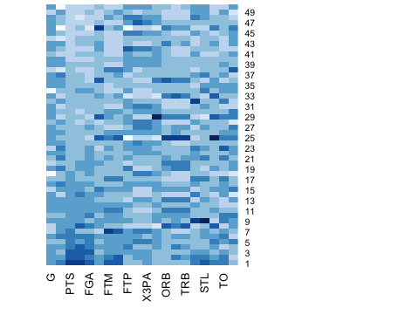

**Spatial Plot**

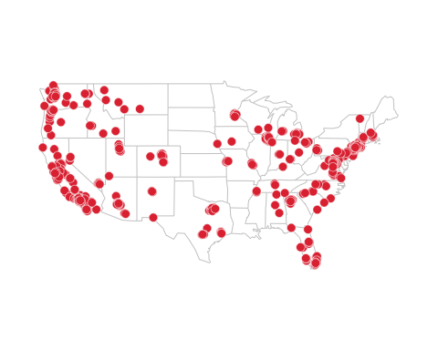

**Countour plot**

