Week 5-6: Prepare - Tree Map, Area Chart & Stacked Area Chart

Shani Kumar

## Week 5-6: Exercises: Charts

You need to submit 3 tree maps, 3 area charts and 3 stacked area charts using Tableau or PowerBI, Python and R using the data below (or your own datasets). You can also submit using D3. You can choose which library to use in Python or R, documentation is provided to help you decide and as you start to play around in the libraries, you will decide which you prefer.

**Data source** We are using dataset from [Data Source URL](https://content.bellevue.edu/cst/dsc/640/datasets/ex3-2.zip) file.

## year category expenditure sex  
## 1 2008 Food 6443 1  
## 2 2008 Alcoholic Beverages 444 1  
## 3 2008 Housing 17109 1  
## 4 2008 Apparel 1801 1  
## 5 2008 Transportation 8604 1  
## 6 2008 Healthcare 2976 1

## Series.id Year Period Value  
## 1 LNS14000000 1948 M01 3.4  
## 2 LNS14000000 1948 M02 3.8  
## 3 LNS14000000 1948 M03 4.0  
## 4 LNS14000000 1948 M04 3.9  
## 5 LNS14000000 1948 M05 3.5  
## 6 LNS14000000 1948 M06 3.6

### Data structure:

## 'data.frame': 350 obs. of 4 variables:  
## $ year : int 2008 2008 2008 2008 2008 2008 2008 2008 2008 2008 ...  
## $ category : Factor w/ 14 levels "Alcoholic Beverages",..: 6 1 8 2 14 7 5 10 12 4 ...  
## $ expenditure: int 6443 444 17109 1801 8604 2976 2835 616 116 1046 ...  
## $ sex : int 1 1 1 1 1 1 1 1 1 1 ...

## 'data.frame': 746 obs. of 4 variables:  
## $ Series.id: Factor w/ 1 level "LNS14000000": 1 1 1 1 1 1 1 1 1 1 ...  
## $ Year : int 1948 1948 1948 1948 1948 1948 1948 1948 1948 1948 ...  
## $ Period : Factor w/ 12 levels "M01","M02","M03",..: 1 2 3 4 5 6 7 8 9 10 ...  
## $ Value : num 3.4 3.8 4 3.9 3.5 3.6 3.6 3.9 3.8 3.7 ...

### Construct Charts:

**Treemap Chart**

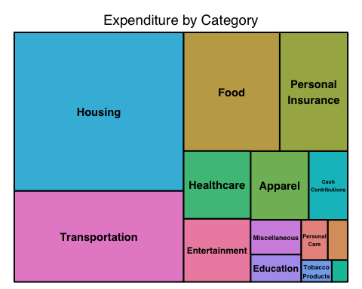

**Area Chart**

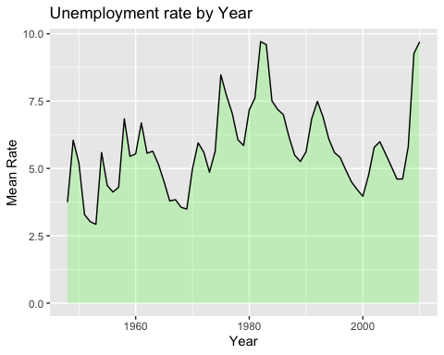

**Stacked Area Chart**

