Week 5-6: Prepare - Scatterplots, Bubble Charts, and Density Plots

Shani Kumar

## Week 5-6: Exercises: Charts

You need to submit 3 scatterplots, 3 bubble charts and 3 density plot charts using Tableau or PowerBI, Python and R using the data below (or your own datasets). You can also submit using D3. You can choose which library to use in Python or R, documentation is provided to help you decide and as you start to play around in the libraries, you will decide which you prefer.

**Data source** We are using dataset from [Data Source URL](https://content.bellevue.edu/cst/dsc/640/datasets/ex4-2.zip) file.

## state murder forcible_rape robbery aggravated_assault burglary  
## 1 Alabama 8.2 34.3 141.4 247.8 953.8  
## 2 Alaska 4.8 81.1 80.9 465.1 622.5  
## 3 Arizona 7.5 33.8 144.4 327.4 948.4  
## 4 Arkansas 6.7 42.9 91.1 386.8 1084.6  
## 5 California 6.9 26.0 176.1 317.3 693.3  
## 6 Colorado 3.7 43.4 84.6 264.7 744.8  
## larceny_theft motor_vehicle_theft population  
## 1 2650.0 288.3 4545049  
## 2 2599.1 391.0 669488  
## 3 2965.2 924.4 5974834  
## 4 2711.2 262.1 2776221  
## 5 1916.5 712.8 35795255  
## 6 2735.2 559.5 4660780

### Data structure:

## 'data.frame': 51 obs. of 9 variables:  
## $ state : Factor w/ 52 levels "Alabama","Alaska",..: 1 2 3 4 5 6 7 8 9 10 ...  
## $ murder : num 8.2 4.8 7.5 6.7 6.9 3.7 2.9 4.4 35.4 5 ...  
## $ forcible_rape : num 34.3 81.1 33.8 42.9 26 43.4 20 44.7 30.2 37.1 ...  
## $ robbery : num 141.4 80.9 144.4 91.1 176.1 ...  
## $ aggravated_assault : num 248 465 327 387 317 ...  
## $ burglary : num 954 622 948 1085 693 ...  
## $ larceny_theft : num 2650 2599 2965 2711 1916 ...  
## $ motor_vehicle_theft: num 288 391 924 262 713 ...  
## $ population : int 4545049 669488 5974834 2776221 35795255 4660780 3477416 839906 582049 17783868 ...

### Construct Charts:

**Scatterplot**

Plot: Motor Vehicle Theft Incidents vs Robbery Incidents 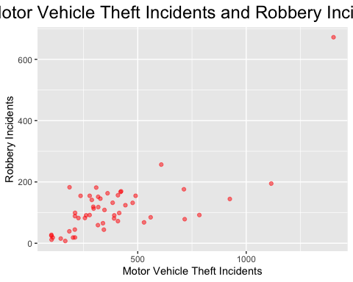

**Bubble Chart**

Plot: Motor Vehicle Theft Incidents vs Robbery Incidents (Bubble Size - Murder) 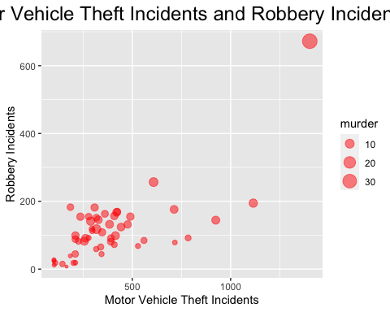

**Density Plot**

Density Plot: For Burglary Incidents 