AI Customer Intelligence Platform
Assignment Completion Report

1. Project Overview

The AI Customer Intelligence Platform is a lightweight, locally deployable customer analytics and AI system combining customer data analysis, churn prediction, explainable machine learning, customer-support text analysis, semantic search, RAG, a local small LLM, tool calling, and a Flask application.
- Data analysis and SQL analytics
- Customer churn prediction
- Explainable machine learning
- Customer-support text analysis
- Semantic search
- Retrieval-Augmented Generation (RAG)
- A small locally running Large Language Model (LLM)
- Tool-based AI workflows
- A lightweight Flask application

2. Technologies Used
- Python, Pandas and NumPy
- Matplotlib and Seaborn
- SQLite
- Scikit-learn and XGBoost
- SHAP
- NLTK and TF-IDF
- Sentence Transformers and FAISS
- PyTorch / Transformers
- Flask, HTML, CSS and JavaScript
- Git and GitHub
The project was implemented with CPU-first execution and local/open-source components.

Structured Customer Dataset
Used the IBM Telco Customer Churn dataset,Customer Support Ticket Dataset
The dataset contains customer demographics, subscribed services, account information, billing information and a Churn target. It contains approximately 7,043 customer records and 21 columns.
Dataset:
IBM Telco Customer Churn Dataset
This dataset used for:
- EDA
- SQL analytics
- Data preprocessing
- Feature engineering
- Churn prediction
- Model comparison
- Explainable AI
- Customer-level predictions
Customer Support Ticket Dataset
This dataset used for:
- Text preprocessing
- Text classification
- Sentiment analysis where applicable
- TF-IDF
- Embeddings
- Semantic search
- RAG demonstrations

3. Exploratory Data Analysis
Perform EDA on the structured customer dataset
Performed detailed EDA by analyzing dataset dimensions, columns, data types, missing values, duplicates, unique values, statistical summaries, churn distribution, customer demographics, services, contracts, payment methods, tenure, monthly charges, total charges, correlations, customer segments, and outliers.

3.1 SQL Customer Analytics
Loaded the processed customer data into SQLite and implemented SQL queries for total customers, churned customers, churn rate, churn by contract/payment/internet service, average charges, high-value customers, high-risk groups, long-tenure customers, service segments, and revenue-related analysis.

3.2 Data Preprocessing
Cleaned the customer dataset by handling missing values, converting incorrect data types, removing the customer identifier from ML features, encoding categorical variables, scaling numerical features, splitting the data into training and testing sets, and handling class imbalance.

3. 3 Feature Engineering
Created customer-level features including new-customer and long-term indicators, charge-to-tenure ratio, high monthly charge indicator, and high-value/high-risk indicators to improve churn analysis

Visualization

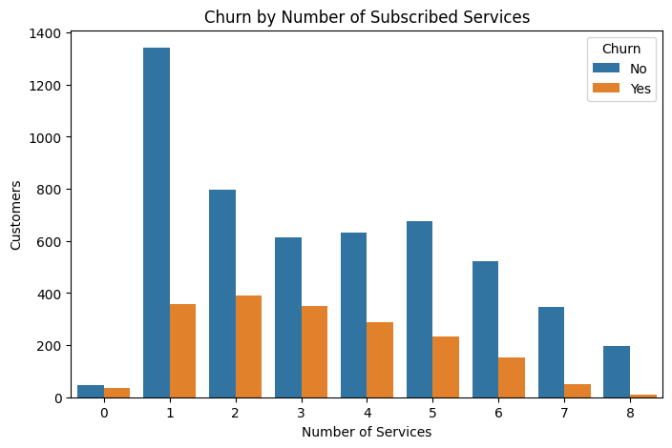
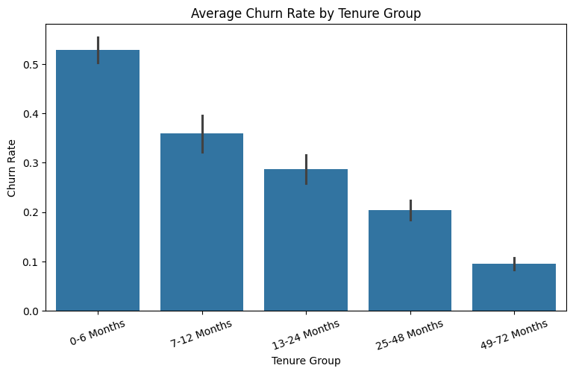
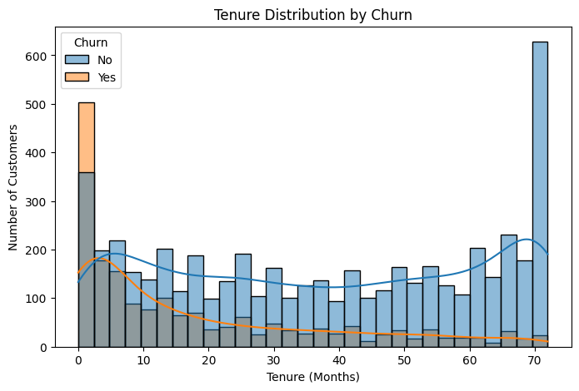

4. Machine Learning
Implemented and compared Logistic Regression, Decision Tree, KNN, Random Forest, Gradient Boosting and XGBoost. Evaluated Accuracy, Precision, Recall, F1-score, ROC-AUC and PR-AUC. Model improvement included class weighting, cross-validation, hyperparameter tuning and probability-threshold adjustment.
Implemented a complete customer churn machine-learning pipeline by preparing the preprocessed customer data, defining churn as the target variable, separating features and target, removing the customer ID identifier, applying numerical scaling and categorical encoding, creating stratified training and testing datasets, and developing baseline models including Logistic Regression, Decision Tree, and K-Nearest Neighbors.
Implemented ensemble models including Random Forest, Gradient Boosting, and XGBoost, and evaluated all models using Accuracy, Precision, Recall, F1-score, ROC-AUC, PR-AUC, and confusion matrices, with particular attention to churn Recall, Precision, and F1-score. Improved the Logistic Regression model using class weighting, Stratified K-Fold cross-validation, hyperparameter tuning with RandomizedSearchCV, and probability-threshold adjustment. Tested multiple classification thresholds from 0.30 to 0.70 and selected a threshold of 0.55 based on the highest F1-score. Saved the improved Logistic Regression model for customer-level churn prediction and integrated the model with the customer profile, SHAP explainability, knowledge-base retrieval, local LLM, and final Flask application.

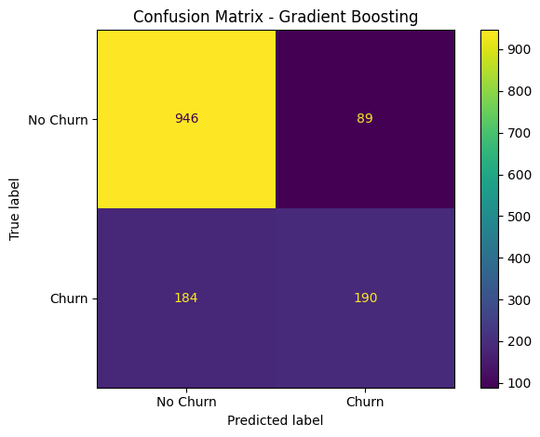

Evaluate the models using:
- Accuracy
- Precision
- Recall
- F1-score
- ROC-AUC
- PR-AUC
- Confusion matrix
Because churn prediction is a customer-retention problem, pay particular attention to:
- Recall for churned customers
- Precision
- F1-score
- ROC-AUC / PR-AUC
Select the best model based on both performance and computational efficiency.

 | Model Accuracy | Accuracy | Precision | Recall | F1 | -AUC | PR-AUC
0 | Logistic Regression | 0.748048 | 0.516295 | 0.804813 | 0.629049 | 0.847157 | 0.659388
1 | Random Forest | 0.772889 | 0.555785 | 0.719251 | 0.627040 | 0.843199 | 0.654105
2 | Decision Tree | 0.739532 | 0.505902 | 0.802139 | 0.620476 | 0.825699 | 0.613713
3 | XGBoost | 0.804826 | 0.670103 | 0.521390 | 0.586466 | 0.846138 | 0.655262
4 | Gradient Boosting | 0.806246 | 0.681004 | 0.508021 | 0.581930 | 0.845271 | 0.661632
5 | KNN | 0.765791 | 0.561798 | 0.534759 | 0.547945 | 0.798704 | 0.540624

5. Explainable AI
Implemented SHAP-based explainability using the tree-based model, providing:
- Global feature importance
- Individual customer explanations
- Positive churn contributors
- Negative churn contributors
- Feature contribution values

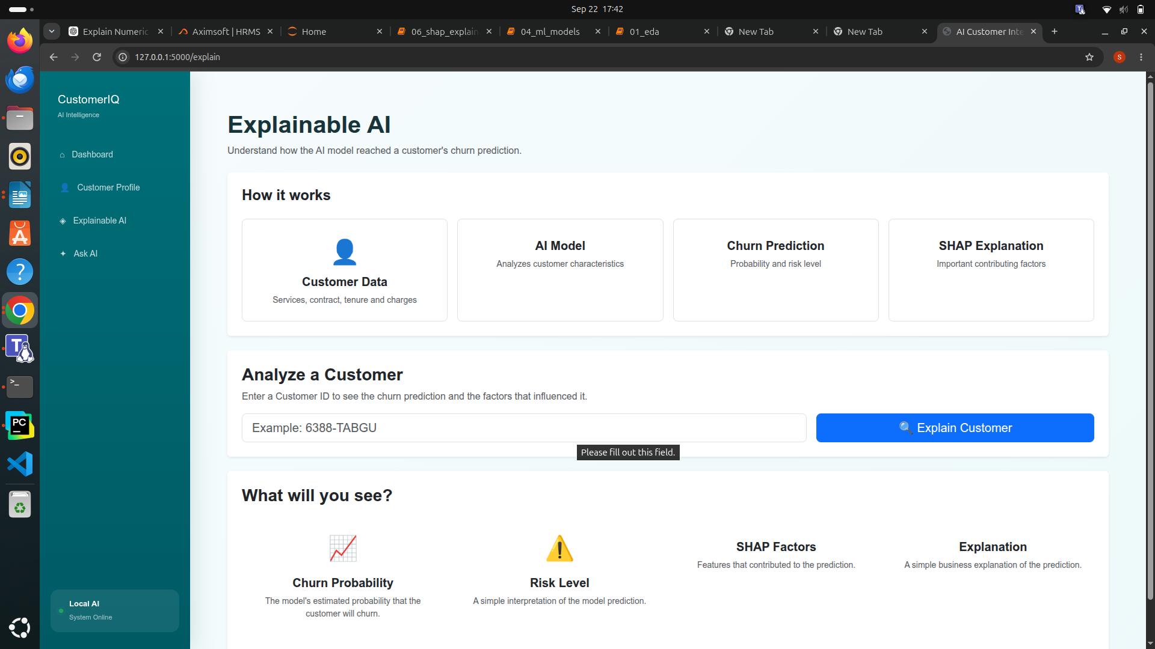

6. NLP, Embeddings and Semantic Search
Processed customer-support tickets using text cleaning, tokenization, stopword handling, word-frequency and n-gram analysis. Implemented TF-IDF classification, Sentence Transformer embeddings and local FAISS semantic search.
Used the customer-support text dataset for NLP.

- Text cleaning
- Lowercasing
- Removing unnecessary characters
- Tokenization
- Stop-word handling where appropriate
- Basic text statistics
- Word /term frequency analysis
- N-gram analysis
Converted text into numerical features using TF-IDF.
Built lightweight text-classification models such as:
- Logistic Regression
- Naive Bayes
Evaluated using appropriate classification metrics.
The goal is to establish a traditional NLP baseline before introducing embeddings and an LLM.

Text Embeddings

Generate semantic embeddings using a small sentence-transformer model.
A lightweight model such as:
all-MiniLM-L6-v2
can be used.
Embeddings should run locally on CPU.
Use embeddings to represent:
- Customer-support questions
- Support tickets
- Knowledge-base documents

7. RAG and Local LLM
Created a local knowledge base covering billing, contracts, cancellation, retention, FAQs and business rules. Implemented FAISS retrieval and a local LLM pipeline for grounded responses.
Implemented a Retrieval-Augmented Generation pipeline that retrieves relevant knowledge-base documents using FAISS and provides the retrieved context to the local LLM for grounded responses.

Integrated the locally running Qwen2.5-1.5B-Instruct model to understand user questions, combine verified information, generate explanations, summarize customer information, and produce grounded responses.
Created and compared different prompting strategies including basic, context-based, structured, customer-intelligence, and evidence-grounded prompts.
The LLM should be responsible for:
- Understanding user questions
- Combining verified information
- Generating explanations
- Summarizing customer information
- Producing grounded responses
The LLM should not calculate churn probability itself.
Create and compare simple prompt strategies.
Examples:

Basic instruction
Ask the model to answer the user’s question.

Context-based prompt
Provide retrieved documents as context.

Structured prompt
Provide:
- Customer information
- Churn probability
- Important SHAP features
- Retrieved knowledge
- User question

Evidence-grounded prompt
Require the model to base its answer only on the supplied information.
Evaluate prompts for:
- Correctness
- Relevance
- Consistency
- Groundedness
- Hallucination
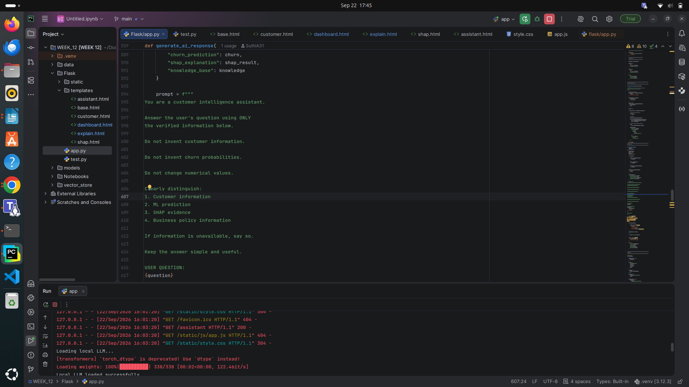

8. Tool Calling and Agent Workflow
Implemented the following local tools:
- get_customer_profile(customer_id)
- predict_churn(customer_id)
- get_shap_explanation(customer_id)
- search_knowledge_base(query)
Implemented a lightweight single-agent workflow that selects required tools, collects verified results and generates the final response.
Integrated SQLite customer information, ML churn prediction, SHAP explanations, knowledge-base retrieval, and the local LLM into a single customer intelligence workflow.
Implemented the required tools get_customer_profile(), predict_churn(), get_shap_explanation(), and search_knowledge_base() to provide verified information from the underlying systems.
Implemented a lightweight single-agent workflow that understands the user question, determines the required information, calls the appropriate tools, collects verified results, and generates the final response using the local LLM.

Customer ID / User Question
↓
SQLite
↓
Customer Profile
↓
ML Churn Model
↓
Churn Probability
↓
SHAP
↓
Important Risk Factors
↓
RAG Search
↓
Relevant Business Knowledge
↓
Local LLM
↓
Final Customer Explanation
The LLM combines verified information from SQL, ML, SHAP and RAG.
It should not invent customer information or calculate model predictions.

9. GenAI Evaluation
Completed evaluation using representative customer and knowledge-base questions, covering correctness, relevance, groundedness, evidence usage, consistency, hallucination and response time.
Questions would be covered:
- Customer lookup
- Churn explanation
- Risk-factor explanation
- Policy questions
- Knowledge-base questions
- Combined customer + policy questions

10. Resource Benchmarking
Completed benchmarking for:
- Model loading
- ML inference
- Embedding generation
- FAISS search
- RAG retrieval
- LLM inference
- End-to-end response
- Approximate RAM usage

11. Flask Application
The final Flask application includes:
- Dashboard: customer and churn analytics
- Customer Profile: customer information, services, contract, tenure and charges
- SHAP Explainable AI: churn probability and important risk factors
- Ask AI: natural-language customer intelligence assistant
The application integrates the SQL, ML, SHAP, RAG and LLM components developed during the project.
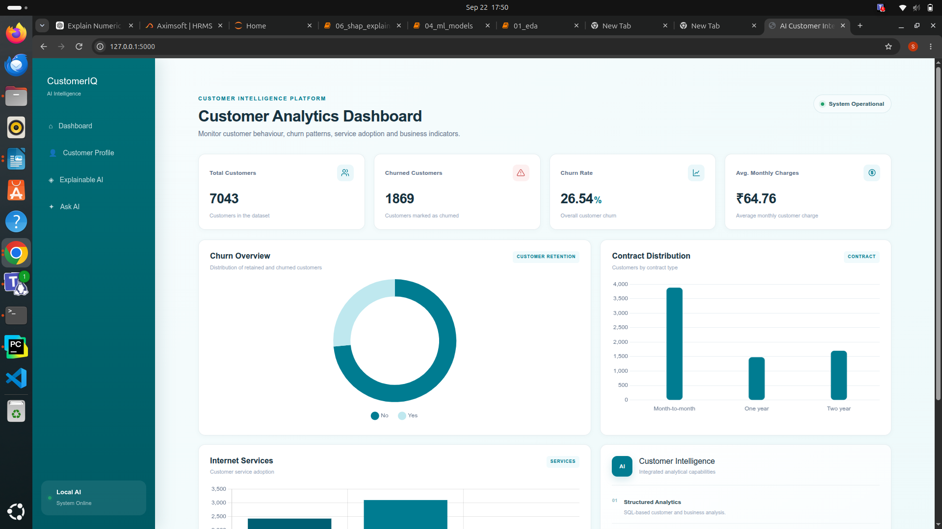

12. Conclusion

All major development stages, AI components, evaluation, benchmarking and Flask integration have been completed. The project is ready for GitHub submission, documentation review and assessment demonstration.

