Electricity Demand Forecasting using Deep Learning
Project Documentation
Deep Learning Time-Series Forecasting
Python | Pandas | NumPy | TensorFlow/Keras | Scikit-learn | Flask | Bootstrap

Objective: Develop an end-to-end electricity demand forecasting system using historical electricity consumption and deep learning models.

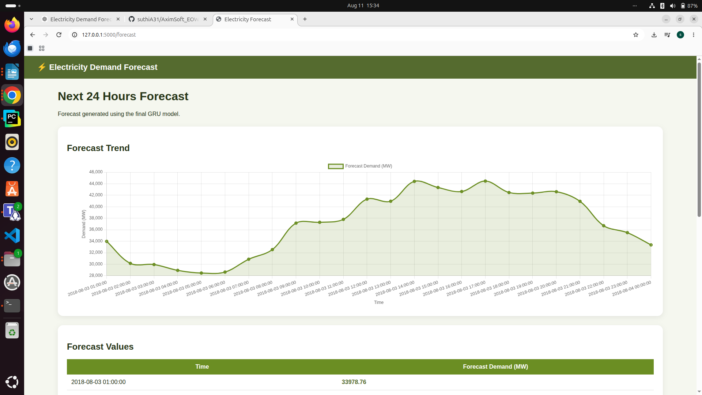

1. Project Overview and Data Understanding
The objective of this project is to build an end-to-end electricity demand forecasting system. The workflow begins with understanding the time-series data and continues through preprocessing, exploratory data analysis, feature engineering, deep learning, validation, evaluation, and dashboard development.

Phase 1 - Data Understanding
The first phase focuses on understanding the structure and behavior of the electricity demand data. The timestamp column is converted to datetime format, records are sorted chronologically, and the time interval between observations is checked.
- Analyze timestamps and hourly time intervals.
- Check missing and duplicate records.
- Analyze long-term electricity demand trends.
- Identify daily, weekly, monthly, and annual patterns.
- Identify abnormal or unusually high demand periods.

Phase 2 - Time-Series Preprocessing
The preprocessing phase prepares the raw time-series for machine learning. The data is sorted chronologically and missing timestamps or missing demand values are checked before modelling.
- Chronologically sort the data.
- Check and handle missing timestamps.
- Handle missing demand values.
- Detect and treat abnormal values where appropriate.
- Create time-based features such as hour, day, week, month, and day of week.
- Create lag and rolling statistical features.
Rolling features capture recent demand behavior. A 24-hour rolling mean represents the recent daily demand level, while a 168-hour rolling mean represents the recent weekly demand level. The shift(1) operation is applied before rolling calculations to prevent target leakage by excluding the current demand value.

Phase 3 - Exploratory Data Analysis
EDA is used to understand demand patterns before model development. Hourly profiles, weekly seasonality, rolling statistics, demand distributions, and autocorrelation can reveal important time-series relationships.
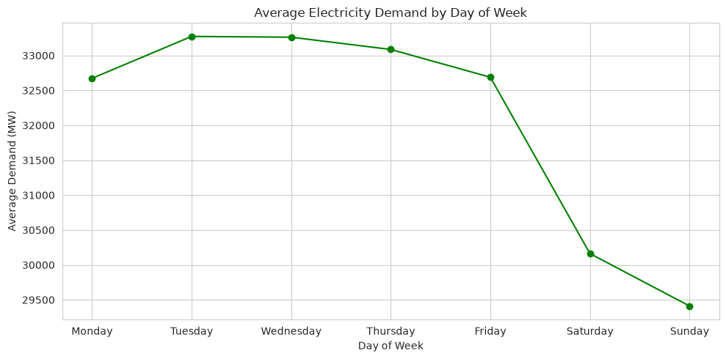
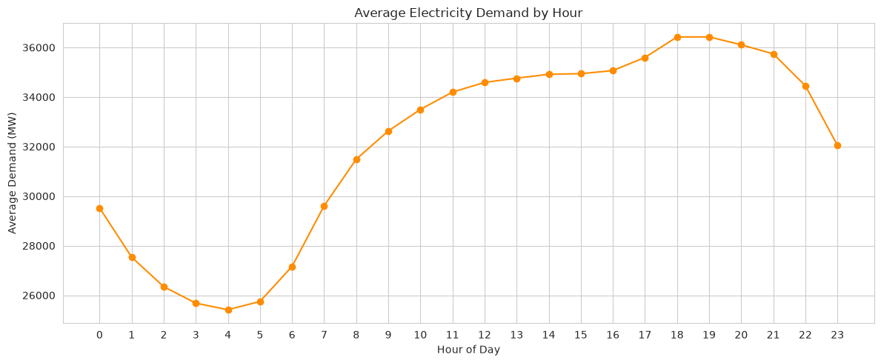
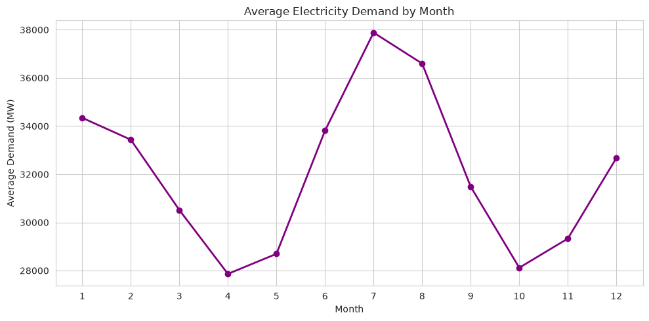

2. Baseline and Deep Learning Models

Phase 4 - Baseline Forecasting Models
Before applying deep learning, simple forecasting methods are created as baseline models. These provide a reference point for determining whether the deep learning models provide meaningful improvement.
Baseline | Description
Naive Forecast | Uses the most recent observed demand as the forecast.
Moving Average | Uses the average of recent demand observations.
Previous-Day | Uses demand from the corresponding previous day.
Previous-Week | Uses demand from the corresponding previous week.

Phase 5 - Deep Learning Models
The deep learning phase uses historical sequences to predict future electricity demand. For example, the model can use the previous 24, 48, or 168 hours to predict the next 24 hours.

Sequence Creation
A sliding-window approach is used to create training samples. For a sequence length of 24 and a forecast horizon of 24, each X sample contains 24 historical hourly observations and the corresponding y sample contains the next 24 hours.
Example: Previous 24 hours → Next 24 hours.

Models Developed
- Simple RNN - learns sequential relationships using recurrent hidden states.
- LSTM - uses gates and memory cells to retain useful long-term information.
- GRU - uses a simpler gated recurrent architecture with fewer gates than LSTM.
- Bidirectional LSTM - processes the sequence in both directions within each input sequence.
The common architecture used in the experiments contains a recurrent layer with 64 units followed by a Dense layer with 24 outputs. The 24 outputs represent the 24-hour forecasting horizon.
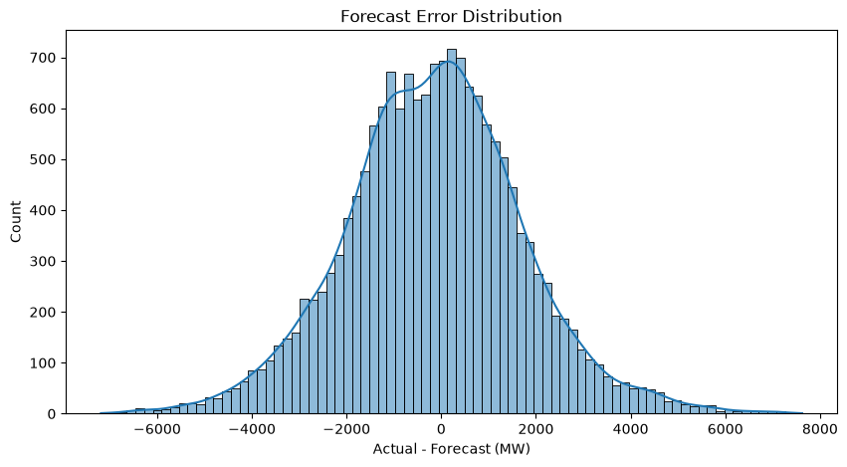
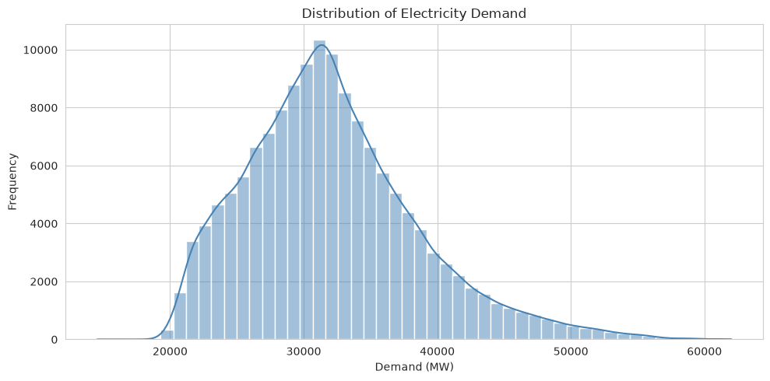

3. Model Improvement, Validation and Evaluation

Phase 6 - Model Improvement
After establishing baseline deep learning models, additional experiments are performed to improve forecasting performance.
- Compare different sequence lengths such as 24, 48, and 168 hours.
- Add lag features and rolling statistical features.
- Scale input features using an appropriate scaler.
- Experiment with dropout and batch normalization.
- Compare optimizers such as Adam and RMSprop.
- Use learning-rate scheduling.
- Use early stopping when appropriate.
- Tune batch size, number of layers, and number of neurons.
- Perform hyperparameter tuning where required.
ReduceLROnPlateau can be used to monitor validation loss and reduce the learning rate when validation performance stops improving. For example, a factor of 0.5 reduces the current learning rate by half after a specified patience period.

Phase 7 - Forecast Validation
The data is split strictly in chronological order to avoid future information leaking into the past. The final 20 percent is reserved as the test period, while a recent 30-day validation period is separated from the training data.
Dataset | Purpose
Training | Historical data used for model learning.
Validation | Recent unseen period used during model development.
Test | Final unseen period used for final evaluation.
For a 30-day validation period, 30 × 24 = 720 hourly observations are evaluated. Actual and predicted demand are compared using forecasting metrics and visualizations.

Peak Demand Error
Peak-demand MAE is calculated separately using the 90th percentile of actual demand as the peak threshold. This identifies the top 10 percent of demand periods and measures how accurately the model forecasts those important high-demand periods.

Peak 30-day validation period
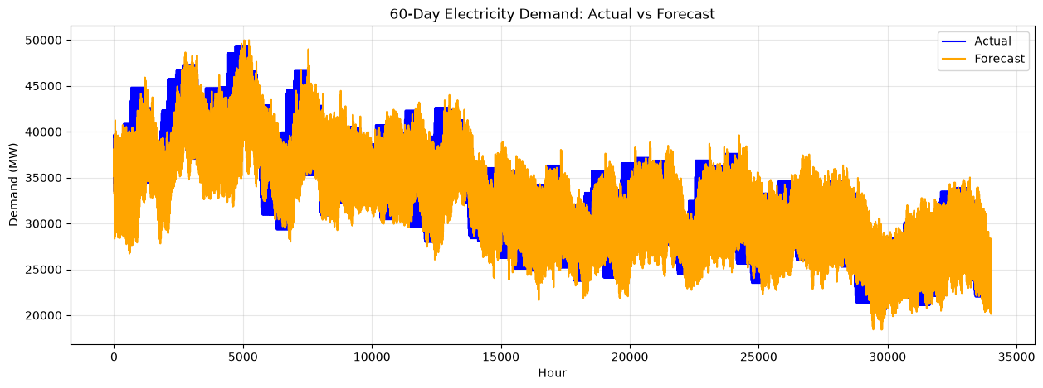

Peak 60-day validation period

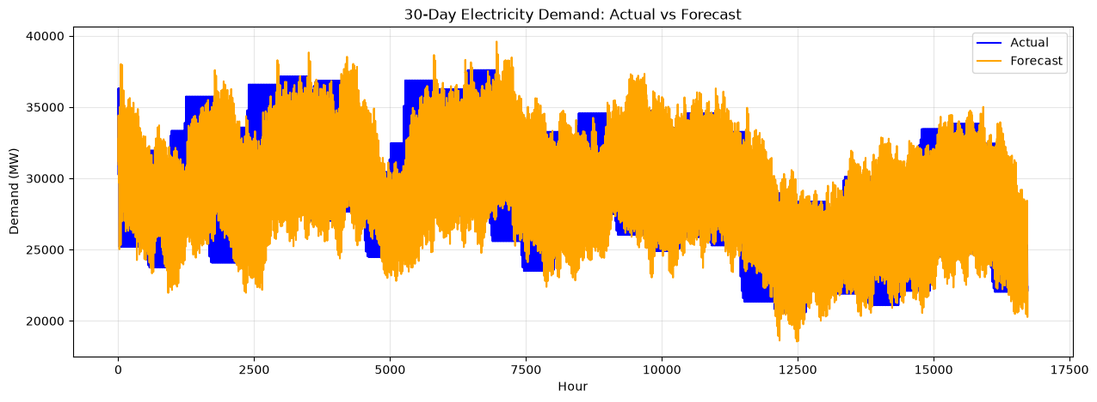

Phase 8 - Model Evaluation
The models are evaluated using MAE, MSE, RMSE, MAPE, R², and forecast bias. Lower MAE, RMSE, and MAPE are preferred, while higher R² is preferred. Bias indicates whether the model systematically overpredicts or underpredicts demand.
Metric | Purpose
MAE | Average absolute forecasting error.
MSE | Average squared forecasting error.
RMSE | Square root of MSE; emphasizes larger errors.
MAPE | Average percentage forecasting error.
R² | Measures explained variation.
Bias | Shows systematic overprediction or underprediction.

Metric | Purpose
MAE | 1344.752508
MSE | 3577180.991042
RMSE | 1891.3437
MAPE | 4.282023
R² | 0.915016
Bias | 218.576061

4. Dashboard, GitHub Integration and Final Outcome

Phase 9 - Forecasting Dashboard
The final system is deployed as an interactive Flask dashboard using Bootstrap for the user interface. The dashboard provides a practical interface for viewing historical demand, generating forecasts, checking model performance, and analyzing forecast errors.

Dashboard Components
- Dashboard home page with latest/current demand.
- Historical electricity consumption visualization.
- Forecast summary and future demand values.
- Model performance comparison.
- Actual versus forecast visualization.
- Daily, weekly, and monthly trend analysis.
- Peak-demand analysis.
- Forecast error analysis.
- 30-day and 60-day validation views.

Git and GitHub Integration
The project is maintained using Git and GitHub. Separate branches can be used for preprocessing, modelling, dashboard development, and improvements. Meaningful commits are used to track development progress.
- Maintain a clear project repository structure.
- Use meaningful commit messages.
- Maintain requirements.txt.
- Maintain .gitignore.
- Document model experiments and results.
- Provide README documentation and project architecture.

Final Model Selection
The final model should be selected based on validation performance first and then confirmed using the unseen test period. The model with lower forecasting error and strong generalization should be preferred rather than selecting a model only from training performance.

Final Conclusion
This project demonstrates a complete end-to-end electricity demand forecasting workflow. The process starts with time-series data understanding and preprocessing, continues through exploratory analysis and feature engineering, and then applies baseline and recurrent deep learning models.
RNN, LSTM, GRU, and Bidirectional LSTM models are compared using multiple forecasting metrics. Model improvement experiments investigate sequence length, rolling features, scaling, optimization, learning-rate scheduling, regularization, and hyperparameter tuning.
Chronological validation is used to ensure that future information does not leak into the training process. Finally, the selected model can be integrated into a Flask and Bootstrap dashboard to provide an interactive forecasting system.

Project Technology Stack
Technology | Purpose
Python | Project implementation
Pandas / NumPy | Data processing
Scikit-learn | Scaling and evaluation
TensorFlow / Keras | Deep learning models
Matplotlib / Seaborn | Visualization
Flask | Backend web application
Bootstrap | Dashboard interface
Git / GitHub | Version control

