Auto suggest search form

Description

Through the search bar provided on the Home and Lesson page, the user will search for courses or videos related to what they desire to learn, which for example might be “JavaScript”. As the user types in the letter “j”, it automatically filters through and suggests with pre-existing data, for courses and videos starting or relatable to the letter “j”, then progressing further if the user adds the letter “a” for the input text to read “ja” should be enough for the search bar to display JavaScript which saves the user spelling the entire word. Once the key word is selected and submitted a new page will open and provide the user with courses that have been filtered to be relatable to the subject of JavaScript.

Pseudo code

1. user enters website
2. clicks on search form input field
3. types text in input field
4. drop down menu appears
5. auto suggestions appear relating to typed text in drop down menu
6. does required suggestion appear -> yes -> continue

else -> go to step 3

1. select keyword by clicking keyword
2. click submit button
3. new page opens
4. pre-filtered information courses/videos
5. is wanted course/video present -> yes -> continue   
   else -> select category field of course/video   
   new page opens

manually scroll through video/courses

find closest match

1. select required video/course
2. follow video instructions provided on watching course/video for learning

Flow chart  
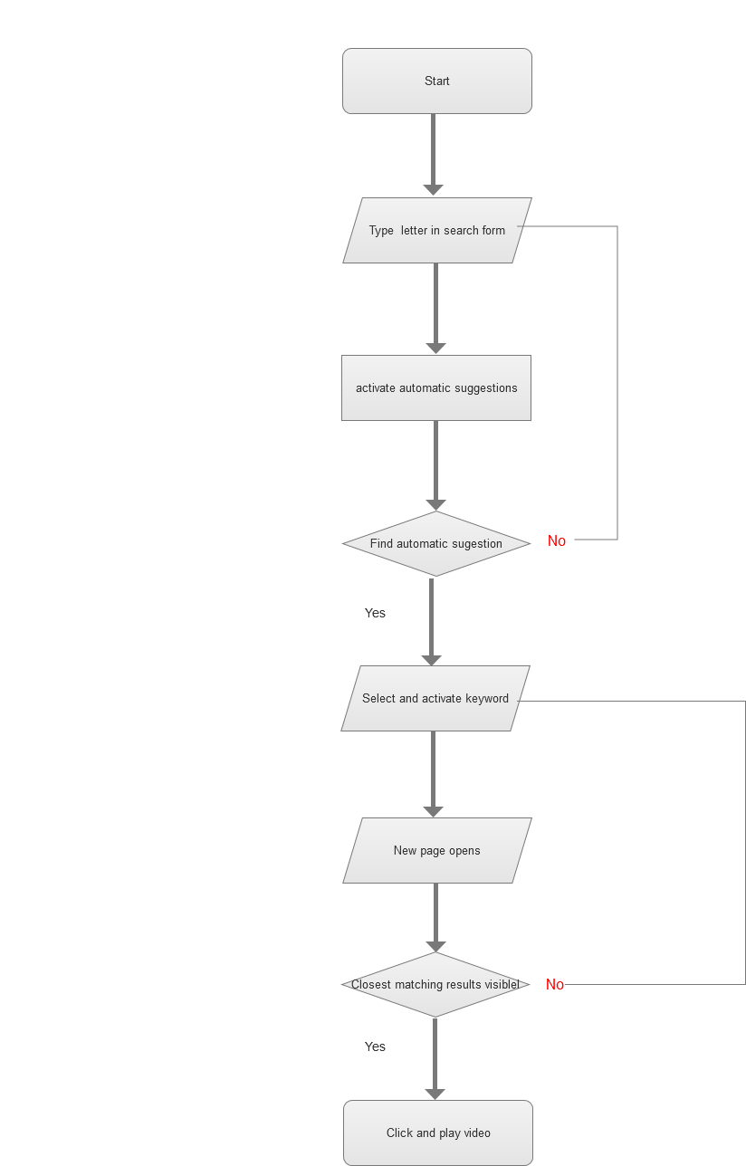

Form validation

Description

For the contact form on the contact page there needs to be a form validation for before it is to be submitted, if there is missing information within the form including your name, email and the message itself, it will be denied before submitting rather a message will appear in above the submit button with “please enter your missing information” which will indicate to fill out all of the requirements. Along with this validation the user will be directed to where the missing information on the form, for example if the user didn’t enter their email address the cursor will appear in that input field and become highlighted so the user is aware that they missed that section of information that is required.

Pseudo code

1. user enters contact page
2. clicks on input field for “name”
3. types text to match their given name
4. clicks on “Your E-mail” input field to match their email address
5. if “@” symbol present -> yes -> continue

else -> text appears in “Your E-mail” input field “enter correct email”

go to step 4

1. clicks on “Your message” input field
2. enters text for reason for enquiry
3. click on submit button
4. if “Your message” input field contains text->yes -> continue

else -> alert will appear “enter text in message field”  
go to step 4

1. new page opens
2. new page contains information of message successfully sent

Flow chart

