Data base project

Zoo

Suto Mara Bianca

Introduction

Zoos play a critical role in wildlife conservation, education, and entertainment. However, managing a zoo is not only about taking care of animals and creating engaging exhibits; it also involves handling significant economic and operational challenges. These challenges include monitoring costs, managing revenues, optimizing visitor experiences, and ensuring the efficient allocation of resources. To address these complexities, the Zoo Management Database System has been designed as a comprehensive solution to streamline data management and support decision-making processes.

The database is designed to collect and manage important information about zoo activities. It keeps track of costs like animal care, staff salaries, and exhibit maintenance, as well as revenue from ticket sales and merchandise. By comparing costs and revenue, the system can help calculate profits and identify areas to save money. It also records visitor data, which can be used to understand trends like how many people visit each month or how much they spend on tickets.

In addition to financial data, the database stores details about the animals, exhibits, employees, and departments. For example, it helps ensure that each exhibit has the right animals and that the staff are assigned to the right roles. By linking all this information together, the database provides a complete view of the zoo’s operations.

This system is useful for both daily tasks and long-term planning. It helps zoo managers make better decisions by showing clear and accurate information about costs, revenue, and resources. With this project, the zoo can run more efficiently and focus on what matters most caring for animals and providing visitors with an enjoyable experience.

The data base schema

* Animals(#animal_id, name, habitat_id, kg_food_consumed, species_id)
* Customers(#customer_id, first_name, last_name, age, email)
* Diets(#diet_id, diet_name, price_per_kg)
* Employees(#employee_id, first_name, last_name, salary, manager_id)
* Habitat_plans(habitat_id, employee_id, plan_date)
* Habitats(#habitat_id, maintenence_cost)
* Species(#species_id, name, diet_id, og_country)
* Tickets(habitat_id, customer_id, visitation_date)

Constructing the database(including DDL and DML statements)

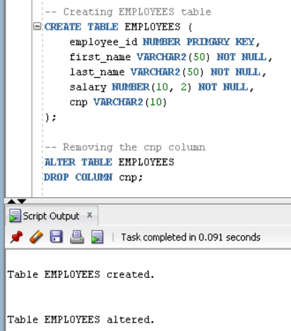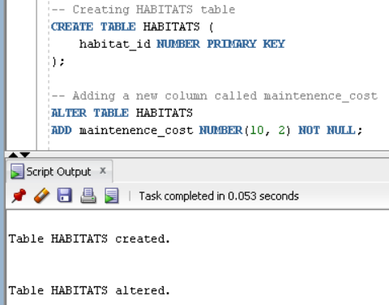

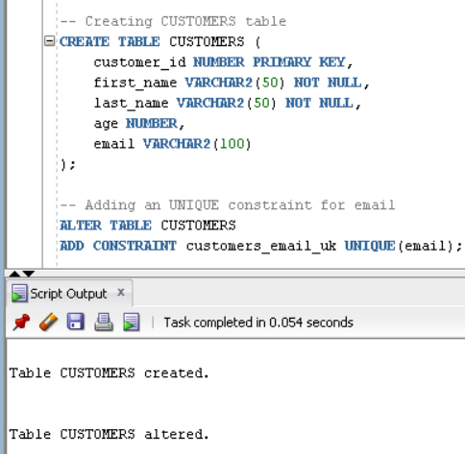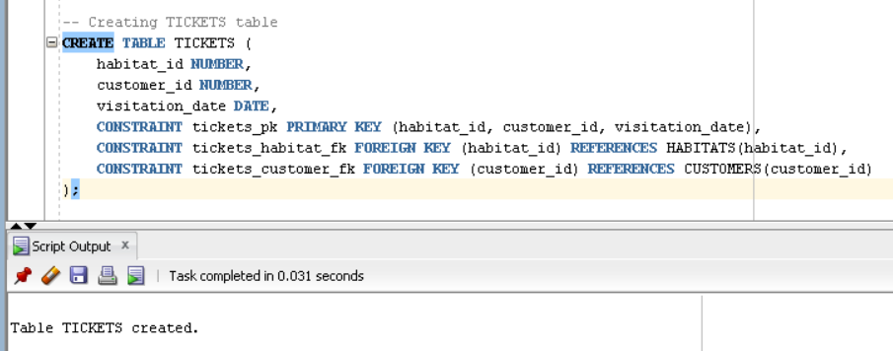

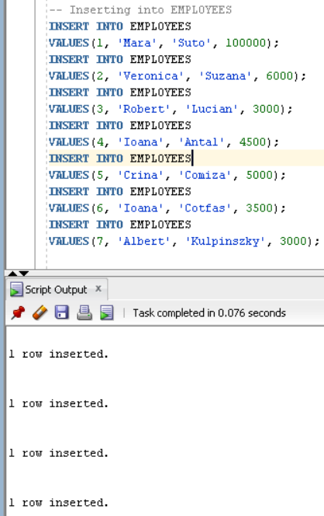

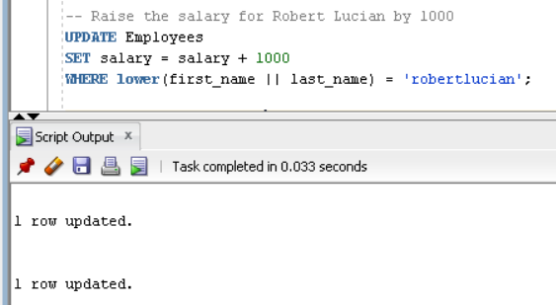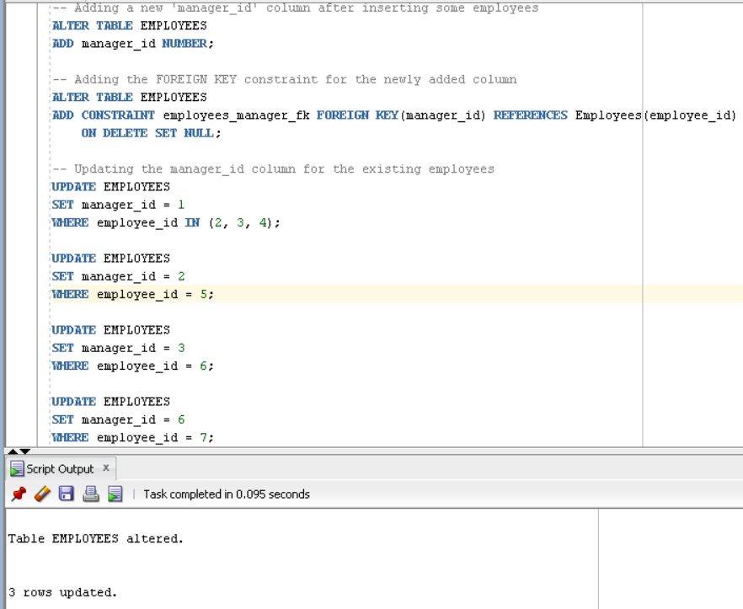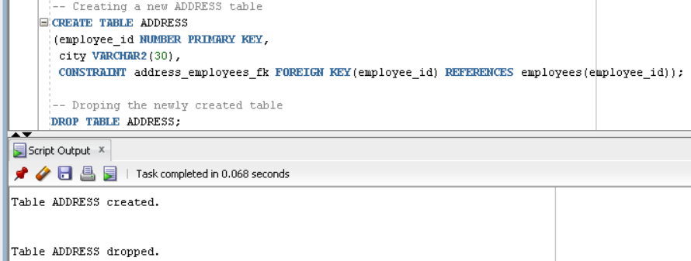

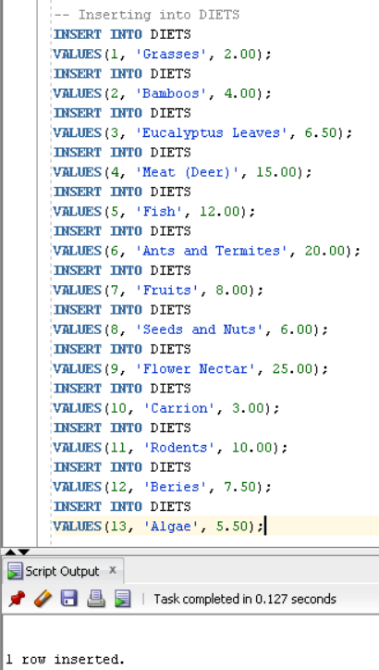

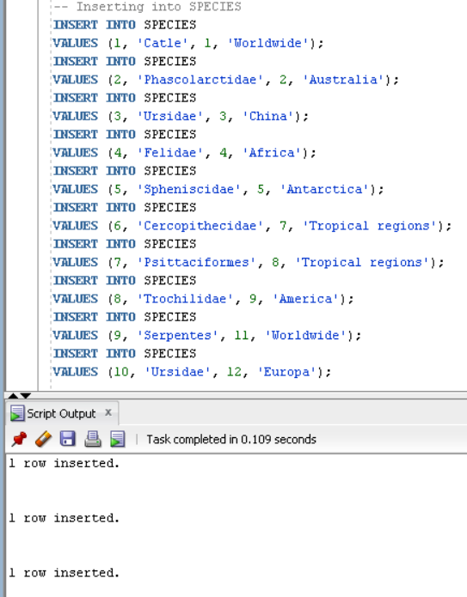

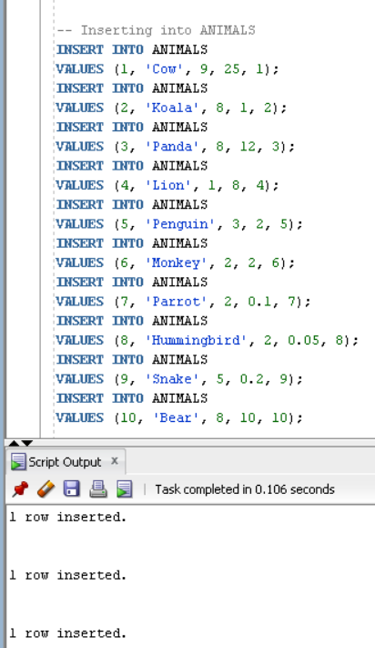

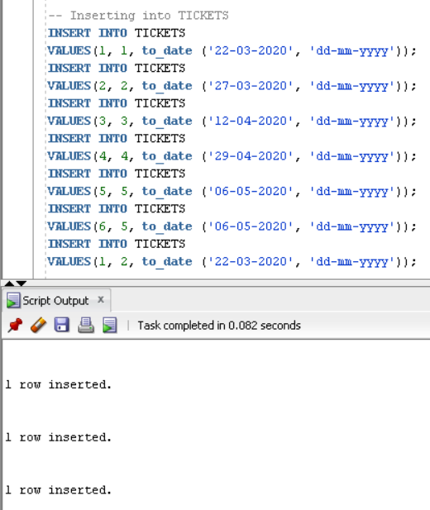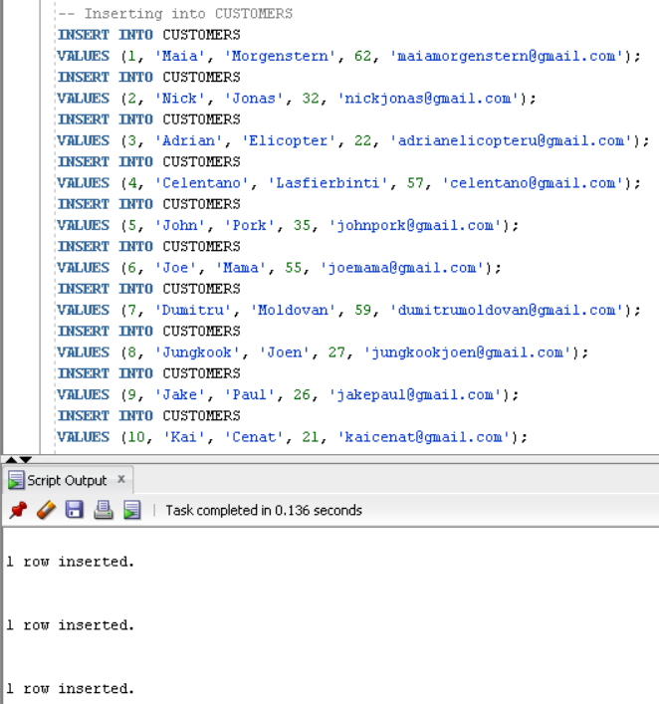

Here we have our diverse and relevant SELECT statements for the project theme(including the obtained results)



