Stock Market Time Series
Feature Descriptions and SQL Queries
Project Introduction Document
Team Members | Johnathan Nguyen (DB Owner), Chase Wasalaski
Project Name | Stock Market Time Series
Database Owner | Johnathan Nguyen
Document Scope | Feature descriptions and application SQL queries for the implemented database features.
Features and Queries
Each feature below is available from the application's Feature dropdown. The SQL shown in each section is the exact query used by the app.
1. Stocks in a category
What it does: You type a category name, such as an industry or sector label from the dataset. The app lists every stock tied to that category, including ticker, company name, exchange, and category details. This is useful for seeing everything grouped under one label.
SQL Query
SELECT s.symbol_id, s.ticker, s.name, s.exchange, c.category_name, c.category_type
FROM symbol s
JOIN symbol_category sc ON s.symbol_id = sc.symbol_id
JOIN category c ON sc.category_id = c.category_id
WHERE UPPER(c.category_name) = UPPER(:category_name)
ORDER BY s.ticker
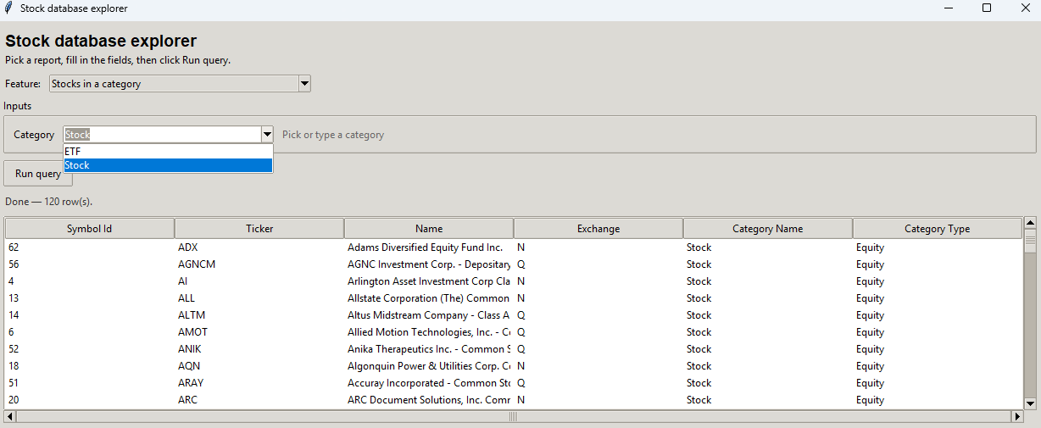

2. Stocks by country (optional exchange)
What it does: You enter a country. You can also enter an exchange to narrow the list, or leave the exchange blank to include all exchanges. The app returns matching stocks along with currency and description information from the profile table.
SQL Query
SELECT s.ticker, s.name, s.exchange, p.country, p.currency, p.description
FROM symbol s
JOIN symbol_profile p ON s.symbol_id = p.symbol_id
WHERE UPPER(p.country) = UPPER(:country)
AND (:exchange IS NULL OR UPPER(s.exchange) = UPPER(:exchange))
ORDER BY s.ticker
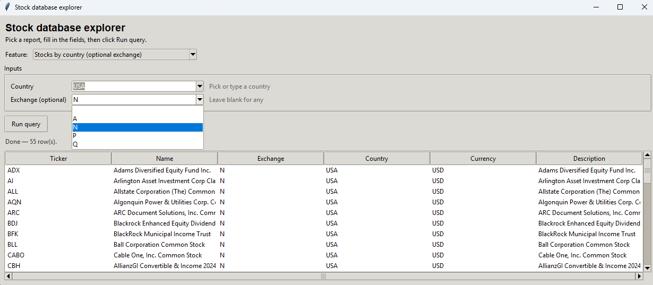

3. Days with a wide high-low range
What it does: You choose a start date, an end date, and a minimum swing size. The swing is calculated as (high - low) / open. The app lists trading days that are at least that active, which helps identify unusually wide daily price movements.
SQL Query
SELECT s.ticker, d.trade_date, d.open, d.high, d.low, d.close,
(d.high - d.low) / NULLIF(d.open, 0) AS range_vs_open
FROM symbol s
JOIN daily_price d ON s.symbol_id = d.symbol_id
WHERE d.trade_date BETWEEN :start_date AND :end_date
AND (d.high - d.low) / NULLIF(d.open, 0) >= :min_range
ORDER BY range_vs_open DESC, d.trade_date DESC
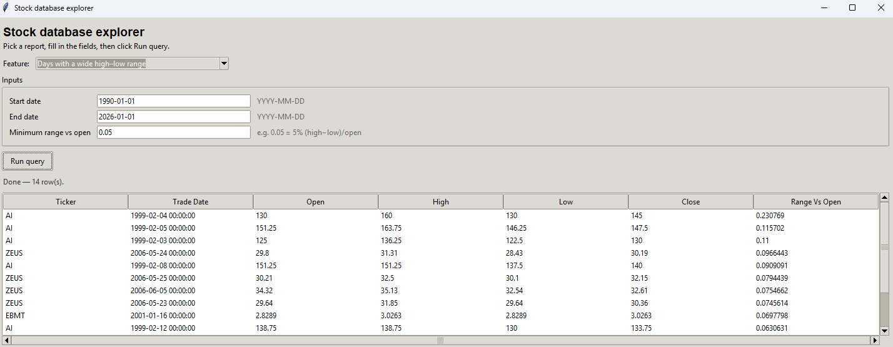

4. Category history for one stock
What it does: You enter a ticker symbol. The app shows every category that stock was linked to, along with assignment dates ordered from newest to oldest. This is useful for questions such as when a category label was applied.
SQL Query
SELECT s.ticker, s.name, c.category_name, c.category_type, sc.assigned_date
FROM symbol s
JOIN symbol_category sc ON s.symbol_id = sc.symbol_id
JOIN category c ON sc.category_id = c.category_id
WHERE UPPER(s.ticker) = UPPER(:ticker)
ORDER BY sc.assigned_date DESC, c.category_name
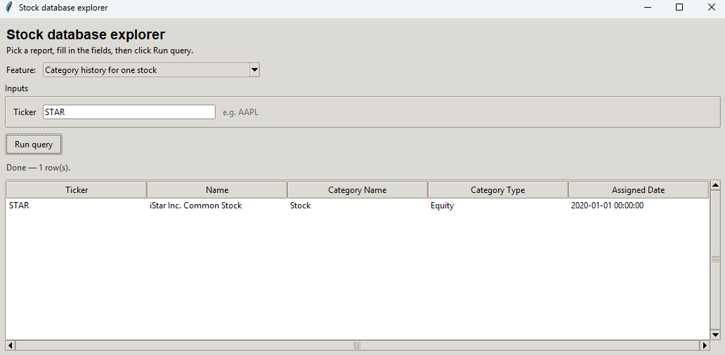

5. Busiest stocks by total volume
What it does: You pick a date range and the number of rows you want returned. The app sums trading volume per stock over that period and displays the largest totals first.
SQL Query
SELECT s.ticker, s.name,
SUM(d.volume) AS total_volume,
COUNT(*) AS num_days
FROM symbol s
JOIN daily_price d ON s.symbol_id = d.symbol_id
WHERE d.trade_date BETWEEN :start_date AND :end_date
GROUP BY s.symbol_id, s.ticker, s.name
HAVING SUM(NVL(d.volume, 0)) > 0
ORDER BY total_volume DESC
FETCH FIRST :top_n ROWS ONLY
