From Segmentation to Instruction: Language-Level Operator Guidance Built on an Image-Quality Function in Transabdominal Bladder Ultrasound for HoLEP Morcellation
Seong Jeong^{1, 2, 5}, Minsung Kim^{1,2,4}, Dongho Yee^{1,2,4}, Yechan Seo^{1,2,5}, Juahn Oh^{1,2,3}, Hyoun-Joong Kong^{1,2,5,*}
¹ Department of Transdisciplinary Medicine, Seoul National University Hospital, Seoul, Republic of Korea
² Rosota Inc., Seoul, Republic of Korea
³ Eulji University College of Medicine, Daejeon, Republic of Korea
⁴ Department of Mechanical Engineering, Seoul National University, Seoul, Republic of Korea
⁵ Department of Medicine, Seoul National University, Seoul, Republic of Korea

Abstract
During the morcellation phase of holmium laser enucleation of the prostate (HoLEP) an operator holds a suprapubic probe and must keep the bladder lumen in view. We present a guidance architecture that turns each bladder ultrasound frame into one corrective instruction with two readers: a U-Net segments the lumen, a transparent image-quality function Q judges the frame, and the judgment is emitted as a language instruction naming the next movement — move left, move right, hold, or check bladder filling. To a human operator it is pixel-level probing feedback, displayed or spoken; to a robotic probe holder the same emission is an action token (word, ê), translated to a twist by lookup. An instruction is only as fine as the function issuing it, so we first measure what Q can tell apart: it attains [0.14, 0.78] of its nominal domain, separating 47 states above its noise — the ceiling any honest vocabulary must fit under. The vocabulary is then derived, not chosen: one boundary is physical (a non-anechoic lumen cannot be a filled bladder), the other statistical (an offset below 1.64σ of the segmentation's centroid noise, σ = 4.92 px, cannot be signed). On 1,936 displaced held-out frames the three-word vocabulary is emitted correctly on 85.2% of frames at a 0.10% direction-error rate; the magnitude travels beside the word as a continuous value (slope 0.993), since graded vocabularies drop accuracy to 76.5% and 70.7%. We outline how the judgments would enter robot control, without validating that loop.
Keywords — bladder ultrasound segmentation, image-quality function, operator guidance, language instruction, attained range

1. Backgrounds
During the morcellation phase of holmium laser enucleation of the prostate (HoLEP) an assistant holds a suprapubic probe and keeps the bladder lumen in view. Keeping it there is a skill of the kind HoLEP training is built to teach [1]: the lumen drifts as the bladder volume changes, and deciding which way to slide the probe — or recognising that the image has degraded for a reason no probe motion can fix — currently rests on the operator's judgment alone. Automated support for bladder ultrasound has concentrated on the two ends of that judgment: deep networks segment the bladder and its wall accurately and cheaply enough for wearable monitors [3, 4], and guidance systems steer the operator toward a standard view [5]. The image itself carries the information that judgment needs, and for any operator, human or robot alike, the missing piece is not a better segmentation mask but the path from a mask to something the operator can be told to do.
This paper builds and argues for that path as an architecture of three stages and one interface (Figure 1): segmentation — a U-Net delineates the bladder lumen on each frame; quality judgment — a transparent function Q, computed from the segmentation and the image, decides whether and how the frame falls short; corrective action — the judgment is reduced to one of a small set of words naming the next corrective movement, the movement's magnitude travelling beside the word as a continuous value in pixels; and an output interface with two readers. To a human operator the words are pixel-level probing feedback that can be displayed or spoken; to a robotic probe holder the same emission is an action token — the word selects a pre-declared condition and axis, the number scales the motion — so translation into a twist command is a lookup, not an inference. The paper validates the architecture up to the emitted instruction and deliberately stops short of closing a robot loop; Section 4.1 records how the token channel would enter one.
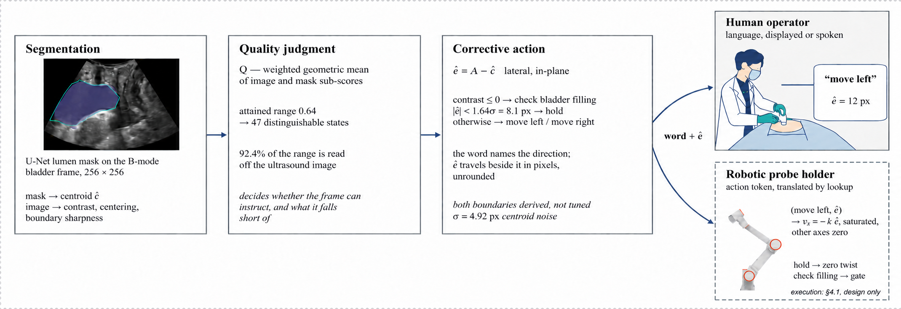
Figure 1. The guidance architecture. A U-Net segments the lumen (1); Q judges the frame from the segmentation and the image (2); the judgment becomes one instruction — a word with the continuous magnitude ê beside it (3). The same emission is read twice: as language feedback by the human operator, and as an action token by a robotic probe holder, translated to a twist by lookup. Stages 1–3 and the emitted instruction are validated here; the robotic execution (dashed) is a design contract, recorded in Section 4.1.
The central technical question is what instruction set Q can honestly support. The property that decides it is the function's attained range — the interval of values it actually takes on real frames — and not its correlation with any accuracy metric. A score that is formally defined on [0, 1] but occupies a band narrower than its own frame-to-frame noise cannot separate any two decisions, however well it ranks. Range divided by noise counts the states the function can genuinely tell apart — score differences a reader can trust as real rather than as noise — and that count is an upper bound on the size of an honest instruction vocabulary: Sections 3.2 and 3.3 measure it, and Section 3.4 derives the vocabulary from it.
2. Methods
2.1 Segmentation and the Image State
A U-Net [2] takes a 256 × 256 B-mode frame and produces a lumen probability map, thresholded at 0.5 and reduced to its largest connected component with interior holes filled. Frames come from PFUS1 [6], a public transperineal pelvic-floor ultrasound dataset: midsagittal videos of 101 women without pelvic-floor pathology, at rest and during Valsalva, acquired on one scanner at one centre, with the urinary bladder among the eight annotated organs [6, 7]. It is not HoLEP imaging — the acoustic window (transperineal rather than suprapubic), the population (women in diagnostic examinations rather than men under morcellation), and the scene (no morcellator, no irrigation inflow) all differ — and Section 4.2 states what that gap leaves unvalidated. The model was trained on a patient-disjoint split and was not retrained or re-tuned for this study. All measurements below are made on the two held-out frame sets (1,661 and 1,292 frames) that share no patient with training or with each other; the segmentation performance on those frames is reported in Section 3.1.
From the mask an image state is computed — centroid, area, boundary statistics, and lumen-to-surround intensity contrast — with every ratio taken over the insonified sector rather than the image rectangle. The sector was measured from the training images (66.4% of the frame, IoU ≥ 0.964 against held-out frames); without it the frame grabber's crop enters every area ratio.
2.2 The Quality Function
Q is a weighted geometric mean of sub-scores, each normalised to [0, 1], every term and weight logged so that a value can be traced back to its components. Three sub-scores consult the ultrasound image — lumen-to-surround contrast, centering on the darkness centroid, and boundary sharpness of the probability map — and the rest restate the mask or its history (completeness, confidence, geometry, temporal agreement).
Q = exp( Σ w_{i} ln s_{i} / Σ w_{i} ) (1)
The geometric aggregation has the shape a decision needs: the mean is dominated by its smallest term, so a frame whose lumen contrast has collapsed scores low no matter how well the remaining terms do — no single degraded property can hide inside an average.
The weights are set by rule, not fitted — with eleven patients per split, any fitted weight would report sampling noise. They are tiered and equal within a tier: the three image-reading terms share the top weight (1.5 each, 4.5 of the 6.0 total), the mask-side domain check keeps 0.5, terms whose measured behaviour disqualifies them are set to zero, and `segmentation confidence` keeps its inherited 1.0 — what that buys is measured rather than assumed, in Section 3.2. The three temporal terms are switched off: the frames are static examinations, so frame-to-frame agreement would score the smoothness of a recording, not the stability of a control loop.
2.3 Range, Noise, and What Q Can Tell Apart
The first property measured is the attained range — the interval of values Q actually takes over all 2,953 held-out frames, set against its nominal domain [0, 1]; because the geometric mean is additive in the logarithm, every part of that range is traceable to one sub-score. A range is then only useful relative to the noise on it. These are static examinations, so the change in Q between adjacent frames is almost entirely the function's own jitter, and two frames whose scores differ by less than that jitter cannot be ordered — the difference is as likely noise as signal. Dividing the attained range by the jitter therefore counts how many states a reader of *Q* can genuinely tell apart; the central 80% of the distribution — the operating region a threshold would actually be placed in — is reported alongside the full range.
2.4 The Instruction Axis
The instruction is issued on the one image axis that leaves the imaging plane invariant. Of the probe's six axes only v_{x}, v_{z} and ω_{y} preserve the plane; of the three the image policy holds, only lateral sliding v_{x} does, and only it presents a measurable vector error rather than a scalar to be searched (Figure 2a). Write the instruction as ê = A − ĉ, with A the beam axis and ĉ the predicted lumen centroid abscissa (Figure 2b).
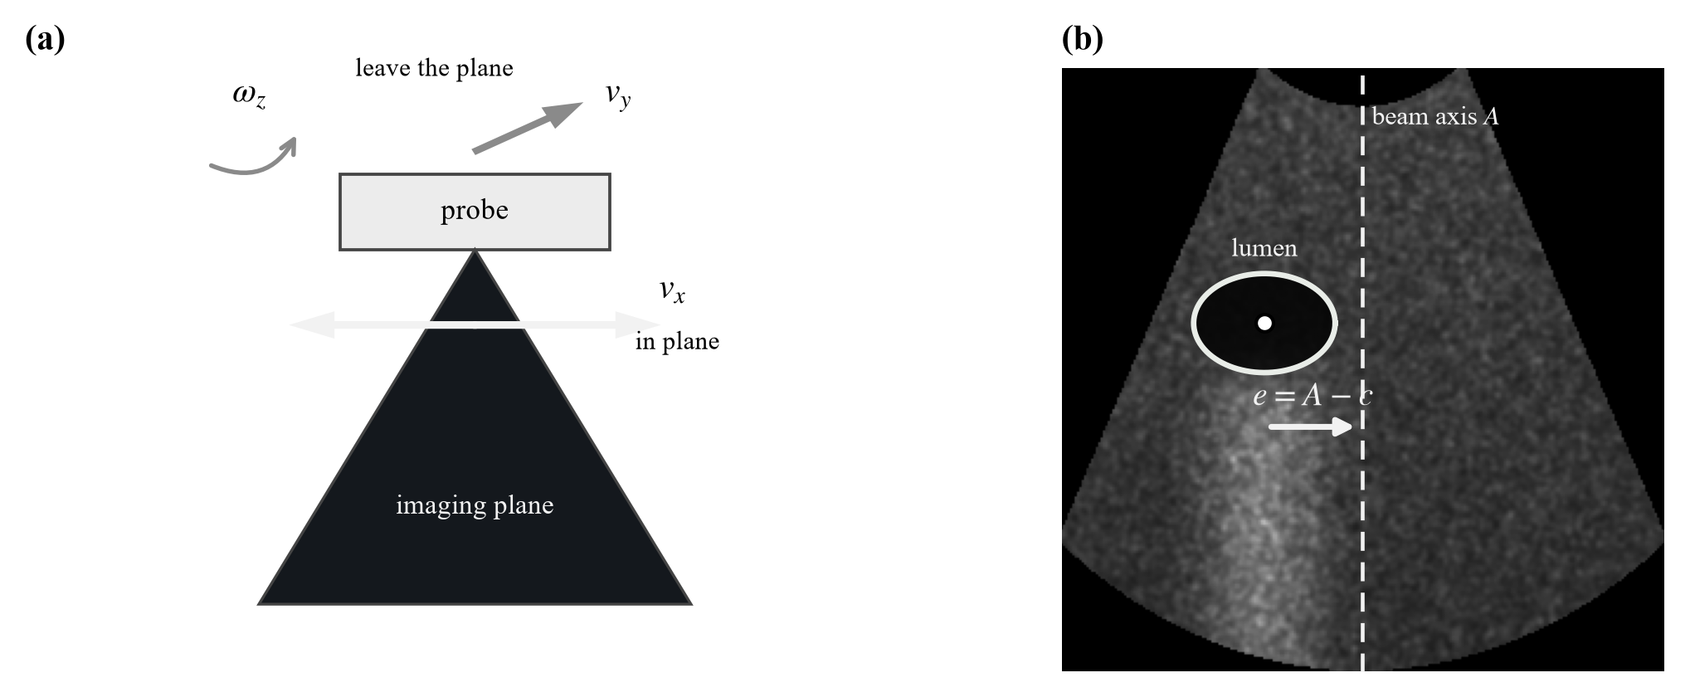
Figure 2. (a) Only v_{x} leaves the imaging plane invariant among the three axes the image policy holds. (b) The lateral instruction on one frame: A is the beam axis, c the lumen centroid abscissa, e = A − c.
2.5 Validation by Lateral Translation
One property of the frames prevents the direction from being validated on them as recorded: in all 2,953 the lumen lies on the same side of the beam axis, so e never changes sign and a constant output would score 99.3%. The sonographer holds a diagnostic view rather than centring the lumen on the axis, which is a property of how the frames were acquired and not of the function.
The instruction is therefore exercised on laterally translated frames. Lateral translation is the one probe motion single-plane frames can reproduce faithfully, and it carries the lumen across the axis so that e changes sign; each frame is shifted by the amount that places e on a prescribed target, sampled densely near the crossing and sparsely away from it. Fabricated margin is filled by edge replication, never black, which every intensity term would read as anechoic lumen. Across the sweep the segmentation is unaffected — Dice holds at 0.858 — and 1,936 frames result, 43% with e < 0.
3. Results
3.1 Segmentation Performance
Table 1 stratifies the segmentation stage by bladder filling — the share of the insonified sector the annotated lumen occupies, the area a filling bladder sweeps. Performance rises monotonically with distension, from 0.825 / 0.807 (val / test, all frames) to above 0.90 in the fullest bands; within the working domain (lumen ≥ 5.7% of the sector, the state morcellation irrigation is meant to maintain) the lateral centroid error, the quantity the instruction is built on, has a median of 3.85 px and 3.65 px. The tail below the domain is the same population the check bladder filling branch of Section 3.4 addresses: segmentation degrades exactly where the instruction refuses to steer.
Table 1. Segmentation by bladder filling: frames stratified by the share of the insonified sector the annotated lumen occupies. Dice is mean ± sd; bold marks the distended-bladder working domain.
Lumen area | n (val) | Dice (val) | n (test) | Dice (test)
all frames | 1,661 | 0.825 ± 0.091 | 1,292 | 0.807 ± 0.123
≥ 3.0% | 1,431 | 0.839 ± 0.084 | 995 | 0.853 ± 0.070
≥ 5.7% | 994 | 0.882 ± 0.044 | 396 | 0.892 ± 0.047
≥ 8.0% | 650 | 0.903 ± 0.030 | 135 | 0.929 ± 0.016
≥ 12.0% | 134 | 0.908 ± 0.036 | 128 | 0.931 ± 0.011

3.2 The Attained Range of Q
Q is defined on [0, 1]. On 2,953 held-out frames it attains [0.14, 0.78] — a width of 0.64 — with a central 80% of 0.45 (Figure 3a).
The decomposition of Section 2.3 attributes 92.4% of the range to two sub-scores (Figure 3b), and both are terms that consult the ultrasound image rather than the mask.
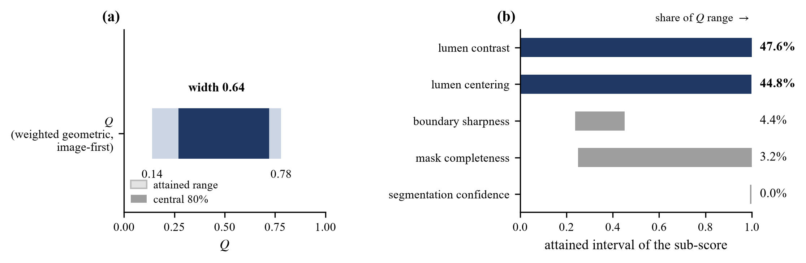
Figure 3. (a) The interval Q actually attains against its nominal domain [0, 1]; the solid band is the central 80%, the operating region a threshold would actually be placed in. (b) The interval each active sub-score attains and its share of the resulting range. `segmentation confidence` occupies a band 0.007 wide and contributes nothing.
`segmentation confidence` is the cautionary term of the panel: it is not a weak term that could be rescued by more weight, but a degenerate one — it returns essentially one value (a band 0.007 wide), so it has no range, and a function with no range cannot participate in any decision. It carries a weight of 1.0 while contributing 0.0% of what Q can express; border penalty and component quality behave the same way and are already at weight 0.
3.3 How Many States Q Tells Apart
Against a frame-to-frame jitter of 0.0095 (Section 2.3), the attained range of 0.635 separates 67 states over the full range and 47 within the central 80% — score differences wide enough for a reader to trust as real rather than as noise. That census, not any accuracy figure, is what an instruction set must fit within: words spaced more finely than the states Q can tell apart would hand the same frame different labels on different frames.
3.4 The Derived Vocabulary
A physical boundary. Two boundaries partition the range, and neither is a fitted hyperparameter. The first is physical. The lumen-to-surround contrast is positive when the delineated region is darker than the tissue ring around it, so a non-positive value means the region is no darker than its surround. A urine-filled bladder lumen, however, is anechoic — a textbook property of the organ [8], not something estimated from these frames — so a region that fails to read dark cannot be a filled bladder. The boundary sits at zero because the physics puts it there: there is no constant to fit, and none to re-fit in a new imaging domain. On 13.1% of frames the contrast is non-positive; those frames have Dice 0.665 against 0.840 elsewhere, and what sets them apart is the delineated region itself — 1.85 times brighter and a third the area, the signature of a bladder that is not yet filled enough to read as anechoic rather than of a poorly placed probe. The remedy is therefore not a lateral slide, which cannot add urine to an under-distended bladder; it is upstream, in bladder filling, and the instruction says exactly that instead of commanding a movement that cannot help.
A statistical boundary. The difference δ = ê − e is the segmentation's lateral centroid error, independent of where the lumen sits, with σ = 4.92 px and a bias of +0.11 px. The instruction points the wrong way exactly when δ opposes e and exceeds it, so
P(wrong direction) = Φ(−|e| / σ) (2)
and the instruction is withheld below 1.64σ = 8.1 px, where the modelled error rate reaches 5%. Below that boundary a controller that keeps acting is following its own segmentation noise; this is a stopping condition, not a defect. The rule — withhold where Equation (2) puts the direction error above 5% — carries no fitted constant; the one measured quantity in it, σ, is a property of this segmentation on these frames, so moving to HoLEP imaging means re-measuring σ there (Section 4.2), not re-tuning a threshold.
Table 2. The instruction vocabulary. Both boundaries are derived — one from the physics of an anechoic lumen [8], one from the segmentation's centroid noise — and neither is tuned.
Instruction | Condition | Acts on
check bladder filling | contrast ≤ 0 | not the probe — filling
move left / move right | contrast > 0 and |ê| ≥ 8.1 px | lateral axis v_{x}
hold | contrast > 0 and |ê| < 8.1 px | nothing — converged

The magnitude is a number, not a word. The word carries the direction; the displacement itself, ê in pixels, enters and leaves the pipeline as a continuous value — shown beside the word to a human operator, consumed directly as a velocity command by a robot. The same noise that derives the boundaries dictates this format. A magnitude put into words means quantising |ê| into classes, and a class narrower than 2σ ≈ 9.8 px cannot be assigned reliably even at its centre; the sweep bears this out, with graded vocabularies dropping word accuracy from 85.2% to 76.5% and 70.7% while the direction error holds at 0.10% (Table 3). The continuous value, by contrast, is validated in Section 3.5 at a regression slope of 0.993 and a median error of 3.15 px: the magnitude is trustworthy as a measurement and unreliable as a word, so the language layer names the direction and passes the measurement through unrounded.
Table 3. Word accuracy of the emitted instruction against the instruction the ground truth implies, over the controlled sweep of Section 2.5. Magnitude grades cut |ê| at successive multiples of the derived 8.1 px hold boundary, so the grading introduces no new constant. Direction errors stay negligible; discretising the magnitude is what costs accuracy — the reason it is passed through as a number.
Vocabulary | Size | Accuracy | Direction error
move / hold | 2 | 85.3% | 0.00%
move left / move right / hold | 3 | 85.2% | 0.10%
+ two magnitude grades | 5 | 76.5% | 0.10%
+ three magnitude grades | 7 | 70.7% | 0.10%

Each word is a complete instruction to two different readers. To the human operator the vocabulary is displayed or spoken as it stands: the word names the direction — the register in which probe handling is actually taught and corrected — while the measured displacement stands beside it as a number. To a robotic probe holder each word is a symbol with a defined condition and axis, so translation into a twist command is a lookup, not an inference (Table 4). The language layer is thus the interface between the two settings: the same judgment drives either operator, and nothing about the pipeline changes when the reader does.
Table 4. One vocabulary, two readers. The mapping from word to action is fixed in advance on both sides; no model sits between the instruction and its execution.
Instruction | Human operator | Robotic probe holder
check bladder filling | pause; reassess filling before scanning on | zero twist; hand control back to the supervisor
move left / move right | slide the probe laterally by the displayed amount | v_{x} = −k ê, saturated; other axes zero
hold | keep the current pose | zero lateral twist; no correction commanded

3.5 Accuracy of the Emitted Instruction
Figure 4 shows one frame of the sweep at three lateral displacements, including one inside the band where the direction is no longer trustworthy.
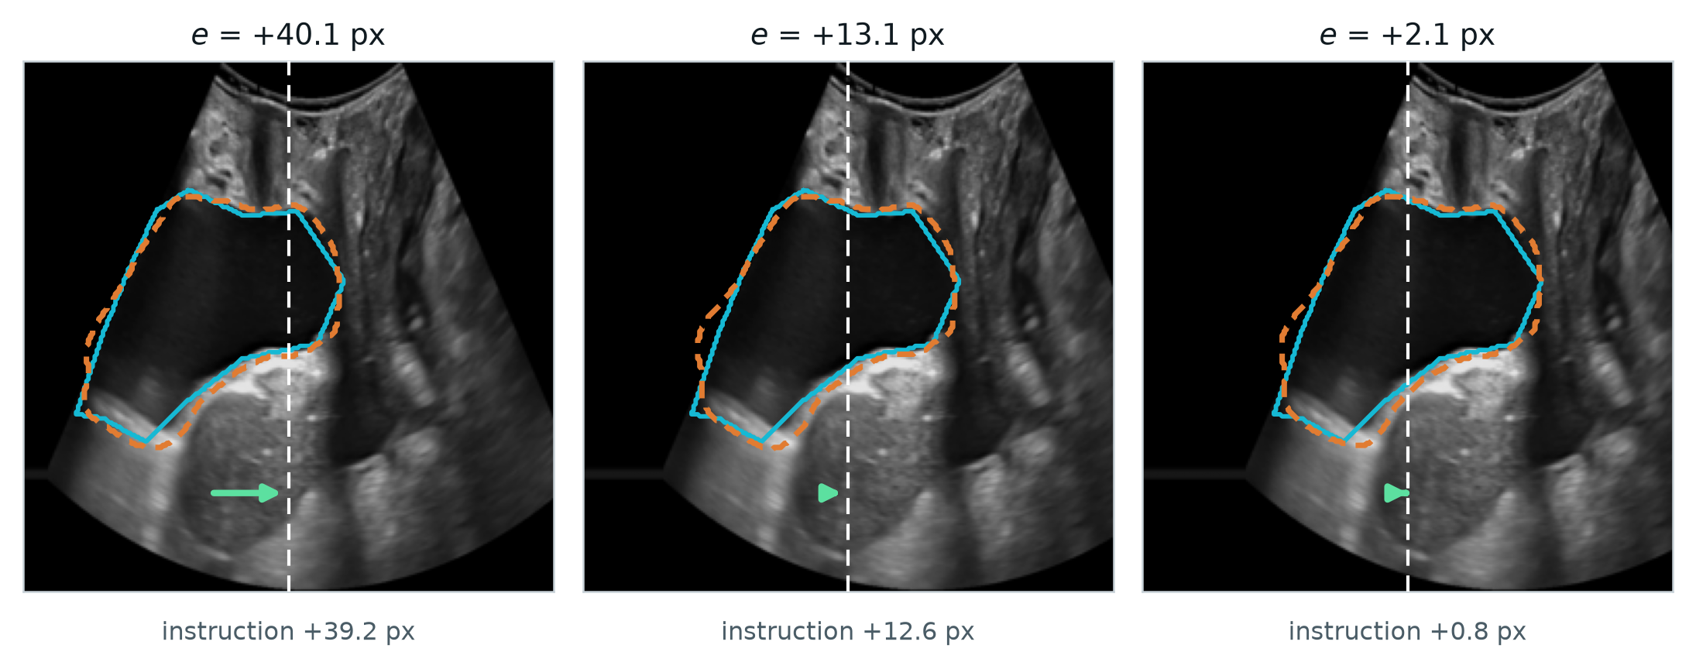
Figure 4. One frame at three lateral displacements. Cyan is the annotation, orange dashed the prediction, white dashed the beam axis, the arrow the instruction. At e = +2.1 px the instruction has collapsed to +0.8 px: the loop has entered the band where Equation (2) says the direction is no longer reliable.
The instruction agrees with the truth in 93.7% of frames, with a median magnitude error of 3.15 px, a regression slope of 0.993 and r = 0.970. A slope this close to unity means the instruction is correctly scaled and not merely directional. The two held-out frame sets agree to within 0.7 px of median error.
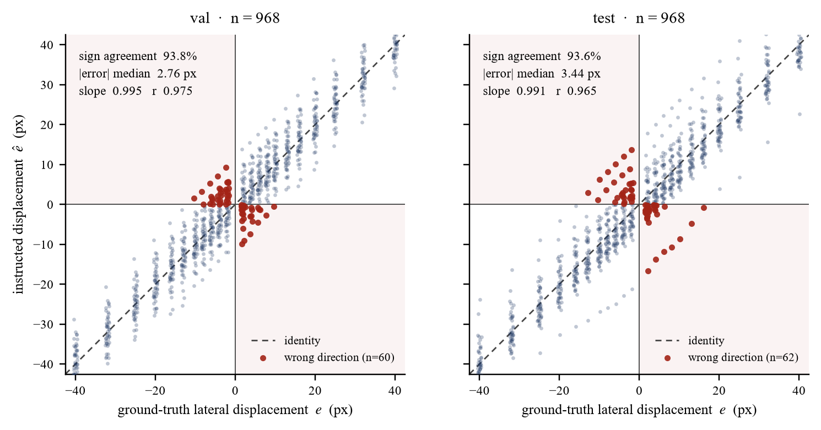
Figure 5. Instructed against ground-truth lateral displacement, one panel per held-out frame set; per-set agreement statistics are inset. Shaded quadrants are wrong-direction outcomes; every one lies within a few pixels of the axis.
The result is not that percentage but the shape of its failure. Wrong directions occur only near the axis — their median required displacement is 7.9 px against 15.8 px for correct ones — and their rate follows Equation (2) with σ fitted once to the centroid error and not to this curve (Figure 6). Agreement across two decades of error rate is what licenses deriving the vocabulary boundary from the model rather than reading it off the data.
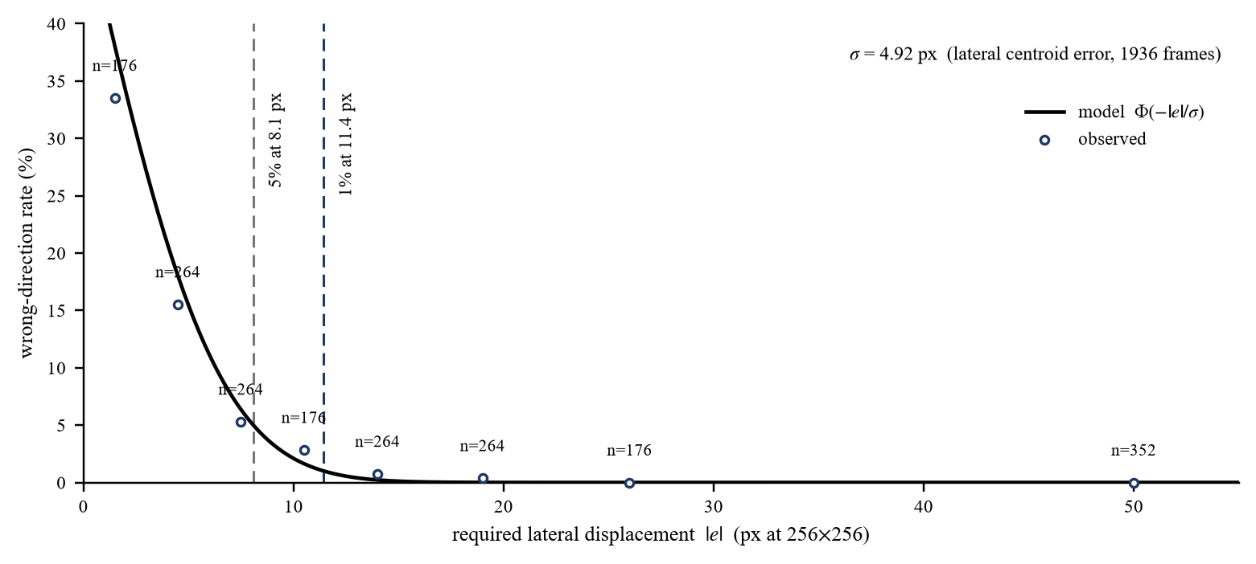
Figure 6. Wrong-direction rate against required displacement. The curve is Equation (2); circles are observed rates with frame counts. Dashed verticals mark where the modelled rate reaches 5% and 1%.
The constants are stable against annotation quality. A model-blind label audit flags four of the frame sets' patients as carrying regions that cannot be lumen; recomputing without them moves σ from 4.92 to 4.67 px (−5%), sign agreement from 93.7% to 94.1%, and the 5% boundary from 8.1 to 7.7 px.
4. Conclusion
Reporting an image-quality function by its correlation with a segmentation metric answers the wrong question. Correlation says how the score orders frames; the attained range over the function's own noise says how many states a reader can genuinely tell apart, and the two come apart — a score can rank frames respectably while supporting fewer distinctions than the instructions a controller would want to issue, a failure invisible to any accuracy figure. Range, its decomposition, and range-over-noise are cheap to compute and we suggest reporting them for any score intended to instruct an operator or drive a device. The decomposition also gives a concrete design rule: a term contributing none of the range is not underweighted but degenerate, and the fix is to measure it where the decision is hard or to remove it — here the two terms that consult the ultrasound image carry 92.4% of the range while three mask-side terms carry almost none.
4.1 The Action-Token Channel: From Judgment to Twist
The pipeline validated above ends at the emitted instruction; this section records how a robotic probe holder consumes it — the design, not a result. The channel's input is the per-frame emission of stage 3: an action token (word, ê), with the quality scalar Q beside it. Decoding is the fixed lookup of Table 4, and no model sits between token and twist. move left and move right select the lateral axis and let the number scale it — v_{x} = −k ê, saturated, every other axis commanded to zero, so the realisation is proportional rather than bang-bang. hold commands zero twist: the 1.64σ boundary of Section 3.4 arrives as a ready-made deadband, and a controller that kept acting inside it would be servoing its own segmentation error. check bladder filling gates image-based motion outright — no twist is preferable to a twist computed from a mask that physics rejects — and because tokens are issued per frame, one degraded frame gates one command, not the session.
Beyond the words, Q has room to scale the commanded speed down as quality falls: 47 distinguishable states give it the room to do that honestly. The token acts only on v_{x}, the one axis that leaves the imaging plane invariant, so nothing the image loop commands can rotate the anatomy out of its own view. Closing and validating this loop — its latency, and Q measured while the probe actually moves — is deliberately outside this paper's scope.
4.2 Limitations
— PFUS1 is transperineal pelvic-floor imaging of women [6], not HoLEP imaging. No suprapubic acoustic window, male pelvic anatomy, morcellator, or irrigation inflow appears in any frame, so every constant reported here — σ and the boundaries derived from it included — must be re-estimated on intraoperative suprapubic frames before the vocabulary is trusted in theatre.
— No real probe motion is validated. The frames are static examinations whose lumen centroid moves 0.45 px between samples, below the segmentation's own centroid error, so lateral displacement is simulated and the instruction has not been closed into a loop with a person or a robot.
— Two of the image policy's three axes are untouched: v_{y} and ω_{z} leave the imaging plane, present only a scalar quality, and cannot be simulated from single-plane frames.
— The target pose — lumen on the beam axis — is a design choice for the robotic setting. The archived frames were not acquired toward it, so the proportion of frames falling in each instruction band describes the frames, not the loop's steady state.
— No pixel spacing accompanies the frames, so σ and every derived boundary are stated at 256 × 256 and must be rescaled before they mean millimetres.
— σ is treated as one constant. Per-frame estimation would tighten the stopping boundary where the segmentation is confident and loosen it where it is not.
— The check bladder filling branch is supported by 13.1% of frames from four patients; whether the cause is under-distension or annotation is not separable here [TO BE CONFIRMED: IRB approval number, scanner model, annotation protocol].
References
[1] T. Jang, H.-J. Kong, C. Baek, J. Kim, M. S. Choo, S.-J. Oh. Effect of Self-Training Using Virtual Reality Head-Mounted Display Simulator on the Acquisition of Holmium Laser Enucleation of the Prostate Surgical Skills. International Neurourology Journal 2024;28(2):138–146.
[2] O. Ronneberger, P. Fischer, T. Brox. U-Net: Convolutional Networks for Biomedical Image Segmentation. In: Medical Image Computing and Computer-Assisted Intervention (MICCAI 2015), LNCS 9351, Springer, 2015, pp. 234–241.
[3] M. Saini, Y. Jiang, T. Gangopadhyay, D. P. Rosen, A. Alizad, M. Fatemi. BWS-Net: An Optimal Deep Learning Architecture for the Anterior Bladder Wall Segmentation using Ultrasound Imaging. IEEE Journal of Biomedical and Health Informatics 2026. doi:10.1109/JBHI.2026.3675965.
[4] Z. Song, M. Asiedu, S. Wang, Q. Li, A. Ozturk, V. Mittal, S. Schoen Jr., S. Ramaswamy, T. T. Pierce, A. E. Samir, Y. C. Eldar, A. Chandrakasan, V. Kumar. Memory-efficient low-compute segmentation algorithms for bladder-monitoring smart ultrasound devices. Scientific Reports 2023;13:16450.
[5] H.-L. Hsu, M. Zahiri, G. Y. Li, R. Al Mukaddim, H. Lee, M. G. Wilson, J. Grube, S. Schmidt, G. Ghoshal, B. Raju. Active guidance in ultrasound bladder scanning using reinforcement learning. Scientific Reports 2026;16:5273.
[6] D. Solís-Martín, J. A. Sainz, J. Galán-Páez, J. Borrego-Díaz, J. A. García-Mejido. PFUS1: Premier pelvic floor ultrasound segmentation dataset. A resource for advancing research. Data in Brief 2026;64:112346.
[7] J. A. García-Mejido, D. Solís-Martín, M. Martín-Morán, C. Fernández-Conde, F. Fernández-Palacín, J. A. Sainz-Bueno. Applicability of deep learning to dynamically identify the different organs of the pelvic floor in the midsagittal plane. International Urogynecology Journal 2024;35(12):2285–2293.
[8] Trinkler, Dietrich. Ultrasound of the Urinary Bladder. In: EFSUMB Course Book, European Federation of Societies for Ultrasound in Medicine and Biology, 2019.
[TO BE COMPLETED] Citations for HoLEP morcellation, ultrasound visual servoing and image-quality assessment are to be added before submission.

