An Explainable Action-Token Generation Framework Based on Bladder Ultrasound Segmentation and Image Quality Assessment
Seong Jeong^{1, 2, 5}, Minsung Kim^{1,2,4}, Dongho Yee^{1,2,4}, Yechan Seo^{1,2,5}, Juahn Oh^{1,2,3}, Hyoun-Joong Kong^{1,2,5,*}
¹ Department of Transdisciplinary Medicine, Seoul National University Hospital, Seoul, Republic of Korea
² Rosota Inc., Seoul, Republic of Korea
³ Eulji University College of Medicine, Daejeon, Republic of Korea
⁴ Department of Mechanical Engineering, Seoul National University, Seoul, Republic of Korea
⁵ Department of Medicine, Seoul National University, Seoul, Republic of Korea
*Corresponding Author

Abstract: During the morcellation phase of holmium laser enucleation of the prostate (HoLEP), a suprapubic ultrasound probe must be kept over the bladder lumen. Automating that view requires an explicit, auditable representation mapping image-derived states to actionable outputs; a segmentation mask alone is not such a representation. We present an explainable framework that converts bladder ultrasound segmentation and image-quality assessment into a safety-constrained, machine-readable action token. A U-Net segments the bladder lumen; a transparent image-quality function Q, computed from interpretable image and mask features, summarises the frame; and the system emits a structured token pairing a discrete action state, one of move-left, move-right, hold, or check-filling, with a continuous lateral displacement estimate ê, designed for deterministic decoding rather than natural-language recommendation. The vocabulary is bounded by what Q can distinguish: Q attains [0.14, 0.78] of its nominal domain and, against frame-to-frame jitter, separates 47 distinguishable states, the ceiling on safe action states. Two boundaries are derived, not tuned. A physical gate assigns check-filling because a non-anechoic lumen cannot be a filled bladder, and a statistical deadband assigns hold because an offset below 1.64σ of the centroid noise, σ = 4.92 px, cannot be signed. On 1,936 laterally translated held-out frames the action state is correct on 85.2% of frames at 0.10% direction error; the displacement stays continuous (slope 0.993), since quantising it into graded classes drops accuracy to 76.5% and 70.7%. The framework supplies an explainable action-token layer for HoLEP probe guidance; closed-loop validation on intraoperative imaging remains future work.
Keywords: bladder ultrasound segmentation, image quality assessment, explainable artificial intelligence, action token, robotic probe control, HoLEP morcellation

I. Introduction
During the morcellation phase of holmium laser enucleation of the prostate (HoLEP), a suprapubic ultrasound probe must be kept over the bladder lumen [1]. Automated analysis of that view needs an explicit representation of what the current image implies for an actionable state; a segmentation mask alone is not such a representation. Deep networks already segment the bladder accurately and cheaply [3, 4] and guidance systems can steer toward a standard view [5], but a mask is not something a downstream module can act on. An end-to-end learned mapping would produce motion directly yet hide why an action was issued and is hard to audit under segmentation uncertainty, whereas a raw geometric rule acts on the mask with no account of when the image is too degraded to act on at all. What is wanted instead is a structured layer that encodes the direction to move, withholds motion when the estimate is untrustworthy, and flags failures upstream of any probe motion.
We build that layer as an explainable action-token generation framework of three stages (Figure 1): a U-Net segments the bladder lumen; a transparent image-quality function Q, computed from interpretable image and mask features, summarises whether and how the frame falls short; and the state is emitted as a structured token pairing a discrete action state (move-left, move-right, hold, or check-filling) with a continuous lateral displacement estimate ê. The token is designed for deterministic decoding, with the identical human-readable wording retained only as an optional monitoring layer for oversight. The framework is confined to the lateral, image-preserving axis — the one axis presenting a measurable image-domain displacement that can be simulated from single-plane frames. This study validates the pipeline up to token generation; the token-to-command mapping is a design specification for future integration (Section IV), not a closed-loop result.

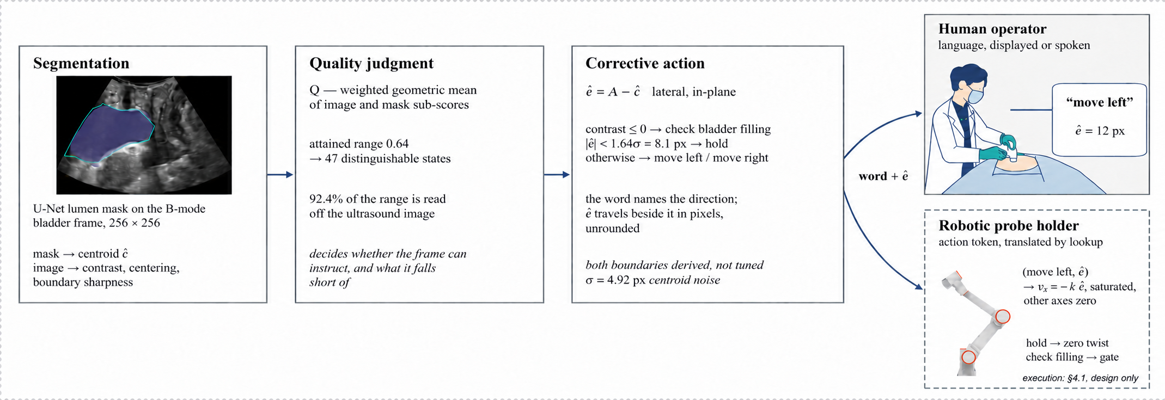
Figure 1. The action-token generation framework: an ultrasound frame is segmented (U-Net), summarised by the image-quality function Q, and emitted as a structured action token (a, ê, Q) that a fixed decoder maps to a potential downstream system output. Stages 1–3 are validated; the dashed downstream execution (a potential future robotic-control integration) is not validated (Section IV).

II. Methods
1. Segmentation, Image State, and Quality Assessment
A U-Net [2] maps a 256 × 256 B-mode frame to a lumen probability map, thresholded at 0.5 and reduced to its largest hole-filled connected component. Frames come from PFUS1 [6], a public transperineal pelvic-floor dataset (101 women, midsagittal, rest and Valsalva, one scanner) whose eight annotated organs include the bladder [6, 7]; it is not intraoperative HoLEP imaging. The model was trained on a patient-disjoint split and used unchanged; all measurements use two held-out sets (1,661 and 1,292 frames) that share no patient. From the mask we compute an interpretable image state — centroid, area, boundary statistics, and lumen-to-surround contrast — every ratio taken over the insonified sector rather than the image rectangle.
The quality score is a weighted geometric mean of sub-scores s_{i} ∈ [0, 1], every term and weight logged so a value is traceable to its components:
Q = exp( Σ w_{i} ln s_{i} / Σ w_{i} ) (1)
Dominated by its smallest term, Q cannot let one collapsed property hide inside an average; three image-reading terms (lumen contrast, centring, boundary sharpness) carry the top weight, and weights are tiered by rule, not fitted. As these are static examinations, the change in Q between adjacent frames estimates its own frame-to-frame jitter; the attained range divided by that jitter counts the states Q can distinguish — the ceiling on the number of reliable action states.
2. Action Token and Safety Boundaries
The token acts on the lateral, image-preserving axis v_{x}, the only plane-preserving axis presenting a measurable image-domain displacement. At frame t the framework emits a structured action token
τ_{t} = ( a_{t}, ê_{t}, Q_{t} ) (2)
where a_{t} ∈ {move-left, move-right, hold, check-filling} is the discrete action state, ê_{t} = A − ĉ_{t} is the continuous lateral displacement (beam axis A minus predicted lumen-centroid abscissa ĉ), and Q_{t} is the score of Equation (1). A fixed and auditable rule can decode the token for downstream use: the state selects an action mode, ê supplies the continuous lateral scaling variable, and Q is available for conservative confidence-aware scaling, with no learned policy between the token and its downstream interpretation. A robotic lateral-velocity command is one potential future implementation of this decoding rule, but no hardware integration or closed-loop execution is evaluated in this study. Two derived, untuned boundaries fix the states (Table 1). The physical gate is exact: a urine-filled lumen is anechoic [8], so a non-positive lumen-to-surround contrast cannot be a filled bladder, and lateral motion cannot remedy insufficient filling. The uncertainty deadband follows from the centroid error δ = ê − e (σ = 4.92 px, bias +0.11 px): the estimated direction is wrong when δ opposes and exceeds e, a Gaussian-tail probability Φ(−|e|/σ); requiring the modelled error below 5% withholds motion under 1.64σ = 8.1 px.
Table 1. Action-token specification: trigger, safety rationale, and deterministic control interpretation for each state (both boundaries derived, not tuned).
Action state | Trigger | Safety rationale | Control interpretation
check-filling | contrast ≤ 0 | image failure, not a pose error | gate: no lateral motion
move-left / move-right | contrast > 0, |ê| ≥ 8.1 px | direction reliable above noise | v_{x} ∝ ê, other axes zero
hold | contrast > 0, |ê| < 8.1 px | direction within noise | deadband: zero lateral twist

3. Validation by Lateral Translation
In every recorded frame the lumen lies on one side of the beam axis, so e never changes sign and a constant output would score 99.3%. We therefore translate each frame laterally — the one probe motion single-plane frames reproduce faithfully — to place e on prescribed targets, sampled densely near the axis crossing; fabricated margin is edge-replicated, never black. Segmentation is unaffected across the sweep (Dice 0.858), yielding 1,936 frames, 43% with e < 0.
III. Results
1. Segmentation and Quality Discrimination
Segmentation improves with bladder filling; in the working domain (annotated lumen ≥ 5.7% of the sector, the state morcellation irrigation is meant to maintain) Dice reaches 0.882 (val) and 0.892 (test), and the lateral centroid error the token's displacement rests on has a median of 3.85 and 3.65 px (Table 2). Below that domain segmentation degrades — exactly the population the check-filling state gates.
Q is defined on [0, 1] but attains only [0.14, 0.78] (width 0.64, central 80% 0.45); against a frame-to-frame jitter of 0.0095 this separates 67 states over the full range and 47 within the central 80% — the ceiling on the number of reliable action states (Figure 2). Two image-reading terms carry 92.4% of the range, confirming that the discriminating information is image-derived rather than mask-derived.

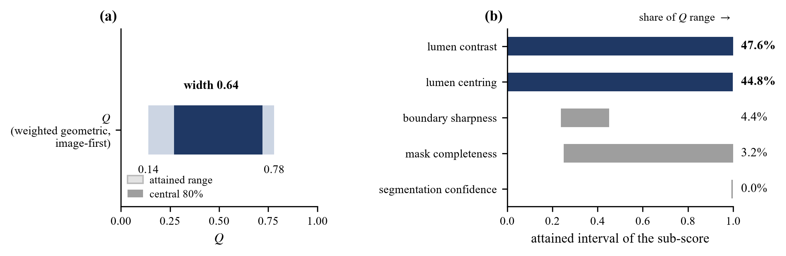
Figure 2. Quality-function discrimination: (a) the interval Q attains within its nominal [0, 1] domain, with the central-80% operating band; (b) each active sub-score's attained interval and share of the range.

2. Action-Token Validation
On the 1,936-frame sweep the discrete action state is classified correctly on 85.2% of frames with a 0.10% direction error, and the continuous displacement is estimated at slope 0.993, r = 0.970, median error 3.15 px (Table 2, Figure 3). Wrong directions occur only near the axis — median required displacement 7.9 px against 15.8 px for correct ones — and their rate follows the Gaussian tail Φ(−|e|/σ), which is what licenses deriving the 8.1 px hold deadband from the model rather than reading it off the data (Figure 3).
Direction is thus robustly discretisable, whereas quantising the magnitude into graded action classes narrower than 2σ ≈ 9.8 px lowers classification accuracy to 76.5% (five states) and 70.7% (seven states) at unchanged direction error; the displacement is therefore kept as a continuous control variable rather than a class.

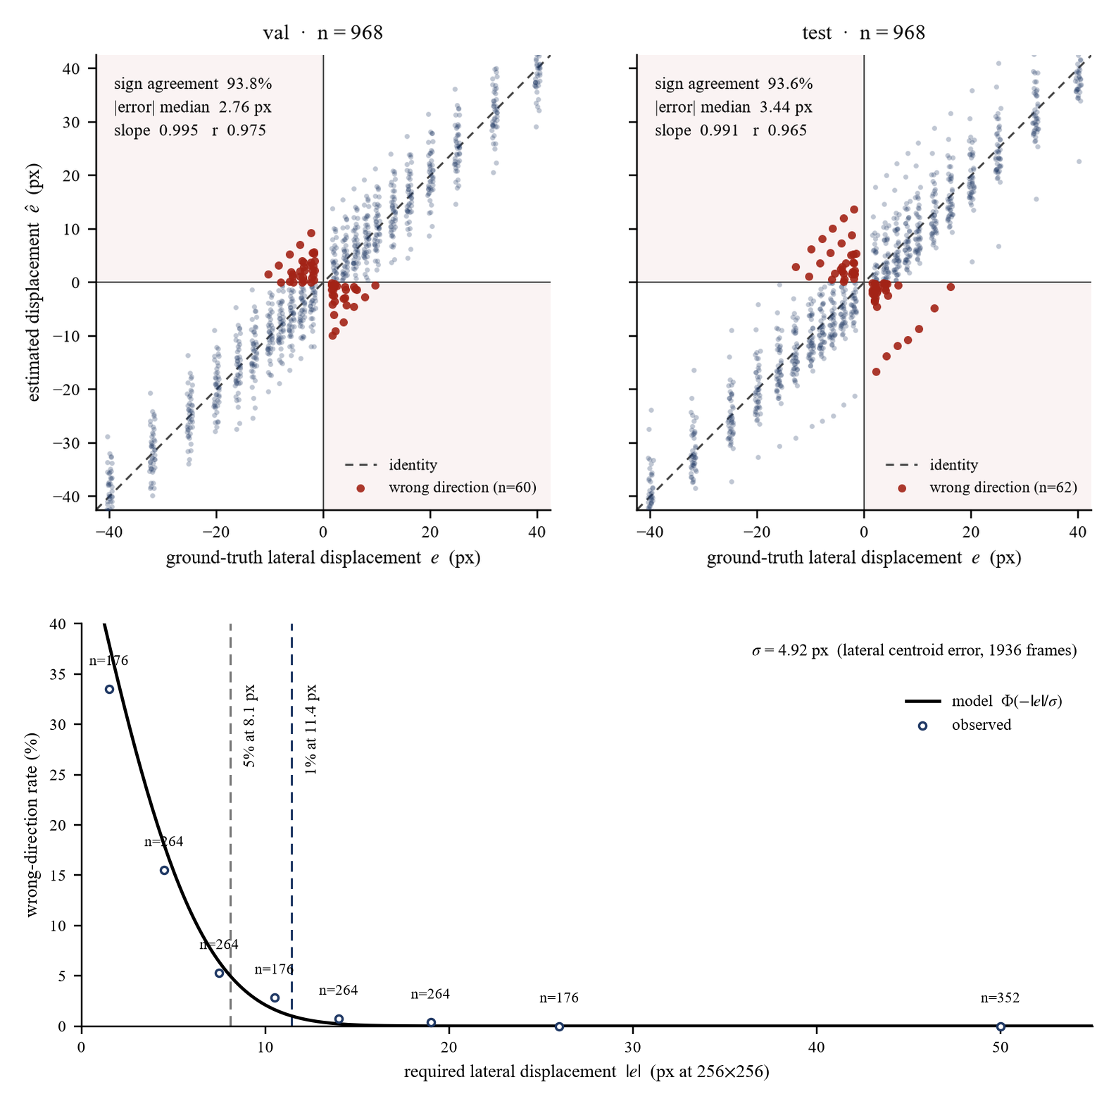
Figure 3. Action-token validation: (a) estimated versus ground-truth lateral displacement per held-out set (shaded quadrants are wrong-direction outcomes); (b) wrong-direction rate versus required displacement against the Gaussian-tail model Φ(−|e|/σ), with the modelled 5% and 1% boundaries marked.

Table 2. Main quantitative results: segmentation and action-token performance on the held-out and laterally translated frames.
Metric | Value
Segmentation Dice, all frames (val / test) | 0.825 / 0.807
Segmentation Dice, working domain (val / test) | 0.882 / 0.892
Lateral centroid error, working domain, median (val / test) | 3.85 / 3.65 px
Attained Q range (width; central 80%) | 0.64; 0.45
Distinguishable states (full; central 80%) | 67; 47
Action-state accuracy (3 states); direction error | 85.2%; 0.10%
Displacement estimate (slope; median error) | 0.993; 3.15 px
Graded-magnitude accuracy (5; 7 states) | 76.5%; 70.7%

IV. Discussion
An image-quality function intended to support structured downstream action handling should be judged by its attained range relative to its noise, because that ratio — not correlation with a segmentation metric — sets the number of safely distinguishable action states. A score can rank frames respectably while supporting fewer distinctions than a controller needs, a failure invisible to any accuracy figure; range and range-over-noise are cheap to compute and we suggest reporting them for any score intended to support downstream action handling.
The contribution is deliberately not to automate a judgment a trained observer makes by inspection — move-left, move-right, hold, and check-filling are visually obvious on screen, and we claim no diagnostic insight or improvement to human performance. It is to turn image-derived information into a structured, explainable, safety-constrained representation that can be interpreted deterministically by a downstream system, each token traceable to explicit features, segmentation geometry, a physical constraint, and measured uncertainty. The two non-motion states are the safety core: hold is an uncertainty-aware deadband that stops a controller from servoing its own segmentation noise near the axis, and check-filling is a physics-based motion-inhibition gate marking that lateral repositioning is the wrong remedy — keeping an unreliable estimate, an upstream image failure, and a safety decision out of a black-box policy. The fixed decoding rule is an auditable integration specification for potential future systems, including robotic-control implementations, rather than a validated controller or hardware system.
Limitations. PFUS1 is transperineal pelvic-floor imaging, not intraoperative suprapubic HoLEP data; actual probe motion and closed-loop control were not validated, so the token-to-command mapping is a specification; and all target-domain constants — the segmentation uncertainty σ and its derived boundaries — must be re-estimated before use in theatre.
V. Conclusion
An explainable, quality-aware action-token layer can bridge bladder ultrasound segmentation and structured downstream action handling. Its vocabulary is bounded by the measurable discrimination capacity of the image-quality function, and its hold and check-filling states supply explicit safety logic — an uncertainty-aware deadband and a physics-based gate — that a downstream system can interpret deterministically without a black-box policy. The study validates action-token generation and continuous displacement estimation on translated held-out frames; it does not validate closed-loop control or clinical deployment. Re-estimating the constants on intraoperative suprapubic HoLEP imaging and evaluating downstream integration remain future work.
References
1. T. Jang, H.-J. Kong, C. Baek, J. Kim, M. S. Choo, S.-J. Oh. Effect of Self-Training Using Virtual Reality Head-Mounted Display Simulator on the Acquisition of Holmium Laser Enucleation of the Prostate Surgical Skills. International Neurourology Journal 2024;28(2):138–146.
2. O. Ronneberger, P. Fischer, T. Brox. U-Net: Convolutional Networks for Biomedical Image Segmentation. In: Medical Image Computing and Computer-Assisted Intervention (MICCAI 2015), LNCS 9351, Springer, 2015, pp. 234–241.
3. M. Saini, Y. Jiang, T. Gangopadhyay, D. P. Rosen, A. Alizad, M. Fatemi. BWS-Net: An Optimal Deep Learning Architecture for the Anterior Bladder Wall Segmentation using Ultrasound Imaging. IEEE Journal of Biomedical and Health Informatics 2026. doi:10.1109/JBHI.2026.3675965.
4. Z. Song, M. Asiedu, S. Wang, Q. Li, A. Ozturk, V. Mittal, S. Schoen Jr., S. Ramaswamy, T. T. Pierce, A. E. Samir, Y. C. Eldar, A. Chandrakasan, V. Kumar. Memory-efficient low-compute segmentation algorithms for bladder-monitoring smart ultrasound devices. Scientific Reports 2023;13:16450.
5. H.-L. Hsu, M. Zahiri, G. Y. Li, R. Al Mukaddim, H. Lee, M. G. Wilson, J. Grube, S. Schmidt, G. Ghoshal, B. Raju. Active guidance in ultrasound bladder scanning using reinforcement learning. Scientific Reports 2026;16:5273.
6. D. Solís-Martín, J. A. Sainz, J. Galán-Páez, J. Borrego-Díaz, J. A. García-Mejido. PFUS1: Premier pelvic floor ultrasound segmentation dataset. A resource for advancing research. Data in Brief 2026;64:112346.
7. J. A. García-Mejido, D. Solís-Martín, M. Martín-Morán, C. Fernández-Conde, F. Fernández-Palacín, J. A. Sainz-Bueno. Applicability of deep learning to dynamically identify the different organs of the pelvic floor in the midsagittal plane. International Urogynecology Journal 2024;35(12):2285–2293.
8. Trinkler, Dietrich. Ultrasound of the Urinary Bladder. In: EFSUMB Course Book, European Federation of Societies for Ultrasound in Medicine and Biology, 2019.
[TO BE COMPLETED] Citations for HoLEP morcellation, ultrasound visual servoing and image-quality assessment are to be added before submission.

