Sonologger: A Synchronized Ultrasound–IMU Platform for Robot-Free Acquisition of Robotic Ultrasound Learning Data
[TO BE CONFIRMED: Given Name Surname]¹, [TO BE CONFIRMED: Given Name Surname]¹, [TO BE CONFIRMED: Given Name Surname]², [TO BE CONFIRMED: Corresponding Author]^{1,}
¹ [TO BE CONFIRMED: Department / Institution, City, Republic of Korea]
² [TO BE CONFIRMED: Department of Urology, Institution, City, Republic of Korea]
* Correspondence: [TO BE CONFIRMED: e-mail address]
Abstract
Objectives. Learning-based robotic ultrasound requires large collections of expert scanning demonstrations, yet the usual routes to that data — mounting the probe on a robot, instrumenting the room with an external tracker, or working in a dedicated laboratory — restrict where and how often recordings can be made. We present Sonologger, a lightweight platform that records synchronized ultrasound video and probe motion while a clinician scans by hand, with no robot in the loop. Methods. A printed clamp shell fits a GE 4C-RS convex probe and carries a BNO085 inertial measurement unit (IMU). The display output of a GE Voluson P6 scanner is captured over HDMI while the IMU streams over USB serial; the host timestamps both streams with a single PC Unix clock at reception, so image frames and motion records join on one key. Orientation is estimated with a magnetometer-free Madgwick filter and expressed relative to a stationary reference pose. Results. Bench sessions recorded 776 ultrasound frames over 96.9 s (8.00 fps) alongside 24,471 IMU records (252 Hz) on the shared clock. Against robot forward-kinematics ground truth during teleoperated probing-like motion, latency-corrected angular root-mean-square error was 1.14°, 0.73° and 1.95° for tilt x, tilt y and axial rotation, with 0.23°/min heading drift. Conclusions. Sonologger lowers the barrier to collecting scanning demonstrations. It records relative orientation, not translation or complete pose; downstream policy learning remains future work.
Keywords: robotic ultrasound; learning from demonstration; inertial measurement unit; data acquisition; time synchronization; bladder ultrasound
1. Introduction
Diagnostic ultrasound is inexpensive, real-time and free of ionizing radiation, but examination quality depends heavily on how the operator holds and moves the probe. Robotic ultrasound systems have been proposed to make probe placement and contact more reproducible [1–4]. Our target workflow is narrower than a full examination: during holmium laser enucleation of the prostate (HoLEP), an assisting clinician repeatedly re-establishes a transabdominal view of the bladder lumen so that the relationship between the bladder wall and the morcellator stays visible. The task is repetitive, constrained, and performed under time pressure by personnel whose availability is itself a constraint [5,6] — the profile of a task worth standardizing.
Contemporary robot manipulation policies are learned from demonstrations rather than hand-designed [7–10]. Transferring that recipe to ultrasound requires many paired sequences of image and probe motion produced by people who already scan well, and this is where the field is constrained. Such data are normally acquired with the probe held by the robot, with an optical or electromagnetic tracker observing the probe, or in a laboratory arranged for the purpose. Each option changes what is recorded: a robot-held probe removes the human behaviour to be imitated, external trackers need line of sight and per-session calibration, and a laboratory limits the case mix. In manipulation, the Universal Manipulation Interface showed that this trade can be avoided by instrumenting a hand-held tool instead of the robot [10].
Freehand three-dimensional ultrasound has combined a tracked probe with B-mode video for decades [11,12], usually with electromagnetic or optical tracking and more recently by estimating inter-frame motion from the images themselves [13]. Inertial sensing is cheap, unobtrusive and compatible with a clinical room, but it measures orientation; recovering position from it requires double integration, which is dominated by bias growth unless the motion is periodically brought to rest [14,15]. The defensible claim for an IMU-only rig is therefore orientation, not pose, and the design presented here is built around that constraint rather than against it.
This paper contributes:
• a robot-free acquisition platform pairing clinical ultrasound display video with on-probe inertial data on a single host clock, using an unmodified scanner and probe;
• a reference-pose convention with a gated stationary calibration, making relative orientation reproducible across sessions and operators;
• a characterization of the orientation channel against robot forward-kinematics ground truth, including the evidence for disabling the magnetometer; and
• an explicit account of what the platform does not measure, with the session format by which recordings are intended to become learning data.
No robotic learning model has been trained, validated or deployed on Sonologger data; robot learning is the intended downstream application and is identified as such throughout.
2. Materials and Methods
2.1. System overview
Sonologger consists of an instrumented probe, two independent acquisition paths, and one host computer that timestamps both (Figure 1). The image path carries what the operator sees; the pose path carries how the probe is oriented while they see it. Neither path requires a robot.
2.2. Instrumented probe
The probe housing was surveyed dimensionally, reconstructed as a CAD solid, and used to design a hinged split shell that clamps around the existing housing and carries a sensor bracket (Figure 1a). The printed shell is added before a session and removed afterwards; neither the probe nor the scanner is modified, and no internal signal is taken from either. The IMU is rigidly fixed with respect to the transducer array, so the rotation it reports is the rotation of the imaging plane. We use a probe frame in which +z is the beam axis directed into tissue, +x lies along the array inside the image plane, and +y is the elevational direction normal to it; rotations about these axes are termed tilt (out-of-plane), rock (in-plane) and axial rotation.
2.3. Ultrasound acquisition
The GE 4C-RS probe is connected to a GE Voluson P6 scanner and used normally. The scanner's display output is taken over HDMI into a USB video capture device, and the host timestamps each captured display frame on arrival. Capturing the display rather than beamformed data keeps the platform scanner-agnostic and requires no access to the machine's internals, but it also fixes two properties of the dataset: the recorded image is exactly what the operator saw, including overlays and the machine's own post-processing, and the effective frame rate is that of the capture chain — approximately 8 fps here — rather than the scanner's internal rate. Frames are written as raw bytes without reorientation or scan conversion, and a per-frame index records the host timestamp, sequence number and byte offset into the frame store.
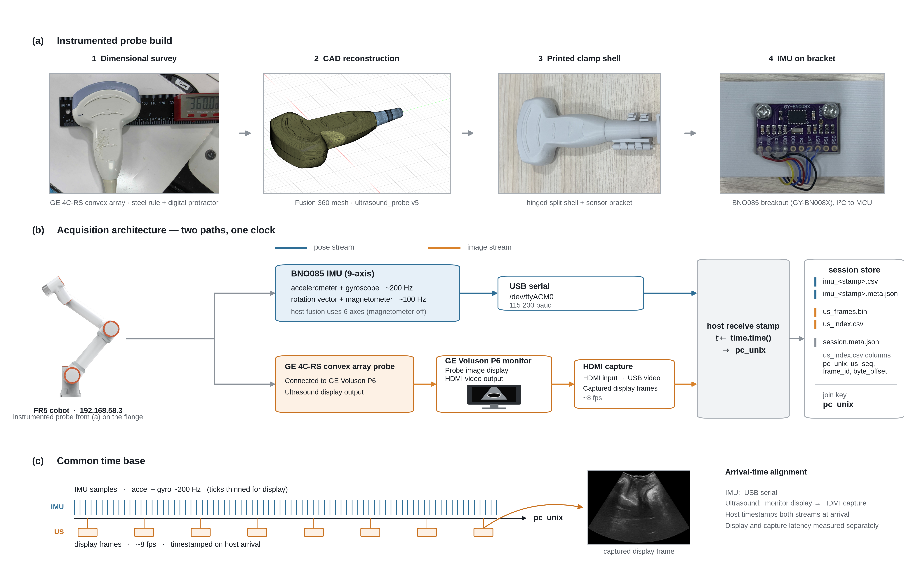
Figure 1. Sonologger acquisition. (a) Build of the instrumented probe: dimensional survey of the GE 4C-RS convex array, CAD reconstruction, printed hinged split clamp shell with sensor bracket, and the BNO085 breakout on that bracket. (b) Acquisition architecture: the inertial stream reaches the host over USB serial while the ultrasound stream leaves the scanner as display video, is digitized by an HDMI capture device, and arrives as captured display frames; both are stamped with the host clock on arrival and stored in one session directory whose join key is pc_unix. (c) The resulting common time base. The arm in (b) is the bench fixture used in Section 3, not part of the acquisition path.
2.4. Inertial acquisition and orientation estimation
The IMU is a BNO085 on a microcontroller board. Firmware requests calibrated accelerometer and gyroscope reports at 200 Hz each and calibrated magnetometer and on-chip rotation-vector reports at 100 Hz; records are framed with an 8-bit cyclic redundancy check, carry a device timestamp in microseconds, and reach the host over USB serial at 115,200 baud. Host-side attitude is estimated with a Madgwick attitude-and-heading reference filter [16] in a north-west-up earth frame; with no magnetometer vector supplied it uses the six-axis update, which is the configuration the platform runs, for reasons measured in Section 3.3. Each logged row nevertheless retains the raw and calibrated magnetometer vectors, the host and on-chip quaternions and the sensor's calibration status, so this choice can be revisited offline without re-acquiring data.
2.5. Reference-pose calibration
Filtered attitude is referenced to the earth frame and therefore bears no fixed relation to the patient, the bed or the scanner. Every session begins with a short stationary hold defining a reference from which subsequent orientation is read:
R_{rel}(t) = R₀^{T} R(t), q_{rel}(t) = q₀⁻¹ ⊗ q(t) (1)
Here R(t) ∈ SO(3) is the estimated rotation from the sensor frame to the earth frame at time t and q(t) the corresponding unit quaternion; R₀ and q₀ are their values during the reference hold; R₀^{T} denotes matrix transpose, q₀⁻¹ the conjugate of the unit quaternion q₀, and ⊗ quaternion multiplication. R_{rel}(t) and q_{rel}(t) are two representations of the same quantity: the rotation accumulated since the reference. The hold is accepted only if gyroscope standard deviation and mean are below 0.005 rad/s and accelerometer standard deviation is below 0.15 m/s²; a failing hold is refused and reported rather than silently recorded, because a reference captured during motion is indistinguishable from a valid one in the log. The same hold estimates the earth-frame accelerometer bias, whose magnitude is reported as a measured gravity value and a scale error.
Equation (1) yields relative orientation only; it does not provide probe position. A pose state T_{probe}(t) ∈ SE(3), should a later control stage require one, would have to come from an additional modality — robot kinematics, an external tracker, or image-based motion estimation — and is named here only as a future or externally augmented representation. The present IMU-only configuration does not produce it.
2.6. Time synchronization and frame–motion association
The two streams reach the host by different physical routes and at different rates. They are placed on one axis by the simplest available means: the host reads its own Unix clock as each record completes and writes that value, pc_unix, into both logs. Association is a join on that key — for each ultrasound frame, the inertial records nearest in pc_unix. Two properties of the scheme are stated in the session metadata rather than left implicit. First, it is arrival-time alignment: residual drift between host and device clocks is measurable from the device timestamp and correctable after the fact. Second, the fixed end-to-end delay of the ultrasound path — beamforming, display refresh, capture, USB transport — is not removed by arrival stamping and has not yet been measured [TO BE CONFIRMED: ultrasound display-to-host latency]; being a fixed delay rather than jitter, it appears as a constant image-to-motion offset and can be compensated once measured against a common physical event.
2.7. Session organization
A session is one directory holding the per-sample inertial log as CSV with a sidecar metadata file, the ultrasound frames as one concatenated binary store, a per-frame index (host timestamp, sequence number, frame identifier, byte offset), and session metadata naming the shared time axis, the join key and the known caveats. The inertial log carries raw and calibrated inertial and magnetic vectors, host and on-chip attitude, the reference-relative orientation of Equation (1), and per-sample calibration status, so every estimator choice in this paper can be reversed offline.
2.8. Intended conversion to robotic learning data
Figure 3 shows how recorded sessions are intended to become training data and how a resulting policy would be embedded in a control stack. Sessions would be segmented into brackets bounded by stillness, so that net motion within a bracket is observable even where per-step velocity labels are not, and each bracket treated as one action chunk paired with a short window of raw frames and the recorded state. This pipeline is a design: it has not been trained on Sonologger data, and no component of the control stack in Figure 3b has been evaluated with a policy learned from this platform.
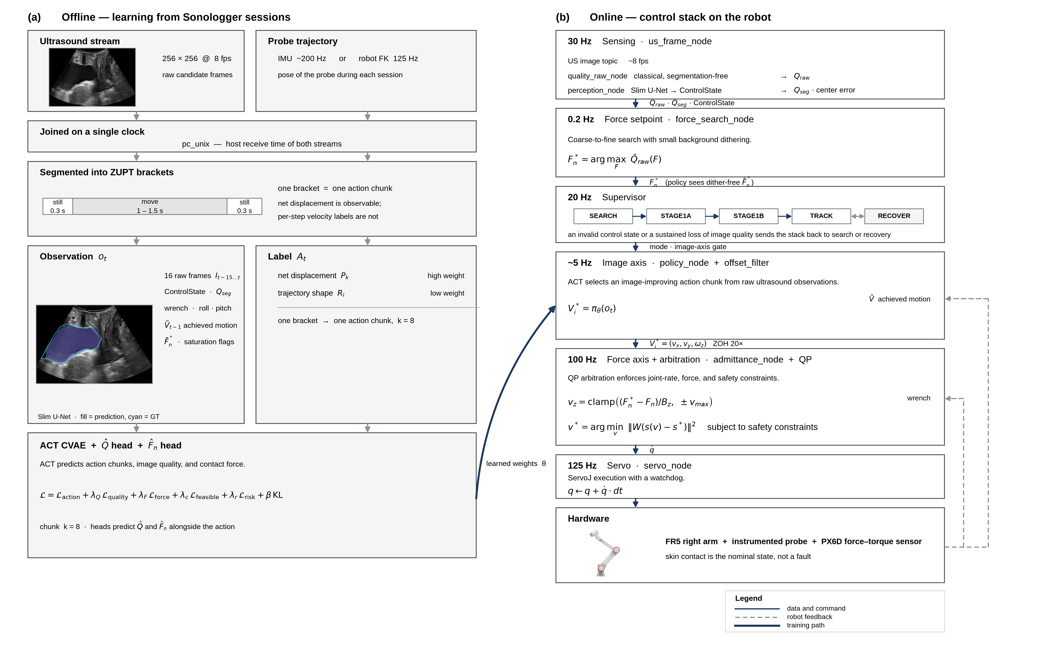
Figure 3. Intended downstream use of Sonologger sessions — a planned workflow, not a result. (a) Offline: sessions joined on the host clock, segmented into stillness-bounded brackets, and converted into observation–action chunks for policy training. (b) Online: the control stack such a policy is intended to drive. No policy has been trained on Sonologger data and no component of (b) has been evaluated with one; the quantities shown are design targets from the system specification.
3. System Demonstration and Preliminary Evaluation
3.1. Synchronized acquisition
This section reports what was measured; it evaluates neither a learned policy, nor image quality, nor clinical performance, none of which was attempted. Five bench sessions were recorded and three contain both streams. In the longest, 776 ultrasound frames were captured over 96.9 s — 8.00 frames per second, median inter-frame interval 125.9 ms — alongside 24,471 inertial records over 97.0 s, a mean logged rate of 252 Hz. Every frame carries a host timestamp on the same axis as every inertial row, so the frame-to-motion join is direct and needs no interpolation of one stream onto the other's nominal grid. No dropped frame or reconnection event was recorded. These particular sessions were captured with the host collector reading 256 × 256 frames from a research image front end; the host timestamping and join logic are identical for either front end, but no session recorded through the HDMI display path of Figure 1b is yet stored [TO BE CONFIRMED: end-to-end sessions through the HDMI capture path].
3.2. Orientation fidelity against robot ground truth
To characterize the orientation channel against an independent reference, the instrumented probe was mounted on the flange of a six-degree-of-freedom collaborative arm and the arm teleoperated through a probing-like rhythm — position, press, hold at least 1.5 s while looking at the image, move on. Robot forward kinematics served as ground truth at approximately 144 Hz while the IMU logged at approximately 253 Hz. Pairing between the two logs was complete, with −25 ppm clock skew and a pairing residual 95th percentile of 4.9 ms, so the attitude error below is not a timing artefact.
Over an 83.8-s block the effective latency of the orientation channel was −22.8, −21.1 and −6.6 ms for tilt x, tilt y and axial rotation, with cross-correlations of 0.997, 0.999 and 1.000 against ground truth (Figure 2a–b). After latency correction, angular RMS errors were 1.14°, 0.73° and 1.95° for the three channels (95th percentiles 2.23°, 1.29°, 2.57°; Figure 2c). Tilt magnitude — the quantity setting the inclination of the imaging plane — had an RMS error of 0.42°. Treating the rotation as a whole, the geodesic attitude error was 2.50° RMS. Heading drift over the block was 0.23°/min and the static alignment residual across seven stationary poses 0.81° RMS.
Against acceptance criteria fixed before the run, alignment residual, latency, cross-correlation, heading drift and displacement error floor all passed, while the geodesic attitude RMS of 2.50° exceeded the 2.0° limit set for it. We report that outcome as recorded rather than adjusting the threshold; the per-channel errors that matter most for image-plane orientation are below 2°, and the discrepancy is concentrated in the axial-rotation channel.
3.3. Why the magnetometer is disabled
The same raw recordings were re-processed with and without magnetic information. The on-chip nine-axis rotation vector was worse on every rotational channel — 11.23° against 1.95° in axial rotation (×5.8), 6.17° against 1.14° in tilt x (×5.4), 3.98° against 0.73° in tilt y (×5.4) and 0.70° against 0.42° in tilt magnitude (×1.7) — and its static alignment residual was 6.68° against 0.81° (×8.2), its heading drift 8.29°/min against 0.23°/min (×36.1).
The cause was localized rather than assumed. A test searching for stationary pairs of equal attitude but different position — pairs for which any sensor-fixed distortion model must predict an identical field — found no usable pair across three blocks, and a fitted model left residuals up to 9.6 times the sensor noise with direction errors up to 56.8° in one block. The field varied with position, not merely with sensor attitude, which is the regime in which magnetometer calibration cannot help [17]. We therefore run with the magnetometer disabled and accept that absolute heading is then unobservable — precisely why orientation is reported relative to a per-session reference pose (Equation 1): the platform claims rotation since a known stationary moment, not a compass bearing.
3.4. What the platform does not measure
Applying zero-velocity-updated double integration to stationary segments gives an error floor of 0.25, 0.67, 1.97 and 6.32 mm for integration windows of 0.5, 1, 2 and 5 s; without bias removal and zero-velocity updates the same windows give 12.4, 49.5, 197.8 and 1236.5 mm (Figure 2e). On 21 actual moving segments of 20–115 mm travel, displacement error was one to two orders of magnitude above that floor and grew with segment duration (Figure 2d, f), consistent with an independent bench measurement of the same sensor. Sonologger therefore records probe orientation; it does not record probe displacement, and no such claim is made.
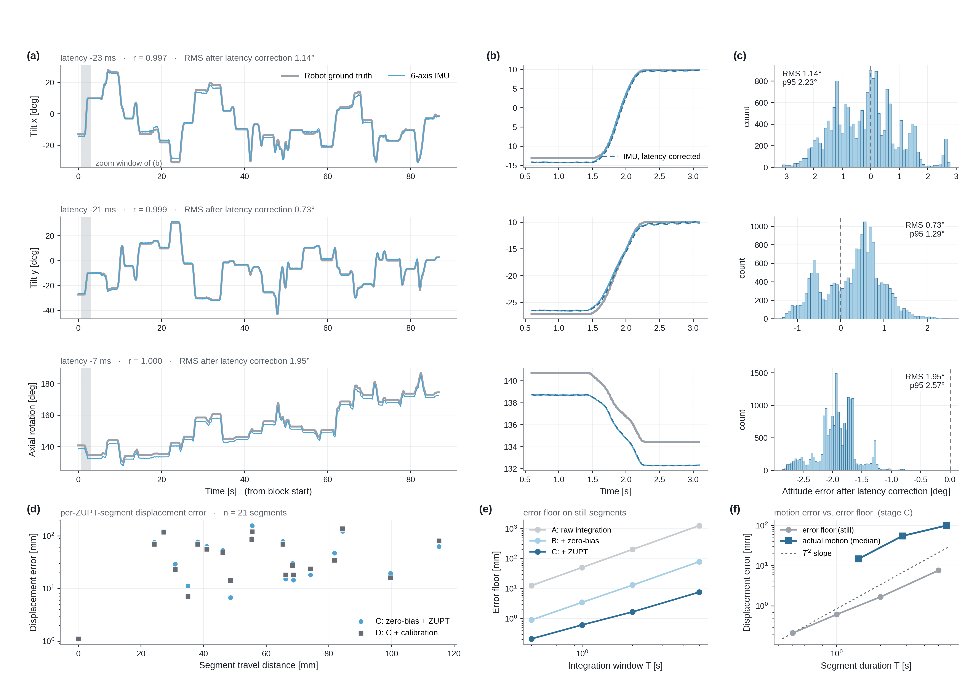
Figure 2. Orientation and displacement of the magnetometer-free channel against robot forward-kinematics ground truth over an 83.8-s teleoperated probing block. (a) Time series per rotational channel, annotated with effective latency, cross-correlation and latency-corrected root-mean-square (RMS) error. (b) Detail of the shaded window after latency correction. (c) Distribution of the latency-corrected attitude error. (d) Displacement error per zero-velocity-bounded segment against travel distance (n = 21). (e) Displacement error floor on stationary segments, for four integration windows and three correction stages. (f) That floor against the error actually incurred while moving. Panels (d)–(f) are the basis for the statement that the platform records orientation and not displacement. The motion is robot-actuated, not a clinician's hand.
4. Discussion
Nothing in the acquisition path is specific to a robot or to a laboratory. The clamp shell is added to an existing probe and removed after the session, the scanner is used unmodified and observed only through its display output, and the sensor is a USB device. Demonstrations can therefore be recorded where the procedure actually takes place and by the clinician who is otherwise the only source of the skill. In the intended clinical direction — bladder ultrasound monitoring during HoLEP morcellation — recording is passive and non-interventional: the existing surgical workflow is preserved, no additional manipulation or examination is requested, and no robot, force–torque sensor or automatic contact-force control is applied to a research subject. No clinical data have been collected and the ethics application is in preparation.
Relative to robotic ultrasound systems [1–4], Sonologger is not a robot and performs no control; it removes the robot from the data-collection stage only, and the broader research programme it belongs to does involve one. Relative to freehand three-dimensional ultrasound [11–13], we attempt no volume reconstruction and claim none of the position accuracy that would require. Relative to inertial motion capture [14–16,18], the contribution is not the estimator — a standard Madgwick implementation — but its pairing with clinical display video on one host clock and a measured account of what that pairing does and does not resolve. Relative to robot-free demonstration collection in manipulation [10], the argument is transferred to a domain where the action is largely a rotation of an imaging plane.
Several limitations bound what this platform can currently support.
• Display-capture rate. At approximately 8 fps, rapid probe motion is undersampled relative to the scanner's own frame rate, and the recorded image is the rendered display, so machine post-processing and overlays are baked in and beamformed data are unavailable.
• Arrival-time uncertainty. Inter-stream clock skew is small and correctable, but the fixed ultrasound path delay is neither removed by arrival stamping nor yet measured, so frame-to-motion association carries an unknown constant offset.
• Orientation limits. The reported errors come from robot-actuated motion over blocks of roughly 84 s, not from a clinician's hand over a whole procedure. With the magnetometer disabled only drift relative to the session reference is meaningful, and the 0.23°/min figure was measured in one environment.
• No translation and no complete pose (Section 3.4). Any application requiring T_{probe}(t) ∈ SE(3) must add a modality.
• No downstream validation. No policy has been trained on Sonologger data, and no segmentation or image-quality result is claimed.
• Bench data only. There is no operator study, no case series and no clinical dataset.
Next steps follow from that list: measure the ultrasound end-to-end latency against a common physical event so the constant offset can be removed; record freehand sessions with a clinician under an approved protocol; and determine empirically whether relative orientation paired with the image is sufficient supervision for the target task, or whether the translational component must come from another modality.
5. Conclusion
Sonologger records clinical ultrasound video and on-probe inertial motion on a single host clock, using an unmodified scanner and probe and requiring no robot, no external tracker and no dedicated room. Bench sessions demonstrate stable simultaneous acquisition at approximately 8 frames and 252 inertial records per second on a shared time axis, and comparison against robot forward kinematics places the latency-corrected angular error of the magnetometer-free channel between 0.4° and 2.0° on the axes that determine image-plane orientation. The platform supplies relative orientation from a stationary reference, not translation and not complete pose. Whether such recordings suffice to train a robotic ultrasound policy is an open question and the subject of future work.
Declarations
Ethics approval. No human-subject data were collected for this work; all recordings reported here are bench sessions. The planned clinical extension is a non-interventional observational study and will not begin before institutional review board approval [TO BE CONFIRMED: IRB name and approval number]. Funding. [TO BE CONFIRMED: funding source and grant number]. Conflicts of interest. [TO BE CONFIRMED: declaration]. Data and code availability. [TO BE CONFIRMED: repository URL and access policy]. Author contributions. [TO BE CONFIRMED: CRediT statement].
References
1. Priester AM, Natarajan S, Culjat MO. Robotic ultrasound systems in medicine. IEEE Trans Ultrason Ferroelectr Freq Control. 2013;60(3):507–523.
2. von Haxthausen F, Böttger S, Wulff D, Hagenah J, García-Vázquez V, Ipsen S. Medical robots for ultrasound imaging: current systems and future trends. Curr Robot Rep. 2021;2:55–71.
3. Li K, Xu Y, Meng MQ-H. An overview of systems and techniques for autonomous robotic ultrasound acquisitions. IEEE Trans Med Robot Bionics. 2021;3(2):510–524.
4. Jiang Z, Salcudean SE, Navab N. Robotic ultrasound imaging: state-of-the-art and future perspectives. Med Image Anal. 2023;89:102878.
5. Robles et al. [TO BE CONFIRMED: full author list with initials, title, volume and pages]. J Endourol. 2025.
6. Tzou et al. [TO BE CONFIRMED: full author list with initials, title, volume and pages]. Urology. 2020.
7. Argall BD, Chernova S, Veloso M, Browning B. A survey of robot learning from demonstration. Robot Auton Syst. 2009;57(5):469–483.
8. Ravichandar H, Polydoros AS, Chernova S, Billard A. Recent advances in robot learning from demonstration. Annu Rev Control Robot Auton Syst. 2020;3:297–330.
9. Zhao TZ, Kumar V, Levine S, Finn C. Learning fine-grained bimanual manipulation with low-cost hardware. In: Proceedings of Robotics: Science and Systems (RSS); 2023.
10. Chi C, Xu Z, Pan C, Cousineau E, Burchfiel B, Feng S, Tedrake R, Song S. Universal Manipulation Interface: in-the-wild robot teaching without in-the-wild robots. In: Proceedings of Robotics: Science and Systems (RSS); 2024.
11. Prager RW, Gee A, Berman L. Stradx: real-time acquisition and visualization of freehand three-dimensional ultrasound. Med Image Anal. 1999;3(2):129–140.
12. Housden RJ, Treece GM, Gee AH, Prager RW. Sensorless reconstruction of unconstrained freehand 3D ultrasound data. Ultrasound Med Biol. 2007;33(3):408–419.
13. Prevost R, Salehi M, Jagoda S, Kumar N, Sprung J, Ladikos A, Bauer R, Zettinig O, Wein W. 3D freehand ultrasound without external tracking using deep learning. Med Image Anal. 2018;48:187–202.
14. Foxlin E. Pedestrian tracking with shoe-mounted inertial sensors. IEEE Comput Graph Appl. 2005;25(6):38–46.
15. Skog I, Händel P, Nilsson J-O, Rantakokko J. Zero-velocity detection — an algorithm evaluation. IEEE Trans Biomed Eng. 2010;57(11):2657–2666.
16. Madgwick SOH, Harrison AJL, Vaidyanathan R. Estimation of IMU and MARG orientation using a gradient descent algorithm. In: Proceedings of the IEEE International Conference on Rehabilitation Robotics (ICORR); 2011. p. 1–7.
17. de Vries WHK, Veeger HEJ, Baten CTM, van der Helm FCT. Magnetic distortion in motion labs, implications for validating inertial magnetic sensors. Gait Posture. 2009;29(4):535–541.
18. Sabatini AM. Estimating three-dimensional orientation of human body parts by inertial/magnetic sensing. Sensors. 2011;11(2):1489–1525.

