Constant-Force Contact Regulation for Robotic Ultrasound: A Placebo-Controlled Phantom Validation
Seong Jeong^{1,2,3}, Minsung Kim^{2,3,4}, Dongho Yee^{2,3,4}, Yechan Seo^{1,2,3}, Juahn Oh^{1,2,5}, Hyoun-Joong Kong^{1,5,6,*}
¹ Department of Medicine, Seoul National University, Seoul, Republic of Korea; ² Department of Transdisciplinary Medicine, Seoul National University Hospital, Seoul, Republic of Korea
³ Rosota Inc., Seoul, Republic of Korea; ⁴ Department of Mechanical Engineering, Seoul National University, Seoul, Republic of Korea
⁵ Eulji University College of Medicine, Daejeon, Republic of Korea; ⁶ ICMIT, Seoul National University Hospital, Seoul, Republic of Korea
*Corresponding Author

Abstract: A robotic ultrasound probe must be pressed with a force that is acoustically sufficient, safe, and stable against a surface that moves. We validated the one-axis admittance force hold of a 6-DoF robotic ultrasound platform on an abdominal phantom driven by a 500 mL syringe. Eight setpoints from 0.5 to 4.0 N were held for 30 s each across 2 independently calibrated sessions (16 holds), and every band then received the same syringe routine twice — once with force hold enabled and once with it disabled, the probe left in contact. The placebo arm makes an unchanged force attributable to control rather than to a disturbance that was never large. Holding error was 0.028 N SD (0.021–0.073 N), every hold inside the ±0.05 N deadband and at the sensor's own ±0.05 N per-axis noise floor. Against 4.6 s syringe steps the peak excursion with the loop enabled (median 0.71 N) was not smaller than without it (0.64 N; rank-sum p = 0.04, n = 70 per arm over 0.5–3.5 N), though the loop did move and recovered 38% of each deviation against 10% open-loop. The loop holds a commanded force to its sensor's resolution; its rejection bandwidth, set by the damping that removed a limit cycle, lies below the rate tested.
Keywords: robotic ultrasound, contact force control, admittance control, patient safety, placebo-controlled validation, phantom study

I. Introduction
An ultrasound robot must keep the probe's contact force inside a narrow window: too little breaks acoustic coupling, too much deforms the anatomy being imaged and becomes a safety problem [1, 2]. Force-controlled probe holders are usually reported with a trace showing the force near its setpoint while the surface moved [3, 4], but that is not evidence of regulation — a compliant abdomen displaced by a few millimetres may never generate a large force, and an arm frozen in contact would give the same trace. We therefore measure holding accuracy over an eightfold range of setpoints and repeat every disturbance with the force hold switched off.
II. Methods
A 6-DoF collaborative arm (FR5) carries the ultrasound probe with a six-axis force/torque sensor at the wrist, streamed at 1 kHz. Every threshold, metric and safety limit applies to the contact-force magnitude ‖F‖ — the scalar the regulator itself compares against its setpoint. The phantom is a water-filled abdominal model whose volume is driven through a 500 mL syringe, lifting and dropping the surface under the probe. The probe axis is closed by a one-axis admittance regulator: with error e = F_{ref} − ‖F‖ and deadband δ,
v_{z} = e / B_{z} for |e| > δ, v_{z} = 0 otherwise (1)
where v_{z} is the probe-axis velocity (positive toward tissue). Start and stop use different thresholds (δ and 0.2δ) so the loop converges to the setpoint instead of parking on the band edge. Advance is forbidden above 4.5 N and the arm retreats at 5 mm/s above 5.0 N, whether or not force hold is enabled. Deployed tuning: B_{z} = 4500 N·s/m, δ = 0.05 N.
Eight setpoints (0.5–4.0 N in 0.5 N steps) were run back to back, each with three captures: A, an undisturbed 30 s hold; B, ten 500 mL syringe steps (five in, five withdrawn) with force hold enabled; C, the same routine with it disabled — the placebo arm, the probe left in contact. A working zero was taken at the test pose each session and the first 3 s after contact entry discarded as approach transient; holds from a second session at the same tuning are pooled (16 holds, 2 sessions). Hold quality is the SD of ‖F‖ about the setpoint, band-width independent and so comparable across setpoints; disturbance response is each step's peak |‖F‖ − F_{ref}|, the fraction of it recovered by the step's end, and the probe travel that separates a robot absorbing the disturbance from a phantom relaxing on its own.
III. Results
Steady-state hold. All 16 holds sit inside the ±0.05 N deadband (worst mean error 0.049 N), with 0.028 N SD on average and 0.073 N at worst (Table 1, Figure 1); the force is inside the band 87% of the time, and relative error falls from 6.3% of setpoint at 0.5 N to 0.8–1.4% at and above 3 N. That scatter is the sensor's own ±0.05 N per-axis noise floor, so it is bounded by the instrument rather than the controller, and the two separately calibrated sessions agree within 0.047 N. The negative bias is the deadband as designed: the regulator stops inside the band.

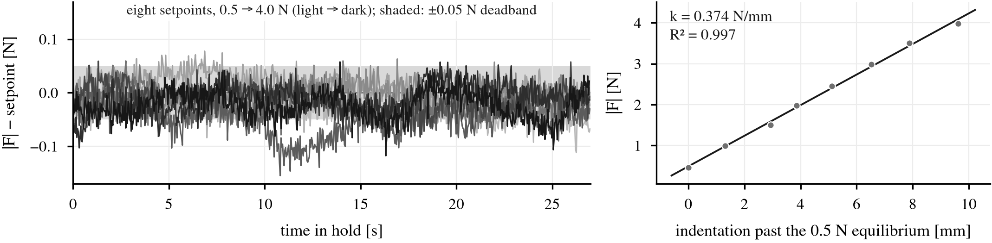
Figure 1. (a) Every hold of one session as error from its own setpoint, over the 27 s scored after the entry transient. (b) The eight steady-state equilibria and their fit — the phantom, measured by the holds.

Table 1. Constant-force hold by setpoint; each row pools two 30 s holds from two independently calibrated sessions. SD is band-width independent, so rows are comparable.
Target [N] | SD [N] | Mean error [N] | In band [%] | Peak ‖F‖ [N]
0.5 | 0.023 | -0.017 | 89 | 0.60
1.0 | 0.022 | -0.013 | 84 | 1.10
1.5 | 0.022 | -0.012 | 94 | 1.57
2.0 | 0.026 | -0.016 | 90 | 2.09
2.5 | 0.029 | -0.031 | 73 | 2.59
3.0 | 0.026 | -0.015 | 90 | 3.10
3.5 | 0.025 | -0.008 | 94 | 3.59
4.0 | 0.049 | -0.025 | 83 | 4.36

Disturbance, against its own control. The 8 steady-state equilibria lie on a straight force-indentation line (k = 0.374 N/mm, R² = 0.997 over 9.6 mm), a controller-independent measurement of the phantom that turns each syringe step into surface motion: the median open-loop step of 0.89 N is 2.4 mm of travel. Steps arrived every 4.6 s (median) and the force peaked 3.1 s after onset. Peak excursion with the loop enabled was not smaller than with it disabled: median 0.71 N against 0.64 N over 0.5–3.5 N (70 events per arm, rank-sum two-sided p = 0.04); over all eight bands, 0.74 against 0.70 N (p = 0.11). Band by band the direction is inconsistent (ratio of medians 0.72–1.07), so the finding is no demonstrated rejection at this forcing rate, not harm from control. The loop was nevertheless acting: it travelled 0.17 mm per event against 0.01 mm frozen and recovered 38% of each deviation by the step's end against 10% (Table 2, Figure 2).
Table 2. Disturbance response over 0.5–3.5 N against the placebo arm — same phantom, contact point and routine. The 4.0 N band is excluded: the forced retreat fired in both arms.
Metric (per syringe step) | Hold on | Hold off
Peak |‖F‖ − target| [N], median (IQR) | 0.71 (0.58–0.95) | 0.64 (0.51–0.77)
Deviation recovered by step end [%] | 38 | 10
Probe travel, |peak| [mm] | 0.17 | 0.01
Steps returning inside the band | 3/70 | 0/70

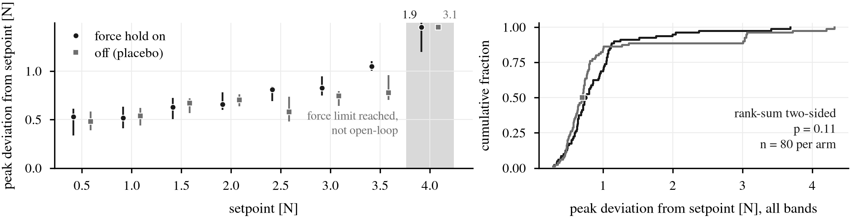
Figure 2. Placebo-controlled disturbance response. (a) Peak deviation per syringe step, median and IQR, force hold on against off; the safety-contaminated 4.0 N band is shaded, its medians printed above the axis. (b) Both arms' distributions.

Safety layer. Undisturbed holds stayed 0.4 N below the 4.5 N warning; under disturbance it was reached in 4 runs and the 5.0 N limit crossed in 2 — the 4.0 N band in both arms, peaking at 5.38 N — where the forced retreat fired and capped it, in the placebo arm as well.
IV. Discussion and Conclusion
The loop holds a commanded contact force across an eightfold range of setpoints to within its own sensor's noise — the precondition for using a fixed force as an operating point. Its rejection at 4.6 s forcing is indistinguishable from none, a bandwidth statement about this tuning rather than a defect: the closed-loop time constant B_{z}/k is 12 s at the stiffness measured here, so the force peaks long before the loop can answer. B_{z} was raised to 4500 N·s/m to remove a sustained limit cycle seen at 1000 and 3000 N·s/m (hold SD 0.31 and 0.17 N against 0.03 N here): precision and bandwidth were traded knowingly, and quasi-static drift (tissue relaxation, bladder filling) falls inside this bandwidth while respiration-rate motion does not. Limitations: one contact point and angle, a phantom less viscoelastic than tissue, and a top band shaped by the safety layer. The placebo arm is the transferable part: without it this dataset would have supported the rejection claim it refuses.
References
1. Z. Jiang, S. E. Salcudean, N. Navab. Robotic ultrasound imaging: State-of-the-art and future perspectives. Med. Image Anal. 2023;89:102878.
2. C. Hennersperger, B. Fuerst, S. Virga, et al. Towards MRI-based autonomous robotic US acquisitions: A first feasibility study. IEEE Trans. Med. Imaging 2017;36(2):538–548.
3. M. W. Gilbertson, B. W. Anthony. Force and position control system for freehand ultrasound. IEEE Trans. Robot. 2015;31(4):835–849.
4. P. Chatelain, A. Krupa, N. Navab. Confidence-driven control of an ultrasound probe. IEEE Trans. Robot. 2017;33(6):1410–1424.

