Operator Guidance from Bladder-Lumen Segmentation in Robotic Transabdominal Ultrasound for HoLEP Morcellation: Effective Range of an Image-Quality Function and the Instruction Set It Supports
Seong Jeong^{1, 2, 5}, Minsung Kim^{1,2,4}, Dongho Yee^{1,2,4}, Yechan Seo^{1,2,5}, Juahn Oh^{1,2,3}, Hyoun-Joong Kong^{1,2,5,*}
¹ Department of Transdisciplinary Medicine, Seoul National University Hospital, Seoul, Republic of Korea
² Rosota Inc., Seoul, Republic of Korea
³ Eulji University College of Medicine, Daejeon, Republic of Korea
⁴ Department of Mechanical Engineering, Seoul National University, Seoul, Republic of Korea
⁵ Department of Medicine, Seoul National University, Seoul, Republic of Korea

Abstract
A segmentation model turned toward device control is usually judged by an accuracy figure. We argue that for an image-quality function built on such a model the decisive property is instead its effective range — the interval of values it actually takes on real frames — because that interval, divided by the function's own noise, bounds how many distinct instructions can honestly be issued from it. We characterise a control-quality function Q defined on a U-Net bladder-lumen segmentation. As originally specified Q attains [0.70, 1.00], 30% of its nominal domain, and its central 80% spans 0.12; three of its eight sub-scores are degenerate, one occupying an interval 0.007 wide. Reformulating the aggregation and weighting toward the terms that read the image widens the attained range to [0.14, 0.78] and raises the number of resolvable levels from 9 to 47. Two of the five active sub-scores account for 92.4% of that range. We then derive, rather than choose, an instruction vocabulary for the operator — human assistant or robot alike: one boundary is physical (a lumen that is not anechoic), the other statistical (a lateral displacement below 1.64σ of the segmentation's centroid noise, σ = 4.92 px). The resulting three-word vocabulary is emitted correctly on 85.0% of frames with a 0.10% direction-error rate, and a finer vocabulary is shown to be unsupported: five words drop accuracy to 76.0%, seven to 71.0%.
Keywords — image-quality function, attained range, bladder ultrasound segmentation, operator feedback, instruction vocabulary

1. Introduction
During the morcellation phase of holmium laser enucleation of the prostate (HoLEP) an assistant holds a suprapubic probe and keeps the bladder lumen in view. A companion study established that the contact-force channel of a robotic probe holder is steady and bounded on a phantom, and marked lumen segmentation and image-guided control as components absent from the validated stack. The missing link is not a better mask: it is the path from a mask to something an operator can be told to do.
That path runs through an image-quality function. This paper studies the function, not a patient population. Frames are the sample; the object of study is Q, a transparent weighted score computed from the segmentation and the image, and the question is what set of instructions Q can support.
Our claim is that the property which decides this is the function's attained range — the interval of values it actually takes — and not its correlation with any accuracy metric. A score that is formally defined on [0, 1] but occupies a band narrower than its own frame-to-frame noise cannot separate any two decisions, however well it ranks. Range divided by noise is the number of levels available, and that number is an upper bound on the size of an honest instruction vocabulary.
2. Segmentation Model and Control State
A U-Net takes a 256 × 256 transabdominal B-mode frame and produces a lumen probability map, thresholded at 0.5 and reduced to its largest connected component with interior holes filled. Frames come from PFUS1, a retrospective transabdominal bladder dataset; the model was trained on a patient-disjoint split and reaches Dice 0.807 ± 0.123 on 1,292 held-out frames. It was not retrained or re-tuned for this study, and all measurements below are made on the two held-out frame sets (1,661 and 1,292 frames) that share no patient with training or with each other.
From the mask a control state is computed — centroid, area, boundary statistics, and lumen-to-surround intensity contrast. Every ratio is taken over the insonified sector rather than the image rectangle; the sector is not recorded in the frame metadata and was measured from the training images, covering 66.4% of the frame and agreeing with held-out frames at an intersection-over-union of at least 0.964. Without it the frame grabber's crop enters every area ratio and a mask cut by the sector edge registers as touching no edge.
3. The Quality Function
Q is a weighted mean of sub-scores, each normalised to [0, 1], every term and weight logged so that a value can be traced back to its components. Two aggregations are compared below: the arithmetic mean of the original specification, and a weighted geometric mean.
Q = exp( Σ w_{i} ln s_{i} / Σ w_{i} ) (1)
The aggregation is not a cosmetic choice. With eight terms an arithmetic mean caps the effect of one collapsed sub-score at its weight share, so a frame whose lumen contrast has vanished entirely still scores near the top of the range. A geometric mean is dominated by its smallest term, which is the shape a decision needs.
Table 1. Sub-scores of Q and what each reads. Only the first three consult the ultrasound image; the rest restate the mask or its history.
Sub-score | Reads | Definition
lumen contrast | image | (ring − lumen) / (ring + lumen), normalised
lumen centering | image | exp(−offset to the darkness centroid / 0.25)
boundary sharpness | prob. map | exp(−mean boundary entropy / 0.30)
mask completeness | mask | plateau on the lumen area ratio
segmentation confidence | prob. map | mean |2p − 1| over the sector
border penalty, component quality | mask | mask geometry (weight 0 here)
temporal terms (3) | mask history | agreement with the previous mask

The three temporal terms are switched off for this study. The frames are static examinations in which nothing moved in response to the image, so frame-to-frame agreement measures the smoothness of a recording rather than the stability of a control loop; scoring it would credit Q for a property the setting has not been asked to produce.
4. The Attained Range of Q
Q is defined on [0, 1]. On 2,953 held-out frames the original specification attains [0.70, 1.00] — a width of 0.30, or 30% of the nominal domain — and its central 80% spans only 0.12. Reformulated with the geometric aggregation and weighted toward the terms that read the image, it attains [0.14, 0.78], a width of 0.64, with a central 80% of 0.45 (Figure 2a).
Because the geometric mean is additive in the logarithm, the range decomposes exactly: each term contributes its weight share times the log-width of the interval it attains. Two sub-scores account for 92.4% of the range (Figure 2b, Table 2), and both are terms that consult the ultrasound image rather than the mask.

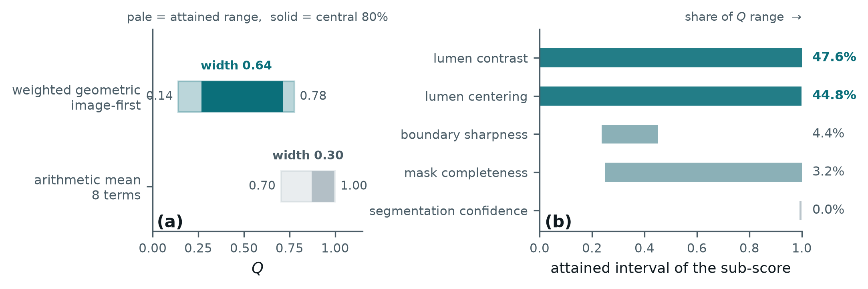
Figure 2. (a) The interval Q actually attains under the two aggregations, against its nominal domain [0, 1]. (b) The interval each active sub-score attains and its share of the resulting range. `segmentation confidence` occupies a band 0.007 wide and contributes nothing.

Table 2. Attained interval of each active sub-score and its share of the range of Q. Shares follow from the geometric aggregation and sum to 100%.
Sub-score | Weight | Attained interval | Width | Share
lumen contrast | 1.5 | 0.000 – 1.000 | 1.000 | 47.6%
lumen centering | 1.5 | 0.001 – 0.999 | 0.997 | 44.8%
boundary sharpness | 1.5 | 0.237 – 0.451 | 0.214 | 4.4%
mask completeness | 0.5 | 0.250 – 1.000 | 0.750 | 3.2%
segmentation confidence | 1.0 | 0.992 – 0.999 | 0.007 | 0.0%

The last row is the point of the section. `segmentation confidence` is not a weak term that could be rescued by more weight: it returns essentially one value, so it has no range, and a function with no range cannot participate in any decision. It carries a weight of 1.0 while contributing 0.0% of what Q can express. Two further terms — border penalty and component quality — behave the same way and are already at weight 0.
5. What the Range Permits
A range is only useful relative to the noise on it. These are static examinations, so the change in Q between adjacent frames is almost entirely measurement noise; its standard deviation is therefore a direct estimate of the function's own jitter. Dividing the attained range by that jitter gives the number of levels a reader of Q can distinguish.
Table 3. Resolution of Q: attained range over frame-to-frame jitter. The central 80% figure is the operating region a threshold would actually be placed in.
Aggregation | Range | Jitter | Levels | Central 80% | Levels
arithmetic, 8 terms | 0.296 | 0.0144 | 21 | 0.123 | 9
geometric, image-first | 0.635 | 0.0095 | 67 | 0.450 | 47

Nine levels is the quantitative statement of a failure that had previously been described only qualitatively: with the original specification, no threshold below 0.75 rejected a single frame out of 2,953, and the whole usable operating region lay between 0.85 and 0.95. Any instruction set finer than nine states would have been reporting noise. The reformulated function has room for 47.
6. From Range to an Instruction Vocabulary
The instruction is issued on the one image axis that leaves the imaging plane invariant. Of the probe's six axes only v_{x}, v_{z} and ω_{y} preserve the plane; of the three the image policy holds, only lateral sliding v_{x} does, and only it presents a measurable vector error rather than a scalar to be searched (Figure 1a). Write the instruction as ê = A − ĉ, with A the beam axis and ĉ the predicted lumen centroid abscissa (Figure 1b).

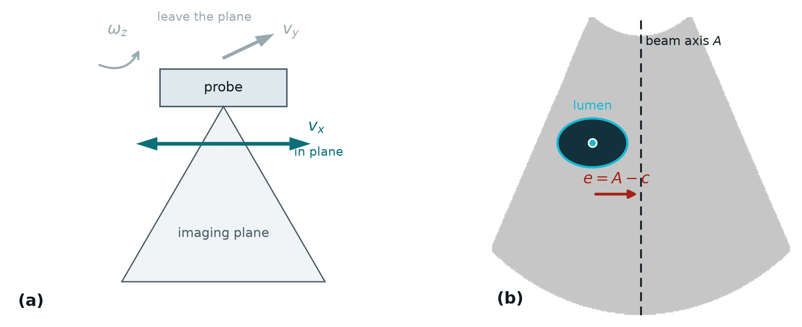
Figure 1. (a) Only v_{x} leaves the imaging plane invariant among the three axes the image policy holds. (b) The lateral instruction on one frame: A is the beam axis, c the lumen centroid abscissa, e = A − c.

Two boundaries partition the range, and neither is a fitted hyperparameter.
A physical boundary. A urine-filled lumen is anechoic, so a non-positive lumen-to-surround contrast means the delineated region cannot be one. On 13.1% of frames the contrast is non-positive; those frames have Dice 0.665 against 0.840 elsewhere. Running the platform's separate contact-quality score Q_{raw} on them shows the cause is not the force channel: Q_{raw} is 0.821 against 0.852, near-field echo and contact continuity differ by under 5%, and no contact rejection reason fires in either group. What differs is that the lumen is 1.85 times brighter and a third the area. The remedy is neither a lateral slide nor more contact force; it is upstream, in bladder filling.
A statistical boundary. The difference δ = ê − e is the segmentation's lateral centroid error, independent of where the lumen sits, with σ = 4.92 px and a bias of +0.11 px. The instruction points the wrong way exactly when δ opposes e and exceeds it, so
P(wrong direction) = Φ(−|e| / σ) (2)
and the instruction is withheld below 1.64σ = 8.1 px, where the modelled error rate reaches 5%. Below that boundary a controller that keeps acting is following its own segmentation noise; this is a stopping condition, not a defect.
Table 4. The instruction vocabulary. Both boundaries are derived — one from the physics of an anechoic lumen, one from the segmentation's centroid noise — and neither is tuned.
Instruction | Condition | Acts on
check bladder filling | contrast ≤ 0 | not the probe — filling
move left / move right | contrast > 0 and |ê| ≥ 8.1 px | lateral axis v_{x}
hold | contrast > 0 and |ê| < 8.1 px | nothing — converged

Vocabulary size is bounded by the same noise. A magnitude class narrower than 2σ cannot be assigned reliably even at its centre, and the data bear this out: adding graded magnitudes costs accuracy without buying direction (Table 5). Three words is what the function supports.
Table 5. Accuracy of the emitted instruction against the instruction the ground truth implies, over the controlled sweep of Section 7. Direction errors stay negligible; it is the magnitude classes that fail.
Vocabulary | Size | Accuracy | Direction error
move / hold | 2 | 85.1% | 0.00%
move left / move right / hold | 3 | 85.0% | 0.10%
+ two magnitude grades | 5 | 76.0% | 0.11%
+ three magnitude grades | 7 | 71.0% | 0.11%

7. Validating the Emitted Instruction
One property of the frames prevents the direction from being validated on them as recorded: in all 2,953 the lumen lies on the same side of the beam axis, so e never changes sign and a constant output would score 99.3%. The sonographer holds a diagnostic view rather than centring the lumen on the axis, which is a property of how the frames were acquired and not of the function.
The instruction is therefore exercised on laterally translated frames. Lateral translation is the one probe motion single-plane frames can reproduce faithfully, and it carries the lumen across the axis so that e changes sign; each frame is shifted by the amount that places e on a prescribed target, sampled densely near the crossing and sparsely away from it. Fabricated margin is filled by edge replication, never black, which every intensity term would read as anechoic lumen. Across the sweep the segmentation is unaffected — Dice holds at 0.858 — and 1,936 frames result, 43% with e < 0.

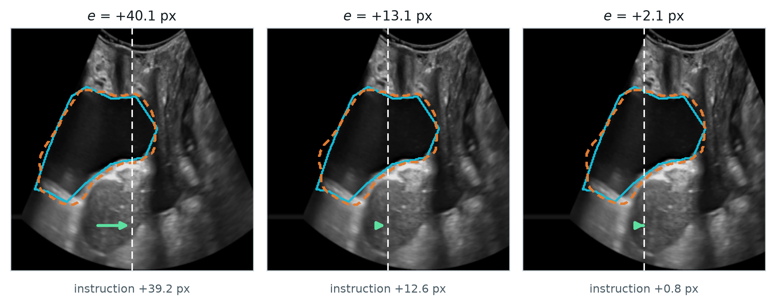
Figure 3. One frame at three lateral displacements. Cyan is the annotation, orange dashed the prediction, white dashed the beam axis, the arrow the instruction. At e = +2.1 px the instruction has collapsed to +0.8 px: the loop has entered the band where Equation (2) says the direction is no longer reliable.

The instruction agrees with the truth in 93.7% of frames, with a median magnitude error of 3.15 px, a regression slope of 0.993 and r = 0.970. A slope this close to unity means the instruction is correctly scaled and not merely directional. The two held-out frame sets agree to within 0.7 px of median error.

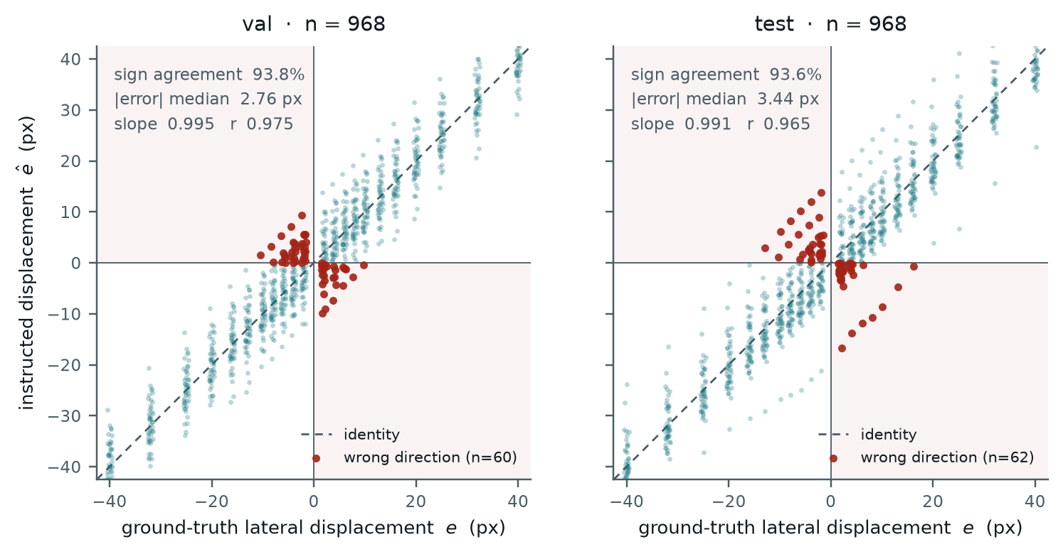
Figure 4. Instructed against ground-truth lateral displacement, one panel per held-out frame set. Shaded quadrants are wrong-direction outcomes; every one lies within a few pixels of the axis.

Table 6. Agreement between the emitted instruction and the truth.
Frame set | n | Sign agr. | |err| med. | |err| p90 | Slope | r
val | 968 | 93.8% | 2.76 | 7.35 | 0.995 | 0.975
test | 968 | 93.6% | 3.44 | 6.95 | 0.991 | 0.965
pooled | 1,936 | 93.7% | 3.15 | 7.24 | 0.993 | 0.970

The result is not that percentage but the shape of its failure. Wrong directions occur only near the axis — their median required displacement is 7.9 px against 15.8 px for correct ones — and their rate follows Equation (2) with σ fitted once to the centroid error and not to this curve (Figure 5, Table 7). Agreement across two decades of error rate is what licenses deriving the vocabulary boundary from the model rather than reading it off the data.

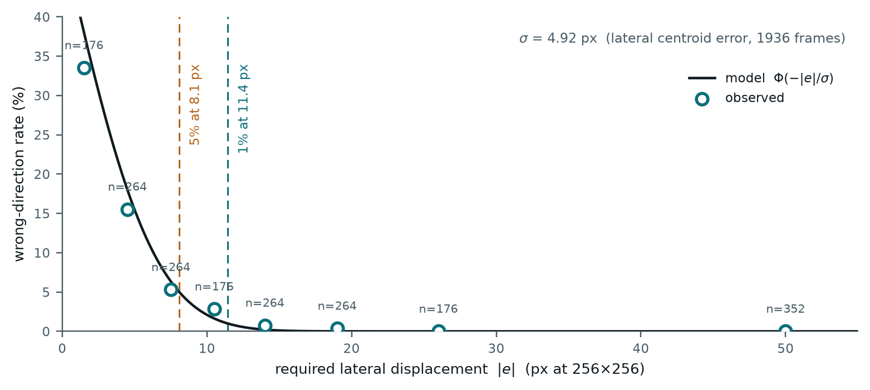
Figure 5. Wrong-direction rate against required displacement. The curve is Equation (2); circles are observed rates with frame counts. Dashed verticals mark where the modelled rate reaches 5% and 1%.

Table 7. Observed and modelled wrong-direction rates. The model is conservative in the largest bins, where it predicts rates below what a few hundred frames resolve.
|e| [px] | n | Observed | Model
0–3 | 176 | 33.5% | 34.2%
3–6 | 264 | 15.5% | 17.9%
6–9 | 264 | 5.3% | 6.9%
9–12 | 176 | 2.8% | 2.1%
12–16 | 264 | 0.8% | 0.3%
16–22 | 264 | 0.4% | 0.0%
22–30 | 176 | 0.0% | 0.0%
> 30 | 352 | 0.0% | 0.0%

The constants are stable against annotation quality. A model-blind label audit flags four of the frame sets' patients as carrying regions that cannot be lumen; recomputing without them moves σ from 4.92 to 4.67 px (−5%), sign agreement from 93.7% to 94.1%, and the 5% boundary from 8.1 to 7.7 px.
8. Discussion and Limitations
Reporting an image-quality function by its correlation with a segmentation metric answers the wrong question. Correlation says how the score orders frames; the attained range says how many decisions can be taken from it, and the two come apart. The function studied here ordered frames respectably in its original form while supporting nine distinguishable states — fewer than the instructions a controller would want to issue — and the diagnosis was invisible to any accuracy figure. Range, its decomposition, and range-over-noise are cheap to compute and we suggest reporting them for any score intended to drive a device.
The decomposition also gives a concrete design rule. A term contributing 0.0% of the range is not underweighted; it is degenerate, and the fix is to measure it somewhere the decision is hard or to remove it. Here the two terms that consult the ultrasound image carry 92.4% of the range while three mask-geometry and probability-map terms carry almost none.
Limitations.
— No real probe motion is validated. The frames are static examinations whose lumen centroid moves 0.45 px between samples, below the segmentation's own centroid error, so lateral displacement is simulated and the instruction has not been closed into a loop with a person or a robot.
— Two of the image policy's three axes are untouched: v_{y} and ω_{z} leave the imaging plane, present only a scalar quality, and cannot be simulated from single-plane frames.
— The target pose — lumen on the beam axis — is a design choice for the robotic setting. The archived frames were not acquired toward it, so the proportion of frames falling in each instruction band describes the frames, not the loop's steady state.
— No pixel spacing accompanies the frames, so σ and every derived boundary are stated at 256 × 256 and must be rescaled before they mean millimetres.
— σ is treated as one constant. Per-frame estimation would tighten the stopping boundary where the segmentation is confident and loosen it where it is not.
— The check bladder filling branch is supported by 13.1% of frames from four patients; whether the cause is under-distension or annotation is not separable here, and Q_{raw} only excludes the force channel [TO BE CONFIRMED: IRB approval number, scanner model, annotation protocol].
References
[1] S. Jeong, M. Kim, D. Yee, Y. Seo, J. Oh, H.-J. Kong. Contact-Force Regulation for Robotic Transabdominal Ultrasound in HoLEP Morcellation: Bench Validation on a Volume-Changing Phantom. Companion submission.
[TO BE COMPLETED] Citations for HoLEP morcellation, U-Net segmentation, ultrasound visual servoing and image-quality assessment are to be added before submission; no external work is cited in this draft.

