Contact-Force Regulation for Robotic Transabdominal Ultrasound in HoLEP Morcellation: Bench Validation on a Volume-Changing Phantom
[TO BE CONFIRMED: author list, affiliations, corresponding author]

1 Clinical Motivation
During the morcellation phase of holmium laser enucleation of the prostate (HoLEP), a rotating morcellator works inside a distended bladder. Keeping the bladder adequately filled and knowing where the morcellator sits relative to the bladder wall are what protect the mucosa, and transabdominal ultrasound is the bedside means of seeing both. In the workflow that motivates this work, an assistant holds a suprapubic probe and keeps the bladder lumen in view for as long as morcellation lasts.
That task is narrow but unrelenting. It is not a diagnostic sweep: the region is already known, and the work is to hold one plane while the abdominal wall moves with irrigation inflow and outflow, so that the lumen does not leave the image and acoustic coupling does not lapse. Holding it occupies a pair of hands for the duration, and image steadiness tracks the assistant's attention. A robot that maintains probe contact could return those hands to the operation without touching surgical judgement, which is the narrow question this work addresses. What follows is a benchtop system and a phantom experiment, intended to establish whether the contact-force channel is steady and bounded enough to carry forward — not to demonstrate clinical use. No patient data were collected and no part of morcellation is automated.
2 Robotic Ultrasound Platform
A six-degree-of-freedom collaborative arm (FR5) carries the probe on its flange behind a six-axis force–torque sensor (PaXini PX6D) read at 1 kHz over a dedicated USB link. The probe mounted for these experiments is a 3D-scanned replica of the clinical GE 4C-RS convex probe, reproducing its contact geometry and mass; it does not image, and no ultrasound was acquired during the force experiments reported here.
Wrenches are compensated for gravity and tool payload and referred to the probe contact point, and the controller acts on a single scalar — the contact-force magnitude ‖F‖ = √(Fx²+Fy²+Fz²) in the probe frame, signed by the normal component. Using the magnitude rather than the normal force matters at the forces of interest: a probe that lands slightly tilted puts much of the contact into shear, and a normal-force threshold would then read the contact as absent.
An admittance loop runs at 100 Hz on the probe penetration axis alone, with servo output at 125 Hz. Once contact is detected the arm drops to contact velocity limits of 10 mm/s and 0.2 rad/s. A supervisor holds a soft warning level of 4.5 N and a hard limit of 5.0 N at which the arm is driven back, together with command watchdogs that retreat the probe if operator input or robot state stops arriving. This supervisor and the force loop contain no learned or image-derived component; the force channel is deterministic and runs whether or not anything is looking at an image.
The measurement chain itself was checked against an external reference. The probe was pressed onto an electronic scale of 1 g resolution at 19 poses spanning 0.9–9.8 N, and the compensated probe normal force compared with the scale reading. Unloaded multi-pose residuals gave the gravity-compensation error separately.

Table 1. Robot system and safety-control specifications. Every entry is read from the running control stack or its configuration.
Component / parameter | Specification | Role
Robot arm | FR5, 6-DoF collaborative | Probe positioning
Mounted probe | 3D-scanned GE 4C-RS replica | Contact geometry (non-imaging)
Force sensor | PX6D, six-axis, 1 kHz | Contact-force measurement
Controlled quantity | contact-force magnitude ‖F‖ | Gravity- and payload-compensated, referred to the contact point
Admittance controller | 100 Hz, penetration axis | Contact-force regulation (servo output 125 Hz)
Linear velocity limit | 10 mm/s | Contact safety
Angular velocity limit | 0.2 rad/s | Contact safety
Warning level | 4.5 N | Supervisory warning, no advance
Force limit | 5.0 N | Forced retreat threshold
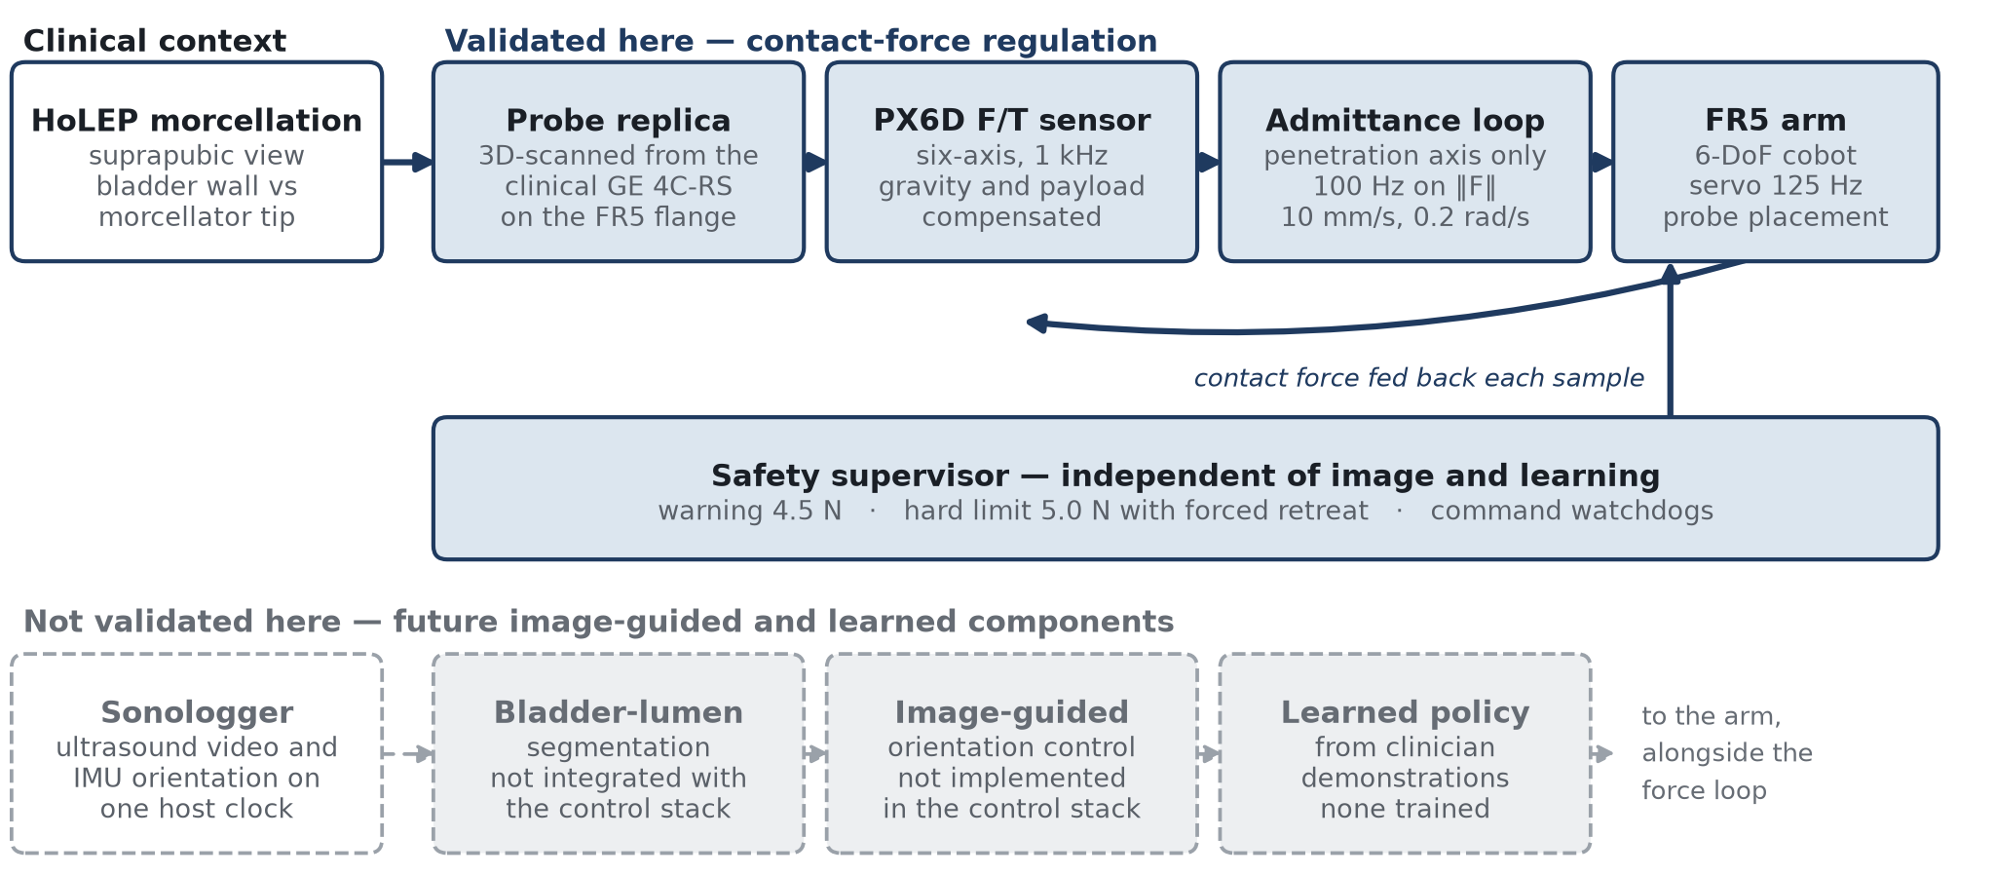
Figure 1. System architecture and clinical role. Solid dark-blue: the pathway validated in this work. Light-grey dashed: future components — bladder-lumen segmentation, image-guided orientation control and any learned policy — none of which is present in the robot control stack.

3 Phantom Force-Holding Validation
Force holding was measured on an abdominal phantom whose internal volume is set by a 500 mL syringe [TO BE CONFIRMED: phantom make and model]. Injecting and withdrawing fluid lifts and lowers the surface under the probe, which is the bench analogue of an abdominal wall moving with irrigation.
Contact probing was engaged at a fixed 0.4 N entry threshold in every run, so each setpoint received the same approach transient and the bands remain comparable. Four setpoints were held for 60 s each: 0.5, 2.0, 3.0 and 4.0 N. The deadband was ±0.15 N at 0.5 N and ±0.50 N at the others. Because the regulator commands zero velocity inside the deadband, the force settles where it first enters the band rather than at the setpoint; that entry force is reported below as the operating point, and tracking is measured against it. The first 3 s after entry are excluded as approach transient.
Disturbance runs repeated 150 mL injections and withdrawals at the same setpoints, each syringe action timestamped at its onset. A separate run drove the force up deliberately with rapid injections to probe the upper end. Every wrench sample the controller acted on was recorded at sensor rate and no signal was filtered before analysis.
4 Results
Across the four setpoints the held force had a standard deviation of 0.022–0.065 N and departed from its operating point by no more than 0.10 N. Standard deviation is independent of band width and is therefore the quantity that compares setpoints; it shows no trend across the tested range. In relative terms the loop is tighter at higher forces — 1.0–1.4 % of setpoint above 2 N against 13.0 % at 0.5 N — because the noise floor is set by the sensor rather than by the controller.
Twenty-two excursions above the deadband were recorded across two disturbance runs and one deliberate hard-press run. All of them returned inside the band; the slowest took 1.39 s, with per-run medians of 0.19–1.09 s. The highest force seen anywhere in the campaign was 4.41 N, and no run reached the 4.5 N warning level, leaving 0.59 N of margin to the hard limit at the worst point.
Flange pose logged beside force shows how the disturbance was absorbed: over one disturbance run the probe travelled 2.29 mm along its own penetration axis while the force stayed within 3.0 ± 0.5 N. The force was held by moving the arm, not by tolerating the load — a distinction that a force-only record cannot make.
Against the electronic scale the compensated force tracked the reference with slope 1.019 (95 % CI 0.975–1.064) and R² 0.993, at a mean bias of −0.293 N and RMSE 0.366 N — 3.7 % of the 9.85 N full scale — with Bland–Altman limits of agreement of −0.734 to +0.148 N. The reference is itself known only to 0.182 N, a term dominated by gravity compensation rather than by the scale (0.003 N). Absolute accuracy is therefore an order coarser than the short-term stability above. The loop repeats a force far more finely than it knows that force in absolute terms, and a setpoint chosen for tissue should be read against the accuracy figure.
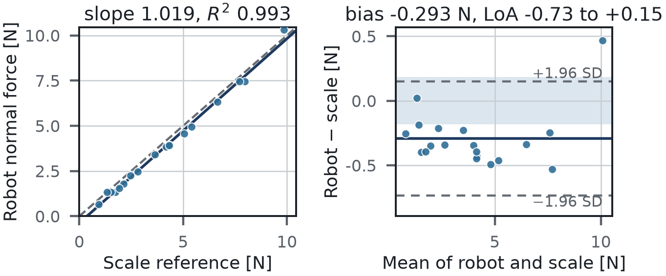
Figure 3. Compensated probe normal force against an electronic scale, n = 19 over 0.9–9.8 N. Shaded band is the combined reference uncertainty (0.182 N), which the gravity-compensation residual dominates.

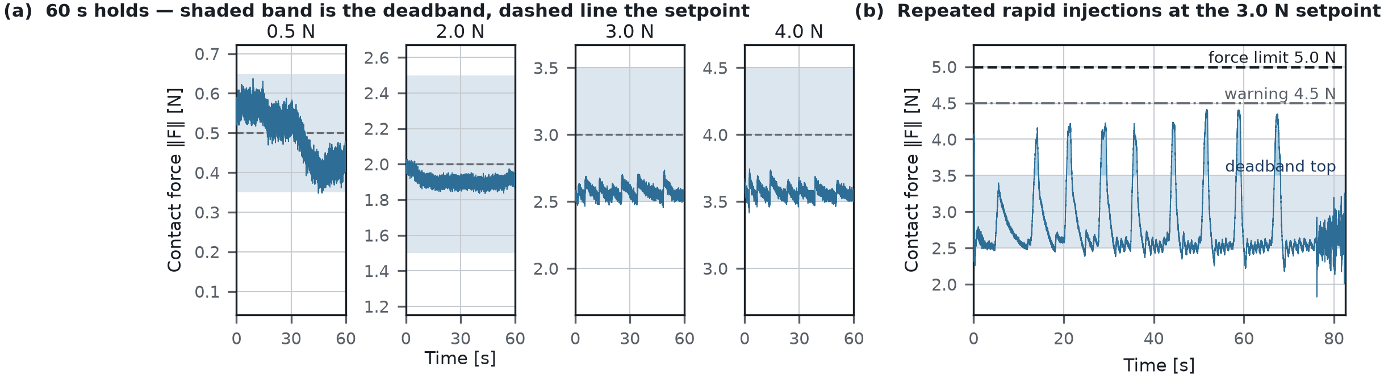
Figure 2. Force holding on the volume-changing phantom, from the recorded wrench logs. (a) 60 s holds at four setpoints; shaded band is the commanded deadband, dashed line the setpoint. (b) Hard-press run at 3.0 N: nine rapid injections, each returning inside the band; peak 4.41 N against the 5.0 N limit.
Table 2. Quantitative validation summary. All entries are bench measurements on the phantom; none is a clinical-safety claim.
Metric | Result | Interpretation
Tested force range | 0.5–4.0 N | Bench validation range
Held-force SD | 0.022–0.065 N | Short-term force stability
Deviation from operating point | ≤ 0.10 N | Operating-point stability
Band excursions recovered | 22 of 22 | All returned inside the deadband
Slowest recovery | 1.39 s | After the tested disturbance
Peak force observed | 4.41 N | Below the 4.5 N warning level
Probe-axis travel | 2.29 mm | Compensation for surface displacement
Scale-referenced bias | −0.293 N | Robot reads low against the scale (n = 19)
Scale-referenced RMSE | 0.366 N (3.7 % FS) | Absolute accuracy of the force channel
Sonologger frames / IMU records | 776 / 24,471 | Synchronized bench acquisition
Angular RMS error | 1.14°, 0.73°, 1.95° | Tilt x, tilt y, axial rotation (Sonologger)
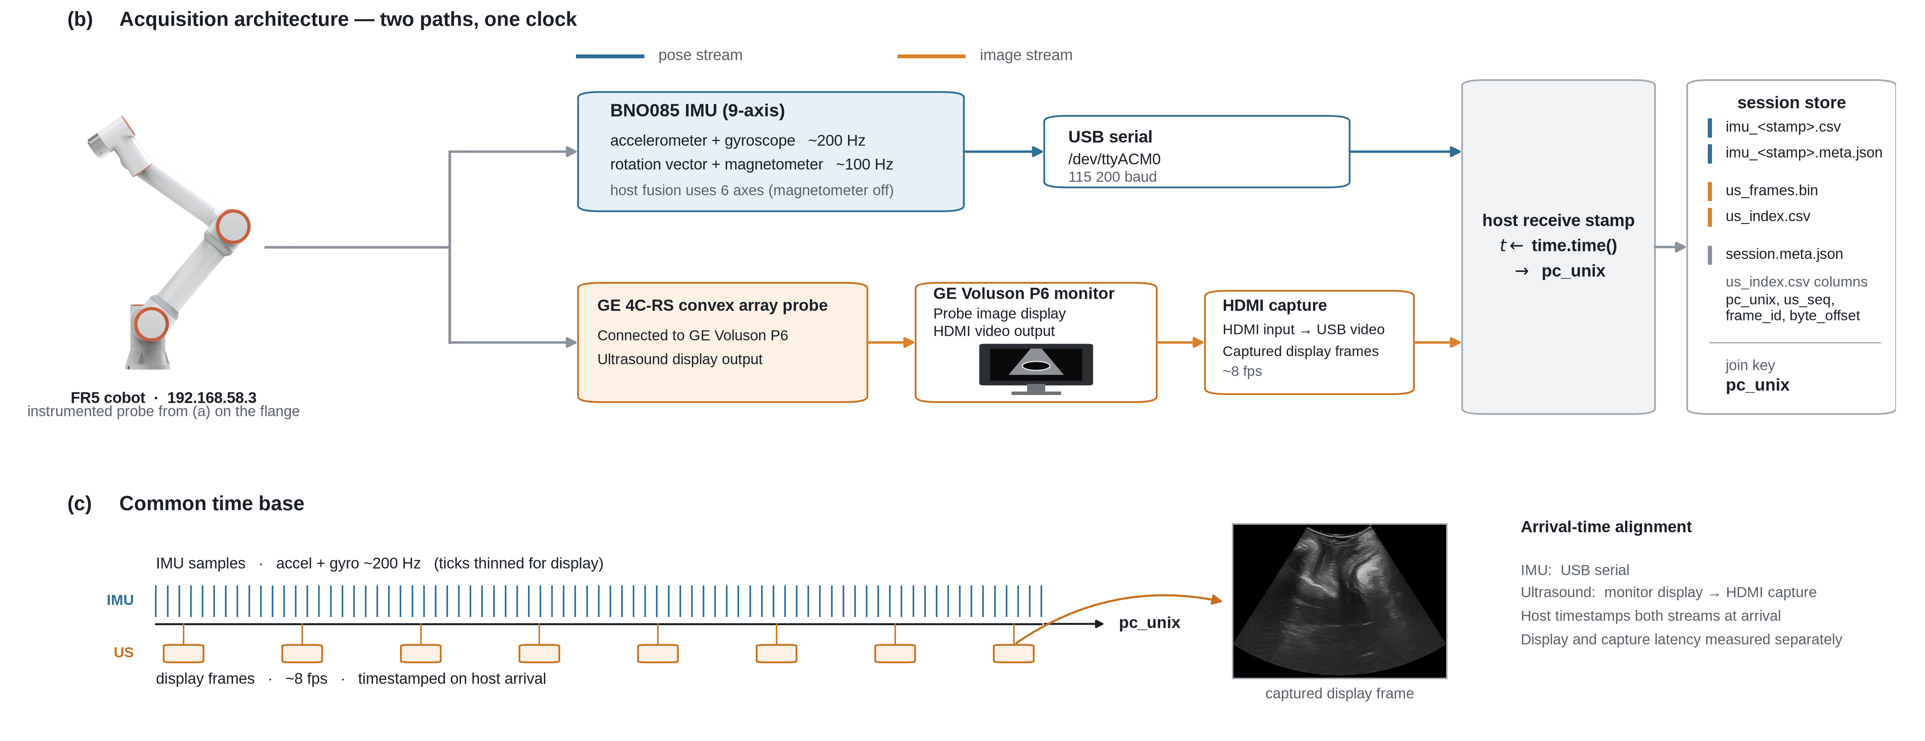
Figure 4. Sonologger acquisition — two paths, one host clock. Latency-corrected angular RMS error against robot forward kinematics was 1.14°, 0.73° and 1.95°. The IMU gives relative orientation — not translation and not absolute SE(3) pose.

5 Sonologger and Future Learning Data
Sonologger is a separate acquisition platform for the data a future image-guided or learned controller would need. A printed clamp shell fits the clinical GE 4C-RS probe and carries a BNO085 inertial measurement unit; the scanner's display output is captured over HDMI, the IMU streams over USB serial, and the host timestamps both on one clock.
In bench sessions Sonologger recorded 776 ultrasound frames over 96.9 s (8.00 fps) alongside 24,471 inertial records (252 Hz) on that shared clock. Against robot forward-kinematics ground truth during teleoperated probing-like motion, latency-corrected angular RMS error was 1.14°, 0.73° and 1.95° for tilt x, tilt y and axial rotation, with 0.23°/min heading drift. Sonologger records relative orientation from a stationary reference — not translation, and not absolute SE(3) pose. No policy has been trained on its recordings; learning from demonstration is future work, not a result.
6 Conclusion and Limitations
On a volume-changing phantom the platform held 0.5–4.0 N with a standard deviation of 0.022–0.065 N, stayed within 0.10 N of its operating point, and recovered within 1.39 s after every tested disturbance, peak force remaining 0.59 N below the limit. The force channel achieving this is deterministic and independent of image and learning.
Limitations. Phantom and bench only, with no clinical data [TO BE CONFIRMED: IRB status]; a water-filled phantom is more linear and less viscoelastic than an abdomen, so these recovery times are a lower bound. Peak force stayed 0.59 N below the limit, leaving forced retreat untested at its threshold. Deadband width differed at 0.5 N, so standard deviation is the comparable quantity. No image-guided orientation control, segmentation or learned policy is part of the validated system.

