Force-controlled contact: first validation
1. Method
A convex ultrasound probe on an FR5 arm was brought into contact with an abdominal phantom whose internal volume is set by a 500 mL syringe. The control stack (us_diff_ik) closes an admittance loop on the probe penetration axis: once the contact force crosses an entry threshold the arm switches to contact velocity limits and holds the force itself, leaving the operator no axis.
All forces are the contact-force magnitude ‖F‖ = √(Fx²+Fy²+Fz²) in the compensated probe frame — the same scalar the controller compares against its setpoint and its limits. Force is read from the PX6D six-axis sensor over its own USB link at 1 kHz, gravity- and payload-compensated, and referenced to the probe contact point. Every sample the controller acted on was recorded; nothing was filtered before analysis.
Three measurements were made:
- Hold. The probe was settled on the phantom and held for 60 s at each setpoint, with no operator input and no volume change.
- Disturbance. With the force loop closed, 150 mL was injected and withdrawn repeatedly while recording. Each syringe action was timestamped at its onset.
- Exposure. Every interval in which the force left the intended band was measured, together with the time taken to return.
Probe pose was logged alongside force at the flange, and axial travel is the displacement projected onto the probe penetration axis.
Table 1 — Configuration
Setpoint [N] | Deadband [N] | Entry [N] | Release [N] | Operating point [N] | Warn / Limit [N]
0.5 | ±0.15 | 0.40 | 0.20 | 0.40 | 4.5 / 5.0
2.0 | ±0.50 | 2.00 | 0.30 | 2.00 | 4.5 / 5.0
3.0 | ±0.50 | 2.00 | 0.30 | 2.50 | 4.5 / 5.0
4.0 | ±0.50 | 2.00 | 0.30 | 3.50 | 4.5 / 5.0

2. Force holding
The regulator holds a band rather than a point: inside the deadband it commands zero velocity, so the force settles where it first enters the band and stays there. The operating point in Table 1 is that entry force. Deviation from it is the tracking quality; standard deviation is independent of band width and is therefore the figure that compares setpoints directly.
Figure 1 — 60 s of held force at each setpoint.
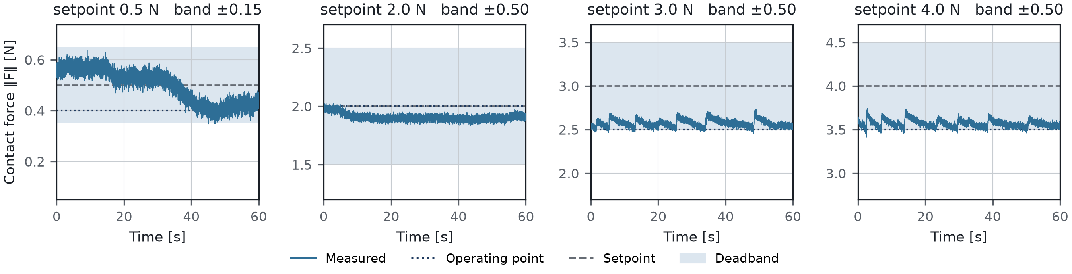

Table 2 — Hold quality
Setpoint [N] | Duration [s] | Samples | SD [N] | Offset [N] | SD / setpoint [%] | In band [%]
0.5 | 57 | 57,118 | 0.065 | +0.092 | 13.0 | 100.0
2.0 | 57 | 57,113 | 0.022 | -0.096 | 1.1 | 100.0
3.0 | 57 | 57,116 | 0.041 | +0.075 | 1.4 | 98.9
4.0 | 57 | 57,111 | 0.040 | +0.070 | 1.0 | 98.6

Figure 2 — Stability, offset and relative stability against setpoint.
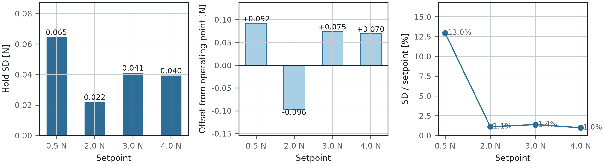

Hold SD is 0.022–0.065 N across a setpoint range of 0.5–4.0 N, with no trend against setpoint. In relative terms the loop is tighter at higher forces — 1.0–1.4 % of setpoint above 2 N — because the noise floor is fixed by the sensor rather than by the controller. Tracking offset from the operating point stays within 0.10 N at every setpoint.
3. Disturbance rejection
Figure 3 — Force change aligned on each 150 mL injection, and the time taken to return inside the band.
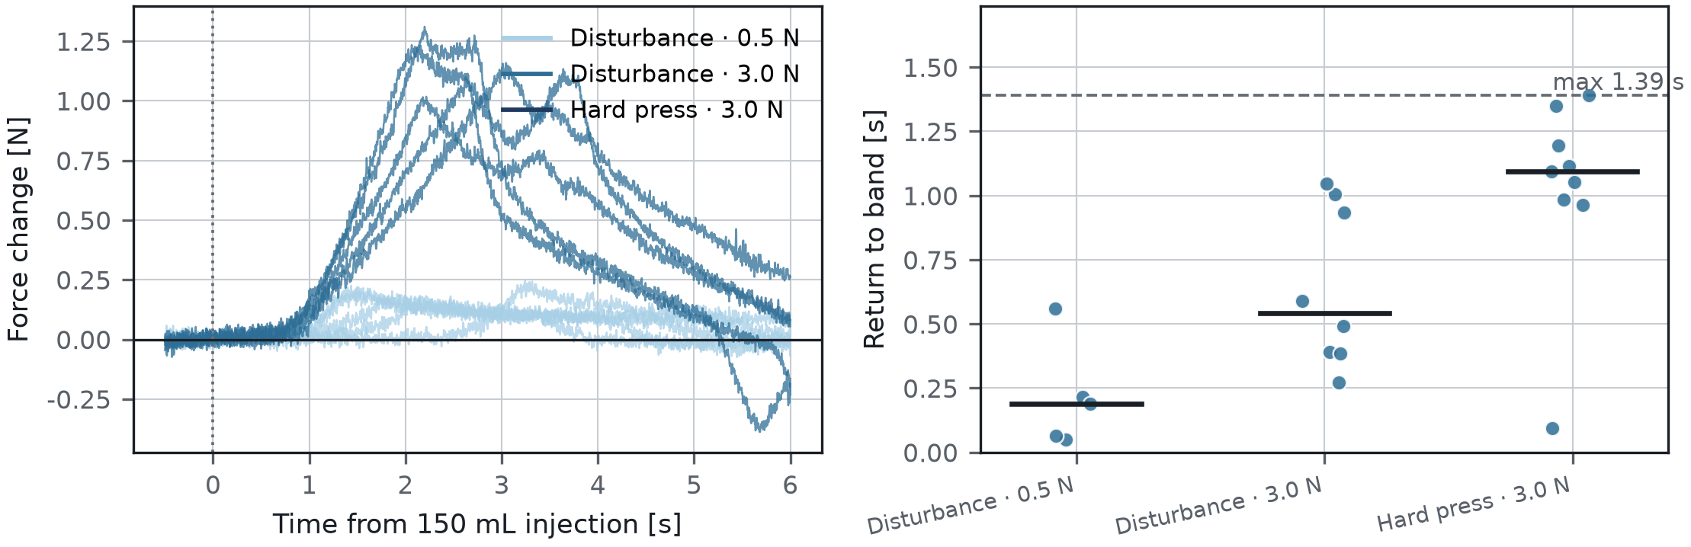

Table 3 — Band excursions
Run | Setpoint [N] | Band top [N] | Excursions | Median return [s] | Max return [s] | Peak ‖F‖ [N]
Disturbance · 0.5 N | 0.5 | 0.65 | 5 | 0.19 | 0.56 | 0.74
Disturbance · 3.0 N | 3.0 | 3.50 | 8 | 0.54 | 1.05 | 3.92
Hard press · 3.0 N | 3.0 | 3.50 | 9 | 1.09 | 1.39 | 4.41

Twenty-two excursions were recorded across the three runs. Every one returned inside the band, the slowest in 1.39 s and the median in 0.19–1.09 s depending on setpoint.
Figure 4 — Longest continuous time spent above a given force, and the hardest-pressed run.
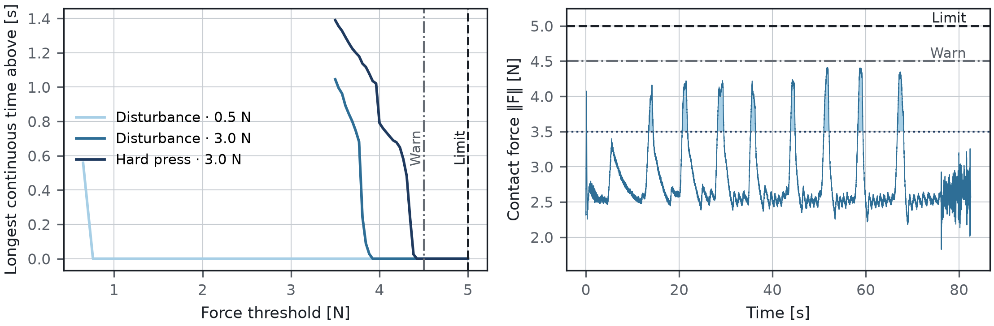

Table 4 — Exposure
Run | Peak ‖F‖ [N] | > 3.5 N | > 4.0 N | > 4.5 N (warn) | > 5.0 N (limit)
Disturbance · 0.5 N | 0.74 | 0 | 0 | 0 | 0
Disturbance · 3.0 N | 3.92 | 1.05 | 0 | 0 | 0
Hard press · 3.0 N | 4.41 | 1.39 | 0.79 | 0 | 0

Peak force reached 4.41 N against a 5.0 N limit. Time spent continuously above the 4.5 N warning level was zero in every run.
4. Direct evidence of regulation
Figure 5 — Contact force and probe axial travel during the disturbance run.
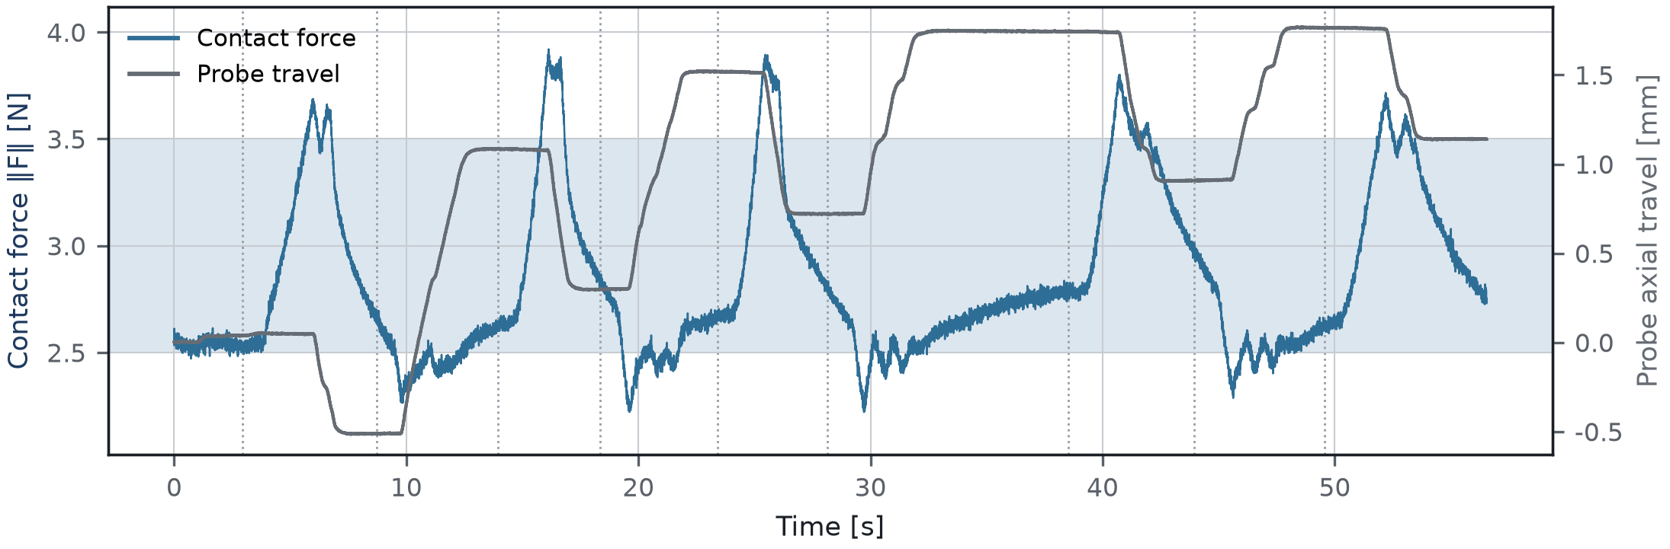

The arm moves against the disturbance. Each injection lifts the phantom surface into the probe; the force rises, the probe retreats, and the force returns to the band. Over the run the probe travels 2.29 mm along its penetration axis while the force stays within 3.0 ± 0.5 N — the displacement is the volume the loop absorbed.
5. What this establishes
- The loop holds a commanded contact force from 0.5 N to 4.0 N with a stability of 0.02–0.07 N, set by the sensor noise floor rather than by the controller.
- Holding stability is flat across the range, so setpoint selection can be driven by imaging requirements rather than by control performance.
- The loop returns the force to its band after an external disturbance, every time, within 1.4 s.
- Under repeated 150 mL volume changes the force stayed clear of the warning level entirely, with 0.59 N of margin to the hard limit at its worst.
- The mechanism is motion, not tolerance: the probe travels millimetres along its own axis to keep the force constant.

