From Segmentation to Instruction: Language-Level Operator Guidance Built on an Image-Quality Function in Transabdominal Bladder Ultrasound for HoLEP Morcellation
Seong Jeong^{1, 2, 5}, Minsung Kim^{1,2,4}, Dongho Yee^{1,2,4}, Yechan Seo^{1,2,5}, Juahn Oh^{1,2,3}, Hyoun-Joong Kong^{1,2,5,*}
¹ Department of Transdisciplinary Medicine, Seoul National University Hospital, Seoul, Republic of Korea
² Rosota Inc., Seoul, Republic of Korea
³ Eulji University College of Medicine, Daejeon, Republic of Korea
⁴ Department of Mechanical Engineering, Seoul National University, Seoul, Republic of Korea
⁵ Department of Medicine, Seoul National University, Seoul, Republic of Korea

Abstract
During the morcellation phase of holmium laser enucleation of the prostate (HoLEP) an operator holds a suprapubic probe and must keep the bladder lumen in view. We present a guidance architecture that turns each transabdominal frame into one corrective instruction with two readers: a U-Net segments the bladder lumen, a transparent image-quality function Q judges the frame from the segmentation and the image, and the judgment is emitted as a language instruction naming the next corrective movement — move left, move right, hold, or check bladder filling. To the human operator the instruction is pixel-level probing feedback, displayed or spoken; to a robotic probe holder the same instruction is an action token (word, ê), translated into a twist command by lookup, because each word carries a defined condition and axis. An instruction is only as fine as the function issuing it, so we first measure what Q can judge. As originally specified Q attains [0.70, 1.00], 30% of its nominal domain, and resolves only 9 levels above its own frame-to-frame noise — too few to ground an instruction set; reformulated, it attains [0.14, 0.78] and resolves 47 levels. The vocabulary is then derived rather than chosen: one boundary is physical (a lumen that is not anechoic cannot be a filled bladder — check bladder filling), the other statistical (a lateral offset below 1.64σ of the segmentation's centroid noise, σ = 4.92 px, cannot be signed reliably — hold). On 1,936 laterally displaced held-out frames the three-word vocabulary is emitted correctly on 85.2% of frames with a 0.10% direction-error rate. The magnitude of the correction travels beside the word as a continuous value, validated at a regression slope of 0.993 against ground truth; words cannot carry it — magnitude classes narrower than the noise cannot be assigned reliably, and graded vocabularies drop accuracy to 76.5% and 70.7%. We close by outlining how the same judgments would enter robot control — gating, twist scaling, and a noise-floor stopping band — without validating that loop here.
Keywords — bladder ultrasound segmentation, image-quality function, operator guidance, language instruction, attained range

1. Introduction
During the morcellation phase of holmium laser enucleation of the prostate (HoLEP) an assistant holds a suprapubic probe and keeps the bladder lumen in view. Keeping it there is a skill of the kind HoLEP training is built to teach [1]: the lumen drifts as the bladder volume changes, and deciding which way to slide the probe — or recognising that the image has degraded for a reason no probe motion can fix — currently rests on the operator's judgment alone. The image itself carries the information that judgment needs, and for any operator, human or robot alike, the missing piece is not a better segmentation mask but the path from a mask to something the operator can be told to do.
This paper builds and argues for that path as an architecture of three stages and one interface (Figure 1): segmentation — a U-Net delineates the bladder lumen on each transabdominal frame; quality judgment — a transparent function Q, computed from the segmentation and the image, decides whether and how the frame falls short; corrective action — the judgment is reduced to one of a small set of words naming the next corrective movement, the movement's magnitude travelling beside the word as a continuous value in pixels; and an output interface with two readers. To a human operator the words are pixel-level probing feedback that can be displayed or spoken; to a robotic probe holder the same emission is an action token — the word selects a pre-declared condition and axis, the number scales the motion — so translation into a twist command is a lookup, not an inference. The paper validates the architecture up to the emitted instruction and deliberately stops short of closing a robot loop; Section 4.1 records how the token channel would enter one.

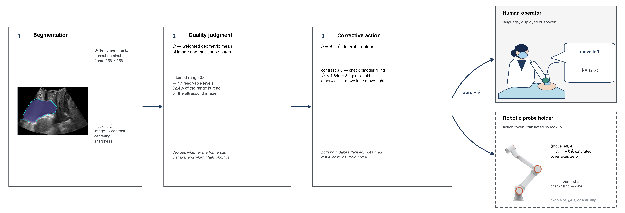
Figure 1. The guidance architecture. A U-Net segments the lumen (1); Q judges the frame from the segmentation and the image (2); the judgment becomes one instruction — a word with the continuous magnitude ê beside it (3). The same emission is read twice: as language feedback by the human operator, and as an action token by a robotic probe holder, translated to a twist by lookup. Stages 1–3 and the emitted instruction are validated here; the robotic execution (dashed) is a design contract, recorded in Section 4.1.

The central technical question is what instruction set Q can honestly support. The property that decides it is the function's attained range — the interval of values it actually takes on real frames — and not its correlation with any accuracy metric. A score that is formally defined on [0, 1] but occupies a band narrower than its own frame-to-frame noise cannot separate any two decisions, however well it ranks. Range divided by noise is the number of levels available, and that number is an upper bound on the size of an honest instruction vocabulary: Sections 3.2 and 3.3 measure it, and Section 3.4 derives the vocabulary from it.
2. Methods
2.1 Segmentation and the Image State
A U-Net [2] takes a 256 × 256 transabdominal B-mode frame and produces a lumen probability map, thresholded at 0.5 and reduced to its largest connected component with interior holes filled. Frames come from PFUS1, a retrospective transabdominal bladder dataset acquired during routine diagnostic examinations — not during HoLEP: no frame carries a morcellator, irrigation inflow, or the intraoperative acoustic conditions of the procedure the guidance is intended for, and Section 4.2 states what that gap leaves unvalidated. The model was trained on a patient-disjoint split and was not retrained or re-tuned for this study. All measurements below are made on the two held-out frame sets (1,661 and 1,292 frames) that share no patient with training or with each other; the segmentation performance on those frames is reported in Section 3.1.
From the mask an image state is computed — centroid, area, boundary statistics, and lumen-to-surround intensity contrast. Every ratio is taken over the insonified sector rather than the image rectangle; the sector is not recorded in the frame metadata and was measured from the training images, covering 66.4% of the frame and agreeing with held-out frames at an intersection-over-union of at least 0.964. Without it the frame grabber's crop enters every area ratio and a mask cut by the sector edge registers as touching no edge.
2.2 The Quality Function
Q is a weighted mean of sub-scores, each normalised to [0, 1], every term and weight logged so that a value can be traced back to its components. Two aggregations are compared below: the arithmetic mean of the original specification, and a weighted geometric mean.
Q = exp( Σ w_{i} ln s_{i} / Σ w_{i} ) (1)
The aggregation is not a cosmetic choice. With eight terms an arithmetic mean caps the effect of one collapsed sub-score at its weight share, so a frame whose lumen contrast has vanished entirely still scores near the top of the range. A geometric mean is dominated by its smallest term, which is the shape a decision needs.
Table 1. Sub-scores of Q and what each reads. Only the first three consult the ultrasound image; the rest restate the mask or its history.
Sub-score | Reads | Definition
lumen contrast | image | (ring − lumen) / (ring + lumen), normalised
lumen centering | image | exp(−offset to the darkness centroid / 0.25)
boundary sharpness | prob. map | exp(−mean boundary entropy / 0.30)
mask completeness | mask | plateau on the lumen area ratio
segmentation confidence | prob. map | mean |2p − 1| over the sector
border penalty, component quality | mask | mask geometry (weight 0 here)
temporal terms (3) | mask history | agreement with the previous mask

The weights are set by rule, not fitted. A pre-declared tuning protocol — candidate weightings scored on the validation cohort by their AUROC for Dice ≥ 0.80 within bladder-volume bands, ties broken by dynamic range, the test cohort untouched — was run and then set aside for cause: with eleven patients per split, every candidate's bootstrapped confidence interval on the selection metric spanned most of the unit interval, so this cohort cannot rank weightings and a fitted weight would report sampling noise. The weights are therefore tiered, and equal within a tier: the three terms that read the ultrasound image share the top weight (1.5 each, 4.5 of the 6.0 total), the mask-side domain check keeps a minority 0.5, and terms whose measured behaviour disqualifies them — a border penalty duplicating a hard limit the validity gate already enforces, a component-quality term that returns one value — are set to zero rather than down-weighted, because a consistently inverted or saturated term is not a tuning question. `segmentation confidence` keeps its inherited weight of 1.0; what that buys is measured rather than assumed, in Section 3.2.
The three temporal terms are switched off for this study. The frames are static examinations in which nothing moved in response to the image, so frame-to-frame agreement measures the smoothness of a recording rather than the stability of a control loop; scoring it would credit Q for a property the setting has not been asked to produce.
2.3 Range, Noise, and Resolvable Levels
The first property measured is the attained range — the interval of values Q actually takes, read over all 2,953 held-out frames and set against its nominal domain [0, 1]. Because the geometric mean is additive in the logarithm, the attained range decomposes exactly: each sub-score contributes its weight share times the log-width of the interval it attains, so every part of the range is traceable to one term.
A range is only useful relative to the noise on it. These are static examinations, so the change in Q between adjacent frames is almost entirely measurement noise, and its standard deviation is a direct estimate of the function's own jitter. Two frames whose scores differ by less than that jitter cannot be ordered — the difference is as likely noise as signal — so thresholds spaced closer than one jitter step do not define distinct decisions; they hand the same frame different labels on different frames. Dividing the attained range by the jitter therefore gives the number of levels a reader of Q can distinguish; the central 80% of the distribution — the operating region a threshold would actually be placed in — is reported alongside the full range.
2.4 The Instruction Axis
The instruction is issued on the one image axis that leaves the imaging plane invariant. Of the probe's six axes only v_{x}, v_{z} and ω_{y} preserve the plane; of the three the image policy holds, only lateral sliding v_{x} does, and only it presents a measurable vector error rather than a scalar to be searched (Figure 2a). Write the instruction as ê = A − ĉ, with A the beam axis and ĉ the predicted lumen centroid abscissa (Figure 2b).

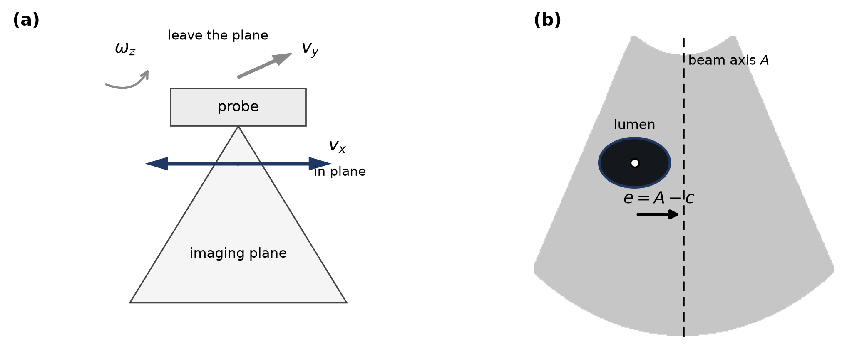
Figure 2. (a) Only v_{x} leaves the imaging plane invariant among the three axes the image policy holds. (b) The lateral instruction on one frame: A is the beam axis, c the lumen centroid abscissa, e = A − c.

2.5 Validation by Lateral Translation
One property of the frames prevents the direction from being validated on them as recorded: in all 2,953 the lumen lies on the same side of the beam axis, so e never changes sign and a constant output would score 99.3%. The sonographer holds a diagnostic view rather than centring the lumen on the axis, which is a property of how the frames were acquired and not of the function.
The instruction is therefore exercised on laterally translated frames. Lateral translation is the one probe motion single-plane frames can reproduce faithfully, and it carries the lumen across the axis so that e changes sign; each frame is shifted by the amount that places e on a prescribed target, sampled densely near the crossing and sparsely away from it. Fabricated margin is filled by edge replication, never black, which every intensity term would read as anechoic lumen. Across the sweep the segmentation is unaffected — Dice holds at 0.858 — and 1,936 frames result, 43% with e < 0.
3. Results
3.1 Segmentation Performance
The segmentation stage is reported in the two numbers the later stages consume, not as a metric study in its own right. Over all held-out frames the U-Net reaches a Dice of 0.825 ± 0.091 (val) and 0.807 ± 0.123 (test); restricted to the distended-bladder working domain — frames whose annotated lumen occupies at least 5.7% of the sector, the state morcellation irrigation is meant to maintain — Dice rises to 0.882 and 0.892, and the lateral centroid error, the quantity the instruction is built on, has a median of 3.85 px and 3.65 px. The tail below the domain is the same population the check bladder filling branch of Section 3.4 addresses: segmentation degrades exactly where the instruction refuses to steer.
3.2 The Attained Range of Q
Q is defined on [0, 1]. On 2,953 held-out frames the original specification attains [0.70, 1.00] — a width of 0.30, or 30% of the nominal domain — and its central 80% spans only 0.12. Reformulated with the geometric aggregation and weighted toward the terms that read the image, it attains [0.14, 0.78], a width of 0.64, with a central 80% of 0.45 (Figure 3a).
The decomposition of Section 2.3 attributes 92.4% of the range to two sub-scores (Figure 3b, Table 2), and both are terms that consult the ultrasound image rather than the mask.

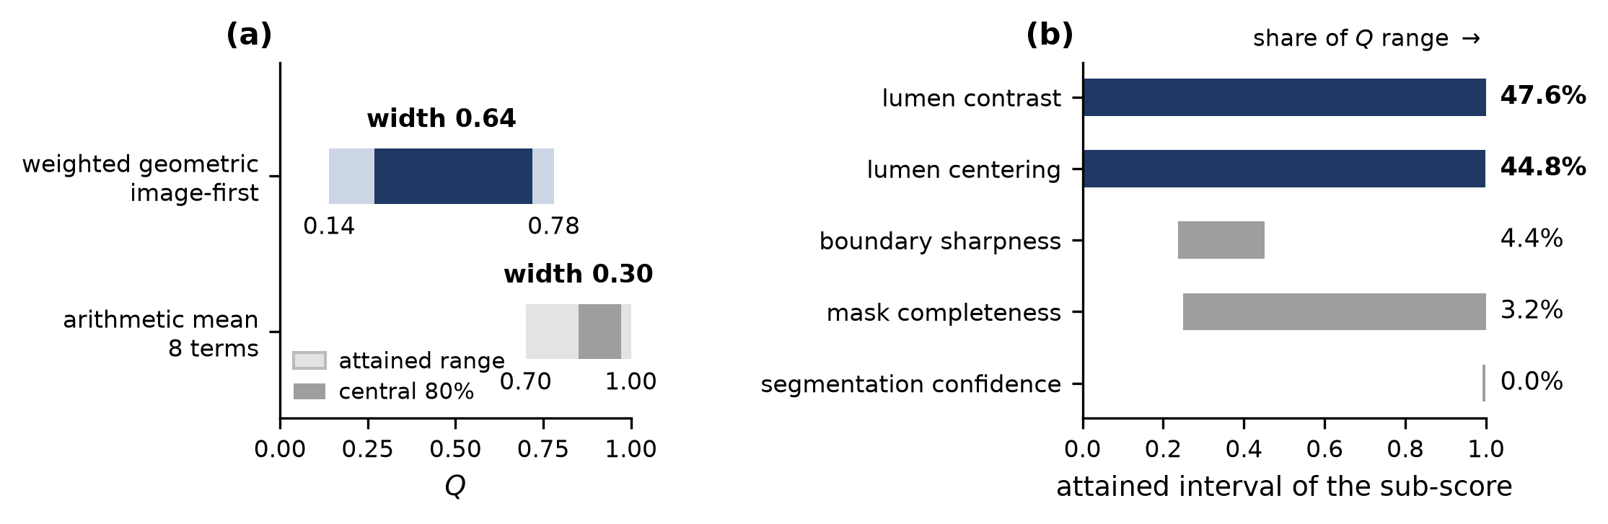
Figure 3. (a) The interval Q actually attains under the two aggregations, against its nominal domain [0, 1]. (b) The interval each active sub-score attains and its share of the resulting range. `segmentation confidence` occupies a band 0.007 wide and contributes nothing.

Table 2. Attained interval of each active sub-score and its share of the range of Q. Shares follow from the geometric aggregation and sum to 100%.
Sub-score | Weight | Attained interval | Width | Share
lumen contrast | 1.5 | 0.000 – 1.000 | 1.000 | 47.6%
lumen centering | 1.5 | 0.001 – 0.999 | 0.997 | 44.8%
boundary sharpness | 1.5 | 0.237 – 0.451 | 0.214 | 4.4%
mask completeness | 0.5 | 0.250 – 1.000 | 0.750 | 3.2%
segmentation confidence | 1.0 | 0.992 – 0.999 | 0.007 | 0.0%

The last row is the point of the section. `segmentation confidence` is not a weak term that could be rescued by more weight: it returns essentially one value, so it has no range, and a function with no range cannot participate in any decision. It carries a weight of 1.0 while contributing 0.0% of what Q can express. Two further terms — border penalty and component quality — behave the same way and are already at weight 0.
3.3 Resolvable Levels
Table 3 divides the attained range by the frame-to-frame jitter measured on the same frames (Section 2.3).
Table 3. Resolution of Q: attained range over frame-to-frame jitter. The central 80% figure is the operating region a threshold would actually be placed in.
Aggregation | Range | Jitter | Levels | Central 80% | Levels
arithmetic, 8 terms | 0.296 | 0.0144 | 21 | 0.123 | 9
geometric, image-first | 0.635 | 0.0095 | 67 | 0.450 | 47

Nine levels is the quantitative statement of a failure that had previously been described only qualitatively: with the original specification, no threshold below 0.75 rejected a single frame out of 2,953, and the whole usable operating region lay between 0.85 and 0.95. Any instruction set finer than nine states would have been reporting noise. The reformulated function has room for 47.
3.4 The Derived Vocabulary
Two boundaries partition the range, and neither is a fitted hyperparameter.
A physical boundary. A urine-filled lumen is anechoic, so a non-positive lumen-to-surround contrast means the delineated region cannot be one. On 13.1% of frames the contrast is non-positive; those frames have Dice 0.665 against 0.840 elsewhere, and what sets them apart is the delineated region itself — 1.85 times brighter and a third the area, the signature of an under-distended bladder rather than of a poorly placed probe. The remedy is not a lateral slide; it is upstream, in bladder filling, and the instruction says so instead of commanding a movement that cannot help.
A statistical boundary. The difference δ = ê − e is the segmentation's lateral centroid error, independent of where the lumen sits, with σ = 4.92 px and a bias of +0.11 px. The instruction points the wrong way exactly when δ opposes e and exceeds it, so
P(wrong direction) = Φ(−|e| / σ) (2)
and the instruction is withheld below 1.64σ = 8.1 px, where the modelled error rate reaches 5%. Below that boundary a controller that keeps acting is following its own segmentation noise; this is a stopping condition, not a defect.
Table 4. The instruction vocabulary. Both boundaries are derived — one from the physics of an anechoic lumen, one from the segmentation's centroid noise — and neither is tuned.
Instruction | Condition | Acts on
check bladder filling | contrast ≤ 0 | not the probe — filling
move left / move right | contrast > 0 and |ê| ≥ 8.1 px | lateral axis v_{x}
hold | contrast > 0 and |ê| < 8.1 px | nothing — converged

The magnitude is a number, not a word. The word carries the direction; the displacement itself, ê in pixels, enters and leaves the pipeline as a continuous value — shown beside the word to a human operator, consumed directly as a velocity command by a robot. The same noise that derives the boundaries dictates this format. A magnitude put into words means quantising |ê| into classes, and a class narrower than 2σ ≈ 9.8 px cannot be assigned reliably even at its centre; the sweep bears this out, with graded vocabularies dropping word accuracy from 85.2% to 76.5% and 70.7% while the direction error holds at 0.10% (Table 5). The continuous value, by contrast, is validated in Section 3.5 at a regression slope of 0.993 and a median error of 3.15 px: the magnitude is trustworthy as a measurement and unreliable as a word, so the language layer names the direction and passes the measurement through unrounded.
Table 5. Word accuracy of the emitted instruction against the instruction the ground truth implies, over the controlled sweep of Section 2.5. Magnitude grades cut |ê| at successive multiples of the derived 8.1 px hold boundary, so the grading introduces no new constant. Direction errors stay negligible; discretising the magnitude is what costs accuracy — the reason it is passed through as a number.
Vocabulary | Size | Accuracy | Direction error
move / hold | 2 | 85.3% | 0.00%
move left / move right / hold | 3 | 85.2% | 0.10%
+ two magnitude grades | 5 | 76.5% | 0.10%
+ three magnitude grades | 7 | 70.7% | 0.10%

Each word is a complete instruction to two different readers. To the human operator the vocabulary is displayed or spoken as it stands: the word names the direction — the register in which probe handling is actually taught and corrected — while the measured displacement stands beside it as a number. To a robotic probe holder each word is a symbol with a defined condition and axis, so translation into a twist command is a lookup, not an inference (Table 6). The language layer is thus the interface between the two settings: the same judgment drives either operator, and nothing about the pipeline changes when the reader does.
Table 6. One vocabulary, two readers. The mapping from word to action is fixed in advance on both sides; no model sits between the instruction and its execution.
Instruction | Human operator | Robotic probe holder
check bladder filling | pause; reassess filling before scanning on | zero twist; hand control back to the supervisor
move left / move right | slide the probe laterally by the displayed amount | v_{x} = −k ê, saturated; other axes zero
hold | keep the current pose | zero lateral twist; no correction commanded

3.5 Accuracy of the Emitted Instruction
Figure 4 shows one frame of the sweep at three lateral displacements, including one inside the band where the direction is no longer trustworthy.

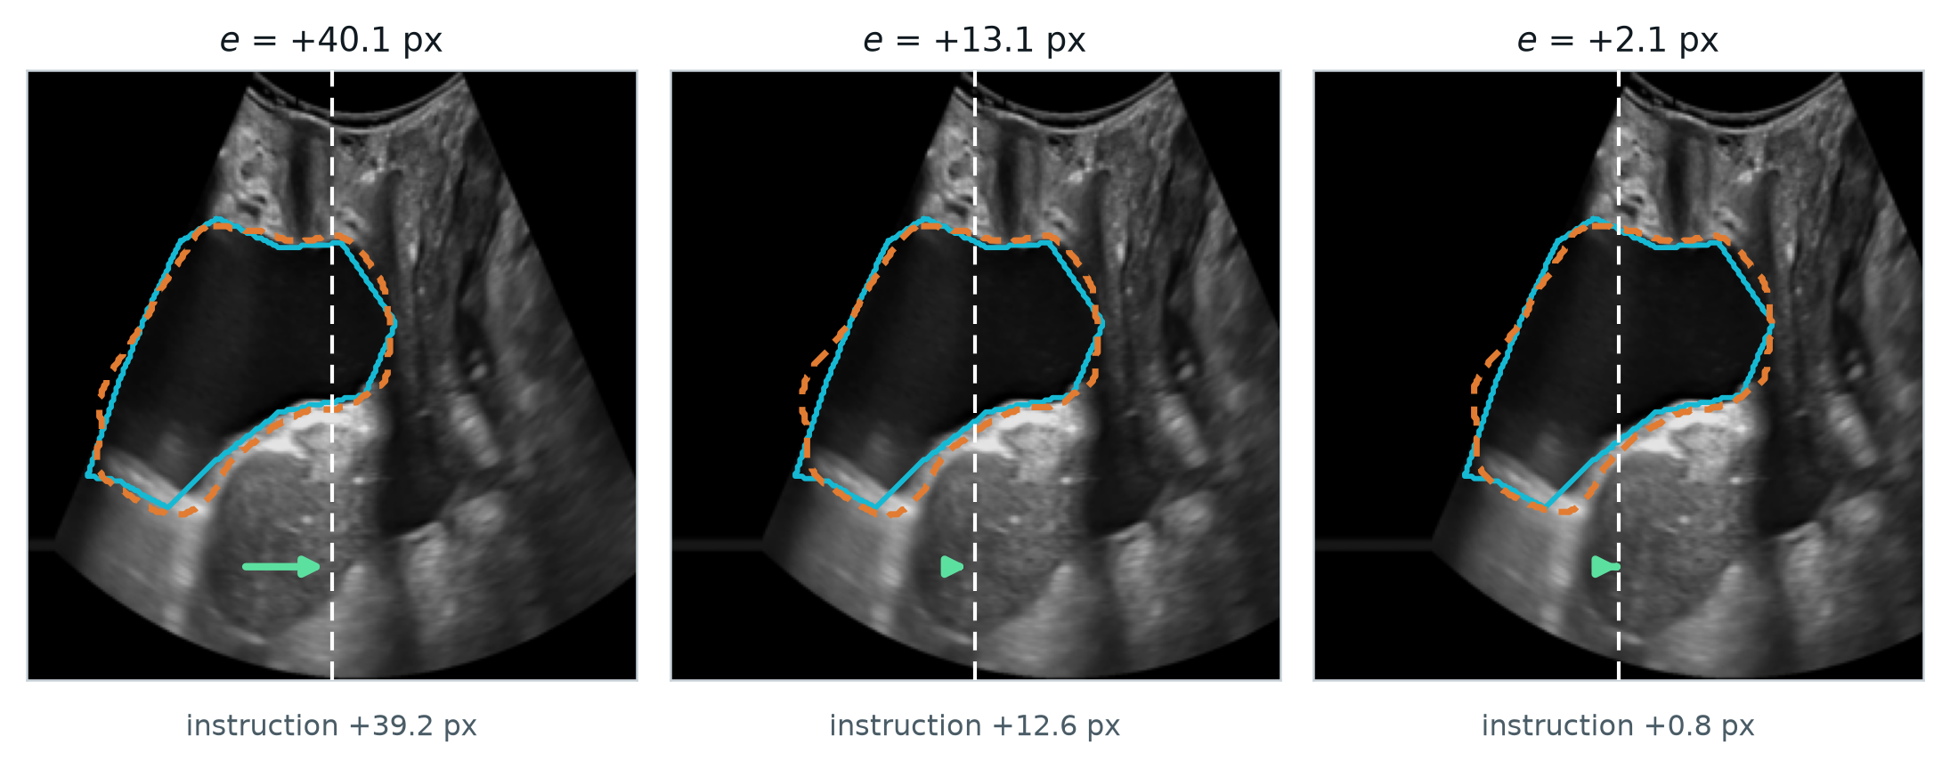
Figure 4. One frame at three lateral displacements. Cyan is the annotation, orange dashed the prediction, white dashed the beam axis, the arrow the instruction. At e = +2.1 px the instruction has collapsed to +0.8 px: the loop has entered the band where Equation (2) says the direction is no longer reliable.

The instruction agrees with the truth in 93.7% of frames, with a median magnitude error of 3.15 px, a regression slope of 0.993 and r = 0.970. A slope this close to unity means the instruction is correctly scaled and not merely directional. The two held-out frame sets agree to within 0.7 px of median error.

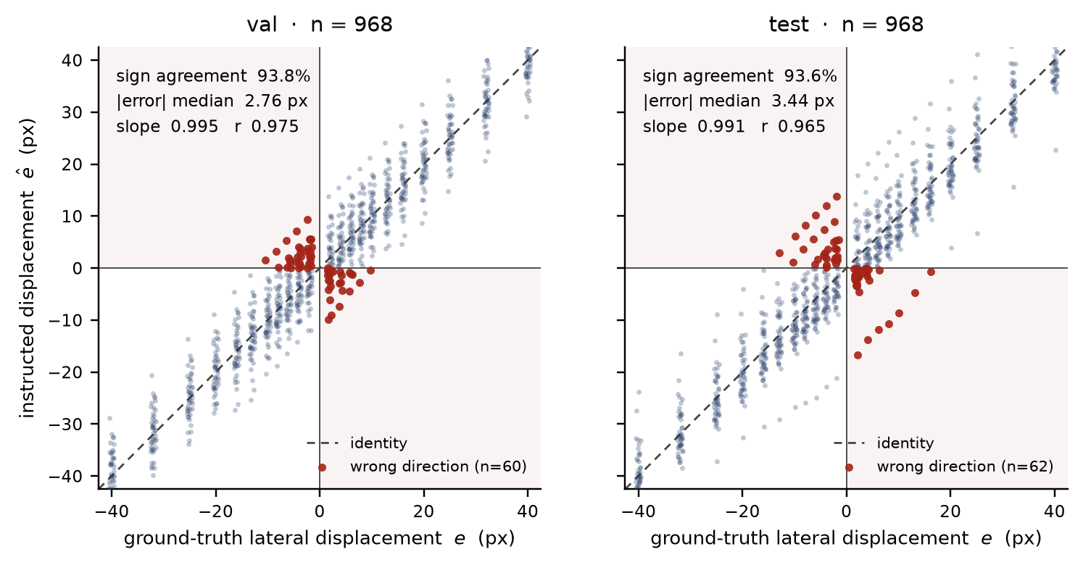
Figure 5. Instructed against ground-truth lateral displacement, one panel per held-out frame set; per-set agreement statistics are inset. Shaded quadrants are wrong-direction outcomes; every one lies within a few pixels of the axis.

The result is not that percentage but the shape of its failure. Wrong directions occur only near the axis — their median required displacement is 7.9 px against 15.8 px for correct ones — and their rate follows Equation (2) with σ fitted once to the centroid error and not to this curve (Figure 6). Agreement across two decades of error rate is what licenses deriving the vocabulary boundary from the model rather than reading it off the data.

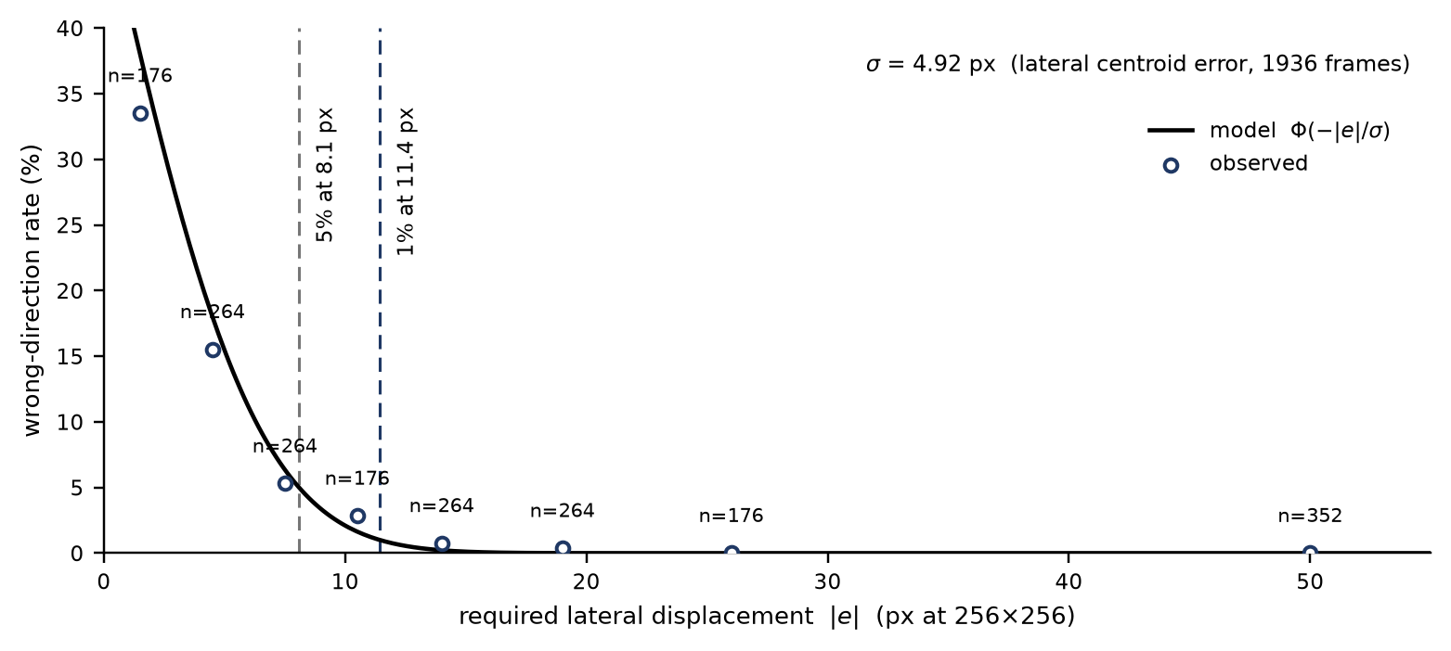
Figure 6. Wrong-direction rate against required displacement. The curve is Equation (2); circles are observed rates with frame counts. Dashed verticals mark where the modelled rate reaches 5% and 1%.

The constants are stable against annotation quality. A model-blind label audit flags four of the frame sets' patients as carrying regions that cannot be lumen; recomputing without them moves σ from 4.92 to 4.67 px (−5%), sign agreement from 93.7% to 94.1%, and the 5% boundary from 8.1 to 7.7 px.
4. Discussion
Reporting an image-quality function by its correlation with a segmentation metric answers the wrong question. Correlation says how the score orders frames; the attained range says how many decisions can be taken from it, and the two come apart. The function studied here ordered frames respectably in its original form while supporting nine distinguishable states — fewer than the instructions a controller would want to issue — and the diagnosis was invisible to any accuracy figure. Range, its decomposition, and range-over-noise are cheap to compute and we suggest reporting them for any score intended to instruct an operator or drive a device.
The decomposition also gives a concrete design rule. A term contributing 0.0% of the range is not underweighted; it is degenerate, and the fix is to measure it somewhere the decision is hard or to remove it. Here the two terms that consult the ultrasound image carry 92.4% of the range while three mask-geometry and probability-map terms carry almost none.
4.1 The Action-Token Channel: From Judgment to Twist
The pipeline validated above ends at the emitted instruction; this section records how a robotic probe holder consumes it — the design, not a result. The channel's input is the per-frame emission of stage 3: an action token (word, ê), with the quality scalar Q beside it. Decoding is the fixed lookup of Table 6, and no model sits between token and twist. move left and move right select the lateral axis and let the number scale it — v_{x} = −k ê, saturated, every other axis commanded to zero, so the realisation is proportional rather than bang-bang. hold commands zero twist: the 1.64σ boundary of Section 3.4 arrives as a ready-made deadband, and a controller that kept acting inside it would be servoing its own segmentation error. check bladder filling gates image-based motion outright — no twist is preferable to a twist computed from a mask that physics rejects — and because tokens are issued per frame, one degraded frame gates one command, not the session.
Beyond the words, Q has room to scale the commanded speed down as quality falls: 47 resolvable levels support that honestly, where the original nine could not. The token acts only on v_{x}, the one axis that leaves the imaging plane invariant, so nothing the image loop commands can rotate the anatomy out of its own view. Closing and validating this loop — its latency, and Q measured while the probe actually moves — is deliberately outside this paper's scope.
4.2 Limitations
— PFUS1 is a diagnostic dataset, not HoLEP imaging. The frames come from routine transabdominal bladder examinations; no morcellator, irrigation inflow, or intraoperative acoustic conditions appear in any of them, so every constant reported here — σ and the boundaries derived from it included — is measured under diagnostic acquisition and must be re-estimated on intraoperative frames before the vocabulary is trusted in theatre.
— No real probe motion is validated. The frames are static examinations whose lumen centroid moves 0.45 px between samples, below the segmentation's own centroid error, so lateral displacement is simulated and the instruction has not been closed into a loop with a person or a robot.
— Two of the image policy's three axes are untouched: v_{y} and ω_{z} leave the imaging plane, present only a scalar quality, and cannot be simulated from single-plane frames.
— The target pose — lumen on the beam axis — is a design choice for the robotic setting. The archived frames were not acquired toward it, so the proportion of frames falling in each instruction band describes the frames, not the loop's steady state.
— No pixel spacing accompanies the frames, so σ and every derived boundary are stated at 256 × 256 and must be rescaled before they mean millimetres.
— σ is treated as one constant. Per-frame estimation would tighten the stopping boundary where the segmentation is confident and loosen it where it is not.
— The check bladder filling branch is supported by 13.1% of frames from four patients; whether the cause is under-distension or annotation is not separable here [TO BE CONFIRMED: IRB approval number, scanner model, annotation protocol].
References
[1] T. Jang, H.-J. Kong, C. Baek, J. Kim, M. S. Choo, S.-J. Oh. Effect of Self-Training Using Virtual Reality Head-Mounted Display Simulator on the Acquisition of Holmium Laser Enucleation of the Prostate Surgical Skills. International Neurourology Journal 2024;28(2):138–146.
[2] O. Ronneberger, P. Fischer, T. Brox. U-Net: Convolutional Networks for Biomedical Image Segmentation. In: Medical Image Computing and Computer-Assisted Intervention (MICCAI 2015), LNCS 9351, Springer, 2015, pp. 234–241.
[TO BE COMPLETED] Citations for HoLEP morcellation, ultrasound visual servoing and image-quality assessment are to be added before submission.

