Keeping the Bladder in View: A Force Regulated Ultrasound Robot for HoLEP Morcellation Trained on Probe Mounted Demonstrations Without Robot Data
Anonymous Authors
Abstract
During the morcellation phase of holmium laser enucleation of the prostate (HoLEP), an assistant holds a suprapubic ultrasound probe for the length of the phase so that the surgeon can watch bladder filling and volume. The task is monotonous but not trivial: the probe must stay coupled at a safe force while the bladder changes shape and volume underneath it. We present an ultrasound robot that takes over this monitoring task, and a demonstration pipeline that trains it without ever moving the robot to collect data. Contact force is measured by a Hall effect force/torque sensor between the flange and the probe. Against a laboratory scale over 0.92–9.85 N the compensated reading is linear with slope 1.019 (95% CI 0.975–1.064, R²=0.993), and an admittance loop holds a commanded contact force to 0.028 N standard deviation across eight set points from 0.5–4.0 N on a torso mannequin holding an air tube that a syringe inflates and deflates. Demonstrations are recorded by instrumenting the clinical probe itself with a six axis inertial sensor: the sonographer scans by hand, and probe rotation is recovered at 2.50 ° geodesic RMS against robot forward kinematics, five times better than the on chip nine axis fusion near the robot (11.23 ° axial RMS). The two streams are joined on one host clock after removing a measured 200 ms effective image latency. A U-Net segments the bladder lumen (Dice 0.874 on bladder present held out frames) and feeds two separate quality functions: Q_seg, the learning objective, which scores whether the bladder is seen, large and laterally centred, and Q_raw, a segmentation independent image score that drives an extremum seeking search over the contact force set point. On 4389 demonstration chunks we train an ACT style conditional VAE that predicts 1.6 s action chunks and ranks candidate chunks by a predicted future quality head. [TODO: closed loop policy result on the dynamic bladder phantom]. We also report a negative result that constrains this class of method: on freehand demonstrations the quality head learns motion magnitude but not motion direction (mirror test 52.4 %, chance 50 %), so candidate ranking collapses onto a single elevational direction in 84 % of held out observations.
Introduction
Holmium laser enucleation of the prostate is performed under continuous irrigation, and during morcellation the bladder must stay adequately filled but never over distended. Standard practice is for an assistant to hold a suprapubic ultrasound probe over the bladder for the duration of the phase so that the operating surgeon can judge filling and volume [1, 2]. The work is static, long, and delegated to a person whose clinical judgement is spent on holding a probe still; and because the assistant tires, the view drifts at the moment the surgeon needs it.
This paper asks whether that monitoring task can be handed to a robot without also handing over the clinical judgement. Our answer is a system built around two loops that are physically separable: a contact loop that keeps the probe pressed within a verified force envelope, and an image loop that keeps the bladder in the picture. Everything above those two loops stays with the clinician.
The obstacle is not control but data. Learning a probe motion policy from demonstrations normally requires the demonstrations to be collected on the robot, and in an operating room that is precisely what cannot be done. Our second contribution is therefore a demonstration route that never involves the robot: the sonographer's own probe carries an inertial sensor, the ultrasound stream is captured in parallel, and the pair is turned into observation and action chunks after the fact. The robot appears only as the ground truth used to validate the sensor, and later as the executor.
Our contributions are:
- A force regulated ultrasound probing stack (Sec. III): a Hall effect force/torque sensor between the FR5 flange and a wireless convex probe, attitude dependent gravity compensation validated against a laboratory scale, an admittance loop that owns the beam axis, and a safety envelope of 3 N target, 4.5 N warning and 5 N forced retreat, verified under repeated volume disturbances.
- Robot free demonstration capture (Sec. IV): probe mounted six axis inertial sensing with a measured image to inertial latency, stillness bracketed action chunks, and a characterisation of what such labels can and cannot support, namely rotation yes and translation no.
- Two quality functions with different jobs (Sec. V): a segmentation based score that defines the learning objective, and a segmentation independent score that defines the contact force set point, so that “press harder” and “look elsewhere” never compete for the same signal. Because the freehand demonstrations carry no force channel, the force axis cannot be imitated and is instead searched online.
- An image conditioned action chunk policy (Sec. VI) with a predicted quality head for candidate selection, evaluated against pre-registered hold and placebo controls on a dynamic bladder phantom (Sec. VII), together with an analysis of why the learned quality head cannot yet supply direction (Sec. VIII).
We do not claim autonomy of the clinical task. The robot is a probe holder that keeps a view; the decisions that follow from the view remain the surgeon's.
[FIGURE TO BE DRAWN]
From the sonographer's hand to the robot's. (a) Demonstration capture: the clinical probe carries a six axis inertial sensor, and ultrasound and inertial data are joined on one host clock. (b) The robot: FR5 arm, Hall effect force/torque sensor, wireless convex probe. (c) Closed loop operation on the dynamic bladder phantom, with the force loop on the beam axis and the policy on the rotational axes.
Related Work
Robotic ultrasound. Robotic ultrasound systems and their control strategies are surveyed in [3, 4, 5, 6]. Force is usually handled either by a hybrid force and position controller for freehand assisted scanning [7] or by pressing along a planned trajectory registered to a preoperative volume [8], and the closest analogue to an image driven objective is confidence driven servoing, which steers the probe by an ultrasound confidence map [9]. Existing systems therefore either servo towards a target view learned from robot collected sweeps, or press with a fixed force profile. Our setting differs in both respects: the demonstrations come from a hand held clinical probe, and the force set point is not fixed but searched online against image quality.
Demonstration collection without a robot. Learning from demonstration normally assumes the demonstration is recorded on the learner [10, 11]; hand held capture devices break that assumption by instrumenting the tool instead [12]. Recovering probe motion from a hand held ultrasound probe is an old problem in freehand 3D reconstruction, solved with external trackers, with speckle decorrelation [13, 14] or, more recently, learned from the images themselves [15]. The medical variant of the problem is that the instrument belongs to the clinician, not the robot. In our case the instrument is the ultrasound probe itself, and the signal that must survive the transfer is probe orientation rather than gripper pose.
Action chunking and imitation. We build on ACT style action chunking with a conditional VAE [16], and add a quality head that scores the future image consequence of a candidate chunk. That head is what is meant to turn replay into selection, and Sec. VIII reports how far it actually gets on freehand data.
Bladder segmentation and ultrasound image quality. Bladder segmentation from ultrasound is well covered, from wall segmentation networks [17] to compute constrained models for handheld bladder monitors [18], and reinforcement learning has been used to guide a bladder scan towards a better view [19]. Our perception stage follows the standard U-Net recipe [20], pretrained on a public pelvic floor corpus [21, 22]. The contribution here is not the network but the physical gating that deletes predictions where no measurement exists, and the separation of the two quality functions.
System
Hardware
A Fairino FR5 six axis arm carries, in series from the flange, a PX6D Hall effect six axis force/torque sensor, a printed mount, and a Konted C10UR wireless convex ultrasound probe. The mount places the probe axis at 43 ° to the flange plane with a 199 mm lever arm, and the probe assembly mass is 231 g. The probe streams 160 A-lines by 512 depth samples as uint8, before scan conversion, at 9.98–10.4 Hz over its own Wi-Fi access point. Differential inverse kinematics runs at 100 Hz, the joint servo at 125 Hz, and the force/torque sensor streams at 1 kHz.
Force measurement and gravity compensation
The sensor sits proximal to a heavy, off axis tool, so the raw wrench is dominated by the tool's own weight, which rotates with the arm; before compensation the beam axis component moves by about ± 8 N with attitude. Mass, centre of mass and mounting angle are identified from a 19 pose sweep (identified mass 200 g, fit residual 0.152 N), and constraining the fit to the single physical stack axis reduces the residual from 0.183 N to 0.047 N on the same data. Only the compensated wrench is published to the control stack.
Over 19 unloaded poses the compensation residual is 0.000±0.182 N (mean ± SD, RMSE 0.177 N, maximum 0.376 N). The residual is not white: its rank correlation with pose index is ρ = +0.896 (p < 1e-4), that is, a systematic attitude dependent term rather than noise. We therefore do not subtract it. In deployment the constant part is removed by a working pose tare taken immediately before each run, and what remains bounds the accuracy of the force loop. Sensor noise is ± 0.05 N per axis at the configured dead band, and 0.015 N standard deviation at 1 kHz.
Validation against a laboratory scale
To check that the compensated reading is the contact force and not an artefact of the compensation, the mounted probe was pressed onto a laboratory scale (resolution 1 g, standard uncertainty 0.0028 N) at loads from 0.92 N to 9.85 N; 19 of 20 trials were analysed. Regressing the robot reading on the scale reference gives slope 1.019 (95% CI 0.975–1.064), intercept -0.373 N (95% CI -0.587–-0.158) and R² = 0.99269. Bland and Altman analysis gives a bias of -0.293 N with 95% limits of agreement -0.734–+0.148 N; mean absolute error is 0.344 N, which is 3.49 % of the 9.85 N full scale. In other words the scale factor is correct to within 2 % while a sub newton offset remains, of the same order as the attitude dependent compensation residual. We report the offset rather than calibrating it away: a fixed offset correction was implemented and then removed, because it is not constant across attitudes and would hide the residual it partially cancels.
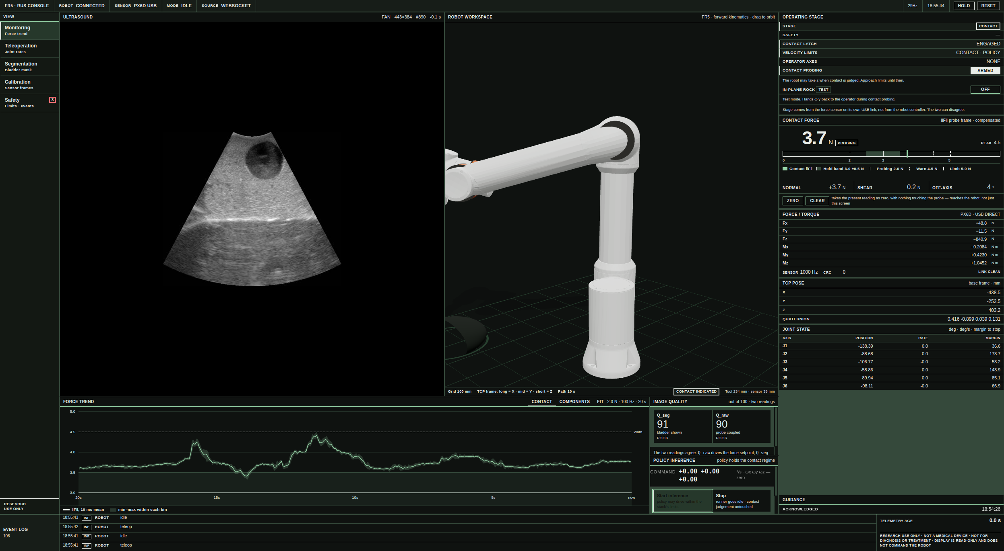
The operator console during a policy episode. Left: the live sector image with the bladder in view. Centre: the arm in its own workspace, and below it the contact force trend against the hold band and the warning line. Right: the declared regime and the contact force with its bands, and at the bottom the two quality readings, Q_seg and Q_raw, beside the policy panel that starts and stops inference and shows the commanded angular rates. The console reads and displays; it issues no motion of its own beyond the two buttons.
Contact regulation and the safety envelope
The beam axis z is owned by an admittance regulator, never by the operator and never by the policy:
v_z = (F* - F_n)/(B_z), |v_z| ≤ v_\max,
with B_z = 4500 N·s/m, a dead band of 0.05 N about F*, and a retreat speed of 5 mm/s. The dead band and gain were chosen together: at B_z = 1000 and 3000 the loop limit cycles with a period of 8–9 s and a force amplitude of ± 0.35 N, because the measured contact stiffness of the phantom rises from 0.28 N/mm at 0.5 N to 1.8 N/mm at 4 N while the force lags indentation by 1.5–2.4 s. At B_z = 4500 the loop gain falls to 0.01–0.20 over that stiffness range and the limit cycle disappears, at the cost of a slow response: the time constant is B_z/k ≈ 12 s for the measured phantom stiffness k = 0.374 N/mm.
Three limits are enforced above the regulator: a hold target of 3 N, a soft warning at 4.5 N at which rising commands are refused, and a hard limit of 5 N at which the regulator overrides everything and retreats along -z until the force falls below 0.2 N. A two layer watchdog retreats the probe if twist commands stop for 100 ms and stops the joints if joint commands stop for the same interval. Velocity limits are switched by regime: 150 mm/s in free space, 10 mm/s and 0.2 rad/s once the contact regime is entered.
Demonstrations Without a Robot
Instrumented probe and synchronisation
A BNO085 inertial measurement unit on a Seeed XIAO nRF52840 Sense is clamped to the probe in a printed split shell. Accelerometer and gyroscope report at 200 Hz each and the on chip rotation vector at 100 Hz; the host runs a magnetometer free gradient descent attitude filter [23] and logs 250–256 Hz of CRC protected records over USB serial, keeping both device and host timestamps. The ultrasound stream and the inertial stream share exactly one clock, the host's reception time.
Reception time is not acquisition time. We measure the fixed delay of the ultrasound path by cross correlating frame to frame image change with the box integrated gyroscope magnitude over the same interval,
τ_us = argmax_τ\ corr(Δ I_i,\ Ω_i(τ)),
and obtain τ_us = 200 ms pooled over 268 sessions (r = 0.817, session bootstrap 95% CI 190–200 ms, and injected artificial delays are recovered with 0 ms error). This is an effective latency that includes the scanner's frame persistence rather than a transport delay specification. It is subtracted once, in the dataset builder.
Six axes, not nine
Near a moving steel arm, magnetometer aided fusion is not merely noisier, it is wrong. We characterise the sensor on a bench in which the instrumented probe is held by the robot, so that forward kinematics supplies ground truth over an 83.8 s teleoperated block of probing rhythm (16757 paired samples). The bench probe is a clamped clinical convex probe in a printed split shell; the phantom demonstrations reported below were captured with a second, wireless probe in the same manner, so the orientation figures characterise the sensing route rather than one specific clamp. Against that ground truth, host side six axis fusion gives per channel rotation RMS of 1.14 °, 0.73 ° and 1.95 ° (tilt x, tilt y, axial), geodesic RMS 2.50 ° (p95 3.56 °), static alignment residual 0.81 ° and axial drift 0.23 °/min. The on chip nine axis rotation vector, on the same recordings, gives 11.23 ° axial RMS, 6.68 ° alignment residual and 8.29 °/min drift (Table 2). The cause is positional rather than attitudinal: a pose paired magnetic test near the robot found no usable stationary pairs at all, and a sensor fixed distortion model leaves residuals up to 9.6 times the noise with direction errors up to 56.8 °. A field that changes with where the probe is cannot be calibrated out by any attitude model, which is the failure mode reported for motion laboratories [24, 25], so we disable the magnetometer, give up absolute heading, and claim only rotation relative to a session reference pose. Against our own pre-registered limit of 2.0 ° the geodesic RMS of 2.50 ° is a fail, and we report it as one; every other criterion (alignment, latency, correlation, drift, displacement floor) passes.
Translation is the counter example. With zero velocity bracketing the displacement error floor is 0.25 mm at 0.5 s and 6.32 mm at 5 s, against 12.4 mm and 1236.5 mm for raw double integration; over 21 real move segments the error is one to two orders of magnitude above that floor. On 65 elevational sweep segments of the demonstration set, the drift removed by the zero velocity bracket has a median of 60 mm against a median net displacement of 14 mm, a ratio of 2.75. Translation is kept in the dataset for completeness and is never commanded.
Sensor to probe rotation
The inertial sensor is clamped in an arbitrary attitude. We rotate the probe about each of its own axes in a dedicated session and take the principal axis of the gyroscope samples, the first right singular vector, as the corresponding row of R_SP. The recovered axes are mutually 93.2 °, 92.7 ° and 97.7 ° apart with a 4.20 ° projection residual and \det R_SP = +1.000, and a gravity check fixes the beam axis sign. Axis assignment is unambiguous, with off diagonal terms below 0.024. The signs of the lateral and elevational rows are not: an independent argument from the demonstration data, in which the sign of the starting acceleration agrees with the direction of image structure motion in 146 of 146 lateral translation sessions, yields the opposite sign to the rotation session above. Both candidates have determinant +1, so this is a convention difference rather than a mounting difference, and it stays open (Sec. IX).
From freehand scanning to action chunks
Freehand scanning is not continuous: the sonographer moves, holds, and moves again. We detect stillness from gyroscope and accelerometer statistics in a 0.30 s window and take each still to still interval as one move segment, accepting durations from 0.15 s to 8.0 s. The median still fraction is 54.2 % and 82 % of intervals are accepted. Within a segment, rotation comes from the fused rotation vector and translation from doubly integrated linear acceleration with a zero end velocity de-drift, the bracketing idea that pedestrian inertial navigation uses between footfalls [26, 27].
The dataset is 268 sessions and 45902 frames, comprising a continuous scanning day (20 sessions, 19708 frames) and a search task (248 episodes, 26194 frames) in which each episode begins with the bladder out of view. Total recording time is 77 min. It yields 1818 move segments and 4389 observation and action chunks, split by session (218 train, 26 validation, 24 test) into 3297, 576 and 516 chunks. Each observation is m = 20 frames at 256^2 with a 21 dimensional perception state per frame and a 15 dimensional scalar vector; each action label is a k = 8 step chunk of 1.6 s at 5 Hz. All demonstrations come from one bladder phantom and one operator, so the validation and test splits measure reproducibility on that phantom, not generalisation.
[FIGURE TO BE DRAWN]
Demonstration pipeline. Freehand scanning is cut into still, move, still intervals; rotation labels come from six axis fusion and translation from zero velocity bracketed integration; ultrasound frames are scan converted, segmented and reduced to a perception state; the pair becomes an observation and action chunk.
Perception and the Two Quality Functions
Scan conversion and contact measurement
Polar frames are converted to a sector B-mode image with the vendor geometry (radius 59 mm, half angle 28 °, depth 220 mm), giving 0.443 mm per pixel and a 512 × 591 grid that is letterboxed to 256^2. The same converter runs in training and at run time.
In freehand capture the probe is often only partially coupled, and near field brightness cannot decide coupling because transducer ring down is bright in air as well (mid depth mean: 6 in air against 55 in contact). We call an A-line coupled when its mid depth mean exceeds a threshold, and define the frame contact ratio ρ as the fraction of coupled lines. Over 45902 frames, 70.0 % of continuous scanning frames are fully coupled (ρ ≥ 0.90) against 43.8 % of search episode frames, and ρ predicts segmentation accuracy monotonically.
Bladder segmentation
A standard U-Net (8.6 M parameters, 16.3 GMAC at 256^2), pretrained on a public pelvic floor ultrasound corpus of 110 patients and 14852 annotated frames, is fine tuned on the phantom with 234 human drawn labels collected over six active learning rounds. Inference takes 1.1 ms per frame and the full perception chain, including the control features, 3.0 ms on an RTX 4090, against a runtime budget of 125 ms set by the observation window. The acquisition function ranks frames by boundary entropy and neighbour frame mask IoU, which correlate with per frame Dice (r = -0.636 and r = +0.694), whereas a threshold free confidence score does not (r = +0.507, and degenerate at 1.0 for empty predictions).
Predictions are then physically gated: frames below ρ < 0.10 are emptied, masks lying mostly outside the coupled angular sector are emptied, and fragments smaller than the smallest human drawn mask are emptied. On a fixed 49 frame held out set the final model reaches Dice 0.815 overall and 0.874 on the 40 bladder present frames (IoU 0.787, recall 0.861, precision 0.903, predicted to human area ratio 0.99, zero missed bladders). The residual error is concentrated in presence decisions rather than boundaries: in an unbiased random audit, 10 of 18 truly empty frames received a mask, and thresholding does not fix it.
Q_\mathrm{seg
, the learning objective}
Q_seg is a weighted mean of interpretable mask and image terms. The version used to label the training data weights eight terms summing to 6.5, of which mask area carries only 1.0: the remaining 85 % asks whether the mask is clean (segmentation confidence, border penalty, component quality, temporal IoU, centroid and area stability, lumen contrast) rather than whether the bladder is in view. As an image quality score this behaves well: on the public test split it ranks frames by Dice with ρ = 0.766 and detects Dice ≥ 0.80 with AUROC 0.891.
As a task objective it is nearly flat, and this matters for Sec. VIII. Substituting area alone into the same function gives 0.89 when no bladder is visible and 0.95 when the bladder is perfectly captured, a span of 0.06; a starting pose with 2 % area scores 0.88, and in one recorded episode the value varied by 1.4e-7 over 636 decisions. A policy objective that barely distinguishes “bladder found” from “bladder absent” cannot teach a value head where to look.
We therefore redefined the reported score on the same axis as the success criterion, with presence, area and lateral centring carrying 76 % of the weight: it reads 0.07 with no bladder, 0.77 when the bladder is barely visible at 0.5 % of the frame, and 0.97 at the 8 % success threshold. The redefined score is used for display, logging and reporting only. The policy's input feature and its trained target remain the original definition, because changing the input of a trained policy mid-experiment would silently change the model; making the policy pursue the new score requires relabelling and retraining, which we report as future work.
Q_\mathrm{raw
, the force objective}
Q_raw is computed from the B-mode image alone, with no network, no mask and no previous frame, and measures whether the image is well formed. It averages four sub scores: near field echo against a reference level (weight 1.0), contact continuity, the fraction of A-lines that are not dark (1.5), total echo energy as a plateau about a target level (0.5), and a shadow penalty counting A-lines whose far field has collapsed relative to the frame's own 90th percentile (1.0). The near field is the shallowest 15 % of the depth range and the far field the deepest 35 %. When fewer than 16 A-lines are usable the score is not zero but undefined, and the consumer must treat it as missing. Its numerical constants are provisional, and the monotonicity of each sub score in contact force has not been verified. It is deliberately not the policy's objective. Because the freehand demonstrations carry no force channel, and the force label is invalid in every sample, contact force cannot be imitated. Instead the set point is found online by square wave dither extremum seeking on Q_raw: the set point is dithered by ± 0.25 N with a 5 s period, the gradient is demodulated once per period, and the set point moves by at most 0.1 N per period within 1.0–4.5 N, the upper bound being the warning line rather than the hard limit.
On this phantom the measured gradient is small, \partial Q_raw / \partial F ∈ 0.0003–0.008 /N near 3 N. The loop gain of 20 N per quality unit per newton is set so that a typical gradient produces a step at the per period limit; with unit gain the set point would move less than 0.09 N over a 90 second episode. The flatness is itself a result: on this phantom the image is nearly indifferent to contact force above coupling, so the safe strategy is the light one.
Policy
Architecture
The policy is an ACT style conditional VAE with 2.69 M parameters. A convolutional frame encoder (channels 32, 64, 128, 256, input 128^2) reduces each of the m = 20 observation frames to a token; the last valid frame also contributes 4 × 4 spatial tokens, and one further token carries the scalar vector. A two layer transformer encoder and two layer decoder (d = 128, 8 heads, feed forward 512) emit a k+1 step cumulative displacement trajectory P ∈ R^(k+1) × 6, from which velocities follow by differencing.
Two departures from ACT matter here. First, the latent z (dimension 4) is added to the decoder queries only, not to the encoder tokens, so that the observation summary seen by the quality head cannot carry label information from the posterior path. Second, the test time convention z = 0 is not used: near a target the demonstrated action distribution is bimodal in the elevational axis, and the mean of a bimodal distribution is the one action that is certainly wrong.
The quality head predicts the future Q_seg of a candidate chunk as a base term plus an action dependent residual,
Q̂(o, A) = b(o) + [g(o, A) - g(o, 0)],
so that the residual vanishes identically at A = 0 without a penalty term. Training minimises a σ normalised Huber loss on the trajectory, a KL term, and quality, force, smoothness, feasibility and risk terms. The deployed checkpoint was trained for 25 epochs with batch 16, learning rate 1e-3, β_KL = 8.0 and λ_Q = 100; the weight λ_Q was chosen by a sweep in which the action effect correlation peaked at ρ = +0.150 for λ_Q = 100 against ρ = +0.050 at λ_Q = 1.
Selection by predicted quality
At run time the decoder is sampled M = 64 times from the prior and the candidates are ranked by
score(A) = Σ(i=1..k) Q̂(o, A)_i + γ sign(A_y) sign(A_y^prev) (k)/(2),
where the second term is a mode consistency bonus that discourages reversing direction at every chunk. The first step of the selected chunk is issued as a twist. This selection step is what is meant to make the system a controller rather than a replayer.
Execution
Fig. 2 shows what the operator sees while this runs. The runner infers at 5 Hz and republishes the held command at 50 Hz to match the control stack's twist watchdog, expiring the held command after three inference periods so that a stalled policy triggers the watchdog rather than being repeated forever. In policy mode the stack passes the three rotational axes and keeps the beam axis for the force loop; translation is never commanded, for the reason given in Sec. IV. Commands are clipped to 3 °/s.
Experiments
Three phantoms are used, each for one question.
Air tube phantom: is the force envelope safe under disturbance? We built this one from an ordinary display mannequin with an inflatable balloon tube laid inside its torso, the tube's line running out to a 500 mL syringe (Fig. 4). Inflating and deflating the tube lifts and drops the surface under the probe on demand while the robot holds a commanded force, and the mannequin shell gives the probe the same standoff and curvature it would meet on an abdomen. Air rather than liquid makes the disturbance compliant as well as large: the tube stores part of the injected volume as pressure, so a step of the plunger produces a surface displacement that keeps settling after the operator stops pushing, which is the behaviour a breathing abdomen presents to a held probe. Eight set points from 0.5–4.0 N in 0.5 N steps were held for 30 s each in two independently calibrated sessions, giving 16 holds, and at each set point five injections and five withdrawals were then applied with force hold enabled and with it disabled, the disabled arm serving as the counterfactual for what the disturbance does on its own. Both phantoms are built in house rather than bought, so their mechanical properties are known by measurement rather than from a specification sheet, and neither is a commercial product whose behaviour a reader could look up.
Bladder ultrasound phantom: can demonstrations be captured? All 268 demonstration sessions were recorded by hand on this phantom with the instrumented probe. In 240 of 248 search episodes the bladder is detected for at least three consecutive frames, and the mask area rises from a median of 0.000 in the first third of an episode to 0.031 in the last third, increasing in 233 of 248 episodes; the task the policy is asked to learn is therefore present in the data.
Dynamic bladder phantom: does the policy hold the view? We cast the dynamic phantom in house from agar, distilled water and gelatin, following the tissue mimicking recipe of Fernandez et al. [28]. The lumen is a pair of water balloons, one inside the other, so that a puncture of the inner wall does not end the run; it is filled and emptied with water through a syringe line, so that its volume and the motion of its surface can be varied while the robot is holding a view (Fig. 5). The doubled wall also gives the lumen a boundary the segmentation can see, since a single balloon collapses against the gel when partly filled. The two phantoms therefore drive the disturbance differently: air in the force experiments, where compressibility is part of what the loop must absorb, and water here, where the lumen is what the image has to keep. Its contact stiffness was measured with the robot's own force sensor and forward kinematics, using a printed probe replica so that the measurement needs neither the scanner nor the control stack (Fig. 6): over an indentation span of 4.7 mm and a force span of 2.5 N the secant stiffness is 0.52 N/mm (R² = 0.997), with tangent stiffness ranging from 0.43–0.66 N/mm. It is therefore slightly stiffer than the air tube mannequin used for the force experiments (0.374 N/mm), which shortens the admittance time constant from 12 s to about 9 s. The two also differ in kind: the gel is a solid elastic medium, whereas the stiffness of the air tube phantom includes the compressibility of the enclosed air and the compliance of the mannequin shell above it, so the force results transfer as an envelope check rather than as a prediction of the loop's behaviour here. Because k belongs to the phantom and the tip together, the absolute value holds for this replica geometry rather than for the clinical probe.
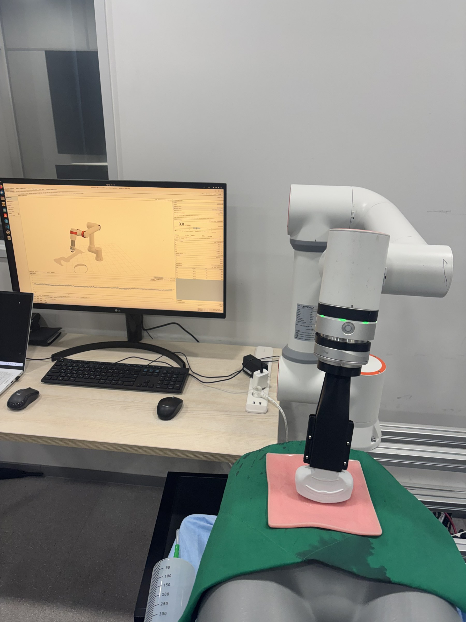
Force experiment rig. An inflatable air tube inside a torso mannequin is inflated and deflated through a 500 mL syringe while the robot holds a commanded contact force on the surface above it. The console at the left shows the live contact force and the commanded set point.
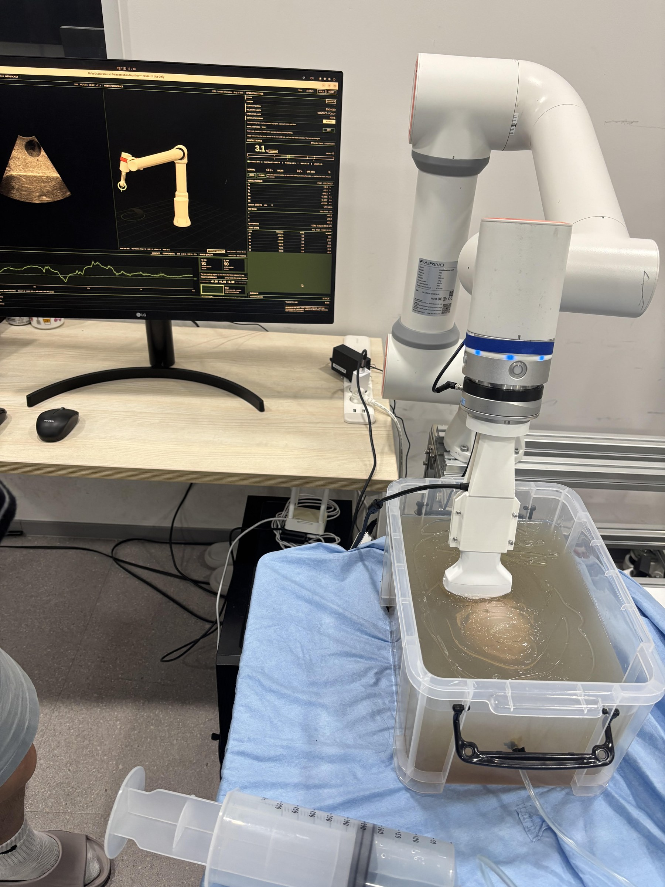
Final experimental setup. The robot holds the clinical convex probe against the gel bladder phantom, which sits in a water bath; the syringe in the foreground fills and empties the phantom lumen through a line during the run, and the console at the left shows the image, the contact force and the two quality readings that the operator watches.
Pre-registered policy evaluation
The evaluation is pre-registered. The primary endpoint is the acquisition success rate, defined as reaching a diagnostic view within 90 s and holding it for 3 s, where a diagnostic view requires simultaneously a bladder mask area of at least 8 % of the frame, a largest connected component of at least 80 % of the mask, and a lateral centroid within 0.30 of the frame centre. Neither Q̂ nor Q_raw is a primary endpoint: the first is the policy's own objective and would be circular, and the second measures coupling rather than anatomy.
Each episode begins from a teleoperated approach to a starting pose in which the bladder is not visible although coupling is good (area below 2 % with Q_raw ≥ 0.6); the operator then releases the stylus and starts inference from the console. Conditions are hold (no command), placebo, policy, and optionally expert teleoperation as an upper bound. The placebo is pre-registered as motion of the same magnitude and duration as the policy's with the direction destroyed: the axes of the selected rotation command are shuffled and the signs flipped, so the multiset of command magnitudes is preserved exactly. Condition order is randomised within each starting pose and the operator is blind to the condition. The primary analysis is a paired McNemar exact test of policy against placebo with bootstrap confidence intervals, with Wilson intervals for proportions and a log rank test on acquisition time as a secondary analysis. A blinded human read of the last five seconds of each episode by two readers on a five point scale, with weighted \kappa, is reported alongside the automatic criterion.
The pre-registration also fixes what would refute the claim: if policy is indistinguishable from placebo, the direction selection contributes nothing; if the safety indicators are poor, the system is unusable regardless of success rate.
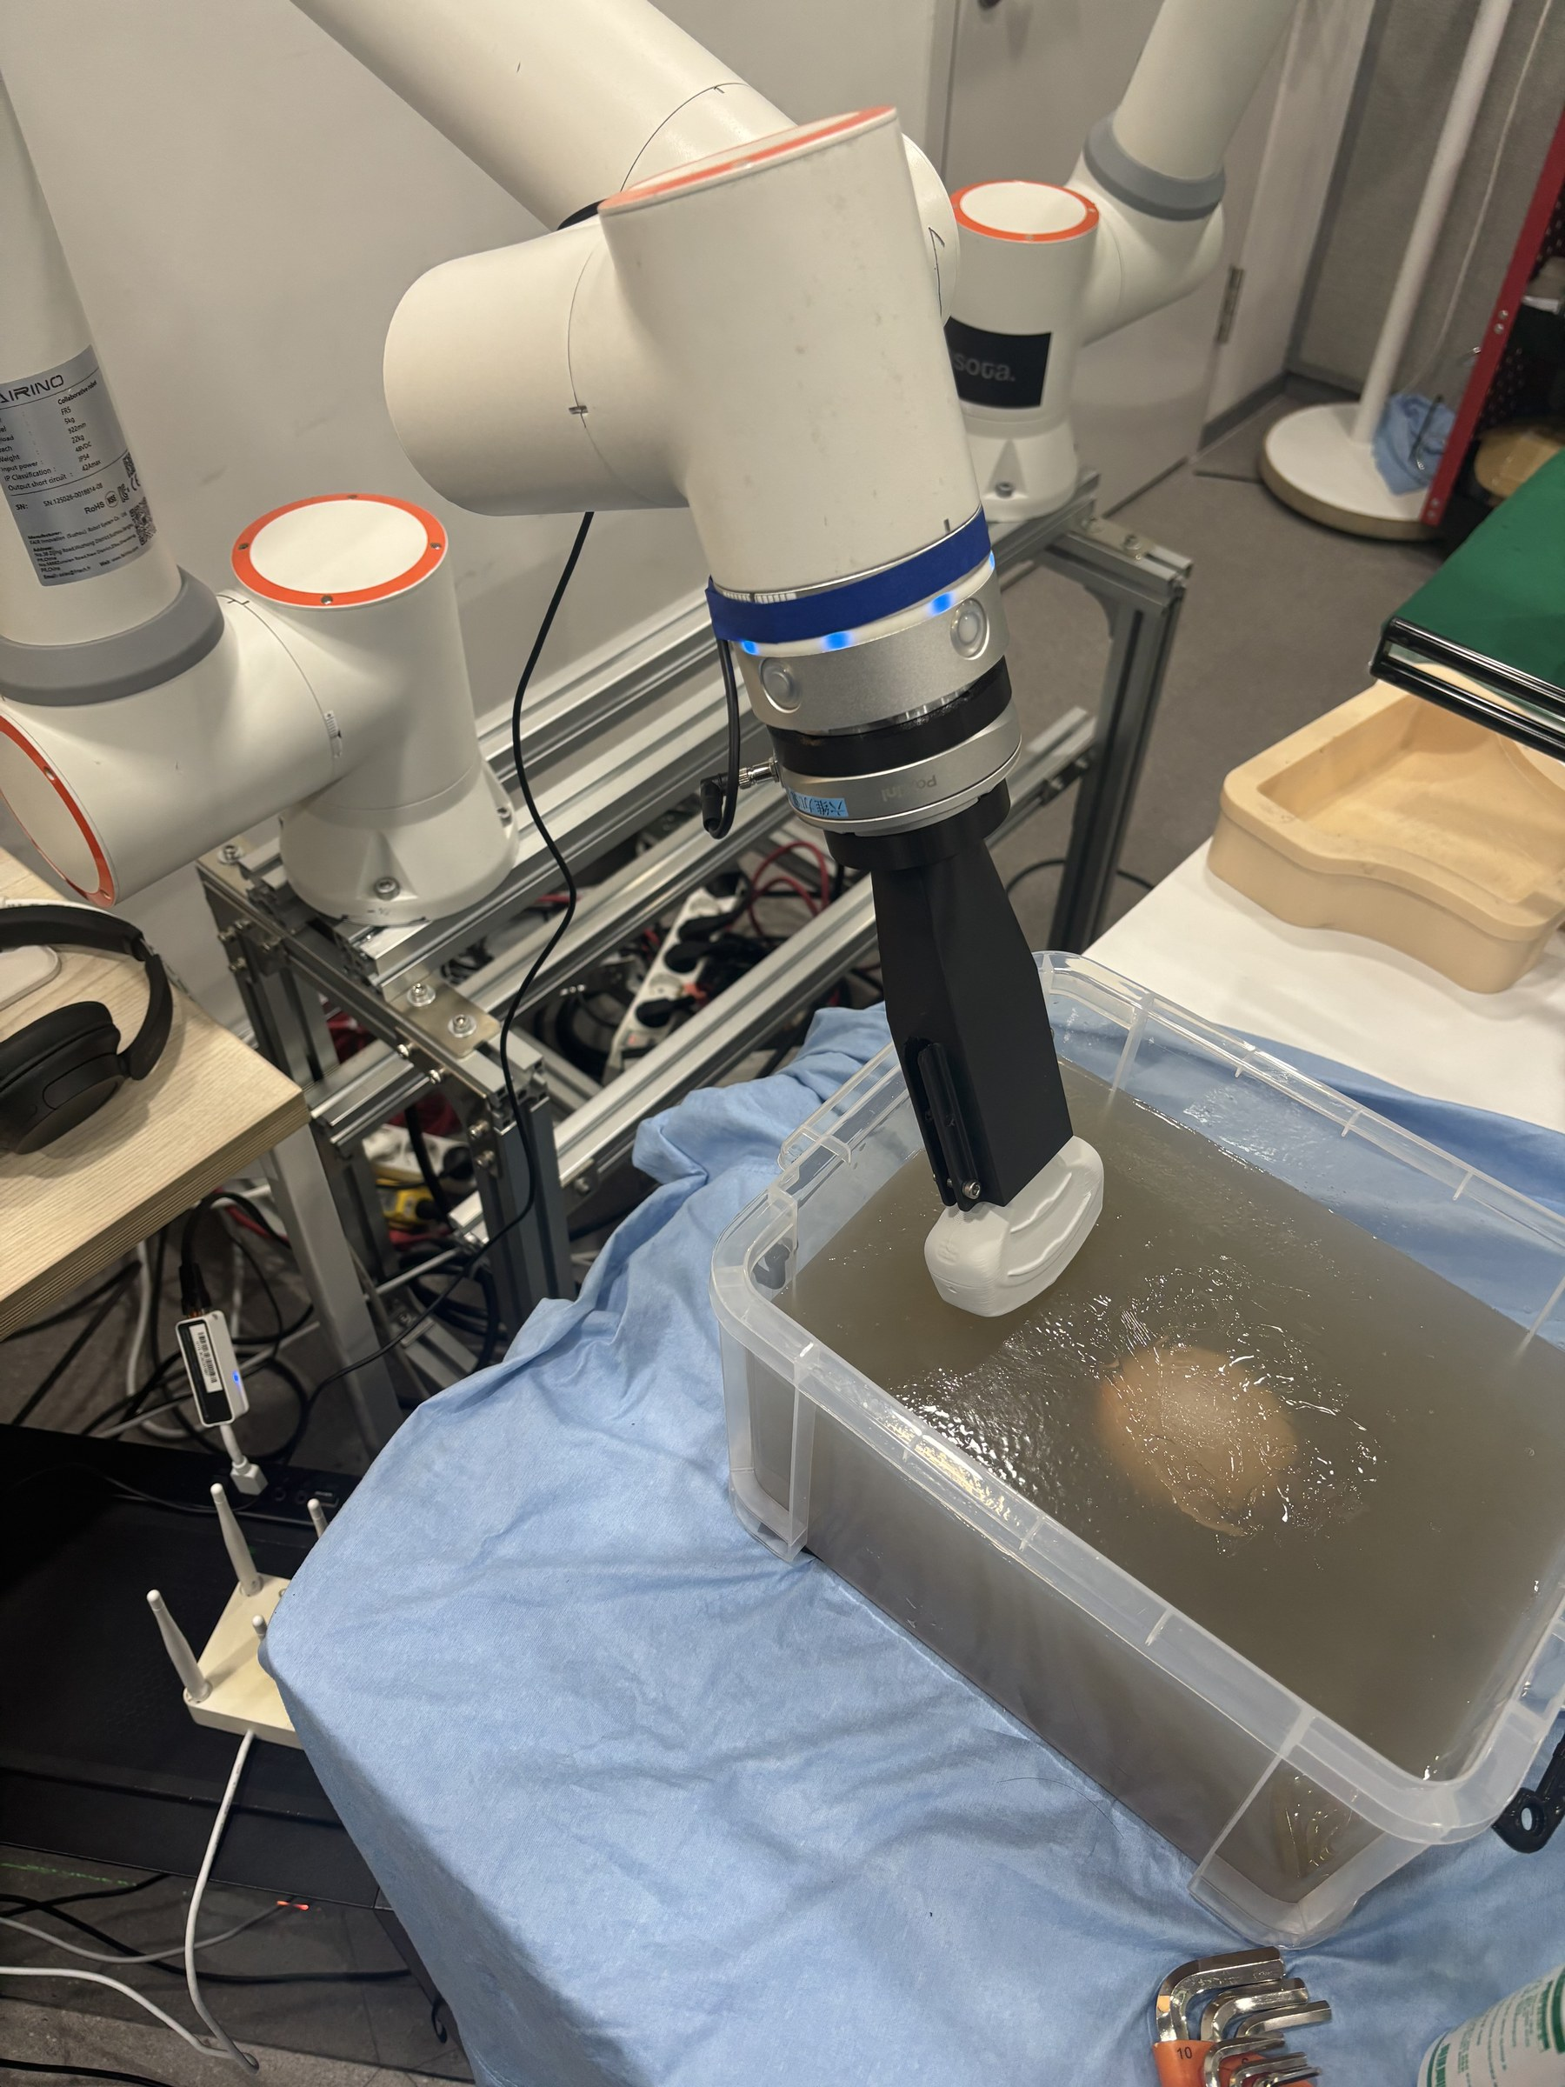
Contact stiffness of the dynamic bladder phantom. A printed probe replica indents the gel phantom while contact force comes from the force/torque sensor and depth from forward kinematics, so that no scanner and no control stack are involved. Force noise is 0.015 N and depth noise 0.4 µm, against indentation steps of about 1 mm.
Results
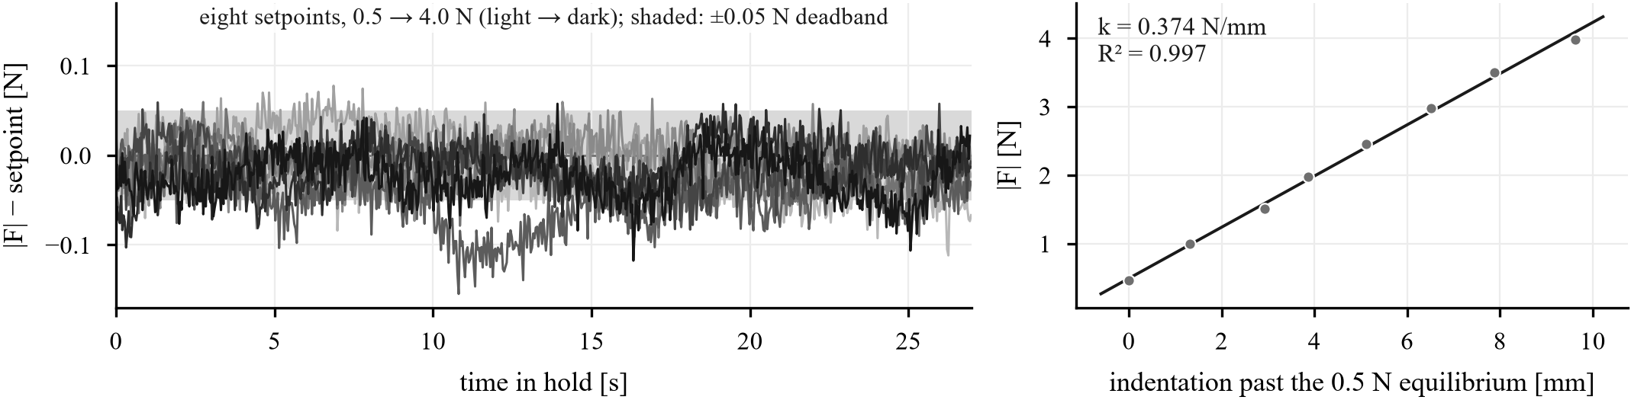
Force hold at eight set points. Left: error from the commanded force during the scored part of each hold, all eight set points from 0.5–4.0 N overlaid (light to dark), with the ± 0.05 N dead band shaded; the first 3 s of each hold are discarded and the traces are 1 kHz samples pooled over two independently calibrated sessions. Right: the equilibrium force against indentation past the 0.5 N point, whose slope is the phantom stiffness used in the time constant above.
Force regulation
Fig. 7 shows every hold as an error trace against its own set point. Across the 16 holds the standard deviation of the held force is 0.028 N on average and 0.073 N at worst, every hold sits inside the ± 0.05 N dead band, and the worst mean error is 0.049 N (Table 1). Relative error falls from 6.3 % at 0.5 N to 0.8–1.4 % above 3 N, and the two independently calibrated sessions agree to within 0.047 N, which is the reproducibility of the whole chain including recalibration.
Under volume disturbance the loop behaves as its time constant predicts. Syringe steps arrive with a median spacing of 4.6 s and the force peak occurs 3.1 s after a step, while the dead band re-entry time is about 35 s. Consequently the regulator does not reduce the peak (0.83 N against 0.74 N with the loop disabled on injection), but it does change everything after the peak: the probe travels 0.17 mm (IQR 0.13–0.24) against 0.01 mm, the post peak return rate rises to 0.23 N\pers from 0.13 N\pers (p < 0.001, n = 70 events per arm), and the residual deviation at the next step falls to 0.28 N from 0.38 N (p = 0.011). We report this as a bounded claim: on this phantom the loop recovers from disturbances but does not attenuate their peaks, and closing that gap requires a faster loop than the limit cycle permits.
The hard limit was exercised rather than assumed. In the two runs at the 4.0 N set point the disturbance drove the force to 5.38 N and the 5 N retreat fired; in all other runs the peak stayed below the warning line.
Force hold on the air tube mannequin phantom. Pooled over two independently calibrated sessions, 30 s per hold, first 3 s discarded, 1 kHz sampling.
Target [N] | SD [N] | Mean error [N] | In band [%] | Peak [N]
0.5 | 0.023 | -0.017 | 88.9 | 0.60
1.0 | 0.022 | -0.013 | 83.9 | 1.10
1.5 | 0.022 | -0.012 | 94.1 | 1.57
2.0 | 0.026 | -0.016 | 89.9 | 2.09
2.5 | 0.029 | -0.031 | 72.9 | 2.59
3.0 | 0.026 | -0.015 | 89.7 | 3.10
3.5 | 0.025 | -0.008 | 93.7 | 3.59
4.0 | 0.049 | -0.025 | 82.9 | 4.36

Demonstration quality
Table 2 summarises the comparison that justifies the demonstration route: six axis fusion on the host against the on chip nine axis rotation vector, on the same recordings, next to the robot.
Probe orientation against robot forward kinematics. Host side six axis fusion against the on chip nine axis rotation vector, same recordings, near the robot.
 | Six axis | Nine axis
Axial rotation RMS [°] | 1.95 | 11.23
Tilt x RMS [°] | 1.14 | 6.17
Tilt y RMS [°] | 0.73 | 3.98
Static alignment residual [°] | 0.81 | 6.68
Axial drift [°/min] | 0.23 | 8.29

What the policy learned
Rotation is learned and translation is not. Against label dispersions of 14.5 mm and 13.4 mm in the lateral and elevational translation axes, the model's mean absolute errors are 12.2 mm and 7.0 mm, which is the accuracy of predicting a constant; against a rotation label dispersion of 0.96 ° the errors are 0.36–0.66 °. This is the empirical reason the deployed policy commands rotation only.
Closed loop policy
[TODO: Main result: success rate per condition with Wilson intervals, the paired McNemar comparison, acquisition time, and behaviour while the dynamic phantom volume changes. As of this draft, 4 of 18 pilot episodes have been run and none reached the success criterion.]
[FIGURE TO BE DRAWN]
Closed loop behaviour on the dynamic bladder phantom. [TODO: caption once the runs are complete]
The quality head learns magnitude, not direction
Candidate selection, equation 4, is where image information is supposed to enter, and it is where the current model fails in an instructive way. We measure the head directly with a mirror test: each candidate chunk is scored against a copy of itself with the elevational tilt sign flipped, and the head is asked which of the two is better. The trained head prefers the correct direction on 52.4 % of held out observations, against a chance level of 50 %, while it prefers the larger of two otherwise identical motions on 70.1 %. Retraining the head on an area weighted quality label raises the label fit from R² = 0.081 to 0.536 and the action effect correlation from -0.035 to +0.196, yet moves the mirror test only to 56.3 %. The two apparently improved numbers are explained by magnitude: in freehand data the size of a motion is correlated with the size of the resulting area change, so a head that has learned only “larger is better” improves on both.
The consequence in closed loop is a policy that tilts steadily in one elevational direction rather than searching. On 480 held out observations the decoder proposes elevational tilt in both directions in equal proportion (52 % positive), matching the demonstration labels (50.4 % positive), but ranking those candidates by Q̂ selects the negative direction in 84 % of observations, and the candidate mean is uncorrelated with the demonstrated label (ρ = -0.04). Lowering the mode consistency bonus makes the lock stronger rather than weaker (78 % at γ = 0.2, 84 % at γ = 0), which places the bias in the quality head and not in the selection prior. The retrained head is worse in exactly this sense: it selects one direction in 91 % of observations.
Part of the explanation is the objective itself. The head was trained to predict the original Q_seg, whose span between “no bladder” and “bladder perfectly captured” is 0.06 (Sec. V), while the span between a small and a large motion in the same data is larger than that. Given that target, a head that reports motion magnitude is not a bug but the best available fit.
We report this because it is also a property of the data rather than only of the implementation. In demonstrations recorded by a sonographer who is already looking at the screen, the direction of motion is confounded with the operator's decision; the marginal rank correlation between elevational tilt and the subsequent area weighted quality change is ρ = +0.10 on the training split and -0.03 on test, which is below what candidate ranking can use, and of the opposite sign to the direction the head prefers. Direction requires interventional data: sweeps executed by the robot itself, labelled by forward kinematics, in which the direction is imposed rather than chosen. As an interim control we also evaluate a condition that replaces the learned ranking with measured hill climbing on Q_seg, which needs no new data but pays for every decision with probe motion.
Limitations
- One phantom, one operator. All demonstrations come from a single bladder phantom, so validation and test splits measure reproducibility rather than generalisation, and no clinical data are used. Clinical recording is planned as non-interventional observation with no robot and no force control applied to subjects.
- Direction is not learned (Sec. VIII). The system maintains contact and image quality; it does not yet decide where to look.
- Peaks are not attenuated. The force loop recovers from volume disturbances but does not reduce their peaks, because its time constant (12 s) is far longer than the disturbance spacing (4.6 s); faster gains reintroduce a limit cycle.
- A sub newton force offset remains. The scale factor is accurate to 2 %, but a bias of -0.29 N and an attitude dependent compensation residual of the same order are not removed.
- The orientation accuracy and the demonstration corpus come from different probes. The bench characterisation against robot kinematics used an instrumented probe on a different scanner from the one used for the phantom demonstrations, and the clamp geometry differs; the transfer of the orientation figures between the two has not been measured.
- Sign convention of two axes. The axis assignment of the sensor to probe rotation is certain; the signs of the lateral and elevational rows are supported by conflicting evidence.
- Vertical centring is unreachable. At the depth setting used, the target lies in the near field and cannot be brought to the vertical centre of the frame by any probe motion, so a servo target defined in frame coordinates is infeasible in that axis.
- Presence errors dominate segmentation error. Boundaries are accurate, but the network still puts a mask on about half of audited empty frames.
- Force labels were never supervised. The force head and the feasibility and risk terms received no gradient, because the freehand demonstrations carry no valid force channel.
Conclusion
We described an ultrasound robot for the bladder monitoring task of HoLEP morcellation, in which contact force is regulated inside a verified envelope and the image objective is learned from demonstrations that were never collected on the robot. The demonstration route is validated end to end: six axis probe mounted inertial sensing recovers rotation to 2.50 ° against robot kinematics, the two streams are aligned to a measured 200 ms, and the resulting chunks train an action chunking policy with a predicted quality head. [TODO: closing sentence once the closed loop results are in.] The negative result on direction learning identifies precisely which data the next iteration needs, and it is data this platform can now collect by itself.
References
[1] Jang, Taejin and Kong, Hyoun-Joong and Baek, Chanwoo and Kim, Jaeyoung and Choo, Min Soo and Oh, Seung-June. Effect of Self-Training Using Virtual Reality Head-Mounted Display Simulator on the Acquisition of Holmium Laser Enucleation of the Prostate Surgical Skills. International Neurourology Journal. 28. 2. 138--146.
[2] Trinkler, Friedrich and Dietrich, Christoph F.. Ultrasound of the Urinary Bladder. EFSUMB Course Book.
[3] Priester, Alan M. and Natarajan, Shyam and Culjat, Martin O.. Robotic Ultrasound Systems in Medicine. IEEE Transactions on Ultrasonics, Ferroelectrics, and Frequency Control. 60. 3. 507--523.
[4] von Haxthausen, Felix and B\"ottger, Sven and Wulff, Daniel and Hagenah, Jannis and Garc\'ia-V\'azquez, Ver\'onica and Ipsen, Svenja. Medical Robots for Ultrasound Imaging: Current Systems and Future Trends. Current Robotics Reports. 2. 55--71.
[5] Li, Keyu and Xu, Yangxin and Meng, Max Q.-H.. An Overview of Systems and Techniques for Autonomous Robotic Ultrasound Acquisitions. IEEE Transactions on Medical Robotics and Bionics. 3. 2. 510--524.
[6] Jiang, Zhongliang and Salcudean, Septimiu E. and Navab, Nassir. Robotic Ultrasound Imaging: State-of-the-Art and Future Perspectives. Medical Image Analysis. 89. 102878.
[7] Gilbertson, Matthew W. and Anthony, Brian W.. Force and Position Control System for Freehand Ultrasound. IEEE Transactions on Robotics. 31. 4. 835--849.
[8] Hennersperger, Christoph and Fuerst, Bernhard and Virga, Salvatore and others. Towards MRI-Based Autonomous Robotic US Acquisitions: A First Feasibility Study. IEEE Transactions on Medical Imaging. 36. 2. 538--548.
[9] Chatelain, Pierre and Krupa, Alexandre and Navab, Nassir. Confidence-Driven Control of an Ultrasound Probe. IEEE Transactions on Robotics. 33. 6. 1410--1424.
[10] Argall, Brenna D. and Chernova, Sonia and Veloso, Manuela and Browning, Brett. A Survey of Robot Learning from Demonstration. Robotics and Autonomous Systems. 57. 5. 469--483.
[11] Ravichandar, Harish and Polydoros, Athanasios S. and Chernova, Sonia and Billard, Aude. Recent Advances in Robot Learning from Demonstration. Annual Review of Control, Robotics, and Autonomous Systems. 3. 297--330.
[12] Chi, Cheng and Xu, Zhenjia and Pan, Chuer and Cousineau, Eric and Burchfiel, Benjamin and Feng, Siyuan and Tedrake, Russ and Song, Shuran. Universal Manipulation Interface: In-the-Wild Robot Teaching Without In-the-Wild Robots. Robotics: Science and Systems (RSS).
[13] Prager, Richard W. and Gee, Andrew and Berman, Laurence. Stradx: Real-Time Acquisition and Visualization of Freehand Three-Dimensional Ultrasound. Medical Image Analysis. 3. 2. 129--140.
[14] Housden, R. James and Treece, Graham M. and Gee, Andrew H. and Prager, Richard W.. Sensorless Reconstruction of Unconstrained Freehand 3D Ultrasound Data. Ultrasound in Medicine and Biology. 33. 3. 408--419.
[15] Prevost, Raphael and Salehi, Mehrdad and Jagoda, Simon and Kumar, Navneet and Sprung, Julian and Ladikos, Alexander and Bauer, Robert and Zettinig, Oliver and Wein, Wolfgang. 3D Freehand Ultrasound Without External Tracking Using Deep Learning. Medical Image Analysis. 48. 187--202.
[16] Zhao, Tony Z. and Kumar, Vikash and Levine, Sergey and Finn, Chelsea. Learning Fine-Grained Bimanual Manipulation with Low-Cost Hardware. Robotics: Science and Systems (RSS).
[17] Saini, Manik and Jiang, Yun and Gangopadhyay, Tapabrata and Rosen, Daniel P. and Alizad, Azra and Fatemi, Mostafa. BWS-Net: An Optimal Deep Learning Architecture for the Anterior Bladder Wall Segmentation Using Ultrasound Imaging. IEEE Journal of Biomedical and Health Informatics. 2026.
[18] Song, Zhiyu and Asiedu, Michael and Wang, Shan and Li, Qian and Ozturk, Arinc and Mittal, Vinay and Schoen Jr., Scott and Ramaswamy, Sheila and Pierce, Theodore T. and Samir, Anthony E. and Eldar, Yonina C. and Chandrakasan, Anantha and Kumar, Viksit. Memory-Efficient Low-Compute Segmentation Algorithms for Bladder-Monitoring Smart Ultrasound Devices. Scientific Reports. 13. 16450.
[19] Hsu, Hsiang-Ling and Zahiri, Mohsen and Li, Guang Yang and Al Mukaddim, Rashid and Lee, Hyunwoo and Wilson, Mark G. and Grube, Jonathan and Schmidt, Sabine and Ghoshal, Goutam and Raju, Balasundar. Active Guidance in Ultrasound Bladder Scanning Using Reinforcement Learning. Scientific Reports. 16. 5273.
[20] Ronneberger, Olaf and Fischer, Philipp and Brox, Thomas. U-Net: Convolutional Networks for Biomedical Image Segmentation. Medical Image Computing and Computer-Assisted Intervention (MICCAI). 9351. 234--241. 2015.
[21] Sol\'is-Mart\'in, David and Sainz, Jos\'e Antonio and Gal\'an-P\'aez, Juan and Borrego-D\'iaz, Joaqu\'in and Garc\'ia-Mejido, Jos\'e Antonio. PFUS1: Premier Pelvic Floor Ultrasound Segmentation Dataset. A Resource for Advancing Research. Data in Brief. 64. 112346.
[22] Garc\'ia-Mejido, Jos\'e Antonio and Sol\'is-Mart\'in, David and Mart\'in-Mor\'an, Mar\'ia and Fern\'andez-Conde, Cristina and Fern\'andez-Palac\'in, Fernando and Sainz-Bueno, Jos\'e Antonio. Applicability of Deep Learning to Dynamically Identify the Different Organs of the Pelvic Floor in the Midsagittal Plane. International Urogynecology Journal. 35. 12. 2285--2293.
[23] Madgwick, Sebastian O. H. and Harrison, Andrew J. L. and Vaidyanathan, Ravi. Estimation of IMU and MARG Orientation Using a Gradient Descent Algorithm. IEEE International Conference on Rehabilitation Robotics (ICORR). 1--7.
[24] de Vries, W. H. K. and Veeger, H. E. J. and Baten, C. T. M. and van der Helm, F. C. T.. Magnetic Distortion in Motion Labs, Implications for Validating Inertial Magnetic Sensors. Gait and Posture. 29. 4. 535--541.
[25] Sabatini, Angelo Maria. Estimating Three-Dimensional Orientation of Human Body Parts by Inertial/Magnetic Sensing. Sensors. 11. 2. 1489--1525.
[26] Foxlin, Eric. Pedestrian Tracking with Shoe-Mounted Inertial Sensors. IEEE Computer Graphics and Applications. 25. 6. 38--46.
[27] Skog, Isaac and H\"andel, Peter and Nilsson, John-Olof and Rantakokko, Jouni. Zero-Velocity Detection: An Algorithm Evaluation. IEEE Transactions on Biomedical Engineering. 57. 11. 2657--2666.
[28] Fernandez, Sophia V. and Kim, Jin-Hoon and Sadat, David and others. A Dynamic Ultrasound Phantom with Tissue-Mimicking Mechanical and Acoustic Properties. Advanced Science. 11. 19. 2400271. 2024.

