IMDb Movie Data Analysis
Exploratory Data Analysis of 1,000 Popular Movies (2006–2016)
Prepared using Python (pandas, seaborn, matplotlib)

1. Introduction
This report presents an exploratory data analysis (EDA) of a dataset of 1,000 popular movies released between 2006 and 2016, sourced from IMDb. The goal is to uncover patterns in audience ratings, genre popularity, runtime, box office revenue, and how these metrics relate to one another and change over time.
The dataset contains 1000 movies spanning 2006–2016, covering 644 unique directors. Key fields analyzed include Title, Genre, Director, Actors, Year, Runtime, IMDb Rating, Votes, Revenue, and Metascore.

2. Key Metrics at a Glance
1000  Movies Analyzed | 6.72  Average Rating | 6.8  Median Rating | 113.2 min  Avg. Runtime
$83.1M  Avg. Revenue | 129 movies  Missing Revenue | 644  Unique Directors | Action  Top Genre

3. Ratings Analysis

3.1 Distribution of IMDb Ratings
Ratings are approximately bell-shaped and centred around the mid-to-high 6s, which reflects the fact that this dataset is already filtered to "popular" movies rather than a random sample of all titles on IMDb — very poorly rated films are underrepresented.
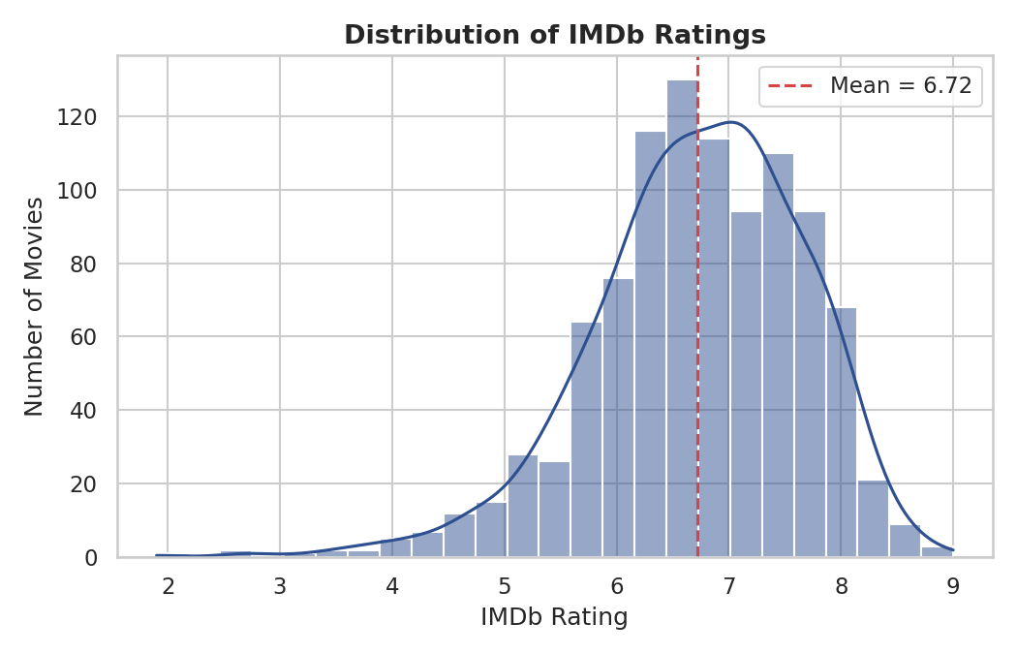
Figure 1. Distribution of IMDb ratings across all 1,000 movies.

3.2 Ratings Over Time
Average ratings stay fairly stable across the decade, with modest year-to-year fluctuation rather than a clear upward or downward trend. The number of movies released per year in the dataset also varies, which should be kept in mind when comparing individual years.
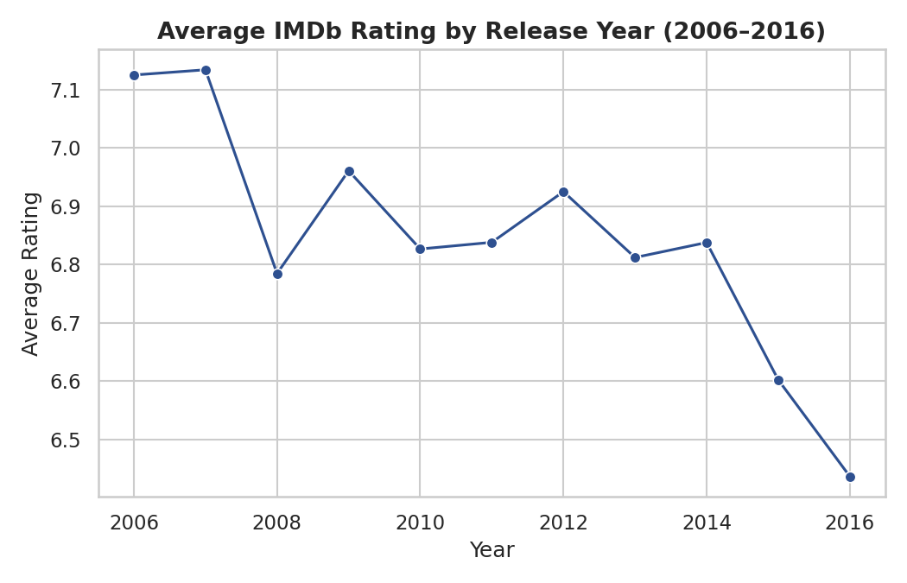
Figure 2. Average IMDb rating by release year.
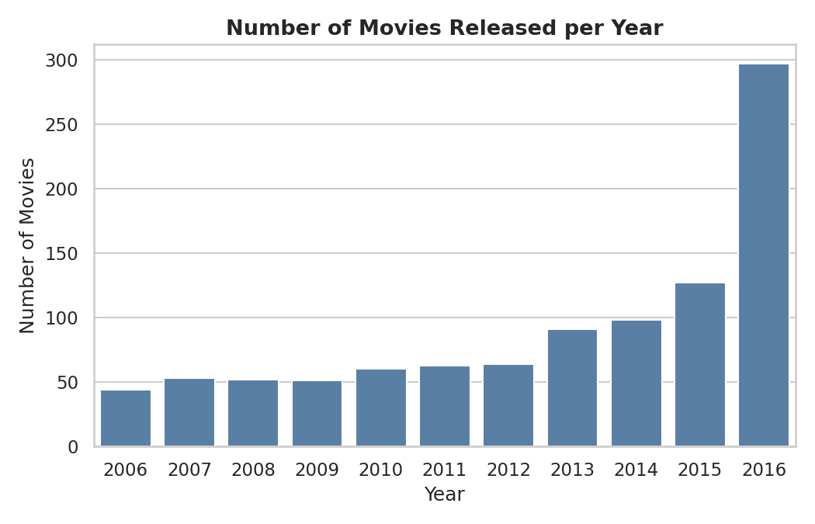
Figure 3. Number of movies released per year in the dataset.

3.3 Top-Rated Movies
Title | Year | Rating | Votes | Director
The Dark Knight | 2008 | 9.0 | 1,791,916 | Christopher Nolan
Inception | 2010 | 8.8 | 1,583,625 | Christopher Nolan
Dangal | 2016 | 8.8 | 48,969 | Nitesh Tiwari
Kimi no na wa | 2016 | 8.6 | 34,110 | Makoto Shinkai
Interstellar | 2014 | 8.6 | 1,047,747 | Christopher Nolan
The Intouchables | 2011 | 8.6 | 557,965 | Olivier Nakache
The Departed | 2006 | 8.5 | 937,414 | Martin Scorsese
The Dark Knight Rises | 2012 | 8.5 | 1,222,645 | Christopher Nolan
Whiplash | 2014 | 8.5 | 477,276 | Damien Chazelle
The Prestige | 2006 | 8.5 | 913,152 | Christopher Nolan

4. Genre Analysis

4.1 Most Common Genres
Action, Comedy, and Drama dominate the volume of releases, which is expected given the dataset's focus on commercially popular films.
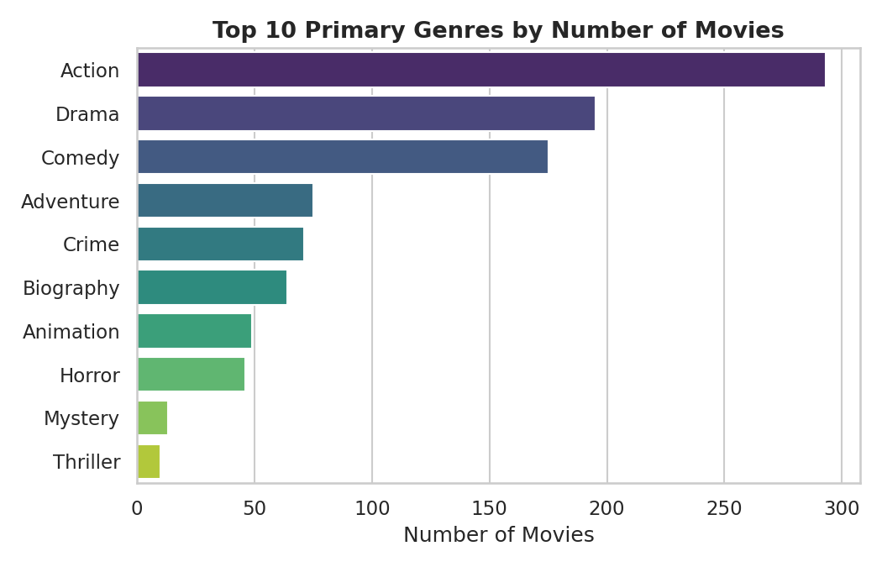
Figure 4. Top 10 primary genres by number of movies.

4.2 Rating by Genre
While Action and Comedy lead in volume, they don't necessarily lead in average rating. Genres such as Biography, Animation, and Crime tend to score higher on average, suggesting a gap between what's most frequently produced and what's most critically well-received.
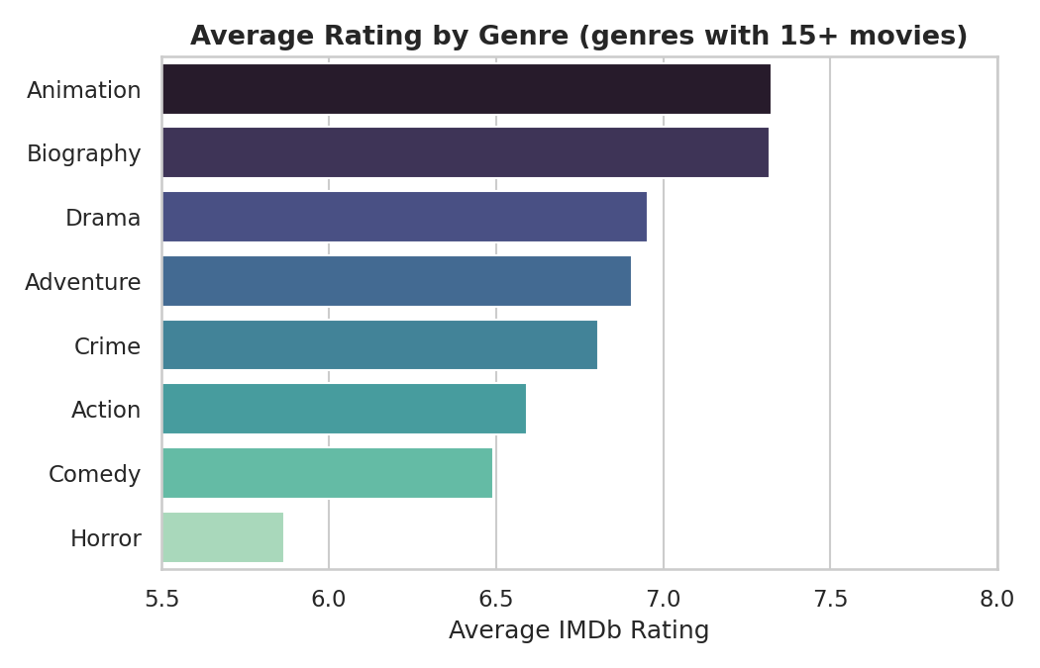
Figure 5. Average rating by genre (genres with 15+ movies only).

5. Runtime, Revenue, and Rating Relationships

5.1 Runtime vs. Rating
There is a weak positive relationship between runtime and rating — longer movies tend to be rated marginally higher on average, though the effect is small and there is wide variance at every runtime.
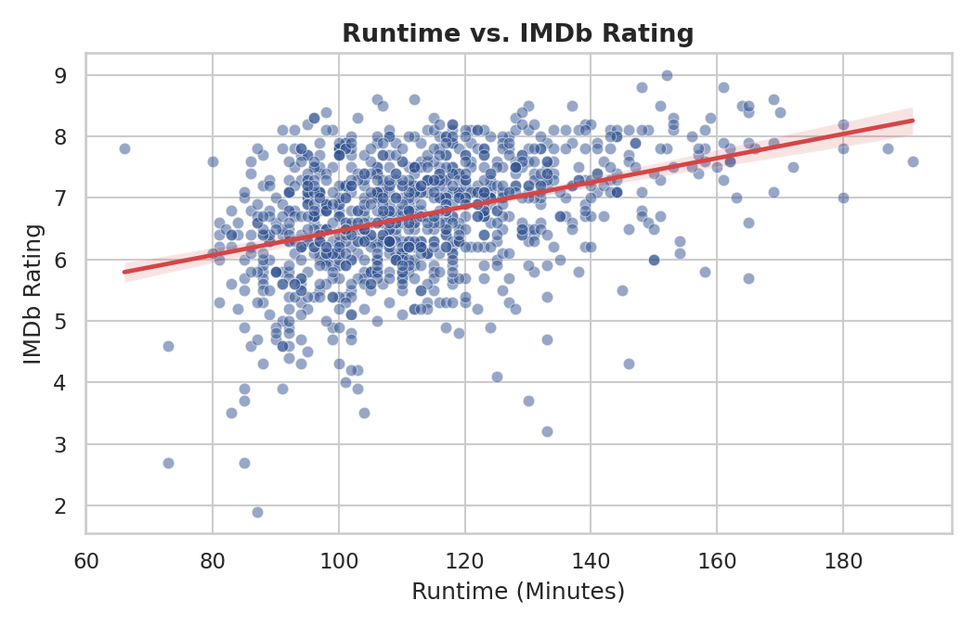
Figure 6. Runtime (minutes) vs. IMDb rating, with trend line.

5.2 Revenue vs. Rating
Revenue data is missing for 129 movies (likely smaller or non-wide releases); for the remaining titles, higher-rated movies show a mild tendency toward higher box office revenue, but plenty of highly rated films underperform commercially and vice versa — rating alone is a weak predictor of revenue.
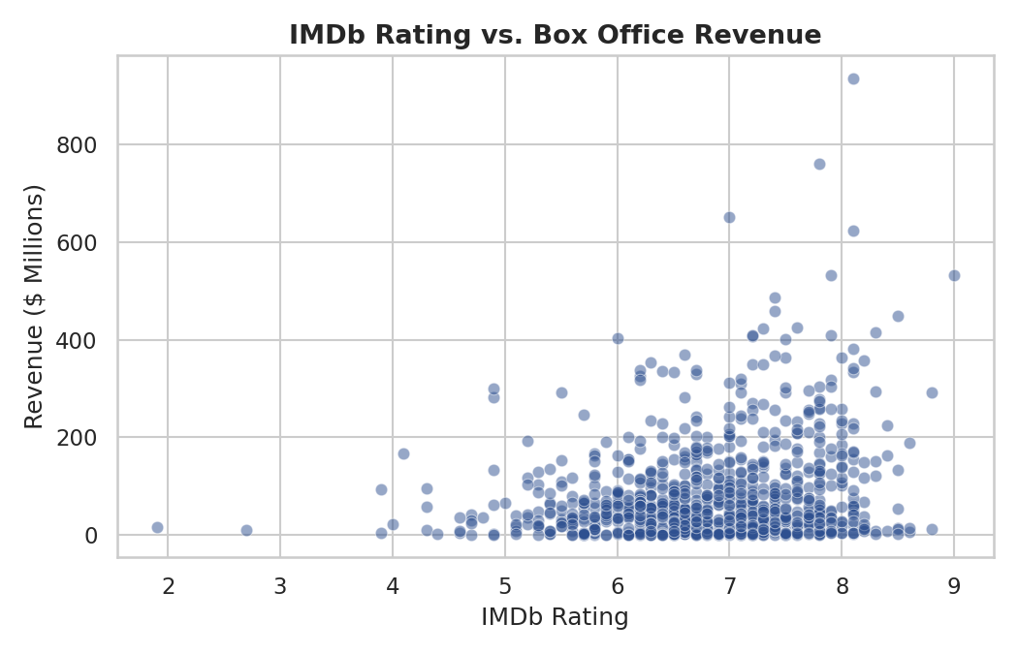
Figure 7. IMDb rating vs. box office revenue ($ millions).

5.3 Correlation Between Numeric Features
The correlation matrix below summarizes linear relationships between the key numeric fields. Votes and Revenue show the strongest positive correlation with Rating among the available metrics, while Runtime and Year show weaker associations.
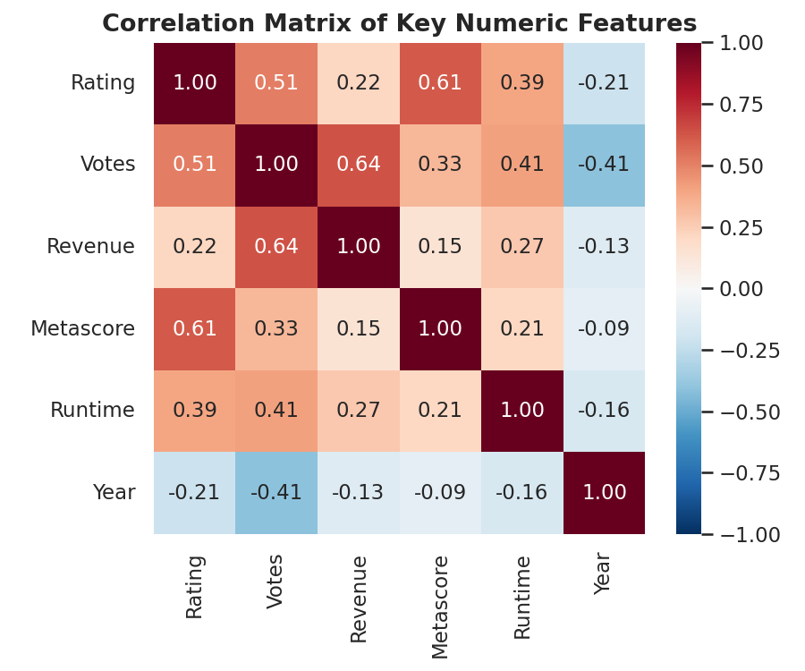
Figure 8. Correlation matrix of Rating, Votes, Revenue, Metascore, Runtime, and Year.

6. Directors and Commercial Performance

6.1 Top Directors by Average Rating
Restricting to directors with at least three movies in the dataset highlights a small group of consistently high-rated filmmakers, led by names closely associated with critically acclaimed, high-grossing films.
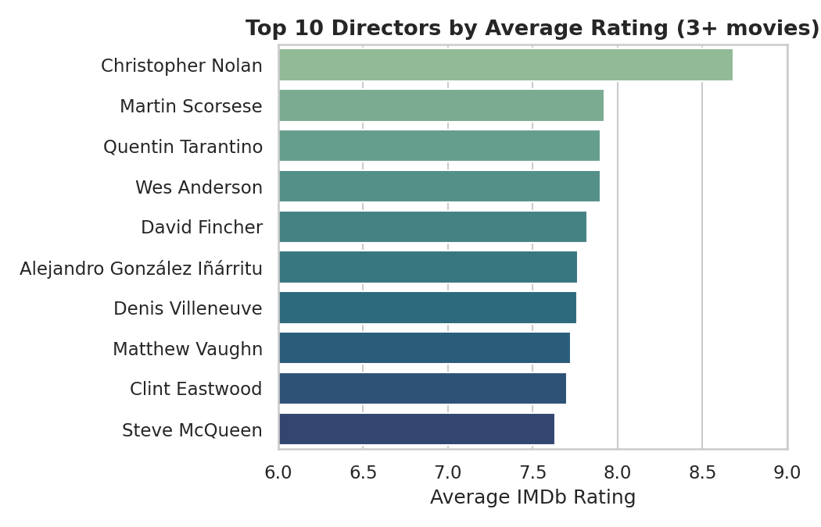
Figure 9. Top 10 directors by average IMDb rating (3+ movies in dataset).

6.2 Highest-Grossing Movies
Title | Year | Revenue ($M) | Rating
Star Wars: Episode VII - The Force Awakens | 2015 | 936.63 | 8.1
Avatar | 2009 | 760.51 | 7.8
Jurassic World | 2015 | 652.18 | 7.0
The Avengers | 2012 | 623.28 | 8.1
The Dark Knight | 2008 | 533.32 | 9.0
Rogue One | 2016 | 532.17 | 7.9
Finding Dory | 2016 | 486.29 | 7.4
Avengers: Age of Ultron | 2015 | 458.99 | 7.4
The Dark Knight Rises | 2012 | 448.13 | 8.5
The Hunger Games: Catching Fire | 2013 | 424.65 | 7.6

7. Key Findings
- Ratings across the 1,000-movie dataset are centred around 6.7–6.8, reflecting a sample already skewed toward popular/notable releases.
- Action, Comedy, and Drama are the most frequently produced genres, but Biography, Animation, and Crime titles tend to earn higher average ratings.
- Runtime has only a weak positive relationship with rating — longer films are not reliably better-rated.
- Revenue and rating are only mildly correlated: critical/audience approval does not strongly predict box office success.
- Votes correlate more strongly with rating than revenue does, suggesting engagement/visibility matters as much as raw earnings.
- A small set of directors (e.g., those behind Inception, The Dark Knight, Whiplash) account for a disproportionate share of the top-rated titles.

8. Data Source & Methodology
Dataset: "1,000 Popular Movies" (2006–2016), originally compiled from IMDb listings (Title, Genre, Description, Director, Actors, Year, Runtime, Rating, Votes, Revenue, Metascore). Analysis performed in Python using pandas for data cleaning/aggregation and matplotlib/seaborn for visualization. Zero values in Revenue and Metascore were treated as missing rather than true zero, since a movie cannot literally gross $0 or receive a Metascore of 0.
This report and the underlying analysis script are structured so the same pipeline can be re-run on an updated or larger IMDb extract (e.g., the full IMDb non-commercial datasets at datasets.imdbws.com) with minimal changes.

