**https://github.com/suvaatnbu/SKILL-TEST2.git**

Microservices Kubernetes Deployment Assessment ([Link](https://github.com/mohanDevOps-arch/Microservices-Task.git))

**Total Marks: 50  
Time Limit: 1 hour**

Objective

**Deploy a microservices application on Kubernetes using Minikube, ensuring proper service communication and configuration.**

Application Components

**You are provided with four containerized Node.js microservices:**

* **User Service (Port 3000)**
* **Product Service (Port 3001)**
* **Order Service (Port 3002)**
* **Gateway Service (Port 3003)**

Task Requirements

1. Basic Kubernetes Deployment (30 marks)

A. Create Kubernetes Deployment manifests for all services (18 marks)

* **User Service deployment**
* **Product Service deployment**
* **Order Service deployment**
* **Gateway Service deployment  (includes additional proxy handling setup if required)**

**Each deployment must include:**

* **Correct container image reference**
* **Resource limits and requests**
* **Environment variables**
* **Liveness and readiness probes**
* **Proper labels and selectors**

      B. Create corresponding Service resources (12 marks)

* **Configure correct ports**
* **Choose proper service types**
* **Enable cluster-level service discovery using ClusterIP**

2. Minikube Setup and Validation (15 marks)

* **Initialize and configure Minikube**
* **Deploy all components successfully**
* **Validate inter-service communication using curl or logs**

3. Documentation and Testing (5 marks)

**Provide a well-structured README.md with:**

* **Minikube setup steps**
* **Deployment process using kubectl apply -f**
* **Service testing instructions using kubectl port-forward or direct service names**
* **Troubleshooting tips**

**Include screenshots of:**

* **Running pods (kubectl get pods)**
* **Logs showing service communication**
* **Any port-forwarded test results**
* 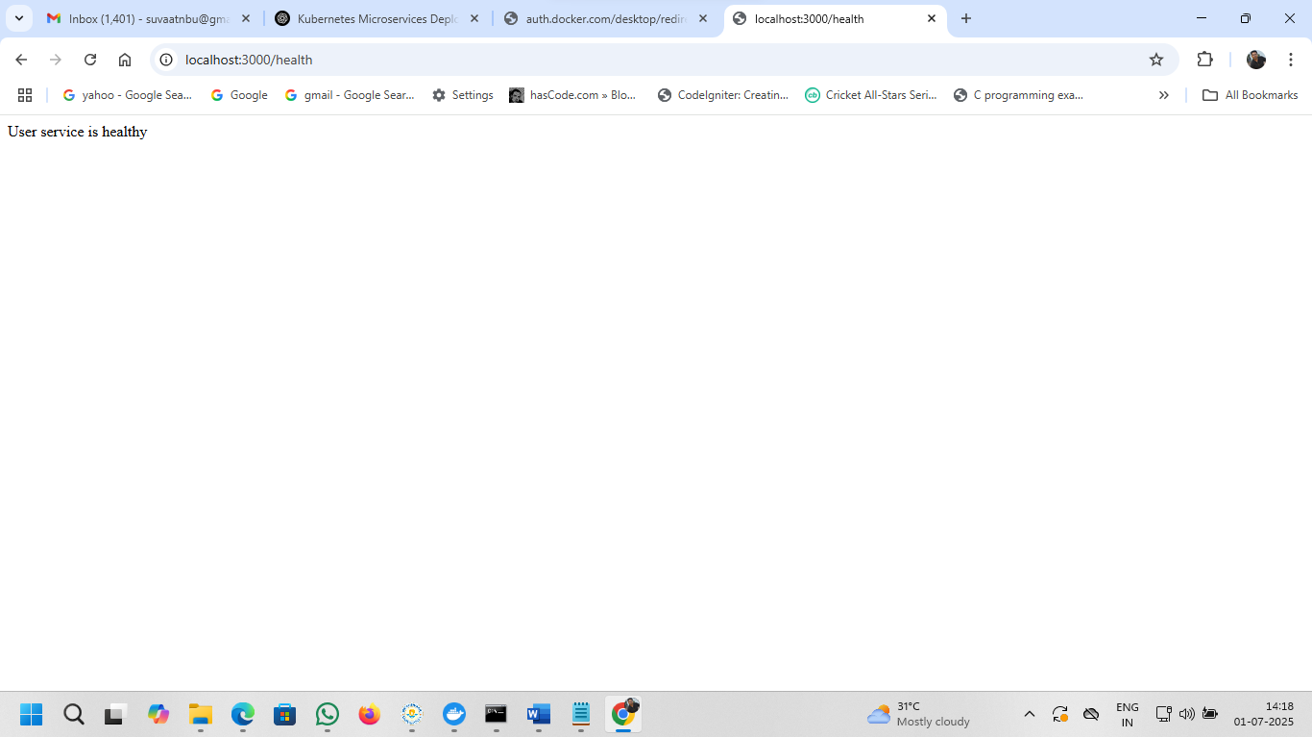
* 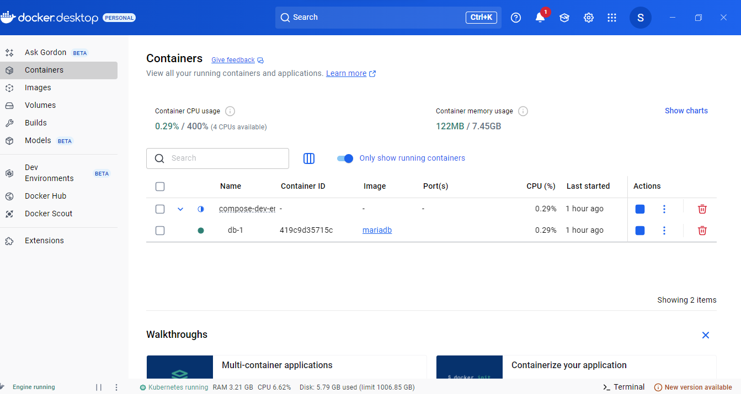

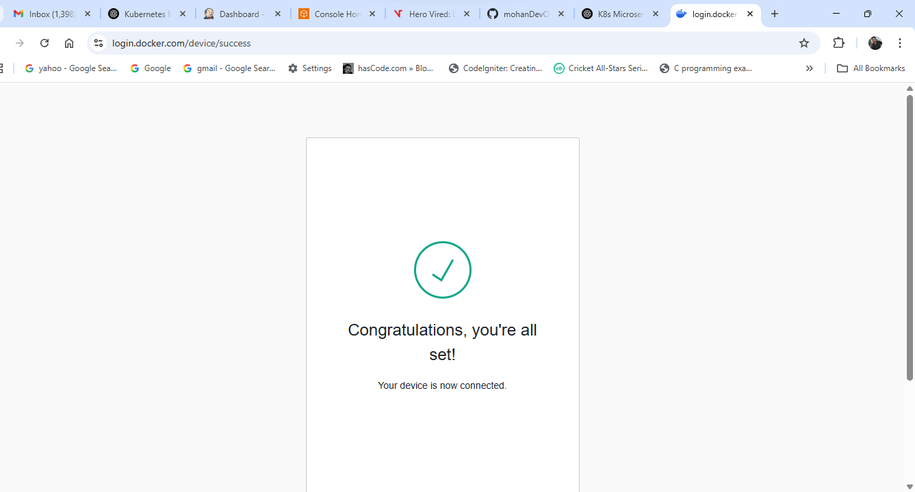

**Microservices Kubernetes Deployment (Minikube)**

This document guides you through deploying a Node.js microservices application to Kubernetes using Minikube. It includes setup instructions, deployment commands, service testing, and troubleshooting tips.

**📦 Application Overview**

The application consists of four microservices:

| **Service Name** | **Port** | **Description** |
| --- | --- | --- |
| User Service | 3000 | Handles user data |
| Product Service | 3001 | Manages product information |
| Order Service | 3002 | Handles order transactions |
| Gateway Service | 3003 | API gateway / proxy router |

**🛠️ Minikube Setup**

1. **Start Minikube:**

minikube start

1. **Enable Ingress (optional for advanced routing):**

minikube addons enable ingress

**🚀 Deployment Steps**

1. **Clone this repo or copy YAML files to a directory.**
2. **Apply Deployments and Services:**

kubectl apply -f user-deployment.yaml

kubectl apply -f user-service.yaml

kubectl apply -f product-deployment.yaml

kubectl apply -f product-service.yaml

kubectl apply -f order-deployment.yaml

kubectl apply -f order-service.yaml

kubectl apply -f gateway-deployment.yaml

kubectl apply -f gateway-service.yaml

1. **Check Pod Status:**

kubectl get pods

1. **Check Services:**

kubectl get svc

**🔁 Testing Inter-Service Communication**

**Option 1: Using Port Forwarding**

kubectl port-forward service/gateway-service 3003:3003

Then test with:

curl http://localhost:3003/user

curl http://localhost:3003/product

curl http://localhost:3003/order

**Option 2: Using Pod Networking**

kubectl exec -it <pod-name> -- sh

# Inside the pod:

curl http://user-service:3000/health

curl http://product-service:3001/health

**🧪 Example Screenshots to Include**

* Output of:
* kubectl get pods

kubectl get pods

suva@BWULPT931:/mnt/d/TCS/SKILL-TEST2$ kubectl get pods

NAME READY STATUS RESTARTS AGE

gateway-deployment-5d844b4f4-xtd86 0/1 ImagePullBackOff 0 2d21h

gateway-deployment-bf56c789c-h9f7n 1/1 Running 3 (52m ago) 2d21h

user-deployment-5f48759ccb-gxppp 0/1 ImagePullBackOff 0 25s

user-service-b65bfcc47-rp59t 0/1 ImagePullBackOff 0 25s

user-service-fdbb9cf94-tfcjk 0/1 Running 0 25s

suva@BWULPT931:/mnt/d/TCS/SKILL-TEST2$ kubectl logs user-service-fdbb9cf94-tfcjk

> gateway-service@1.0.0 start

> node index.js

[HPM] Proxy created: / -> http://user-service:3000

[HPM] Proxy rewrite rule created: "^/user" ~> ""

[HPM] Proxy created: / -> http://product-service:3001

[HPM] Proxy rewrite rule created: "^/product" ~> ""

[HPM] Proxy created: / -> http://order-service:3002

[HPM] Proxy rewrite rule created: "^/order" ~> ""

API Gateway running on port 3003

* **Pods not starting?** Run:
* kubectl describe pod <pod-name>
* kubectl logs <pod-name>
* **Check image pull issues** if using private DockerHub or custom images.
* docker images
* REPOSITORY TAG IMAGE ID CREATED SIZE
* user-service latest 90ee05faf4f7 11 seconds ago 1.12GB
* <none> <none> 486256c64a00 37 minutes ago 1.12GB
* <none> <none> e6f376e6d92d 41 minutes ago 1.11GB
* suvaatnbu/gateway-service latest ffcf3389fa54 2 days ago 1.11GB
* registry.k8s.io/kube-controller-manager v1.33.1 ef43894fa110 6 weeks ago 94.6MB
* registry.k8s.io/kube-apiserver v1.33.1 c6ab243b29f8 6 weeks ago 102MB
* registry.k8s.io/kube-scheduler v1.33.1 398c985c0d95 6 weeks ago 73.4MB
* registry.k8s.io/kube-proxy v1.33.1 b79c189b052c 6 weeks ago 97.9MB
* registry.k8s.io/etcd 3.5.21-0 499038711c08 3 months ago 153MB
* node 18 b50082bc3670 3 months ago 1.09GB
* registry.k8s.io/coredns/coredns v1.12.0 1cf5f116067c 7 months ago 70.1MB
* registry.k8s.io/pause 3.10 873ed7510279 13 months ago 736kB
* gcr.io/k8s-minikube/storage-provisioner v5 6e38f40d628d 4 years ago 31.5MB
* **Check service name mismatches** for inter-service curl commands.
* **Ensure port numbers in deployment and service YAML match.**
* kubectl port-forward service/user-service 3000:3000
* Forwarding from 127.0.0.1:3000 -> 3000
* Forwarding from [::1]:3000 -> 3000
* Handling connection for 3000
* Handling connection for 3000

**✅ Cleanup (After Test)**

kubectl delete -f .

minikube delete

