REPORT

AICT-LAB WEEK 2

Submitted to: Mr. Mohsin Mumtaz

CYBER SECURITY

Submitted by: Muhammad Suvaid Dawar

🐍 Python Programming

ASSIGNMENT 2
Programming Lab Report

❓ Question / Problem Statement 1
binary = input("Enter a binary number: ")
decimal = 0
for i in range(len(binary)):
decimal += int(binary[-(i+1)]) * (2 ** i)
print("Decimal equivalent:", decimal)
OUTPUT: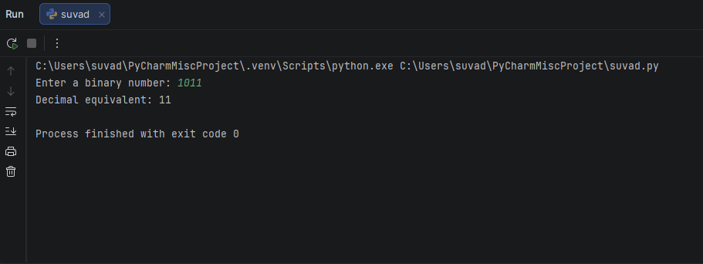

❓ Question / Problem Statement 2
sentence = input("Enter a sentence: ")
vowels = 0
consonants = 0

for char in sentence.lower():
if char.isalpha():
if char in "aeiou":
vowels += 1
else:
consonants += 1

print("Vowels:", vowels)
print("Consonants:", consonants)
OUTPUT:

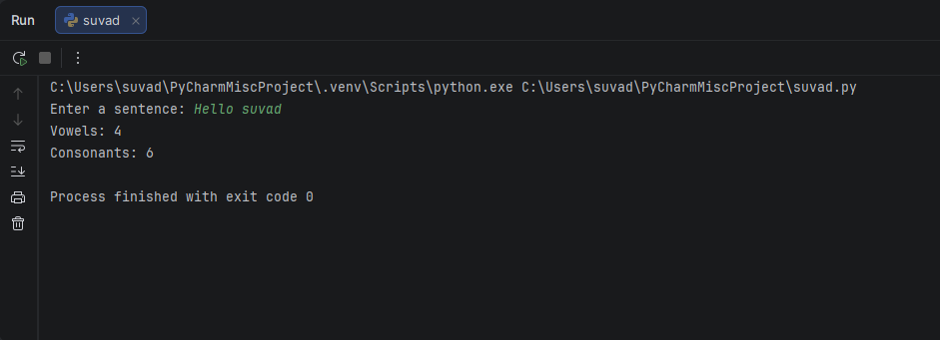

❓ Question / Problem Statement 3:

start = int(input("Enter the starting number: "))
end = int(input("Enter the ending number: "))
prime_sum = 0

for num in range(start, end + 1):
if num > 1:
for i in range(2, int(num ** 0.5) + 1):
if num % i == 0:
break
else:
print(num, end=" ")
prime_sum += num

print("\nSum of prime numbers:", prime_sum)

OUTPUT:

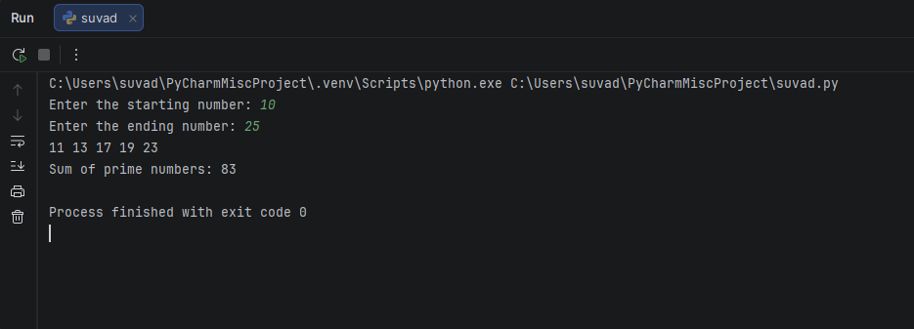

❓ Question / Problem Statement 4:

import random

length = int(input("Enter password length: "))
use_upper = input("Include uppercase letters? (yes/no): ").lower() == "yes"
use_lower = input("Include lowercase letters? (yes/no): ").lower() == "yes"
use_digits = input("Include digits? (yes/no): ").lower() == "yes"
use_special = input("Include special characters? (yes/no): ").lower() == "yes"

chars = ""
if use_upper:
chars += "ABCDEFGHIJKLMNOPQRSTUVWXYZ"
if use_lower:
chars += "abcdefghijklmnopqrstuvwxyz"
if use_digits:
chars += "0123456789"
if use_special:
chars += "!@#$%^&*()-_=+[]{}|;:,.<>?/"

if chars == "":
print("No valid characters selected!")
else:
password = "".join(random.choice(chars) for _ in range(length))
print("Generated password:", password)

OUTPUT:

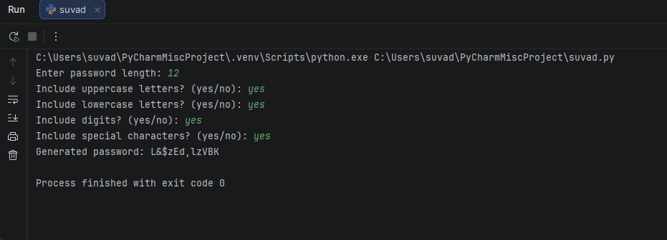

❓ Question / Problem Statement 5:
n = 4

for i in range(1, n + 1):
for j in range(i):
print("*", end=" ")
print()

for i in range(n - 1, 0, -1):
for j in range(i):
print("*", end=" ")
print()

OUTPUT:

