Java Programming Lab
50 Practice Tasks — Non-OOP (33 Tasks)
Name: Muhammad Suvaid Dawar

Roll No: 2026(S)CYS-50

Course: Object Oriented Programming

Level 1: Basic

Task 1
Read an integer and print whether it is even or odd without using the % operator.
Code
import java.util.Scanner;

public class Main
{
public static void main(String[] args)
{
Scanner sc = new Scanner(System.in);
System.out.print("Enter an integer : ");
int number = sc.nextInt();

if ((number & 1) == 0)
{
System.out.println(number + " is Even");
}
else
{
System.out.println(number + " is Odd");
}
}
}
Output

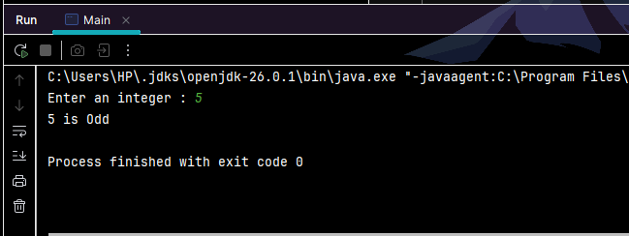

Task 2
Swap two int variables without using a third variable. Print the values before and after swapping.
Code:

import java.util.Scanner;

public class Main
{
public static void main(String[] args)
{
Scanner sc = new Scanner(System.in);
System.out.print("Enter first number : ");
int a = sc.nextInt();
System.out.print("Enter second number : ");
int b = sc.nextInt();

System.out.println("Before swap : a = " + a + ", b = " + b);

a = a + b;
b = a - b;
a = a - b;
System.out.println("After swap : a = " + a + ", b = " + b);
}
}

Output:
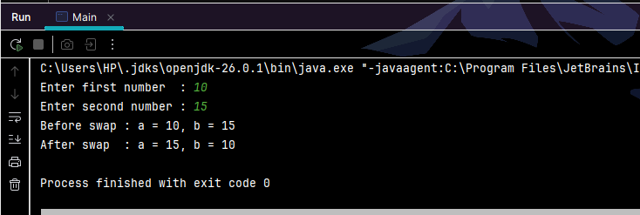

Task 3
Read three numbers and print the middle (median) one without using arrays or sorting.
Code:
import java.util.Scanner;

public class Main
{
public static void main(String[] args)
{
Scanner sc = new Scanner(System.in);
System.out.print("Enter three numbers : ");
int a = sc.nextInt();
int b = sc.nextInt();
int c = sc.nextInt();
int median;

if ((b <= a && a <= c) || (c <= a && a <= b))
{
median = a;
}
else if ((a <= b && b <= c) || (c <= b && b <= a))
{
median = b;
}
else
{
median = c;
}

System.out.println("Median is : " + median);
}
}
Output:
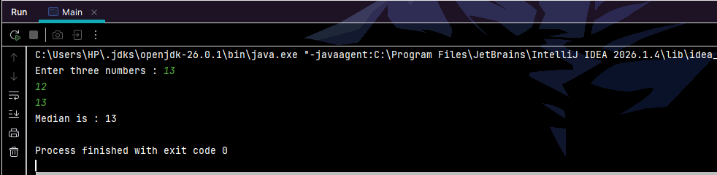

Task 5
Print a number triangle where row i contains the digit i repeated i times (1, 22, 333, ...) for a user-given n.
Code
import java.util.Scanner;

public class Main
{
public static void main(String[] args)
{
Scanner input = new Scanner(System.in);
System.out.print("Enter your number : ");
int number = input.nextInt();

for (int i = 1; i <= number; i++)
{
for (int j = 1; j <= i; j++)
{
System.out.print(i);
}
System.out.println();
}
}
}

Output:

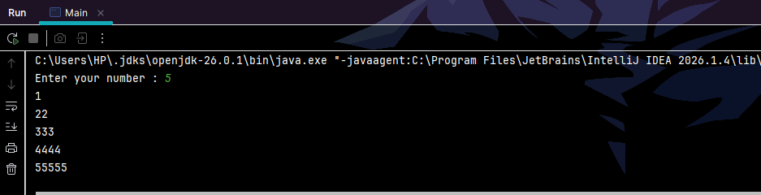

Task 6
Read an integer and print its digits in reverse order without converting it to a String. Trailing zeros must be kept (1200 prints 0021).
Code
import java.util.Scanner;

public class Main
{
public static void main(String[] args)
{
Scanner sc = new Scanner(System.in);
System.out.print("Enter your number : ");
int number = sc.nextInt();

if (number == 0)
{
System.out.print(0);
}

while (number > 0)
{
int digit = number % 10;
System.out.print(digit);
number = number / 10;
}

System.out.println();
}
}
Output:
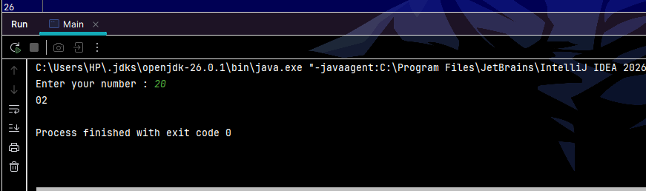

Task 7
Repeatedly add the digits of a number until a single digit remains (for example 9875 gives 29, then 11, then 2).
Code
import java.util.Scanner;

public class Main
{
public static void main(String[] args)
{
Scanner sc = new Scanner(System.in);
System.out.print("Enter your number : ");
int number = sc.nextInt();

while (number >= 10)
{
int sum = 0;

while (number > 0)
{
sum = sum + number % 10;
number = number / 10;
}

number = sum;
System.out.println(number);
}
}
}
Output:
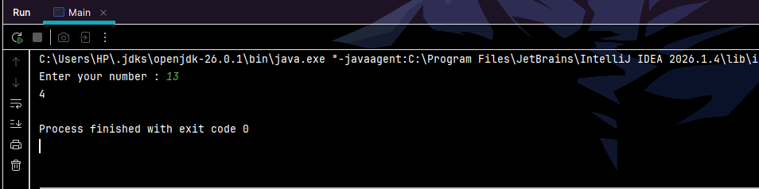

Task 9
Write a method isPrime(int n) that loops only up to the square root of n. Use it to print all primes from 1 to 100.
Code:
public class Main
{
static boolean isPrime(int n)
{
if (n < 2)
{
return false;
}

for (int i = 2; i * i <= n; i++)
{
if (n % i == 0)
{
return false;
}
}
return true;
}

public static void main(String[] args)
{
for (int n = 1; n <= 100; n++)
{
if (isPrime(n))
{
System.out.print(n + " ");
}
}
System.out.println();
}
}
Output:
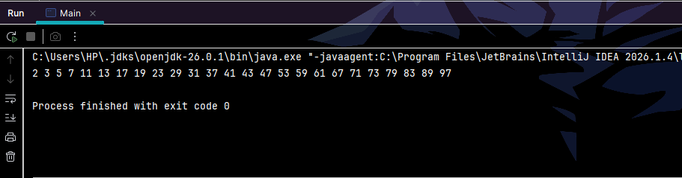

Task 10
Read a String and count vowels, consonants, digits and other characters using a single loop.
Code
import java.util.Scanner;

public class Main
{
public static void main(String[] args)
{
Scanner sc = new Scanner(System.in);
System.out.print("Enter a string : ");
String s = sc.nextLine();

int vowels = 0;
int consonants = 0;
int digits = 0;
int others = 0;

for (int i = 0; i < s.length(); i++)
{
char c = Character.toLowerCase(s.charAt(i));

if (c >= 'a' && c <= 'z')
{
if (c == 'a' || c == 'e' || c == 'i' || c == 'o' || c == 'u')
{
vowels++;
}
else
{
consonants++;
}
}
else if (c >= '0' && c <= '9')
{
digits++;
}
else
{
others++;
}
}

System.out.println("Vowels : " + vowels);
System.out.println("Consonants : " + consonants);
System.out.println("Digits : " + digits);
System.out.println("Others : " + others);
}
}
Output:
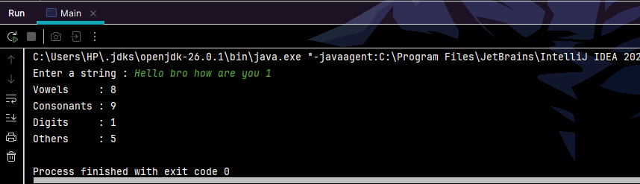

Task 11
Print the first N Fibonacci numbers (N from the user) using only three variables, no arrays.
Code
import java.util.Scanner;

public class Main
{
public static void main(String[] args)
{
Scanner sc = new Scanner(System.in);
System.out.print("How many Fibonacci numbers : ");
int n = sc.nextInt();

int prev = 0;
int curr = 1;
int next;

if (n >= 1)
{
System.out.print(prev + " ");
}
if (n >= 2)
{
System.out.print(curr + " ");
}

for (int i = 3; i <= n; i++)
{
next = prev + curr;
prev = curr;
curr = next;
System.out.print(curr + " ");
}

System.out.println();
}
}
Output:
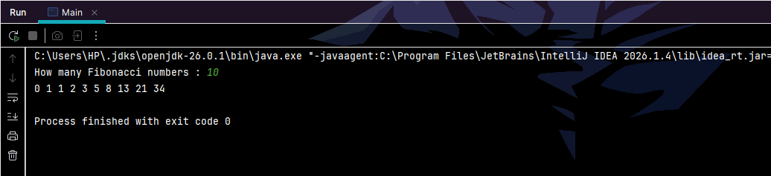

Task 12
Check whether a String is a palindrome, ignoring case, spaces and punctuation ("A man, a plan, a canal: Panama" must return true).
Code
import java.util.Scanner;

public class Main
{
public static void main(String[] args)
{
Scanner sc = new Scanner(System.in);
System.out.print("Enter a string : ");
String s = sc.nextLine();

StringBuilder clean = new StringBuilder();
for (int i = 0; i < s.length(); i++)
{
char c = Character.toLowerCase(s.charAt(i));
if ((c >= 'a' && c <= 'z') || (c >= '0' && c <= '9'))
{
clean.append(c);
}
}

int left = 0;
int right = clean.length() - 1;
boolean isPalindrome = true;

while (left < right)
{
if (clean.charAt(left) != clean.charAt(right))
{
isPalindrome = false;
break;
}
left++;
right--;
}

System.out.println("Cleaned : " + clean);
System.out.println("Palindrome : " + isPalindrome);
}
}
Output:
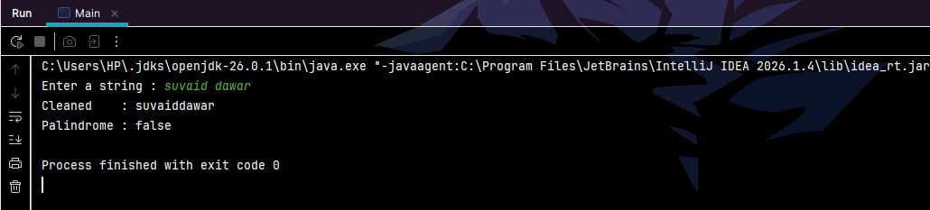

Level 2: Intermediate

Task 14
Find the second largest value in an int array of 10 elements without sorting. The array may contain duplicates of the largest value.
Code
public class Main
{
public static void main(String[] args)
{
int[] arr = {12, 45, 7, 45, 3, 22, 45, 9, 31, 18};

int largest = Integer.MIN_VALUE;
int second = Integer.MIN_VALUE;

for (int i = 0; i < arr.length; i++)
{
if (arr[i] > largest)
{
second = largest;
largest = arr[i];
}
else if (arr[i] < largest && arr[i] > second)
{
second = arr[i];
}
}

System.out.println("Largest : " + largest);

if (second == Integer.MIN_VALUE)
{
System.out.println("Second largest : none (all values are the same)");
}
else
{
System.out.println("Second largest : " + second);
}
}
}
Output:
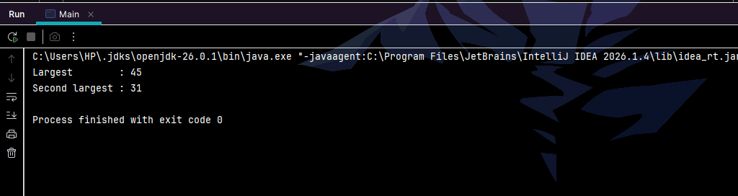

Task 15
Rotate an array to the left by k positions in place, without creating a second array (k may be larger than the array length).
Code
public class Main
{
static void reverse(int[] a, int start, int end)
{
while (start < end)
{
int temp = a[start];
a[start] = a[end];
a[end] = temp;
start++;
end--;
}
}

public static void main(String[] args)
{
int[] arr = {1, 2, 3, 4, 5, 6, 7};
int k = 10;

int n = arr.length;
k = k % n;

reverse(arr, 0, k - 1);
reverse(arr, k, n - 1);
reverse(arr, 0, n - 1);

for (int i = 0; i < n; i++)
{
System.out.print(arr[i] + " ");
}
System.out.println();
}
}
Output:
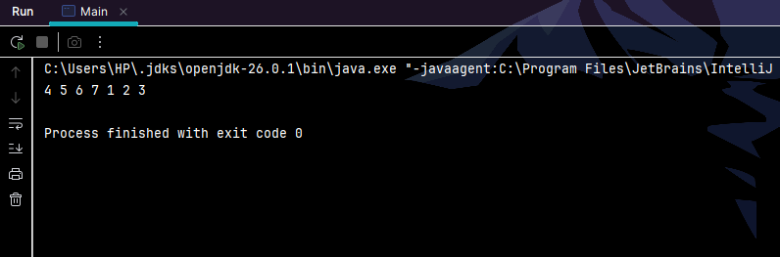

Task 16
Print a hollow diamond of stars for an odd n given by the user.
Code
import java.util.Scanner;

public class Main
{
public static void main(String[] args)
{
Scanner sc = new Scanner(System.in);
System.out.print("Enter an odd number : ");
int n = sc.nextInt();

if (n % 2 == 0)
{
System.out.println("Please enter an odd number.");
return;
}

int mid = n / 2;

for (int i = 0; i < n; i++)
{
int stars;
if (i <= mid)
{
stars = 2 * i + 1;
}
else
{
stars = 2 * (n - 1 - i) + 1;
}

int spacesBefore = (n - stars) / 2;

for (int j = 0; j < spacesBefore; j++)
{
System.out.print(" ");
}

for (int j = 0; j < stars; j++)
{
if (j == 0 || j == stars - 1)
{
System.out.print("*");
}
else
{
System.out.print(" ");
}
}

System.out.println();
}
}
}
Output:
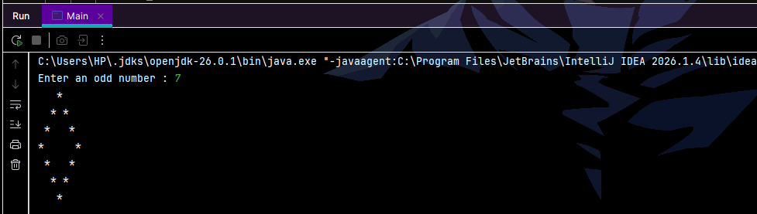

Task 18
Check whether two Strings are anagrams without using any sorting method.
Code
import java.util.Scanner;

public class Main
{
public static void main(String[] args)
{
Scanner sc = new Scanner(System.in);
System.out.print("Enter first string : ");
String s1 = sc.nextLine();
System.out.print("Enter second string : ");
String s2 = sc.nextLine();

if (s1.length() != s2.length())
{
System.out.println("Anagrams : false");
return;
}

int[] count = new int[256];

for (int i = 0; i < s1.length(); i++)
{
count[s1.charAt(i)]++;
count[s2.charAt(i)]--;
}

boolean isAnagram = true;
for (int i = 0; i < 256; i++)
{
if (count[i] != 0)
{
isAnagram = false;
break;
}
}

System.out.println("Anagrams : " + isAnagram);
}
}
Output:
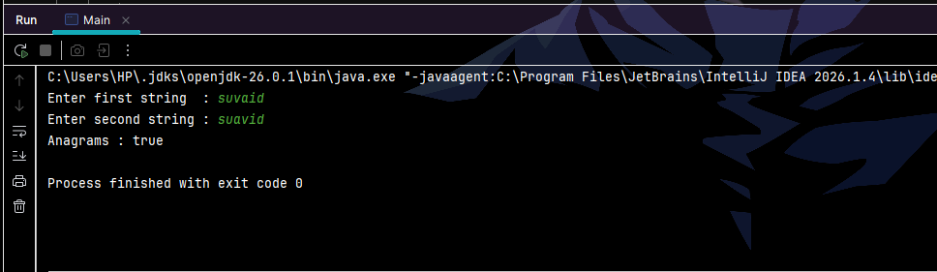

Task 19
Remove duplicates from an int array while preserving the original order. Print the result without using any Collection class.
Code:
public class Main
{
public static void main(String[] args)
{
int[] arr = {4, 2, 4, 7, 2, 9, 7, 1, 4, 9};

int[] result = new int[arr.length];
int size = 0;

for (int i = 0; i < arr.length; i++)
{
boolean alreadySeen = false;

for (int j = 0; j < size; j++)
{
if (result[j] == arr[i])
{
alreadySeen = true;
break;
}
}

if (!alreadySeen)
{
result[size] = arr[i];
size++;
}
}

for (int i = 0; i < size; i++)
{
System.out.print(result[i] + " ");
}
System.out.println();
}}
Output:
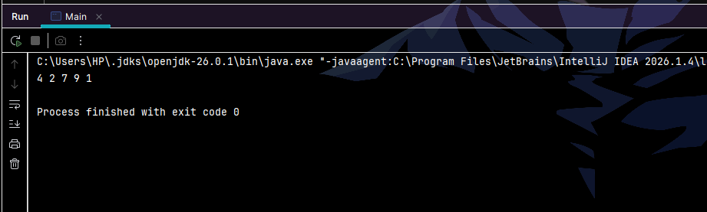

Task 21
Write a recursive method that computes x^n using fast exponentiation. Also count and print how many multiplications were performed for n = 30.
Code
public class Main
{
static int multiplications = 0;

static double power(double x, int n)
{
if (n == 0)
{
return 1;
}

double half = power(x, n / 2);
if (n % 2 == 0)
{
multiplications++;
return half * half;
}
else
{
multiplications = multiplications + 2;
return half * half * x;
}
}

public static void main(String[] args)
{
double x = 2;
int n = 30;

double result = power(x, n);

System.out.println(x + " ^ " + n + " = " + result);
System.out.println("Multiplications performed : " + multiplications);
}
}
Output:
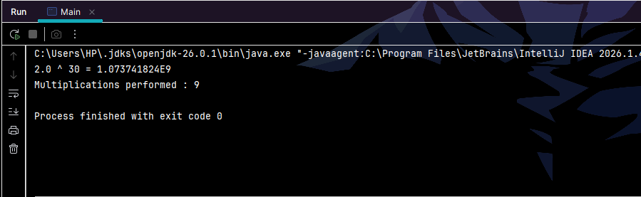

Task 22
Read a 3x3 matrix, print its transpose, and report whether the matrix is symmetric.
Code
import java.util.Scanner;

public class Main
{
public static void main(String[] args)
{
Scanner sc = new Scanner(System.in);
int[][] m = new int[3][3];

System.out.println("Enter 9 values for the 3x3 matrix :");
for (int i = 0; i < 3; i++)
{
for (int j = 0; j < 3; j++)
{
m[i][j] = sc.nextInt();
}
}

System.out.println("Transpose :");
for (int i = 0; i < 3; i++)
{
for (int j = 0; j < 3; j++)
{
System.out.print(m[j][i] + " ");
}
System.out.println();
}

boolean symmetric = true;
for (int i = 0; i < 3; i++)
{
for (int j = 0; j < 3; j++)
{
if (m[i][j] != m[j][i])
{
symmetric = false;
}
}
}

System.out.println("Symmetric : " + symmetric);
}
}
Output:
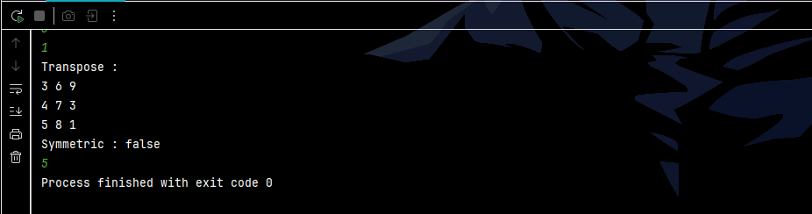

Task 23
Convert a decimal number to binary without using Integer.toBinaryString(). Solve it once with a loop and once with recursion.
Code
import java.util.Scanner;

public class Main
{

static String toBinaryLoop(int n)
{
if (n == 0)
{
return "0";
}

String result = "";
while (n > 0)
{
result = (n % 2) + result;
n = n / 2;
}
return result;
}

static String toBinaryRecursive(int n)
{
if (n == 0)
{
return "";
}
return toBinaryRecursive(n / 2) + (n % 2);
}

public static void main(String[] args)
{
Scanner sc = new Scanner(System.in);
System.out.print("Enter a decimal number : ");
int n = sc.nextInt();

System.out.println("Binary (loop) : " + toBinaryLoop(n));

if (n == 0)
{
System.out.println("Binary (recursion) : 0");
}
else
{
System.out.println("Binary (recursion) : " + toBinaryRecursive(n));
}
}
}
Output:
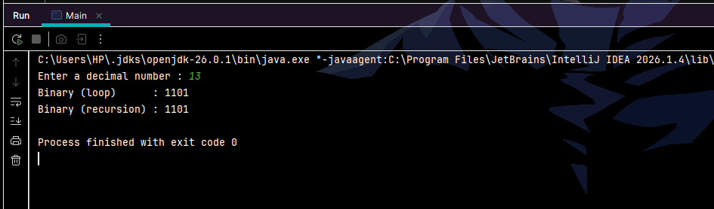

Task 25
Print the first non-repeating character of a String, or "none" if every character repeats.
Code
import java.util.Scanner;

public class Main
{
public static void main(String[] args)
{
Scanner sc = new Scanner(System.in);
System.out.print("Enter a string : ");
String s = sc.nextLine();

int[] count = new int[256];

for (int i = 0; i < s.length(); i++)
{
count[s.charAt(i)]++;
}

char answer = 0;
boolean found = false;

for (int i = 0; i < s.length(); i++)
{
if (count[s.charAt(i)] == 1)
{
answer = s.charAt(i);
found = true;
break;
}
}

if (found)
{
System.out.println("First non-repeating character : " + answer);
}
else
{
System.out.println("none");
}
}
}
Output:
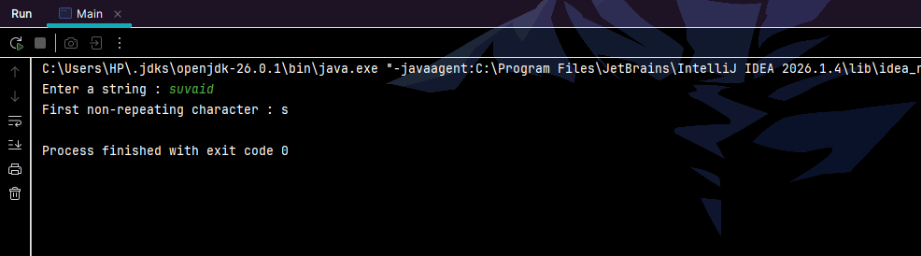

Task 26
Print all Armstrong numbers between 1 and 1000.
Code
public class Main
{
public static void main(String[] args)
{
System.out.println("Armstrong numbers between 1 and 1000 :");

for (int n = 1; n <= 1000; n++)
{

int digits = 0;
int temp = n;
while (temp > 0)
{
digits++;
temp = temp / 10;
}

int sum = 0;
temp = n;
while (temp > 0)
{
int d = temp % 10;

int p = 1;
for (int i = 0; i < digits; i++)
{
p = p * d;
}

sum = sum + p;
temp = temp / 10;
}

if (sum == n)
{
System.out.print(n + " ");
}
}
System.out.println();
}
}
Output:
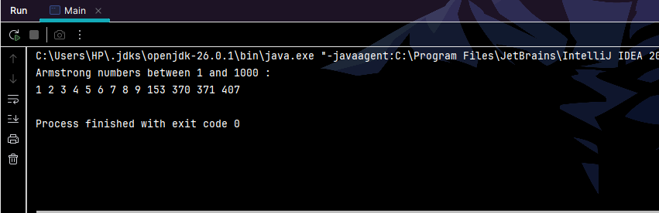

Task 28
Compress a String so that "aaabbc" becomes "a3b2c1". Also write the reverse (decompress) method.
Code:

public class Main
{
static String compress(String s)
{
if (s.length() == 0)
{
return "";
}

StringBuilder out = new StringBuilder();
int count = 1;

for (int i = 1; i <= s.length(); i++)
{
if (i < s.length() && s.charAt(i) == s.charAt(i - 1))
{
count++;
}
else
{
out.append(s.charAt(i - 1)).append(count);
count = 1;
}
}
return out.toString();
}

static String decompress(String s)
{
StringBuilder out = new StringBuilder();
int i = 0;

while (i < s.length())
{
char c = s.charAt(i);
i++;

int num = 0;
while (i < s.length() && s.charAt(i) >= '0' && s.charAt(i) <= '9')
{
num = num * 10 + (s.charAt(i) - '0');
i++;
}

for (int j = 0; j < num; j++)
{
out.append(c);
}
}
return out.toString();
}

public static void main(String[] args)
{
String original = "aaabbc";
String compressed = compress(original);

System.out.println("Original : " + original);
System.out.println("Compressed : " + compressed);
System.out.println("Decompressed : " + decompress(compressed));
}
}
Output:
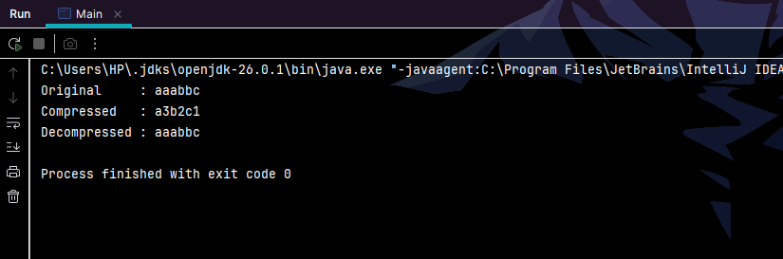

Task 30
An array holds the numbers 1 to n with exactly one missing. Find the missing number without sorting and without using an extra array.
Code
public class Main
{
public static void main(String[] args)
{
int[] arr = {1, 2, 4, 5, 6, 7, 8, 9, 10};

int n = arr.length + 1;
int expected = n * (n + 1) / 2;

int actual = 0;
for (int i = 0; i < arr.length; i++)
{
actual = actual + arr[i];
}

System.out.println("Missing number : " + (expected - actual));
}
}
Output:
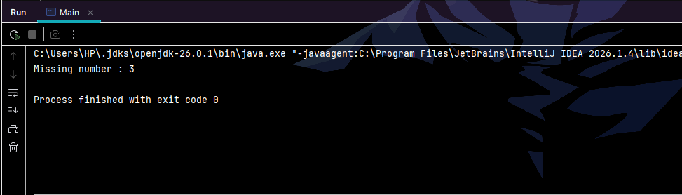

Level 3: Advanced

Task 31
Print Pascal's triangle for n rows using a jagged 2D array.
Code
import java.util.Scanner;

public class Main
{
public static void main(String[] args)
{
Scanner sc = new Scanner(System.in);
System.out.print("Enter number of rows : ");
int n = sc.nextInt();

int[][] triangle = new int[n][];
for (int i = 0; i < n; i++)
{
triangle[i] = new int[i + 1];

triangle[i][0] = 1;
triangle[i][i] = 1;

for (int j = 1; j < i; j++)
{
triangle[i][j] = triangle[i - 1][j - 1] + triangle[i - 1][j];
}
}

for (int i = 0; i < n; i++)
{
for (int j = 0; j < triangle[i].length; j++)
{
System.out.print(triangle[i][j] + " ");
}
System.out.println();
}
}
}
Output:
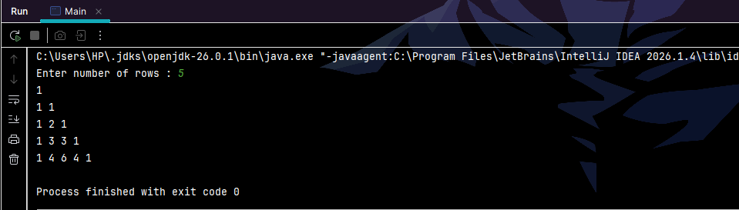

Task 33
Generate and print all permutations of a String with distinct characters using recursion.
Code
public class Main
{
static void permute(String prefix, String rest)
{
if (rest.length() == 0)
{
System.out.println(prefix);
return;
}

for (int i = 0; i < rest.length(); i++)
{
permute(prefix + rest.charAt(i),
rest.substring(0, i) + rest.substring(i + 1));
}
}

public static void main(String[] args)
{
String s = "abc";
System.out.println("Permutations of " + s + " :");
permute("", s);
}
}
Output:
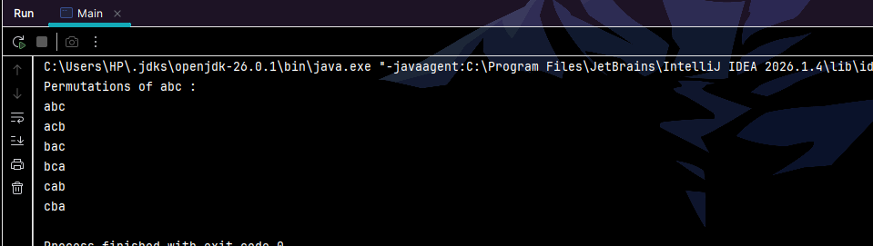

Task 35
Write an iterative binary search that also returns the number of steps taken. Then modify it to return the first occurrence in an array containing duplicates.
Code
public class Main
{
static int steps = 0;

static int binarySearch(int[] a, int target)
{
steps = 0;
int low = 0;
int high = a.length - 1;

while (low <= high)
{
steps++;
int mid = (low + high) / 2;

if (a[mid] == target)
{
return mid;
}
else if (a[mid] < target)
{
low = mid + 1;
}
else
{
high = mid - 1;
}
}
return -1;
}

static int firstOccurrence(int[] a, int target)
{
steps = 0;
int low = 0;
int high = a.length - 1;
int answer = -1;

while (low <= high)
{
steps++;
int mid = (low + high) / 2;

if (a[mid] == target)
{
answer = mid;
high = mid - 1; }
else if (a[mid] < target)
{
low = mid + 1;
}
else
{
high = mid - 1;
}
}
return answer;
}

public static void main(String[] args)
{
int[] arr = {1, 3, 5, 5, 5, 7, 9, 11};
int target = 5;

int pos = binarySearch(arr, target);
System.out.println("Found at index " + pos + " in " + steps + " steps");

int first = firstOccurrence(arr, target);
System.out.println("First occurrence at index " + first + " in " + steps + " steps");
}
}
Output:
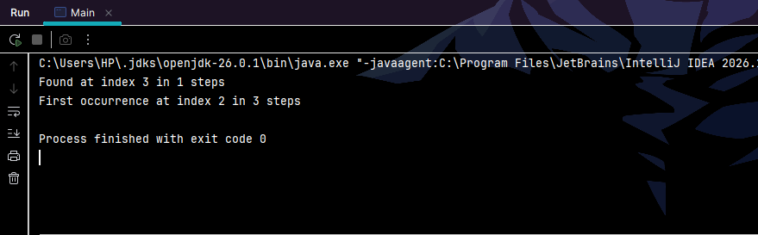

Task 36
Find the longest substring without repeating characters in a given String. Print the substring and its length.
Code
import java.util.Scanner;

public class Main
{
public static void main(String[] args)
{
Scanner sc = new Scanner(System.in);
System.out.print("Enter a string : ");
String s = sc.nextLine();

int[] lastSeen = new int[256];
for (int i = 0; i < 256; i++)
{
lastSeen[i] = -1;
}

int bestLength = 0;
int bestStart = 0;
int windowStart = 0;

for (int i = 0; i < s.length(); i++)
{
char c = s.charAt(i);

if (lastSeen[c] >= windowStart)
{
windowStart = lastSeen[c] + 1;
}

lastSeen[c] = i;

int length = i - windowStart + 1;
if (length > bestLength)
{
bestLength = length;
bestStart = windowStart;
}
}

System.out.println("Longest substring : " + s.substring(bestStart, bestStart + bestLength));
System.out.println("Length : " + bestLength);
}
}
Output:
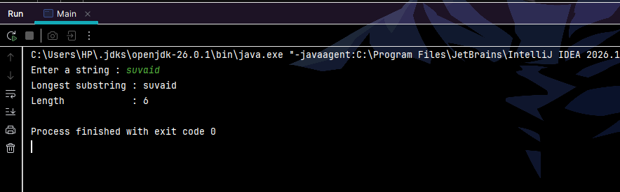

Task 38
Print an n x m matrix in spiral order.
Code
public class Main
{
public static void main(String[] args)
{
int[][] m = {
{ 1, 2, 3, 4},
{ 5, 6, 7, 8},
{ 9, 10, 11, 12}
};

int top = 0;
int bottom = m.length - 1;
int left = 0;
int right = m[0].length - 1;

while (top <= bottom && left <= right)
{
for (int j = left; j <= right; j++) {
System.out.print(m[top][j] + " ");
}
top++;

for (int i = top; i <= bottom; i++)
{
System.out.print(m[i][right] + " ");
}
right--;

if (top <= bottom)
{
for (int j = right; j >= left; j--)
{
System.out.print(m[bottom][j] + " ");
}
bottom--;
}

if (left <= right)
{
for (int i = bottom; i >= top; i--)
{
System.out.print(m[i][left] + " ");
}
left++;
}
}
System.out.println();
}
}
Output:
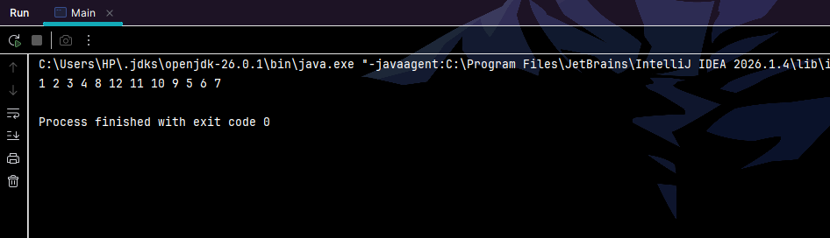

Task 40
Solve Tower of Hanoi for n disks. Print every move and verify that the total equals 2^n - 1.
Code
public class Main
{
static int moves = 0;

static void hanoi(int n, char from, char to, char via)
{
if (n == 0)
{
return;
}

hanoi(n - 1, from, via, to);

moves++;
System.out.println("Move disk " + n + " from " + from + " to " + to);

hanoi(n - 1, via, to, from);
}

public static void main(String[] args)
{
int n = 3;

hanoi(n, 'A', 'C', 'B');

int expected = (int) Math.pow(2, n) - 1;

System.out.println("Total moves : " + moves);
System.out.println("2^" + n + " - 1 : " + expected);
System.out.println("Matches : " + (moves == expected));
}
}
Output:
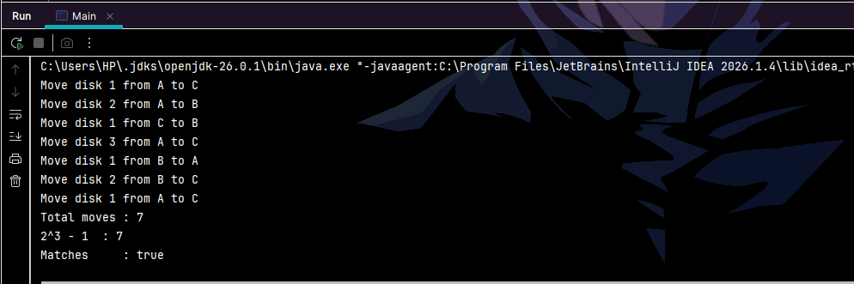

Task 42
Merge two sorted int arrays into one sorted array in O(n + m) time without calling any sort method.
Code
public class Main
{
public static void main(String[] args)
{
int[] a = {1, 4, 7, 9};
int[] b = {2, 3, 8, 10, 15};

int[] merged = new int[a.length + b.length];

int i = 0;
int j = 0;
int k = 0;

while (i < a.length && j < b.length)
{
if (a[i] <= b[j])
{
merged[k] = a[i];
i++;
}
else
{
merged[k] = b[j];
j++;
}
k++;
}

while (i < a.length)
{
merged[k] = a[i];
i++;
k++;
}

while (j < b.length) {
merged[k] = b[j];
j++;
k++;
}

for (int x = 0; x < merged.length; x++)
{
System.out.print(merged[x] + " ");
}
System.out.println();
}
}
Output:
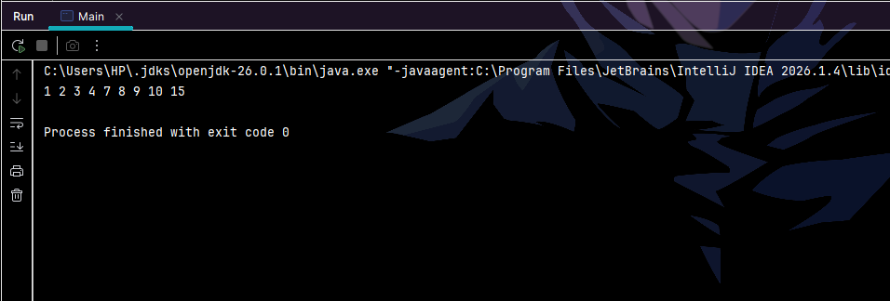

Level 4: Expert (Critical Thinking)

Task 44
Solve the N-Queens problem for N = 6. Print the total number of solutions and display one valid board.
Code
public class Main
{
static int n = 6;
static int[] queen = new int[n];
static int solutions = 0;
static int[] firstSolution = new int[n];

static boolean isSafe(int row, int col)
{
for (int r = 0; r < row; r++)
{
if (queen[r] == col)
{
return false;
}
if (Math.abs(queen[r] - col) == row - r)
{
return false;
}
}
return true;
}

static void solve(int row)
{
if (row == n)
{
if (solutions == 0)
{
for (int i = 0; i < n; i++)
{
firstSolution[i] = queen[i];
}
}
solutions++;
return;
}

for (int col = 0; col < n; col++)
{
if (isSafe(row, col))
{
queen[row] = col;
solve(row + 1); }
}
}

public static void main(String[] args)
{
solve(0);

System.out.println("Total solutions for N = " + n + " : " + solutions);
System.out.println("One valid board :");

for (int i = 0; i < n; i++)
{
for (int j = 0; j < n; j++)
{
if (firstSolution[i] == j)
{
System.out.print("Q ");
}
else
{
System.out.print(". ");
}
}
System.out.println();
}
}
}
Output:
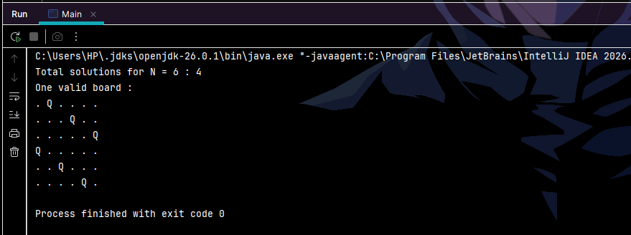

Task 46
Find the contiguous subarray with the maximum sum (Kadane's algorithm). Print the sum with the start and end indices, and make sure an all-negative array works.
Code
public class Main
{
public static void main(String[] args)
{
int[] arr = {-2, 1, -3, 4, -1, 2, 1, -5, 4};

int bestSum = arr[0];
int currentSum = arr[0];
int bestStart = 0;
int bestEnd = 0;
int currentStart = 0;

for (int i = 1; i < arr.length; i++)
{
if (currentSum + arr[i] < arr[i])
{
currentSum = arr[i];
currentStart = i;
}
else
{
currentSum = currentSum + arr[i];
}

if (currentSum > bestSum)
{
bestSum = currentSum;
bestStart = currentStart;
bestEnd = i;
}
}

System.out.println("Maximum sum : " + bestSum);
System.out.println("Start index : " + bestStart);
System.out.println("End index : " + bestEnd);
}
}
Output:
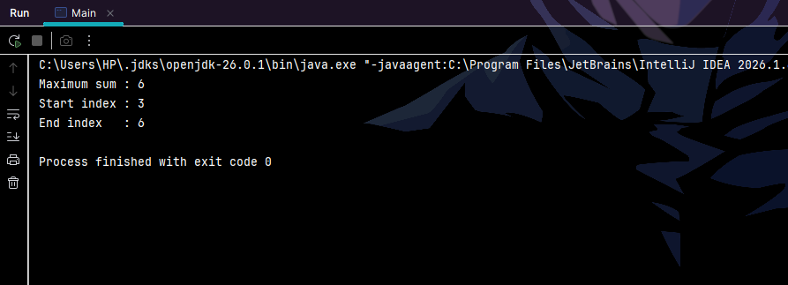

Task 48
Write a method that validates a 9x9 Sudoku grid, checking every row, every column and every 3x3 box.
Code
public class Main
{
static boolean isValid(int[][] grid)
{

for (int i = 0; i < 9; i++)
{
boolean[] seen = new boolean[10];
for (int j = 0; j < 9; j++)
{
int v = grid[i][j];
if (v < 1 || v > 9 || seen[v])
{
return false;
}
seen[v] = true;
}
}

for (int j = 0; j < 9; j++)
{
boolean[] seen = new boolean[10];
for (int i = 0; i < 9; i++)
{
int v = grid[i][j];
if (seen[v])
{
return false;
}
seen[v] = true;
}
}

for (int boxRow = 0; boxRow < 9; boxRow = boxRow + 3)
{
for (int boxCol = 0; boxCol < 9; boxCol = boxCol + 3)
{
boolean[] seen = new boolean[10];
for (int i = 0; i < 3; i++)
{
for (int j = 0; j < 3; j++)
{
int v = grid[boxRow + i][boxCol + j];
if (seen[v])
{
return false;
}
seen[v] = true;
}
}
}
}

return true;
}

public static void main(String[] args)
{
int[][] grid = {
{5,3,4, 6,7,8, 9,1,2},
{6,7,2, 1,9,5, 3,4,8},
{1,9,8, 3,4,2, 5,6,7},

{8,5,9, 7,6,1, 4,2,3},
{4,2,6, 8,5,3, 7,9,1},
{7,1,3, 9,2,4, 8,5,6},

{9,6,1, 5,3,7, 2,8,4},
{2,8,7, 4,1,9, 6,3,5},
{3,4,5, 2,8,6, 1,7,9}
};

System.out.println("Valid Sudoku : " + isValid(grid));
}
}
Output:
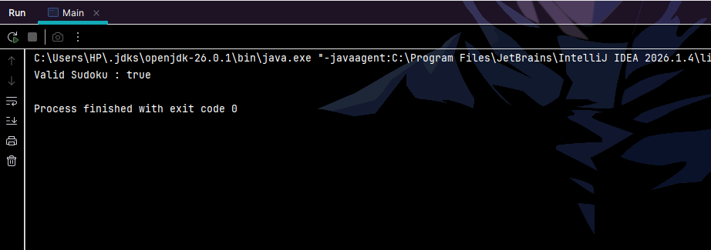

Task 50
Compute the factorial of 50 without BigInteger by storing the digits in an int array. Print the full result.
Code
public class Main
{
public static void main(String[] args)
{
int n = 50;
int[] digits = new int[200];
int size = 1;

digits[0] = 1;

for (int x = 2; x <= n; x++)
{
int carry = 0;

for (int i = 0; i < size; i++)
{
int product = digits[i] * x + carry;
digits[i] = product % 10;
carry = product / 10;
}

while (carry > 0)
{
digits[size] = carry % 10;
carry = carry / 10;
size++;
}
}

System.out.print(n + "! = ");
for (int i = size - 1; i >= 0; i--)
{
System.out.print(digits[i]);
}
System.out.println();
}
}
Output:
