CHAPTER 1

VLSI Design Cycle

The VLSI design cycle starts with a formal specification of a VLSI chip, follows a series of steps, and eventually produces a packaged chip. A typical design cycle may be represented by a flowchart shown in Figure below. Our emphasis is on the physical design step of the VLSI design cycle. However, to gain perspective, we briefly outline all the steps of the VLSI design cycle.
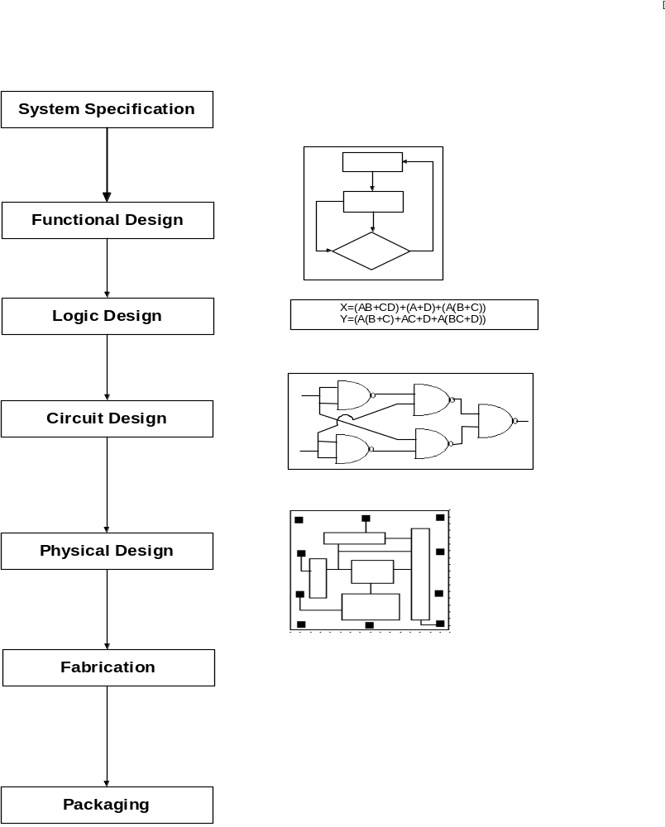

Figure 1.1 : VLSI Design process steps

1. System Specification:
As in any design process the first step is to lay down the specification of the system to be designed. This necessitates creating a high level representation of the system. The factors to be considered in this process include: performance, functionality, and the physical dimensions. The choices of fabrication technology and design techniques are also considered. The end results are specifications for the size, speed, power, and functionality of the VLSI system to be designed.

2. Functional Design:
In this step, behavioral aspects of the system are considered. The outcome is usually a timing diagram or other relationships between sub-units. This information is used to improve the overall design process and to reduce the complexity of the subsequent phases.

3. Logic Design:
In this step, the logic structure that represents the functional design is derived and tested. The achieved design is represented by a textual, schematic or graphic description. Commonly, the logic design is represented by Boolean expressions. These expressions are minimized to achieve the smallest logic design that is simulated and tested to verify its correctness.

4. Circuit Design:
The purpose of circuit design is to develop a circuit representation based on the logic design. The Boolean expressions are converted into a circuit representation by taking into consideration the speed and power requirements of the original design. The electrical behaviors of the various components are also considered in this phase. The circuit design is usually expressed in a detailed circuit diagram.

5. Physical Design:
In this step, the circuit representation of each component is converted into a geometric representation. This representation is in fact a set of geometric patterns that perform the intended logic function of the corresponding component. Connections between different components are also expressed as geometric patterns. A stated earlier, this geometric representation of a circuit is called a layout. The exact details of the layout also depend on design rules, which are guidelines based on the limitations of the fabrication process and the electrical properties of the fabrication materials. Physical design is a very complex process; therefore, it is usually broken down into various sub-steps in order to handle the complexity of the problem. In fact, physical design is arguably the most time consuming step in the VLSI design cycle.

6. Design Verification:
The layout is verified in this step to ensure that the layout meets the system specification and the fabrication requirements. Design verification consists of Design Rule Checking and Circuit Extraction. Design Rule Checking (DRC) is a process that verifies that all geometric patterns meet the design rules imposed by the fabrication process. After checking the layout for design rule violations, the functionality of the layout is verified by circuit representation from the layout. This reverse engineered circuit representation can then be compared with the original circuit representation to verify the correctness of the layout.

7. Fabrication:
After verification, the layout is ready for fabrication. Fabrication process of several processes consists of several steps: preparation of wafer, deposition, and diffusion of various materials on the wafer according to layout description. A typical is 10cm in diameter and can be used to produce between 12 to 30 chips. Before the chip is mass produced, a prototype is made and tested.

8. Packaging, Testing and Debugging:
Finally, the wafer is fabricated and diced in a fabrication facility. Each chip is then packaged and tested to ensure that it means all the design specifications and that it functions properly. Chips used in Printed Circuit Boards (PCBs) are packaged in Dual In-line Package (DIP) or Pin Grid Array (PGA). Chips that are to be used in a Multi-Chip Module (MCM) are not packaged, since MCMs are bare or naked chips.

The VLSI design cycle involves iterations, both within a step and between different steps. The entire design cycle may be viewed as transformations of representations in various steps. In each step, a new representation of the system is created and analyzed. The representation is iteratively improved so that it meets the timing specifications of the system. The objective of VLSI CAD tools is to minimize the number of iterations and thus reduce the time-to-market.

Physical Design Cycle

The input to the physical design cycle is a circuit diagram and the output is the layout of the circuit. This is accomplished in several stages such as partitioning, floorplanning, placement, routing, and compaction. Here we present a brief description of all the stages mentioned above:

Partitioning:
A chip may contain several million transistors. Layout of the entire circuit cannot be handled due to the limitation of memory space as well as computation power available. Therefore, it is normally partitioned by grouping the components into blocks (sub-circuits/modules). The output of partitioning is a set of blocks along with the interconnections required between blocks. The set of interconnections required is referred to as a netlist.

Floorplanning and Placement:
This step is concerned with selecting good layout alternatives for each block, as well as the entire chip. The area of each block can be calculated after partitioning and is based approximately on the number and type of components in that block. Floorplanning is a critical set up the groundwork for a good layout. However, it is computationally quite hard.
During placement, the blocks are exactly positioned on the chip. The goal of placement is to find a minimum area arrangement for the blocks that allows completion of interconnection between the blocks. Placement is typically done in two phases. In the first phase an initial placement is created. In the second phase, the initial placement is evaluated and iterative improvements are made until the layout has minimum area and conforms to design specifications.

Routing:
The objective of the routing phase is to complete the interconnections between blocks according to the specified netlist. First, the space not occupied by the blocks (called the routing space) is partitioned into rectangular regions called channels and switchboxes. The goal of a router is to complete all circuit connections using the shortest possible wire length and using only the channel and switchboxes. This is usually done in two phases, referred to as the Global Routing and Detailed Routing phases.
In global routing, connections are completed between the proper blocks of the circuit disregarding the exact geometric details of each wire and pin. For each wire, the global router finds a list of channels, which are to be used as a passageway for that wire.
Detailed routing that completes the point-to-point connections between pins on the blocks follows global routing. Loose routing is converted into exact routing by specifying geometric information such as width of wires and their layer assignments. Detailed routing includes channel routing and switchbox routing. Routing is a well-studied problem and several hundred articles have been published about at all its aspects. Since, almost all problems in routing are computationally hard, the researchers have focused on heuristic algorithms. As a result, experimental evaluation has become an integral part of all algorithms and several benchmarks have been standardized.

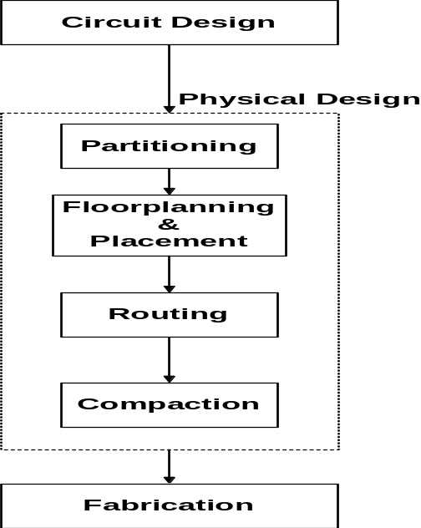

Fig 1.2: Physical design Cycle

Compaction:
Compaction is simply the task of compressing the layout in all directions such that the total area is reduced. By making the chip smaller, wire length is reduced which in turn reduces the signal delay between components of the circuit. At the same time, a smaller area may imply more chips can be produced on a wafer, which in turn reduces the cost of manufacturing.
Physical design, like VLSI design is iterative in nature and many steps such as global routing and channel routing are repeated several times to obtain a better layout. In addition, the quality of results obtained in a step depends on the quality of solution of earlier steps. For example, high quality routing cannot cure a poor quality placement. As a result, earlier steps have more influence on the overall quality of the solution.

CHAPTER 2

Routing:
In a two-phase approach, detailed routing follows the global routing phase. During the global routing phase, wire paths are constructed through a subset of routing regions, connecting the terminals of each net. Global routers do not define the wires; instead, they use the original net information and define a set of restricted routing problems. The detailed router places the actual wire segments within the region indicated by the global router, thus completing the required connections between the terminals.
A routing region may have terminals only on two opposite sides of the region. This type of routing region is called a channel. On the other hand, a rectangular routing region may be closed, and may have terminals on all four sides of the region. This type of routing region is called switchbox. The area of the routing region can be determined exactly only after the routing is completed.

Routing Considerations:
Solving one routing region at a time solves the detailed routing problem. The detailed routing problem is to find the actual geometric path for each wire in a region. The complexity of the routing problems varies due to many factors including shape of the routing region, number of layers available, and number of nets. Before presenting the routing problem formally, we describe important considerations and models used in routing.
In general, the routing problem has many parameters. These parameters are usually dictated by the design rules and the routing strategy.
1. Number of terminals: Majority of nets are two terminal nets, however, the number of terminals in a net may be very large. This is especially true for global nets such as clock nets. In order to simplify the routing problem, traditionally, routing algorithms assume all nets to be two terminal nets. Each multi terminal net is decomposed into several two terminal nets. More recently, algorithms that can directly handle multi terminal nets have also been developed.
2. Net width: The width of a net depends on the layer it is assigned and its current carrying capacity. Usually, a power and ground nets have different widths and routers must allow for such width variation.
3. Via restrictions: The final layout of a chip is specified by means of masks. The chip is fabricated one layer at a time. And the masks for the various layers must align perfectly to fabricate the features such as vias that exists in two layers. Perfect alignment of masks is difficult. Thus vias are normally only allowed between adjacent layers. Even between two layers, minimization of vias reduces mask alignment problems. Improvements in chip manufacturing technology have reduced mask alignment problems and today stacked vias (vias passing through more than two layers) can be fabricated. However, vias still remain a concern in routing problems and must be minimized to improve yield and performance.
4. Boundary type: A boundary is a border of the routing region that contains the terminals. Most detailed routers assume that the boundaries are regular (straight). Even simple routing problems, which can be solved in polynomial time for regular boundaries become NP-hard for the irregular boundary routing problem.
5. Number of layers: Almost all fabrication processes allow two layers of metal for routing. Recently due to improvements in fabrication technologies even multiple layers is available for routing.
6. Net types: Some nets are considered critical nets. Power, ground, and clock nets fall in this category. Power and ground wires make special considerations since they are normally wider than signal wires. Clock nets require very careful routing preference, since the delay of the entire chip may depend on clock routing. Due to this type of restrictions based on the critical nets, they need to be routed before signal nets using specialized routers.

Channel Routing:

Since the major goal of a router is to provide area efficient connections for all circuits of the chip, it is important to route channels using minimum possible area. In a two-phase router, the global router does not actually provide any physical connections for nets. Physical connections for nets are completed only after detailed routing of all channels and switchboxes. Thus the area consumed by electrical connections is directly related to the area used in detailed routing phase within channels. In the following subsection we present the structure of a multi-layered channel.

Structure of the channel:

A channel has two open ends, the left and right sides of the rectangle. The other two sides viz, the upper and lower sides of the rectangle have two rows of terminals. The terminals are aligned vertically in columns. A set of terminals that need to be electrically connected together is called a net. The subnet of a net is the subset of the set of terminals of the net. Typically, the connections required are specified as two equal sized lists of numbers, one for terminals of the upper row of the channel and the other for the terminals of the lower row of the channel. The size of each of these lists is the number of columns in the channel. These lists are together called the net list or the channel specification.

Often we use the terms channel and channel specification interchangeably. The terminals of the same net are assigned the same number. The unconnected terminals are assigned the number zero. A channel is a three dimensional rectilinear grid with t+2 rows, m+2 columns and z layers. The figure below shows the three-dimensional view of the channel. This channel has 6 = t+2 rows, 7 = m+2 columns and z = 4 layers. Columns are numbered 0 through m+1 from right to left, tracks are numbered 0 through t+1 from back to front and layers are numbered 1 through z from top to bottom.

The intersection on layer k of row h and column j is a Grid Point GP [h, j, k]. The edge between adjacent grid points of the channel is called a Grid Segment. A channel is normally viewed from the top so the layers are not visible in this view. They are numbered from front to back. Columns 0 and m+1, and rows 0 and t+1 are not used to make connections inside the channel, but are used to make connections to circuits outside the channel. A circuit whose electrical connections must pass through the channel is connected to a set of grid points on the periphery of the channel.
This set of grid points is called a pin. Pin P [h, j] consists of grid points GP [h, j, k], 1 ≤ k ≤ z, where h is either 0 or t+1 and 1 ≤ j ≤ m, or j is either 0 or m+1 and 1 ≤ h ≤ t. Pins P [0, 0], P [0, m+1], P [t+1, 0], and P [t+1, m+1] are not used.

A circuit that connects to a pin is connected to each of the grid points belonging to the pin. A pin is assigned an integer label corresponding to a circuit that connects to it from outside the channel. A pin that has no connection is assigned a label 0. Two pins are assigned the same integer if circuits connecting them are to be electrically connected inside the channel. A pin that has been assigned a label is called a terminal.

R
o
w
s
L
a
y
e
r
s
C
o
l
u
m
n
s
0
1
2
3
4
5
0
1
2
3
4
5
6
G
r
i
d

p
o
i
n
t

G
P

(
2
,

3
,

1
)
P
i
n

5
,

2
.
1
2
3
4

Fig 2.1: Typical 3D structure of a channel

The rows other than the rows 0 and t+1 are called tracks. While producing the electrical connections inside the channel, altering the terminal assignments on rows 0 and t+1 are not allowed. However, the terminals along the left and right ends of the channel are not fixed. Such movable terminals are called floating terminals. A circuit is assigned to a pin in column 0 or m+1 can be reassigned to another pin in the same column in order to facilitate completion of the routing.
Let the m element vectors TOP and BOTTOM indicate the top and bottom terminal lists, respectively, and contains the labels assigned to the pins P [0, h] and P [t+1, h], 1 ≤ h ≤ m, respectively. Likewise let the t element vectors LCS and RCS indicate the left and right connection sets, respectively, and contain labels assigned to pins P [h, 0] and P [h, m+1], 1 ≤ h ≤ t, respectively. The set of nets that enter in the channel from the left (right) end of the channel is called the left (right) connection set. TOP [h], BOTTOM [h], LCS [h], and RCS [h] refer to the h^{th} label of the respective vectors.
A net with only two terminals is called a two-terminal net. Similarly, a net with more than two terminals is called a multi-terminal net. Two-terminal nets are called trivial if both of the terminals of the net are in the same column. A column is a trivial column if it contains two terminals for the same net. A column is called empty if it has no nets assigned on both its top and bottom pins.
A wire segment is composed of conducting material implanted on a layer. All wires are aligned on the grid segments, and begin and end at grid points. A vertical wire segment is a wire that lies completely in a single track.
A wire segment on layer k which crosses the grid point GP [h, j, k] can be connected to another wire segment of the same net on layer k’, k’= k-1 or k’ = k+1, which crosses grid point GP [h, j , k’] using a via hole. A via hole can connect wire segments on adjacent layers. However, in some fabrication technologies, via holes can be stacked on a grid point with same track and column indices to achieve several layer changes [Bra86a, Ham85]. We have not considered the use of the stacked via holes.
A route for a net is a collection of horizontal and vertical wire segments spread across different layers connecting all the terminals of the net. A legal wiring of a channel is a set of routes that satisfy all the pre-specified conditions where, no two wire segments used to connect different nets overlap on the same conducting layer. A legal wiring is also called a feasible routing solution.
M element vectors TOP and BOTTOM, and t element vectors LCS and RCS specify the general channel routing problem, and the number of layers of interconnects z. The objective is to find a routing solution for the channel using no more than t tracks.
In grid-based models, the channel routing problem is the assignment of horizontal segments of nets to tracks. Vertical segments are used to connect horizontal segments of the same net in different tracks and to connect the terminals to the horizontal segments. There are two key constraints that need to be satisfied while assigning the vertical and horizontal segments.

- Horizontal constraints:

There is a horizontal constraint between two nets, if the trunk of these two nets overlaps when placed on the same track. For a net N_{i}, the interval spanned by the net, denoted by I_{i} is defined by (r_{i}, l_{i}), where r_{i} is the rightmost terminal of the net and l_{i} is the leftmost terminal of the net.
Given a channel routing problem a horizontal constraint graph (HCG) is a undirected graph G_{h} = (V, E_{h}) where,
V = {v_{i}| v_{i} represents I_{i} corresponding to N_{i}}
E_{h} = {(v_{i}, vj)| I_{i} and I_{j} have non-empty intersection}

The HCG is in fact an interval graph. Figure 2.2 shows the channel routing problem and its associated horizontal constraint graph.

The HCG plays an important role in determining the channel height. In a grid based two-layered model, no two nets, which have a horizontal constraint, may be assigned on the same track. As a result, the maximum clique in HCG forms a lower bound for the channel height. In a two-layered grid-less model, the summation of the width of nets involved in the maximum clique determines the lower bound.

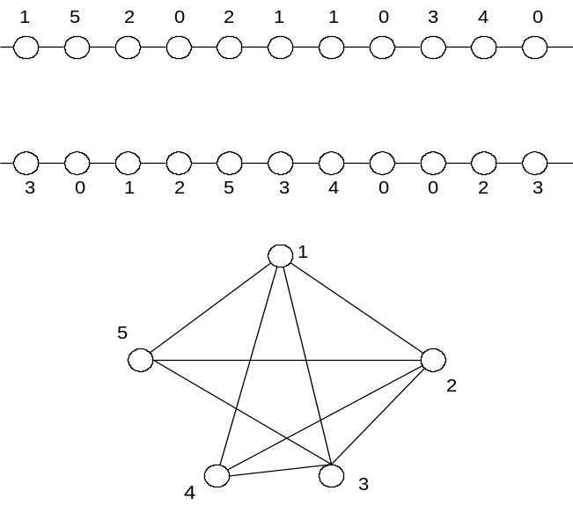
Fig 2.2: A routing problem and its HCG

2. Vertical constraints:

A net N_{i}, in a grid based model, has a vertical constraint with net N_{j} if there exists a column such that the top terminal belongs to the net N_{i} and the bottom terminal belongs to the net N_{j} and i ≠ j. In the case of grid-less model, the definition of the vertical constraint is somewhat similar except that for the overlap is between the actual vertical segments rather than the terminals of the column.
Given a channel routing problem, a vertical constraint graph (VCG) is a directed graph G_{v} = (V, E_{h}) where,
E_{v}= {(v_{i}, v_{j})| N_{i} has vertical constraint with N_{j}}

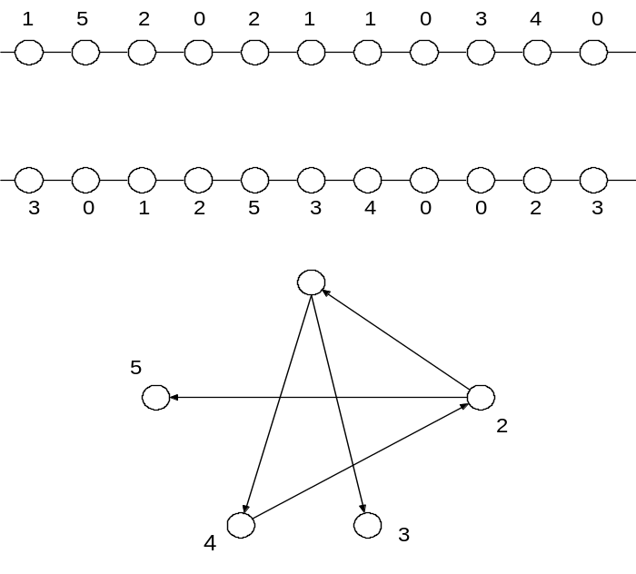
Fig 2.3: A simple routing channel and its VCG
It is easy to see that a vertical constraint implies a horizontal constraint but the converse is not true. The VCG may contain a directed cycle. There is a feasible no-dogleg routing solution if and only if the concerned VCG has no cycles.

Channel Routing Problem:
The channel routing problem (CRP) is the problem of computing a feasible route for the nets so that the number of tracks required (and hence the channel area) is minimized. We assume that the routing wires do not extend beyond the left and right ends of the channel. Therefore, in order to minimize the routing area the horizontal wire segments of the nets need to be distributed amongst a minimum number of tracks. This process of assignments of the horizontal wire segments to tracks is guided by two important constraints viz., the horizontal constraints and the vertical constraints that we have discussed in previous section.
Let L_{i} (R_{i}) be the leftmost (rightmost) column position of net n_{i,} then I_{i}=(L_{i}, Ri) is known as the interval or span of the net. In this report span, interval and horizontal wire segment refer to the same term. Suppose we use a single horizontal wire segment for routing each net. Then, this wire segment spans the entire interval I_{i} of the net n_{i}. So, routing the nets amounts to assigning intervals to horizontal tracks of the channel. The horizontal constraints determine whether two intervals I_{i} and I_{j} of two different nets n_{i} and n_{j}, respectively, are assignable to the same track.
Vertical constraints determine the order in which the intervals should be assigned from top to bottom across the channel. Suppose we have a column in a channel with a terminal of net n_{i} on the top and a terminal of net n_{j} (n_{j}≠n_{i}) at the bottom. Then, in order to assign the vertical wire segments of the nets in the column we mustkeep a gap of at least one track so that these two wire segments do not overlap. In other words we can say that if the horizontal wire segment of net n_{i} is assigned to track t_{i} and the horizontal wire segment of net n_{j} is assigned to track t_{j}, then t_{j} is a track nearer the top row than the track t_{j}.
The horizontal and vertical constraints are represented by two important constraint graphs viz., the horizontal constraint constraint graph (HCG) and the vertical constraint graph (VCG), respectively [Yos82]. Horizontal constraints can be represented using an HCG, HC =(V, E), where a vertex v_{i} ∈ V corresponds to the interval Ii of the net n_{i} in the channel. An undirected edge {v_{i}, v_{j}} ∈ E, if the intervals I_{i} and I_{j}, corresponding to the nets n_{i} and n_{j}, intersect at a column. An edge {v_{i}, vj} in the HCG indicates that the corresponding horizontal constraint graph of the channel. Consider the channel in figure 2.4. In figure 2.5(a) we have the corresponding horizontal constraint graph of the problem.

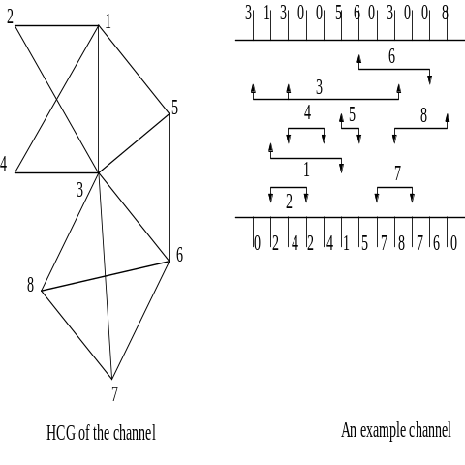

Fig 2.4: An example channel

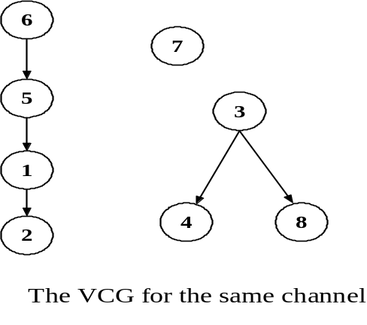
Fig 2.5(a): The HCG of the channel Fig 2.5(b): The VCG of the channel

Channel & Local density
The local density of a column is the maximum number of nets passing through the column. The channel density (or density) of a channel is the maximum of all the local densities. We denote the channel density by d_{max}. A channel of density d_{max} has at least one column spanned by d_{max} nets. Each of these d_{max} nets must be put in distinct tracks of the same horizontal layer. Thus the minimum number of tracks required to route a two-layer channel is d_{max}.

Horizontal non-constraint graph
We often represent horizontal constraints using the complement of the HCG. We call the complement the HCG, HC=(V, E), the horizontal non-constraint graph (HNCG) and denote it by HNC= (V, Ē), where V is the set of vertices corresponding to the intervals, and Ē= { {vi,vj}|{vi,vj}∉E}. A set of vertices of a graph such that each pair of vertices in the set has an edge between them is called a clique. The clique of the HNCG corresponds to a set of non-overlapping intervals that may safely be assigned to the same track in a routing solution.

The VCG, VC= (V,A) is constructed to represent the vertical constraints. Here a vertex vi ∈ V corresponds to the interval I_{i} of the net n_{i} in the channel. A net whose corresponding vertex in the VCG is incident to a directed edge is said to be vertically constrained. If there is a directed edge from from vertex u to v in the VCG, we say that u is the ancestor of u and v is the descendant of u. Suppose we wish to assign two nets, n_{i} and n_{j} to tracks of the same horizontal layer. The directed edge ( v_{i}, v_{j}) ∈ A in the VCG indicates that the nets n_{i} has to connect a top terminal and the net n_{j} has to connect a bottom terminal at the same column position. Therefore the interval I_{i} must be assigned to a track above the one that the interval I_{j} is assigned. For an acyclic VCG we denote the length of the longest path in the VCG by v_{max}, where v_{max} is equal to the number of vertices belonging to the path.
The VCG may contain a directed cycle. There is a feasible no-dogleg two-layer routing solution for the channel if and only if there is no cycle in the VCG.
This problem can be solved using three-layer VHV channel where the horizontal layer is flanked by two vertical layers. Since we have two vertical layers for each horizontal wire segment , a vertical constraint can be resolved using the vertical wire segment in the other V layer.

Reduced Vertical Constraint Graph
The vertical constraint is generally represented as reduced vertical constraint graph (RVCG). The RVCG represents vertical constraints between groups of nets, where each group has a set of non-overlapping nets, representing a clique in the HNCG. Since nets in a track of a routing solution correspond to a clique in the HNCG, the RVCG is used to represent vertical constraints between tracks in a routing solution. The formal definition of RVCG is as follows: Each vertex in the vertex set corresponds to a set of non-overlapping nets. There is a directed edge (u, v), if there is a set n_{i} ∈ u and another net n_{j} ∈ v such that (n_{i}, n_{j}) is a directed edge in the VCG. The RVCG is a natural notion used in the intractability proofs.

Nature of Channel Routing Problem

The computational complexity of the channel routing problem depends on the following three conditions: area minimization, approximate area and total wire length minimization.
An area minimum routing solution for any channel can be easily computed in polynomial time in the absence of vertical constraints [Has71]. Considering both the vertical and horizontal constraints several two-layer and three-layer channel routing problems has been studied extensively. The problem of minimizing the number of tracks (i.e area of routing) has been shown to be NP-hard in the following cases for Manhattan channel routing: (i) no-dogleg and restricted dogleg two-layer VH routing [LaP80], (ii) unrestricted dogleg two-layer VH routing [Szy85], (iii) no-dogleg and restricted dogleg two-layer VH routing with only single-sided nets [Gre92], and (iv) no-dogleg and restricted dogleg three-layer HVH routing [Sch89]
Several heuristics for area minimization in channel routing have been proposed which generate routing solutions for several standard benchmark channels. Even though most of these heuristics run in polynomial time algorithm, it is not known whether there exists a polynomial time algorithm that computes a routing solution for any given instance of the CRP within a constant number of tracks more than the optimal number requires for that instance. Such an algorithm is called absolute approximation algorithm. It has been proved that the problem of computing an absolute approximate solution for no-dogleg two-layer VH routing is NP-hard.
The total wire length in a routing solution is another important cost criterion. Minimizing the total wire length in a routing solution is important because it not only reduces the cost of the physical wiring required, but also the hazards of having long wires in the interconnections. It can be said that this problem is NP-hard for routing in the no-dogleg two-layer VH routing model as well as the no-dogleg three-layer HVH routing model.

CHAPTER 3

Our Proposed High Performance Channel Routing algorithm

Most of the research on channel routing has focused on routing channels using only two or three layers of interconnect. Recent advances in VLSI circuit fabrication technology allow more than two or three layers of interconnection. In order to take full advantage of these additional layers of interconnect, new routing algorithms must be developed.
The density of a channel as defined in earlier sections is the maximum number of horizontal wire segments that must pass through some column of a channel. Any routing solution of a channel must therefore use at least as many tracks as the density of the channel. In the ViHi reserved layer model, each track set contains i tracks in a row. Thus the minimum number of tracks required in a horizontal layer in any routing solution in this model ⎡d_{max}/i⎤. Hence for multi-layer channel routing the routing area can be minimized effectively.
Apart from this, due to scaling down of device geometry in deep submicron technologies, the crosstalk noise between adjacent nets has become a major concern in high performance VLSI circuit design. Increased coupling noise can cause signal delays, logic hazards and even malfunctioning of circuits, and thus controlling the level of crosstalk noise in a chip has become an important task for IC designers.
So, in our project work we have proposed a heuristic solution for minimization of crosstalk in multi-layer channel routing. We have selected no-dogleg Manhattan routing model for our purpose.

To identify the nets that can be assigned to a single track we have to transitively orient the edges the HNCG. A transitively orient-able graph is defined as follows: an undirected edge {v₁, v₂} of an undirected graph can be oriented in two possible directions. If we orient the edge from v₁ to v₂ (v₂ to v₁), we denote the orientation by the directed edge v₁→v₂ (v₂→v₁). An undirected graph can be converted to a directed graph by orienting each edge of the graph. An undirected graph is said to be transitively orient-able if there exists an orientation of all edges such that for any three vertices v_{i}, v_{j} and v_{k}: v_{i}→v_{j} and v_{j}→v_{k} implies v_{i}→ v_{k}. Such an orientation is called transitive orientation.
A transitively oriented graph has three kinds of vertices viz. source, sink and the intermediate vertices. A source (sink) vertex is defined as the vertex having no incoming (outgoing) directed edge. Other vertices are the intermediate vertices. An undirected graph is called a comparability graph if it is transitively orient-able.

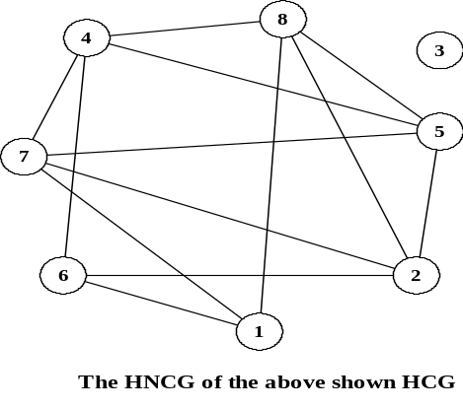
Fig 3.1: The HNCG of the example channel
Note that a clique in the HNCG corresponds to a set of non-overlapping intervals that may safely be assigned to the same track in the same horizontal layer in a routing solution.

Here we are interested in minimizing the routing area. The input is given as a channel specification or net list. Therefore, the objective of obtaining a minimum area routing solution can be achieved by computing a minimum clique cover of the HNCG. After assigning the intervals to tracks according the computed minimum clique cover, we route the vertical wire segments of the nets to the respective terminals. Since each column of the channel consists of terminal(s) of only one net, the vertical wire segments can be routed without any conflict. In the remaining part of the section we develop the algorithm for computing the minimum clique cover of the HNCG.
Now we consider the computation of the minimum clique cover for the HNCG. One way to compute a clique cover is to choose the successive maximal cliques of the HNCG. We first choose one maximal clique. After choosing a maximal clique we delete the vertices of this clique from the graph and repeat the process of choosing the next maximal clique from the remaining graph. This process continues till the whole graph becomes empty. It can be shown that the clique cover thus obtained may not be a minimum clique cover. Therefore arbitrarily chosen maximal cliques may not constitute the minimum clique cover.

Now, we show that the idea if precedence can be used to compute the minimum clique covers. Sort the L_{i}’s of the intervals from left to right along the channel, where L_{i} indicates the starting column position of the net n_{i}. In this manner, the nets are sorted in the increasing order of the starting column positions of the intervals. In the figure below we have shown the starting column positions of net n_{i} by s_{i}. In the diagram below, we have indicated the sorted position of the net n_{i} inside the rectangle corresponding to the vertex v_{i}.

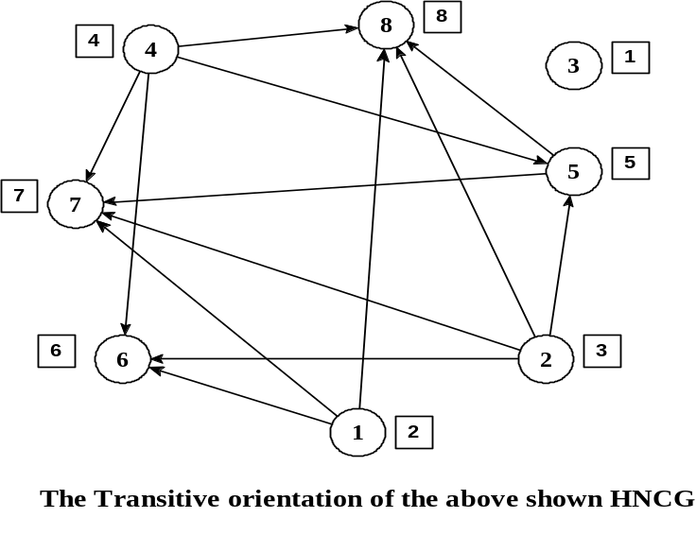

Fig 3.2: The transitive orientation of the above HNCG

Now we are in a position to generate the minimum clique cover of the HNCG. Consider the channel specification of the example taken and the HNCG and the transitively oriented HNCG. Since, v₃ is the first vertex of the sorted list we select it. From the adjacency list of v₃ we see it is a vertex with no incoming and outgoing edges, so we select v₃ to be a clique. Next in the sorted list comes v₁ and from its adjacency list we see that vertices v₆, v₇, v₈ are adjacent to it. Since, v₆ appears first in the sorted order of the vertices we select v₆ next. In this manner we continue selecting vertices till a sink vertex is reached and selected. Here {v₁, v₆} are the selected vertices and constitute a minimal clique. Other cliques selected this way are {v₂, v₅, v₇} and {v₄, v₈}.
On every selection of a clique we delete the vertices constituting the maximal clique from the graph and continue with the selection of the next maximal clique from the remaining vertices. This method continues till the graph becomes empty. Therefore the maximal cliques selected are {{v₃}, {v₁, v₆}, {v₂, v₅, v₇}, {v₄, v₈}}. Note that the number of maximal cliques in the above computed clique cover is the same as the size of the maximum independent set in the HNCG.

Observe that, to compute the maximal cliques in the minimum clique cover stated above, the most important step is the selection of next vertex to be included in the current clique until the sink vertex is selected.
Suppose we have already selected and included the vertex v_{i} corresponding to the interval I_{i} in the current clique. Moreover, there is an interval I_{j} to the left of I_{i} and an interval I_{k} to the right of I_{i} such that they do not overlap I_{i}. Assume that I_{j} and I_{k} do not overlap I_{i}, {v_{i}, v_{j}} and {v_{i}, v_{k}} are edges in the HNCG.
But while computing the maximal cliques, we select an interval only from the right side of the currently selected interval. So, out of the two edges {v_{i}, v_{j}} and {v_{i}, v_{k}} we are interested in only the edge {v_{i}, v_{k}}, as far as selection of the next vertex of the current clique is concerned. This selection can be aided by searching all such vertices v_{k} whose corresponding interval I_{k} is to the right of I_{i}, and I_{k} and I_{i} do not overlap. To search for all such vertices v_{k} we construct a directed graph G* = (V, F) from the HNCG, G= (V, Ē) by suitably orienting the edges of G as follows:

Let L_{i} (R_{i}) be the column position of the leftmost (rightmost) terminal of net n_{i}. Then (L_{i}, R_{i}) denotes the span of the interval I_{i}. We orient an edge {v_{i}, v_{j}} of the HNCG form v_{i} to v_{j}, thereby defining the directed edge (v_{i}, v_{j}) in G* if and only if R_{i} < L_{j}.
This orientation of edge {v_{i}, v_{j}} from v_{i} to v_{j} is denoted by v_{i} → v_{j}. This orientation has a very interesting transitivity property; for any three vertices v_{i}, v_{j} and v_{k}, if v_{i}→v_{j} and v_{j}→v_{k,}, then v_{i}→ v_{k}. This is proved in the following lemma:

Lemma: For any three vertices v_{i}, v_{j} and v_{k} of the HNCG, if v_{i}→v_{j} and v_{j}→v_{k} , then v_{i}→ v_{k}.
Proof: From the given premise we have R_{i} < L_{j} and R_{j} < L_{k}. Moreover, from the interval I_{j} we have L_{j} < R_{j}. So, R_{i} < L_{k}. Therefore, { v_{i}, v_{k}} is oriented from v_{i} to v_{k} i.e., v_{i}→ v_{k}.

If there is no interval I_{k} for which R_{j} < L_{i} then v_{i} is a source vertex of G*. On the contrary, if there is no interval for which R_{i} < L_{j}, then v_{i} is a sink vertex of G*. The above transitive orientation of the HNCG G is a natural transitive orientation based on the geometry of the intervals in the channel. If v_{i} → v_{j}, then the interval I_{j} is to the right of I_{i}.

The steps of the algorithm MINUMUM_CLIQUE_COVER_1 (MCC1) for computing the minimum clique cover are given below.

Algorithm: MINIMUM_CLIQUE_COVER_1.
Input: Channel Specification.
Output: A set (MCCS) of Minimum Cliques.
Begin
Step 1: Sort the intervals according to their starting column positions in ascending order.
Step 2: Construct the HNCG, G = (V, Ē) and find its transitively oriented graph G* = (V, F) based on the natural transitive orientation stated in Lemma 1.
Step 3: While (the sorted list is non-empty) do
Begin
Step 3.1: Assign a clique C ← ø.
Step 3.2: Select the first vertex v from the sorted list. Assign C ← C U v.
Step 3.3: Repeat
Step 3.3.1: Delete v from the sorted list.
Step 3.3.2: If v is not a sink vertex, then let S = {v_{k}| v → v_{k}}. Delete the vertex v from G and all the oriented edges v → v_{k} from G* for all v_{k} belonging to S. Select the vertex with minimum key in this sorted list among the vertices in S and call it v.
Assign C ← C U v.
Step 3.4: Until (the vertex v is a sink vertex).
Step 3.5: C is a clique of the minimum clique cover.
Step 3.6: Assign the vertices of the clique C to the set MCCS
end
end

Our Algorithm:
MCC1 gives us the set MCCS, the set of non-overlapping nets, i.e. a set of classes of nets that can be allocated in the same track. The VCG is modified with this information to construct a Reduced VCG where each node is a super node consisting of the set of non- overlapping nets.
If the channel density is d_{max} and the number of layers for which the channel routing is to be solved is i then number of tracks per layer may be computed directly as ⎡d_{max} / i⎤. Hence we get ⎡ d_{max} / i⎤ tracks per layer to assign the super nodes.
But before allocating the nets in a multilayer channel the type of channel used must be taken in consideration because in Vi+1Hi model each horizontal layer would be flanked by two vertical layers so we can safely ignore the vertical constraints while assigning the nets to tracks .We identify these set of nodes of RVCG which are to be allocated in H layers flanked by V layers as MDL.
But for the case where the model is ViHi a single vertical layer flanks the extreme horizontal layer. Hence for this extreme layer vertical constraint has to be taken in consideration. Now the problem is to identify two sets of super nodes, one for assigning to the middle layers. i.e. the H layers each of which is flanked by two vertical layers, and another for assigning to the extreme H layer, say H₀. However in the extreme layer there should not be any cyclic vertical constraints between the nodes selected for assignment in H_{0.} In order to avoid cyclic vertical constraint between the nodes selected for assignment in H₀ , we try to identify those rogue nodes in RVCG that are likely to be involved in a cycle and assign them to the middle layers, i.e the H layers flanked by two vertical layers. After identifying the maximum number of nodes that can be assigned to the middle layers we cannot assure that remaining super nodes in RVCG are cycle free. If they are cycle free we perform a topological sort on them to assign them to the extreme layer H₀ in the proper order abiding by their vertical constraints.
In the model ViHi+1 the problem is to find three sets, two for the extreme layers say H₀ and H_{l} and the middle layers MDL. The solution is similar as the previous one except we have to identify two extreme layer sets EXT0 and EXTi only after MDL is identified.
Below we describe the actual selection process in our algorithm SELECT_NETS.

Algorithm: SELECT_NETS
Input: Number of horizontal layers and the model type (Vi+1Hi, ViHi, ViHi+1), d_{max}
Output: Sets EXT0, EXTi, MDL.

Step 1: tracks ← ⎡ d_{max} / Number of horizontal layers⎤.
Step 2: if (model is Vi+1Hi) then
Start_layer ← 0.
End_layer ← Number of horizontal layers.
else if (model is ViHi) then
Start_layer ← 1.
End_layer ←Number of horizontal layers.
else
Start_layer ← 1.
End_layer ← Number of horizontal layers-1.
Step 3: Initialize EXT0, MDL, EXTi to Null.
Step 4: for (each layer between Start_layer to End_layer) do
begin
Step 4.1: for (each track) do
begin
Step 4.1.1: max ← The node in the RVCG involved in maximum number of cycles.
Step 4.1.2: MDL ← MDL U max.
Step 4.1.3: Delete the node max from the RVCG and all the incoming edges to node max.
Step 4.1.4: end
Step 4.2: end
Step 5: if (model is other than Vi+1Hi) then
Step 5.1: for (each track) do
begin
Step 5.1.1: max ← The node in the RVCG having the maximum number of outgoing edges.
Step 5.1.2: EXT0 ← max U EXT0.
Step 5.1.3: Delete the node max from the RVCG and all its incoming edges.
Step 5.1.4: end
Step 6: if (model is ViHi+1) and (the RVCG is not empty) then
Step 6.1: for (each track) do
begin
Step 6.1.1: max ← The node in the RVCG having the maximum number of outgoing edges.
Step 6.1.2: EXTi ← max U EXTi.
Step 6.1.3: Delete the node max from the RVCG and all its incoming edges.
Step 6.1.4: end

The above algorithm is the basis of the assignment process. After the MDL set has been identified the set is sorted on the overall interval span and then the actual crosstalk is reduced in the process described previously. The selction of max in the step 4.1.1 in the above algorithm is governed by a depth first search (dfs) having the complexity of O (n + e) and the dfs is performed in a loop for track times which can at most be n for the worst case. Thereby the actual complexity is O (n * (n + e)). The outermost loop is of a finite number and lends little in the complexity calculation.

Crosstalk minimization:
As fabrication technology advances, devices and interconnection wires are placed in closer proximity and circuits operate at higher frequencies. This results in crosstalk between wire segments. Crosstalk depends upon a lot of factors and the most important is the coupling length (the total length of the overlap between wires). The aim should be to avoid long overlapping wire segments and/or the wire segments that lie close to each other on the same layer. Work on the routing channels with reduced crosstalk is a very important area of current research. It is therefore desirable to design a channel routing algorithm that considers this factor.

Let us now discuss the presence of crosstalk between the various nets (or intervals) assigned to the different tracks. We measure the amount of crosstalk in terms of number of units a pair of nets overlaps on adjacent tracks in a feasible routing solution. Consider the problem of minimizing the crosstalk in two-layer VH routing. Suppose we have three intervals a, b and c, as shown in the figure below, in a feasible routing solution of three tracks only.

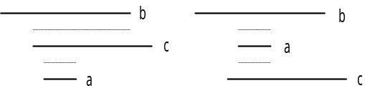
Figure3.3a: A feasible three-track routing solution Fig 3.3b: A minimized crosstalk routing solution

Since all the three nets overlap, we have to assign the nets in three different tracks on the same horizontal layer in any feasible routing solution. But the most important and interesting feature we can point out is that in the first diagram nets b and c that are assigned to two adjacent tracks share a crosstalk of say 19 units. Nets c and a share a crosstalk of say 4 units. Then by reassigning them in the order shown in the adjacent diagram we can reduce the overall crosstalk of the channel to just 8 from the previous total of 19 + 4 = 23 units. Details of the working and the principle are discussed in the paper [AsPal02].

Our algorithm takes this observation into account and assigns the net set to a track that has the smallest interval span in between two tracks that has been assigned with nets with overall greater interval span. If the net set is sorted on the interval span it occupies on a track, then the problem reduces to assigning the largest to the first available track then assigning the smallest to the next track and then assigning the second largest to the track after it (and so on) in the absence of vertical constraints. This process is applied on MDL, the set of super nodes identified by SELECT_NETS to be assigned to the middle layers.
The actual problem of assigning the nets to tracks in a channel routing problem is NP- complete in nature [Pal’00]. Therefore it is not possible to solve the channel routing problem through any polynomial time algorithm.

