PYTHON PROJECT

Name: Suvansh Agrawal

ER NO: 171B139

TOPIC: CAR SERVICE CENTER DATABASE

DOCUMENTION ON PROJECT:

1. TO SEARCH:

Rno =MP05

Rno=MP07

Put these value to search

1. WIDGETS USED:
2. Label
3. Button
4. Checkbutton
5. Radiobutton
6. Option menu
7. Splash Screen
8. Message box
9. My sql
10. Entry Box
11. GUI WINDOW (including splash window):

* 8

1. VARIOUS GUI WINDOW WITH EXPLANATION:
2. Splash: It contains the splash screen with code to show a GUI with a logo image and when cursor moves over it disappear, opening next GUI.

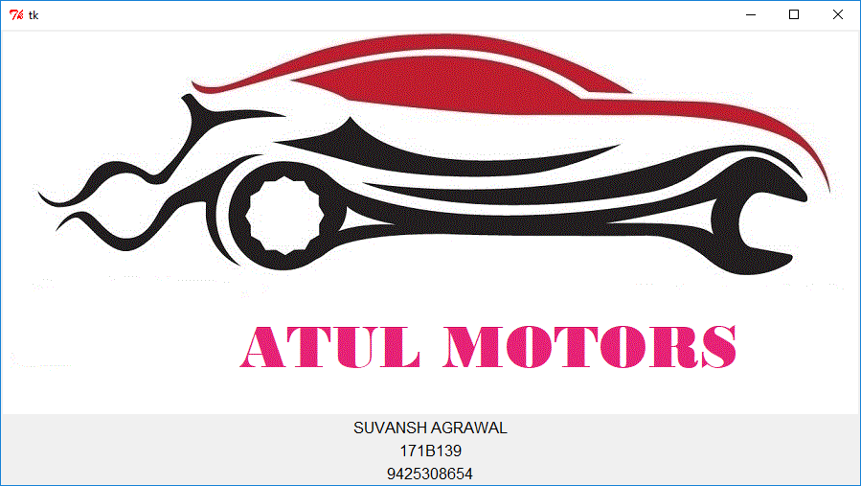

1. Root5: It is the main and welcoming screen of the project. It contains three button as ‘ADD NEW’, ‘SEARCH’, and ‘EXIT’.
   1. ADD NEW: It opens another GUI to make a new entry in database.
   2. SEARCH: It opens another GUI to search information about entry in database.
   3. EXIT: It open a message box which ask option whether to close the main screen.

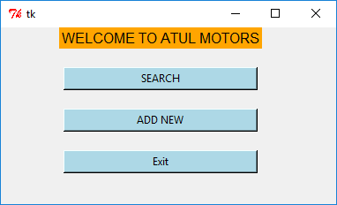

1. Root: It is the GUI which opens on clicking ‘ADD NEW’ button. It asks user to enter various fields like name, contact no, address, etc. It contain four option menu as type of vehicle and date. It contains three radiobutton as ‘MAJOR DAMAGE’, ‘ACCIDENTAL DAMAGE’ and ‘QUICK SERVICE’. Selecting any one of these take program further forward. On selecting ‘QUICK SERVICE’ a entry box opens up which ask no of service. If no of service is less than 4 service is free else paid.

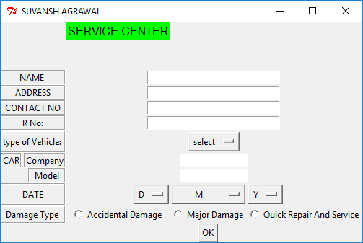

1. Root1: It opens on selecting ‘MAJOR DAMAGE’. It contains various checkbutton as interior, exterior, cabin, engine, body, etc. At the end it has a ‘Done’ button which opens a message box and close this ‘Root3’ GUI on selecting yes.

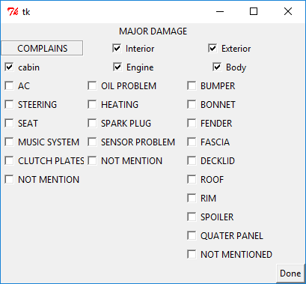

1. Root2: It opens on selecting ‘QIUCK REPAIR’. It contains various checkbutton as AC, ECG, ELECTRIC, STEERING, etc. At the end it has a ‘Done’ button which opens a message box and close this ‘Root2’ GUI on selecting yes.

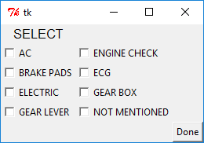

1. After selecting one of three type of damage and further selecting the given options. Method of payment appears with two radiobutton as ‘CASH’ and ‘CARD’. Also a select button which select one of two radiobutton. If cash option is selected ‘submit’ button appears up which further on selecting opens up a message box with “are you sure” dialog. If yes is selected a info box appears with dialog ‘ENTRY SUCCESSFUL” and values are entered into table.

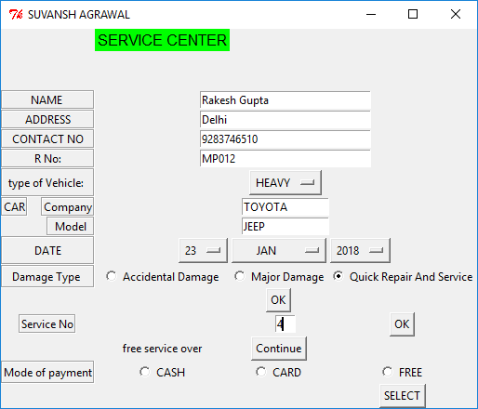

1. Root3: It opens up selecting ‘CARD’ it contains two entry box with label ‘CARD NO’ and ‘CVV’. At the end it has a ‘Done’ button which opens a message box and close this ‘Root3’ GUI on selecting yes. After this ‘submit’ button appears up which further on selecting opens up a message box with “are you sure” dialog. If yes is selected a info box appears with dialog ‘ENTRY SUCCESSFUL” and values are entered into table.

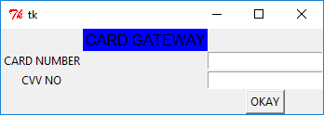

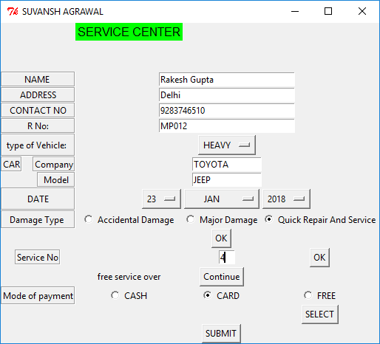

1. Root6: It opens on selecting ‘SEARCH’ button. It contains entry with label rno and a ‘GO’ button to initiate searching for given rno.

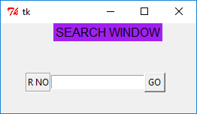

1. Root7: It opens on clicking ‘GO’ button in root6 GUI. It contains bill and information corresponding to the entered rno.

