INTELLIGENT GRAMMAR REWRITE USING
OCR AND NLP TECHNIQUES
Department Of Information Technology
Dhanekula Institute Of Engineering And Technology,Ganguru
Authors
G. Sai Saranya CH.Suvarna Raju B.Jahnavi
Saranyagullipalli07@gmail.com suvarnaraju494@gmail.com jahnavibandaru111@gmail.com

M. Manoj B. Hari Priya A.Sree Ratna Teja
Manojmandla66889@gmail.com hp468348@gmail.com sreeratnatejaavanigadda@gmail.com

ABSTRACT
Handwritten documents are still widely used in academics, offices, and everyday personal work, even with the use of digital technologies. However, converting handwritten text into editable digital format is not easy because handwriting styles vary from person to person, spacing is may be irregular, and images may suffer from noise or poor lighting. This paper presents an intelligent system for handwritten text recognition and grammar improvement by combining transformer-based Optical Character Recognition with Natural Language Processing techniques. The system uses a TrOCR model to accurately recognize handwritten text by processing images line by line after applying suitable preprocessing methods. Along with text recognition, the system improves user experience by providing grammar and spell correction, synonym suggestions, and text-to-speech features. A simple and interactive graphical interface is developed using Python Tkinter to make the system easy to use. The entire system works in offline mode, ensuring data privacy and allowing users to access it without an internet connection. Overall, the proposed approach offers a practical and efficient solution for digital handwritten documents in educational, professional, and documentation environments.
Keywords: Handwritten Text Recognition, Transformer OCR, TrOCR, NLP, Image Processing, Offline OCR

INTRODUCTION
Handwritten text recognition is the technique of converting handwritten characters and words into a machine-readable format or text. Even with the present technological world, the existence of handwritten documents is prevalent in our day-to-day activities such as notes in class, documents in office, and any written information on paper. The usage of handwritten notes for students as well as the preservation of data in a handwritten format are still very prominent in organizations, thereby reducing the usage of paper and simplifying documentation and accessibility. This process also provides scope for modification, easy searching, and document sharing. Conventional Optical Character Recognition systems are highly efficient in reading printed text but struggle to recognize handwriting patterns. This issue can be attributed to the variations in an individual's handwriting based on factors like strokes, spacing, alignment and personal handwriting styles. For such complex, variable handwritten text, deep learning models have gained popularity due to their ability to automatically learn visual patterns from the data, hence making them highly successful. Recent deep learning architectures such as transformers, known for their high efficiency in both language and vision tasks, are successful incapturing the relationship between characters and significantly improving recognition performance. This paper proposes a smart handwritten text recognition system by incorporating TrOCR (Transformer Optical Character Recognition) model along with image preprocessing and segmentation. Natural Language Processing features such as grammar and spell check, synonym generation and text-to-speech conversion are further incorporated to provide the improved recognizable text, in the form of an efficient and Interactive offline application.
RELATED WORK

Initially handwritten character recognition systems relied on simple methods like template matching and manually specified features, which did not work well on variations in writing styles. These were eventually replaced by techniques using Hidden Markov Models (HMMs), which proved efficient in analyzing the sequence in writing patterns. With the advent of machine learning, Convolutional Neural Networks (CNNs) quickly became prominent in image based handwritten recognition due to their ability to automatically learn features from the images.

KardanMoghaddam et al. Proposed a novel handwritten text classification framework that integrates the TrOCR transformer with a large language model to capture the contextual relationships in the text and achieve significantly better accuracy than CNN and RNN based OCR systems. [1]. Sharma, M. R developed a handwritten character recognition system using Python based neural models which proved to be a successful implementation of neural network driven OCR systems over feature based approaches. [2]. Chooi and Ab Ghafar presented a CNN architecture designed for handwritten character recognition which could automatically learn the spatial features. The proposed model proved to be better than traditional machine learning classifiers. [3]. Thangamariappan and Pamila worked on handwritten character recognition using classical machine learning techniques with pre-defined statistical and structural features and were able to achieve an acceptable accuracy but lacked robustness when faced with variability in the handwriting. [4]. Pal and Singh presented a early neural network (ANN) based handwritten English character recognition system that was better than rule-based character recognition systems. [5]. Mohamad provided a review on feature extraction and feature selection in handwritten character recognition mentioning zoning, projection profiles, gradient based features and contour descriptors to be vital parameters. [6]. Suresh proposed a transformer based OCR system by integrating unified residual recurrent networks to recognize handwritten multilingual documents while dealing with the dependence in writing. [7]. Purohit and Chauhan reviewed literature in handwritten character recognition, comparing classical machine learning techniques with early deep learning models and emphasizing the development of CNNs as a revolutionary step. [8]. Arica and Yarman-Vural surveyed systems of offline handwritten character recognition covering various processes from preprocessing to classification. [9]. Sharma, Ghose, and Shah implemented an improvedzone-basedhybrid feature extraction technique using Euler numbers and successfully achieved a higher accuracy by significantly increasing feature computation complexity. [10]. Yadav, Sharma, and Kumar implemented a robust offline handwritten English character recognition system by optimizing preprocessing and classification stages that proved reliable against variation and noise in the handwritten text. [11].

PROPOSAL SYSYTEM

Overall Idea
The main idea of this project is to build a smart system that can convert handwritten text into digital text in an accurate and user-friendly way. The system uses a transformer-based deep learning model called TrOCR to recognize handwritten content from images. Instead of only converting text, the system also improves the output using Natural Language Processing (NLP) features. These features help users by providing synonyms for words, correcting text, and converting written content into speech. One of the key advantages of the proposed system is that it works completely offline, which helps protect user data and allows usage without internet access. The recognized text can be edited and saved as a PDF for easy sharing and storage.
The objectives of the proposed system are to convert handwritten documents into readable digital text accurately use TrOCR to achieve better recognition compared to traditional OCR methods. The system to work offline without relying on cloud services. Enhance the output text using NLP features like synonym suggestions and auto-correction. Provide text-to-speech functionality for better accessibility. Generate digital PDF documents from handwritten inputs. Support multilingual handwritten text and allow future improvement.

SYSTEM ARCHITECTURE
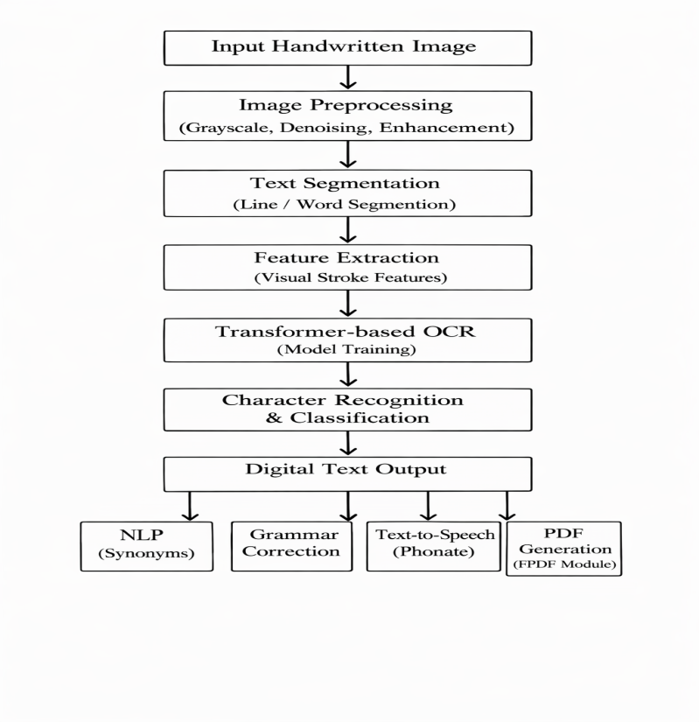

Working of the Proposed System (Step-by-Step)

Input Handwritten Image process begins when the user uploads or scans a handwritten document. The input can be a photo taken from a mobile camera or a scanned image containing handwritten text. In Image Preprocessing uploaded image is first processed to improve its quality. This includes converting the image to grayscale, removing noise, enhancing contrast, and re-sizing it. These steps help the model clearly understand handwritten characters. In Text Segmentation the preprocessed image is then divided into smaller regions such as lines or words. This ensures that the text is read in the correct order from top to bottom, improving sentence flow and recognition accuracy. Feature Extraction uses visual features such as stroke patterns, character shapes, and spacing are automatically extracted from the segmented image. This is done internally by the deep learning model without manual feature design. Here in Handwritten Text Recognition (TrOCR), extracted features are passed to the TrOCR model. The transformer-based encoder understands the visual patterns, and the decoder converts them into corresponding digital text with high accuracy. Digital Text Generation recognizes characters that are combined to form meaningful words and sentences. The output text is structured properly to maintain the original handwriting flow. NLP Processing techniques are applied to enhance the recognized text. This includes synonym suggestions, auto-correction, and text editing support to improve readability and usability. Text-to-Speech Conversion processes the text that can be converted into speech using a phonetic text-to-speech module. This feature helps visually impaired users and supports auditory learning. PDF Generation , Finally the digital text is formatted and exported as a searchable and editable PDF document. This makes the content easy to store, share, and reuse. Offline Execution , the processing steps are performed offline using locally stored models, ensuring data privacy and usability without internet connectivity.
METHODOLOGY
The system begins by accepting a handwritten image from the user. The image is preprocessed to remove noise and enhance contrast. Preprocessing includes converting the image to grayscale, reducing noise, improving contrast using adaptive histogram equalization, and applying threshold to separate text from the background. These steps help highlight handwritten strokes and improve recognition accuracy.
Once preprocessing is complete, the system detects handwritten text line by line using image processing techniques such as morphological operations and contour detection. Line-level segmentation allows the OCR model to focus on smaller sections of text, which improves overall performance. Each segmented line is resized and normalized before being passed to the TrOCR model.
The TrOCR model uses a transformer-based architecture that extracts visual features from the image and converts them into text sequences. Beam search decoding is applied to generate more accurate predictions. After recognition, the output text is cleaned to remove unnecessary spaces and combined in the correct reading order to form readable sentences and paragraphs.
ALGORITHMS:
- Image Preprocessing Algorithm:
Before recognition, the image is cleaned and standardized to improve accuracy. It is converted to grayscale, resized to a fixed size, and normalized so that pixel values are consistent. Noise is removed using filtering techniques, and thresholding is applied when needed to make the handwriting clearer. This step ensures that all images have a uniform format and better visual quality.
- Feature Extraction Using Convolutional Neural Network
A Convolutional Neural Network (CNN) is used to extract important visual features from the handwritten image. The CNN automatically learns patterns such as edges, curves, and strokes through convolution and pooling layers. These learned features represent the structure of handwritten characters. The extracted features are then converted into a sequence format and passed to the text recognition model.
C .Transformer-Based Handwritten Text Recognition Algorithm (TrOCR)
- Scaled Dot-Product Attention
The handwritten text recognition is performed using a Transformer-based TrOCR model, which employs scaled dot-product attention to align visual features with textual tokens.

Attention(Q, K, V) = softmax( QKᵀ / √dₖ ) V
- Multi-Head Attention
Multi-head attention enables the model to capture diverse spatial and contextual dependencies present in handwritten text.
$\begin{matrix}\text{head_i}\text{ = Attention(QW_i^Q, }\text{KW_i^K}\text{, }\text{VW_i^V}\text{)}\end{matrix}$
- Encoder–Decoder (Cross-Attention)
MultiHead(Q, K, V) = Concat(head₁, … , headₕ)W⁰
cross-attention allows the decoder to selectively focus on relevant visual regions during character generation.
- Feed-Forward Network
A position-wise feed-forward network further refines contextual representations.
FFN(x)=max(0,xW1​+b1​)W2​+b
D. Model Training and Optimization Algorithm
(a).Cross-Entropy Loss
L_CE = - ∑_{t=1}^{T} log P(y_t | y_<t, x)
The model is trained using categorical cross-entropy loss, which penalizes incorrect character predictions

(b).Adam Algorithm
θₜ₊₁ = θₜ − α ( m̂ₜ / ( √v̂ₜ + ε ) )
Model parameters are optimized using the Adam optimizer for faster convergence and stability.

RESULTS AND DISCUSSION
The proposed system was tested on different handwritten images containing single-line and multi-line text. The results show that line-level segmentation improves recognition accuracy significantly. The system performs well on clear handwritten images and produces readable text output. However, recognition accuracy may decrease for extremely cursive handwriting or images with heavy noise. The interactive features improve usability and make the system suitable for educational purposes.
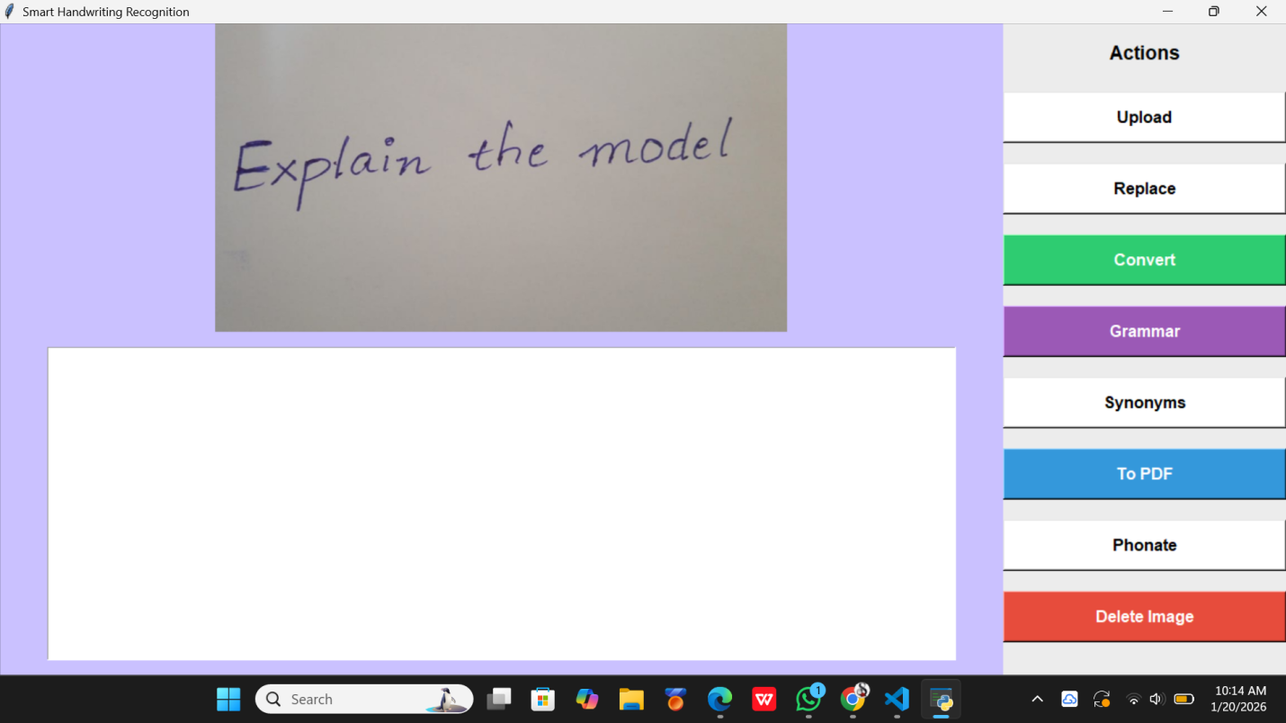
- Above figures shows uploading handwritten image
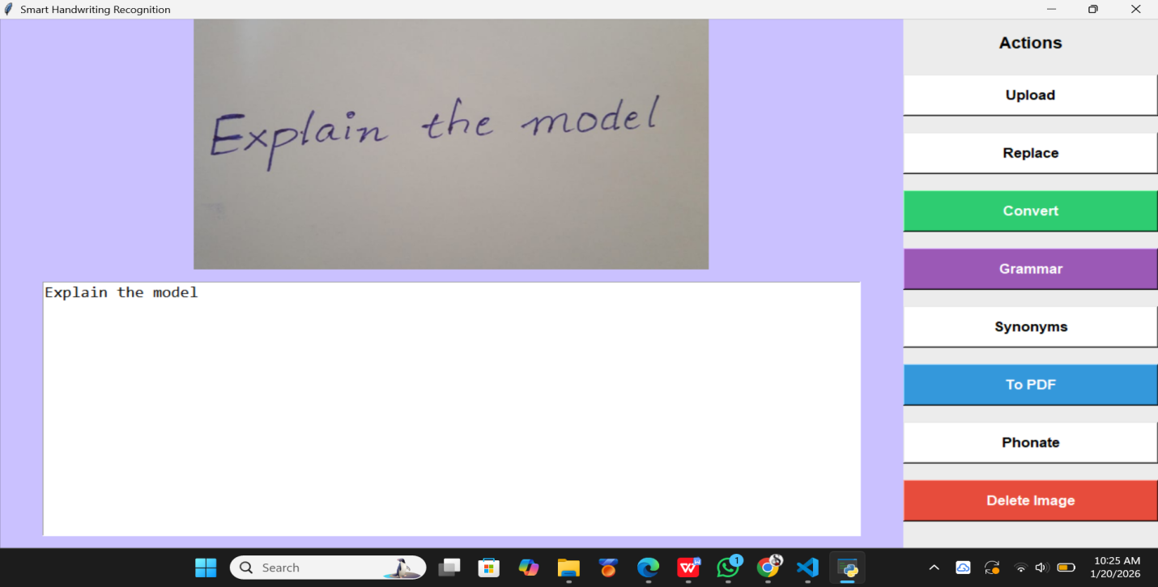
- Above figures shows converting handwritten text into digital form.
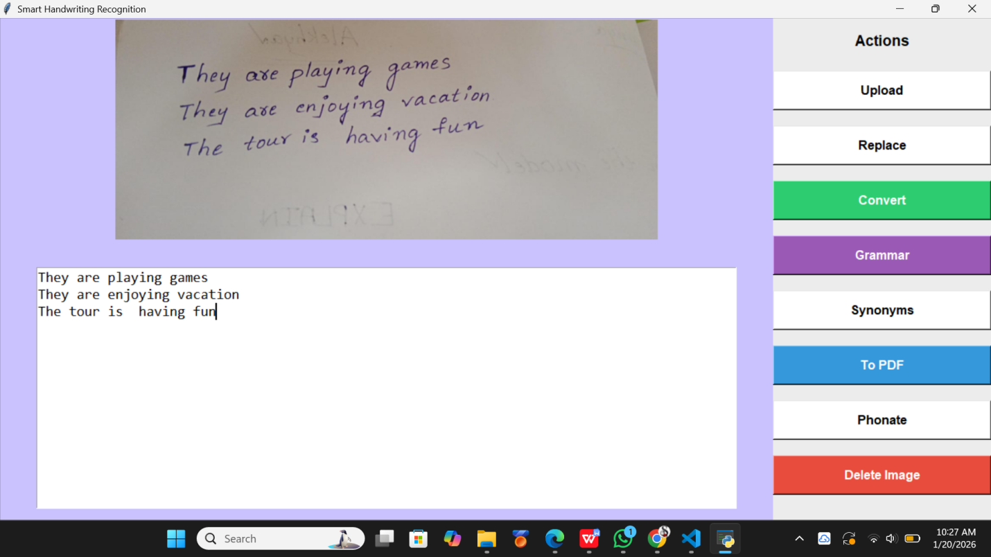
- Above figure shows converting multiple lines into digital format

- Below figure shows generating of synonym for required word
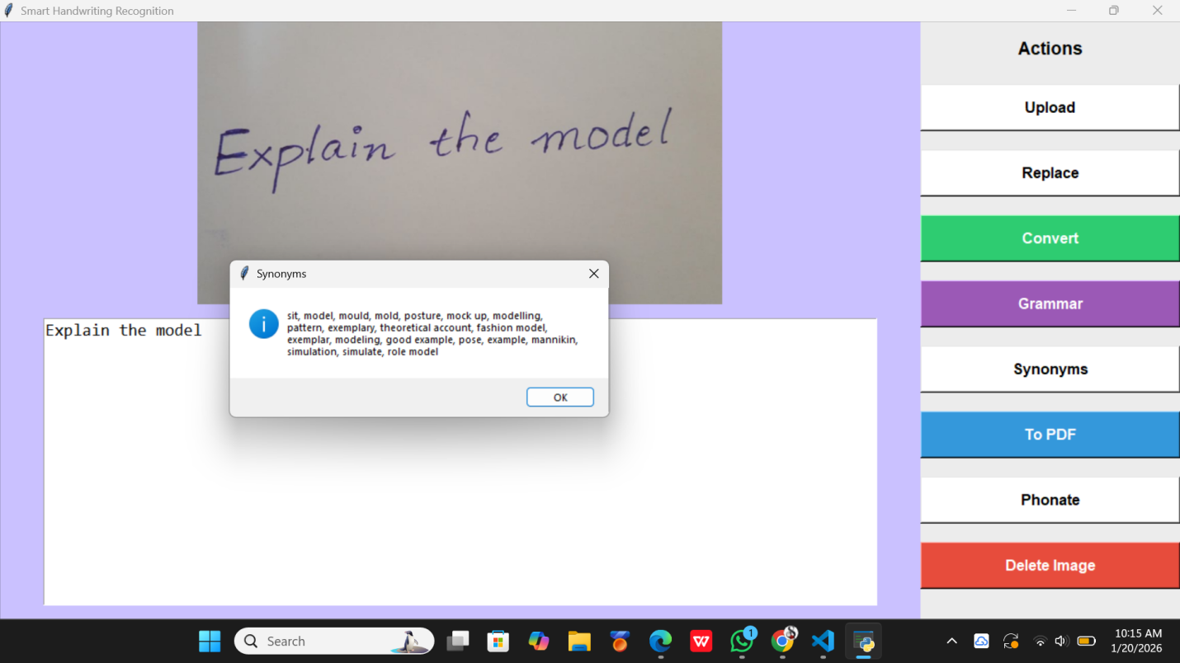

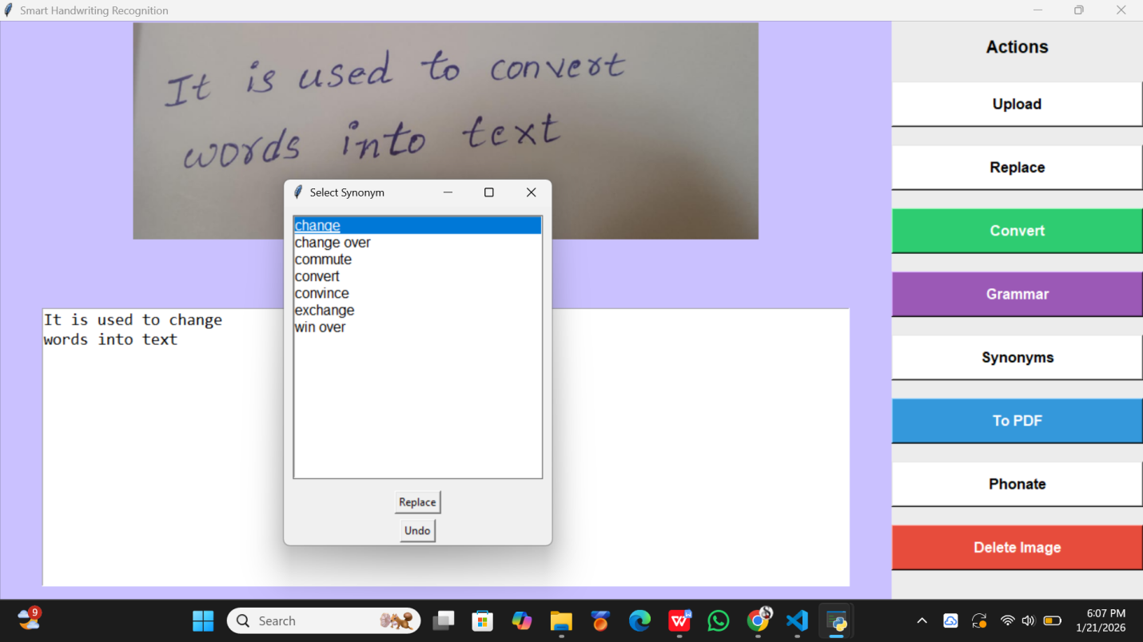
E)Above figure shows represent the modification of the word “convert” with one of its synonyms displayed onscreen.
F) Below figure shows correction of grammar and rewrite the sentence.
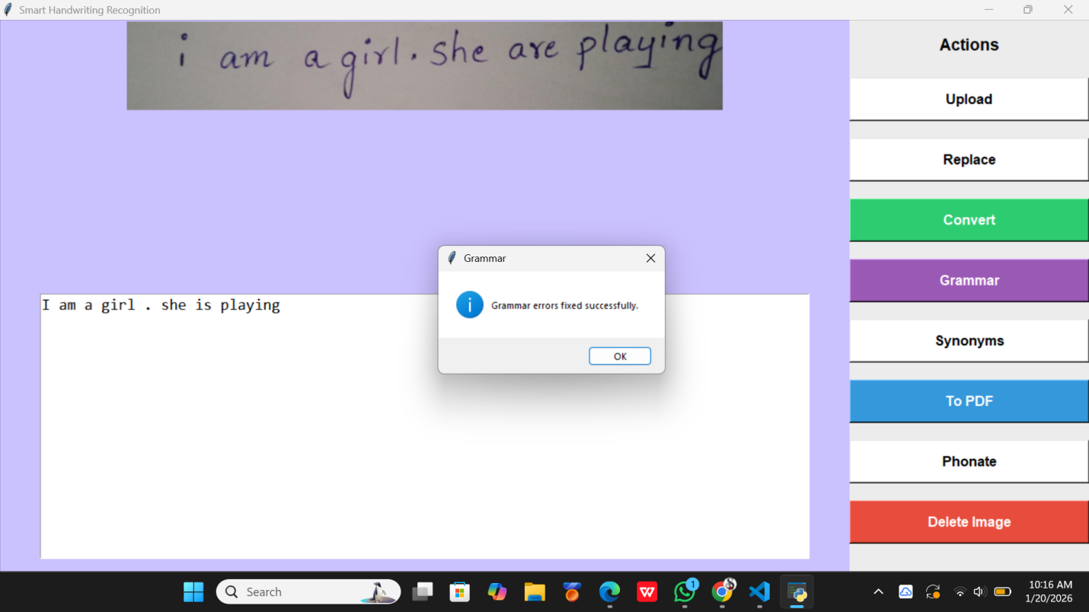

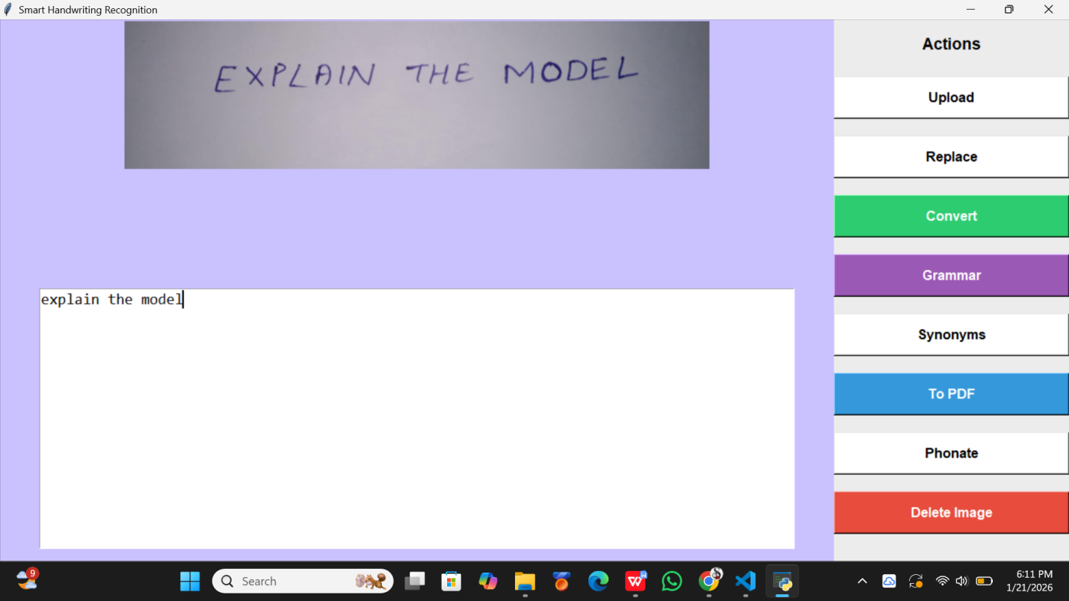
G)Above figure converts Capital letters into Digial form
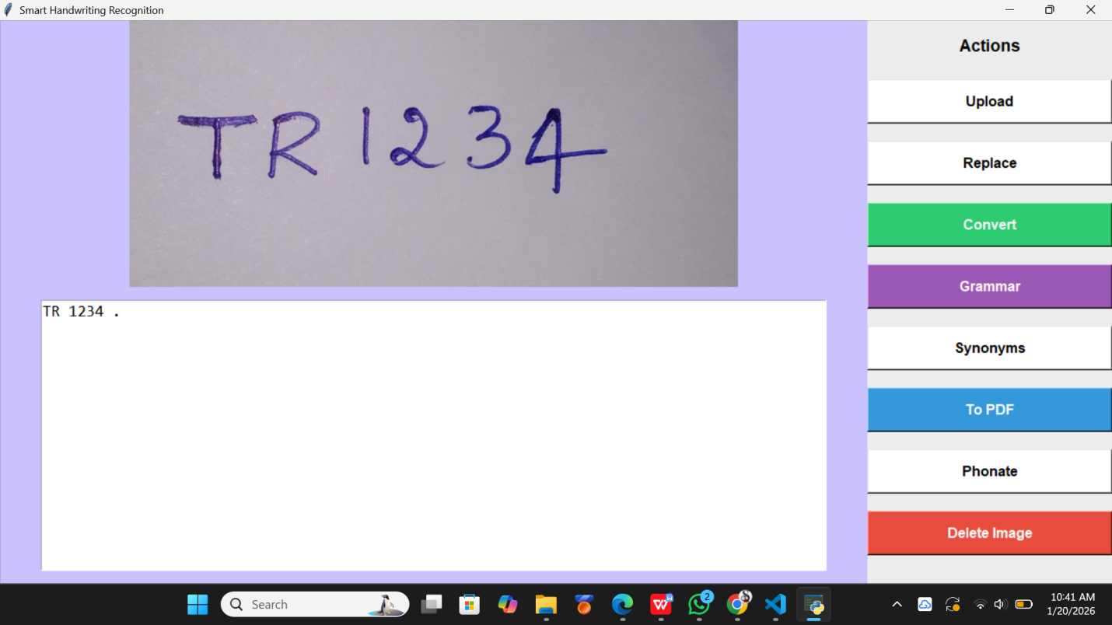
- Above figure shows converting of numbers and text combination.

Comparison Between OCR Engines:
Here we compare between TROCR ,CNN,RNN where for bag of words, character and flex character accuracy. Here for most of the achievements are from Tesseract and for Google Cloud OCR it is best for bag of words .The graph highlights that OCR performance varies depending on the evaluation metric, with no single engine consistently dominating across all measures.
.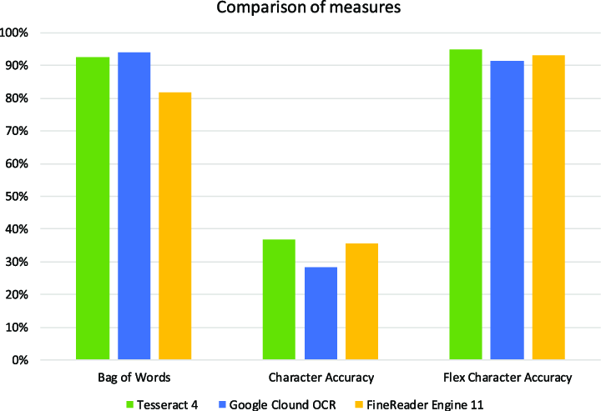
Fig shows Comparison of recognition accuracy between CNN, RNN, and the proposed TrOCR-based handwritten text recognition system.

Comparison Between Traditional and Modern Methods:
The TCNN consistently achieves higher accuracy across all training photos compared to traditional method. But here traditional methods are gradually improving but have lower accuracy than TCNN. So we can prefer latest TCNN method.
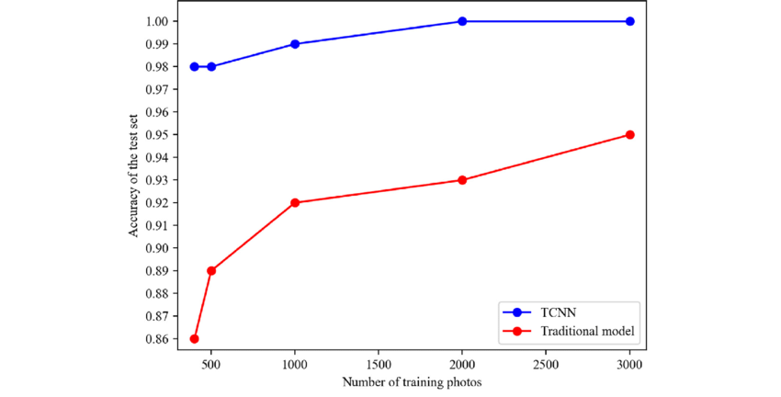
Fig shows graphical comparison between Traditional and Transformer Model
CONCLUSION
The results demonstrate that transformer-based models are well suited for handwritten text recognition and outperform traditional methods in handling diverse writing styles. The proposed system offers a practical solution for handwritten document digitization and can be further enhanced through multilingual support, improved language processing, and deployment on web or mobile platforms.The proposed handwritten text recognition and enhancement system can be widely applied in various real-world scenarios. In the education sector, it can be used to digitize handwritten notes, assignments, and examination papers, enabling easy storage and sharing. In offices and government organizations, the system helps convert handwritten records, forms, and reports into digital documents, reducing manual effort and improving efficiency. The phonation feature makes the system highly beneficial for visually impaired users by converting text into speech, while the PDF conversion feature allows seamless documentation and distribution of processed text.

FUTURE WORK
In the future, the system can be enhanced in several ways. Support for multiple languages and scripts can be incorporated to make the system usable across different regions. And it can also recognize mathematical symbols and expressions. Additionally,can also detect special characters which make completeness and robustness of handwritten text recognition process.

REFERENCES
[1]KardanMoghaddam, H., Akbarimajd, A., Ranjbarpour, M., Nooshyar, M., & Jamali, S. (2025). A structure based on TrOCR transformer and large language model for classification of handwritten texts. Facta Universitatis, Series: Electronics and Energetics, 38(4), 697-714
[2]Shrama, M. R. (2021). Handwritten character recognition using python. Journal of Emerging Technologies and Innovative Research, 8.
[3]Chooi, S. L., & Ab Ghafar, A. S. B. (2021). Handwritten character recognition using convolutional neural network. Progress in Engineering Application and Technology, 2(1), 593-611
[4]Thangamariappan, P., & Pamila, J. C. (2020). Handwritten recognition by using machine learning approach. Int. J. Eng. Appl. Sci. Technol, 4(11), 564-567
[5]Pal, A., & Singh, D. (2010). Handwritten English character recognition using neural network. International Journal of Computer Science & Communication, 1(2), 141-144
[6]Mohamad, M. A., Hassan, H., Nasien, D., & Haron, H. (2015). A review on feature extraction and feature selection for handwritten character recognition. International Journal of Advanced Computer Science and Applications, 6(2)
[7]Suresh, Y. (2026). A Transformer-Based Optical Character Recognition Framework with Unified Residual Recurrent Networks for Multilingual Handwritten Documents. Engineering, Technology & Applied Science Research, 16(1), 31363-31370.
[8]Purohit A, Chauhan SS. A literature survey on handwritten character recognition. International Journal of Computer Science and Information Technologies (IJCSIT). 2016;7(1):1-5.
[9]N. Arica and F. Yarman-Vural, An Overview of Character Recognition Focused on Off-Line Handwriting, IEEE Trans. Systems, Man, and Cybernetics Part C: Applications and Rev., vol. 31, pp. 216-233, 2001.
[10] Om Prakash Sharma, M. K. Ghose, Krishna Bikram Shah, “An Improved Zone Based Hybrid Feature Extraction Model for Handwritten Alphabets Recognition Using Euler Number”, International Journal of Soft Computing and Engineering (ISSN: 2231 - 2307), Vol. 2, Issue 2, pp. 504- 508, May 2012.
[11] S. Yadav, S. Sharma and S. R. Kumar , “A Robust Approach For Offline English Character Recognition”IEEE conference on futuristic trending computational analysis and knowledge management pp.121-126,2025
[12] J.Pradeep, E.Srinivasan, S.Hymavathi.” Neural Network based Handwritten Character Recognition system without feature extraction ”in International Conference on Computer, Communication and Electrical Technology ICCET,2011
[13] Patel, M., & Thakkar, S. P. (2015). Handwritten character recognition in english: a survey. International Journal of Advanced Research in Computer and Communication Engineering, 4(2), 345-350.
[14] Raza, S., Farooq, M., Farooq, U., Karamti, H., Khurshaid, T., & Ashraf, I. (2025). A convolutional neural network based optical character recognition for purely handwritten characters and digits. Computers, Materials, & Continua, 84(2), 3149.
[15] Shiferaw, N. A., Mayaluri, Z. L., Sahoo, P. K., Panda, G., Jain, P., Rath, A., ... & Islam, M. T. (2025). Handwritten amharic character recognition through transfer learning: Integrating cnn models and machine learning classifiers. IEEE Access.
[16] Zanwar, S. R., Bhosale, Y. H., Bhuyar, D. L., Ahmed, Z., Shinde, U. B., & Narote, S. P. (2023). English handwritten character recognition based on ensembled machine learning. Journal of The Institution of Engineers (India): Series B, 104(5), 1053-1067.
[17] Li, Y., Yang, Q., Chen, Q., Hu, B., Wang, X., Ding, Y., & Ma, L. (2022). Fast and robust online handwritten Chinese character recognition with deep spatial and contextual information fusion network. IEEE Transactions on Multimedia, 25, 2140-2152.
[18] Mohamad, M. A., & Ahmad, M. A. (2024). Handwritten Character Recognition using Enhanced Artificial Neural Network. Journal of Advanced Research in Computing and Applications, 36(1), 1-9.
[19] Liman, Muhamad Arief, Antonio Josef, and Gede Putra Kusuma. "Handwritten character recognition using deep learning algorithm with machine learning classifier." JOIV: International Journal on Informatics Visualization 8, no. 1 (2024): 150-157.
[20] Kathigi, A., & Honnamachanahalli Kariputtaiah, K. (2022). Handwritten character recognition using skewed line segmentation method and long short term memory network. International Journal of System Assurance Engineering and Management, 13(4), 1733-1745.
[21]Dey, R., Piri, J., Behera, D. K., & Khan, A. U. (2024). A time efficient offline handwritten character recognition using convolutional extreme learning machine. The Imaging Science Journal, 72(6), 736-748.
[22]Ahmed, T., Uddin, M., Khan, M. A. R., & Hasan, A. M. (2022). Offline handwritten character recognition including compound character from scanned document. Asian Journal of Research in Computer Science, 14(4), 119-129.

