Privileged Access Management (PAM) Implementation Report

Microsoft Entra ID (Azure AD)

1. Introduction
Privileged Access Management (PAM) is a critical component of Identity and Access Management (IAM) that focuses on securing, controlling, and monitoring access to privileged accounts.
Privileged accounts (such as administrators) have elevated permissions that can significantly impact system security if compromised. Therefore, organizations must implement strict controls to minimize risks associated with these accounts.
This project demonstrates a practical implementation of PAM concepts using Microsoft Entra ID in a simulated enterprise environment.

2. Objective
The primary objectives of this project are:
- To separate standard and privileged user accounts
- To enforce least privilege access principles
- To secure privileged accounts using Multi-Factor Authentication (MFA)
- To monitor and audit privileged activities
- To simulate enterprise-level PAM controls

3. Tools & Technologies Used
- Microsoft Entra ID (Azure Active Directory)
- Azure Portal
- Microsoft Authenticator (for MFA)
- Web Browser (for testing login scenarios)

4. Implementation Steps

4.1 User Account Creation
Two types of user accounts were created:
- Standard User Account → jane Smith(User)
- Privileged Admin Account → jane.admin (Administrator)
The separation ensures that administrative tasks are performed only through dedicated privileged accounts.
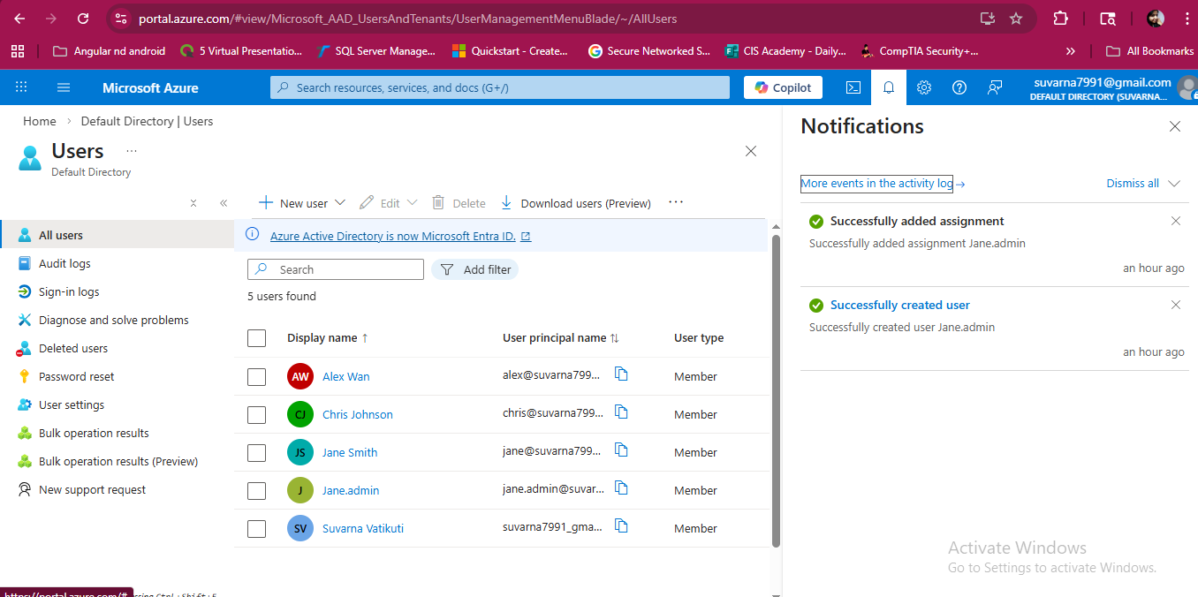
pam-user-accounts.png (Users list showing both accounts)

4.2 Role-Based Privileged Access Assignment
The privileged account (jane.admin) was assigned an administrative role:
- Role: Global Administrator (or User Administrator)
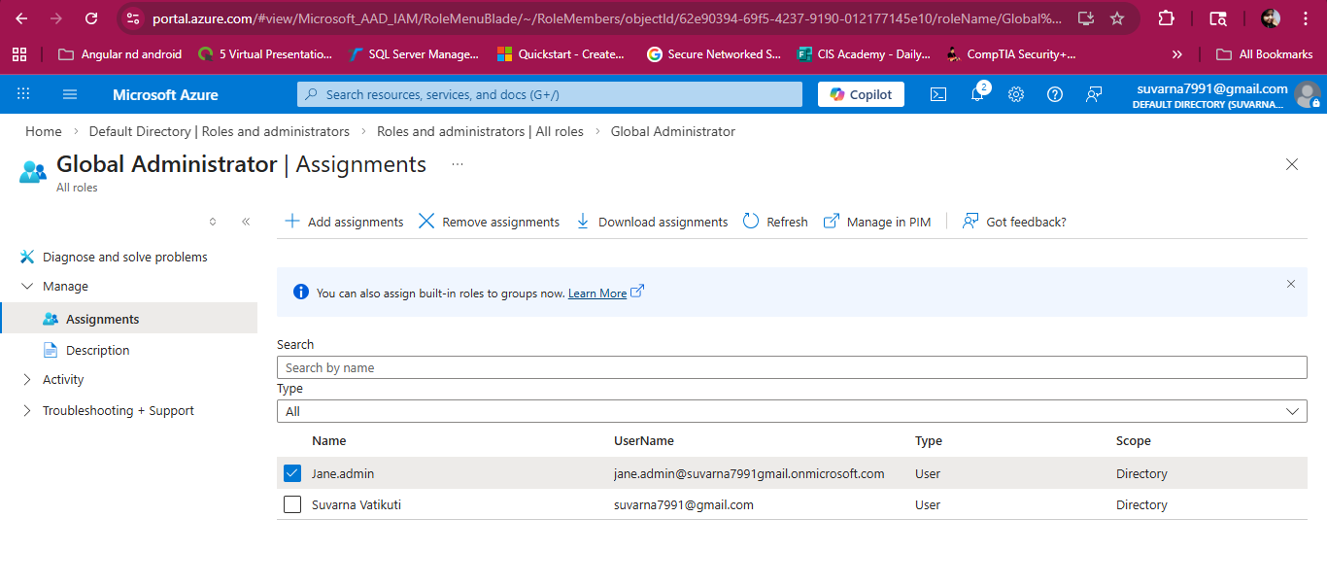
pam-admin-role.png (Admin role assignment)
The standard user account was not assigned any privileged role.
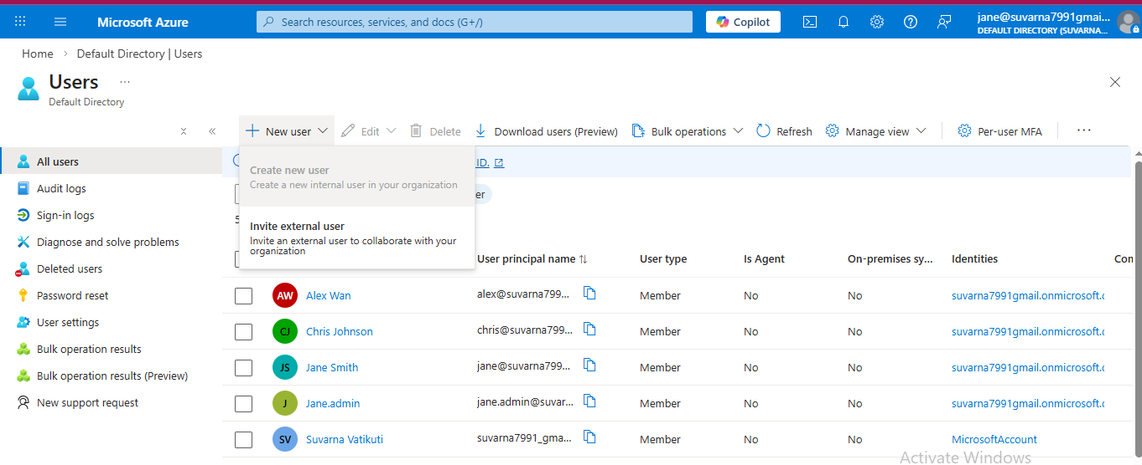pam-least-privilege.png (Standard user with no admin role)
  - Enforcement of Least Privilege Principle
The environment was configured to ensure that standard users have only necessary permissions and administrative privileges are restricted to authorized users only. This reduces the attack surface and prevents unauthorized access.
  - Multi-Factor Authentication (MFA) Enforcement
MFA was enabled to secure privileged accounts, ensuring that admin login requires additional verification and unauthorized access attempts are mitigated.
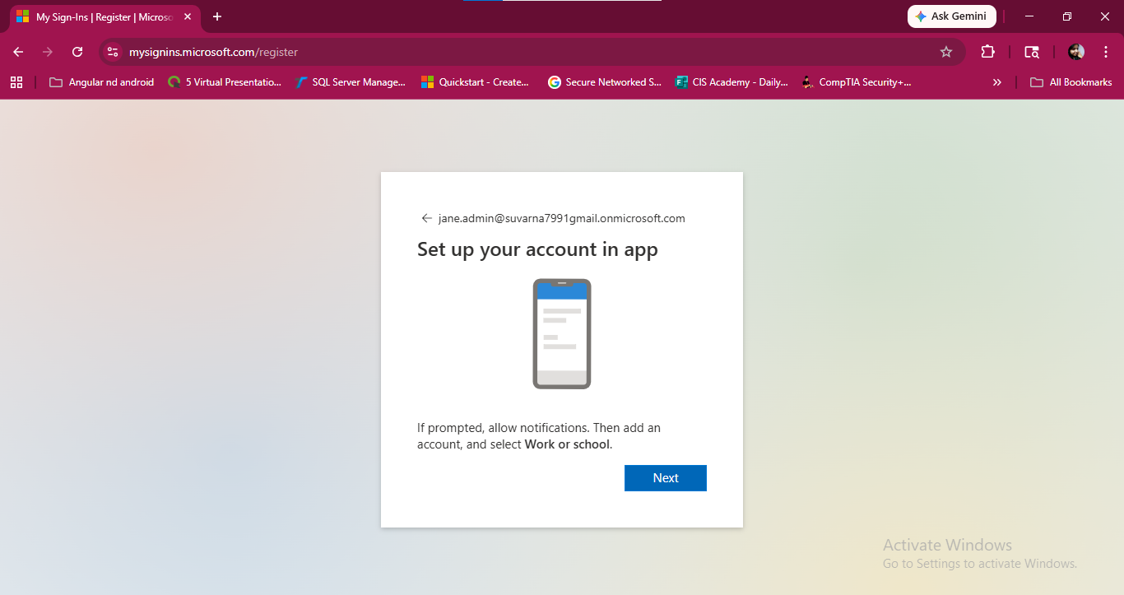
pam-mfa.png (MFA prompt or settings)

4.5 Access Control Testing
Testing was performed to validate access boundaries:
- Standard user attempted administrative action → Access Denied ❌
- Admin user performed administrative action → Access Granted ✔
This confirms proper enforcement of privilege separation.
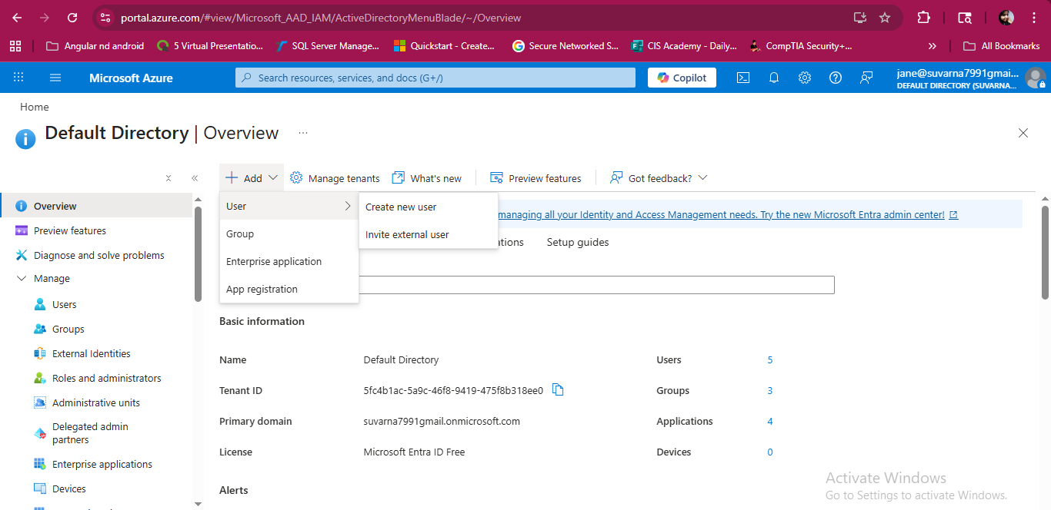
pam-access-test.png (Access denied / success)

4.6 Monitoring and Logging
All activities were monitored using:
- Sign-in Logs
- Audit Logs
These logs provide visibility into:
- User login attempts
- MFA status
- Role assignments
- Administrative actions
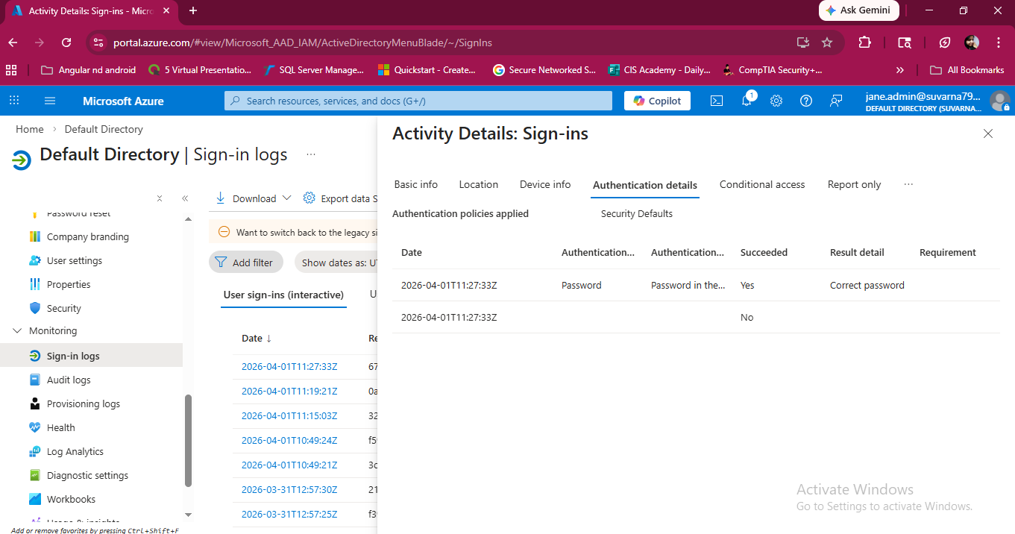pam-signin-logs.png (Login activity)
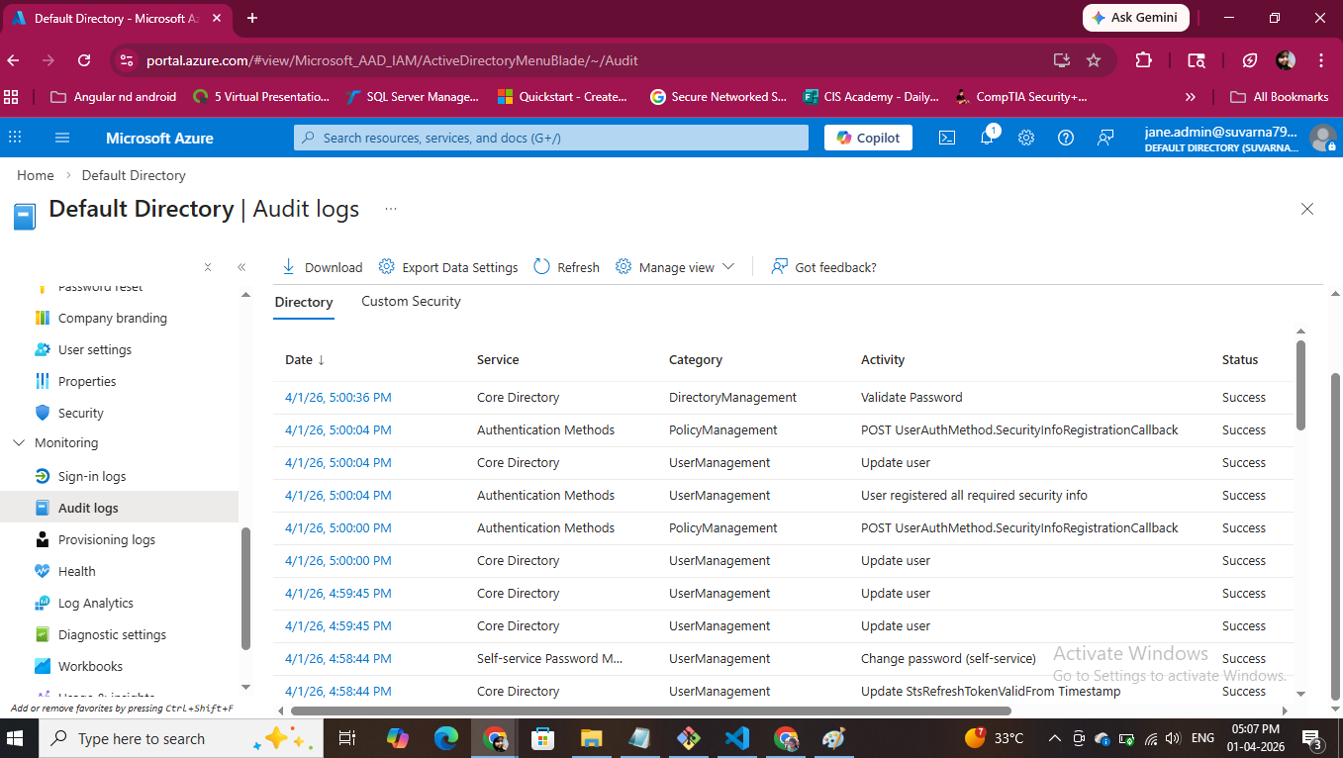pam-audit-logs.png (Role assignment logs)

5. Security Controls Implemented
The following security controls were applied:
- Separation of duties (user vs admin accounts)
- Least privilege enforcement
- Multi-factor authentication (MFA)
- Role-based access control (RBAC)
- Activity monitoring and auditing.

6. Key Learnings
- Importance of separating privileged and non-privileged accounts
- Risks associated with excessive permissions
- Practical implementation of least privilege principle
- Role of MFA in securing administrative access
- Importance of monitoring and auditing privileged activities

7. Enterprise PAM Enhancements (Conceptual)
In a real-world enterprise environment, PAM would be further enhanced using:
- Azure AD Privileged Identity Management (PIM) for Just-In-Time access
- Secure credential storage using Azure Key Vault or CyberArk
- Session monitoring and recording
- Automated privilege elevation workflows
These enhancements were conceptually understood and documented due to free-tier limitations.

8. Conclusion
This project successfully demonstrates the implementation of Privileged Access Management (PAM) fundamentals using Microsoft Entra ID.
By enforcing least privilege, securing privileged accounts with MFA, and monitoring activities, the project aligns with real-world IAM practices used in enterprise environments.
The implementation provides a strong foundation for understanding and applying PAM concepts in cybersecurity roles.

