Cyber Security: Cheatsheet

Labs Overview
To ensure a smooth and effective lab experience, please review the following key points and recommendations:

🖥️ Browser & Access Guidelines
- Use Google Chrome or Microsoft Edge for best performance.
- Avoid using Incognito mode as labs may not function properly in Incognito mode.
- The clipboard functionality from your local machine to the VMs is disabled. You won't be able to use copy-and-paste directly into the VMs.
- As a workaround, you may use a site like dontpad.com . Copy your text to this site from your local machine, then access the same URL within the VM. Copy-and-paste within the same VM will work.
- Please allow at least 2 minutes for desktop icons or applications to respond – this is due to the resource load on the VM environment.
- Deallocating Your Lab: Before ending your day, please ensure that all your VMs are properly shut down to prevent unnecessary lab credit consumption.
- Make sure to repeat the shutdown process for each active VM, so that none remain in a “Running” state. An image reference is provided below to guide you. 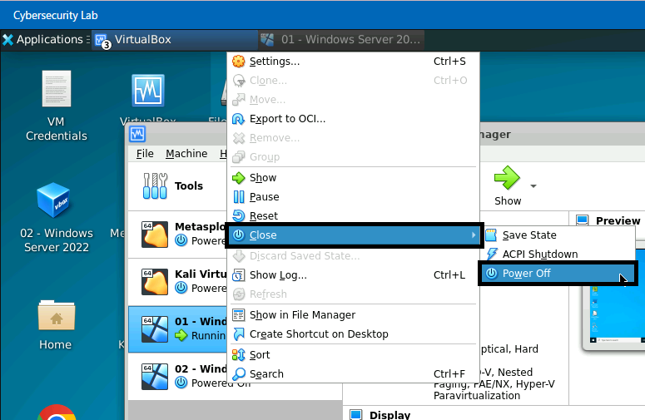

🔄 Connection Issues:
If you experience reconnect issues or unresponsiveness in your Virtual Machines (VMs), please ensure the following:
- Avoid opening multiple LMS windows/tabs simultaneously.
- Switch to Full-Screen mode when working in the lab environment for a more stable connection and to avoid confusion with the VMs inside the Lab Environment.
- Once in full-screen, close the LMS window to reduce load.
How to Enter Full-Screen View:
Once your required VM is launched:
- Click on the "Resources" tab in the VirtualBox window.
- Select "Full-Screen Mode"
- Confirm the switch to full screen. (PFA)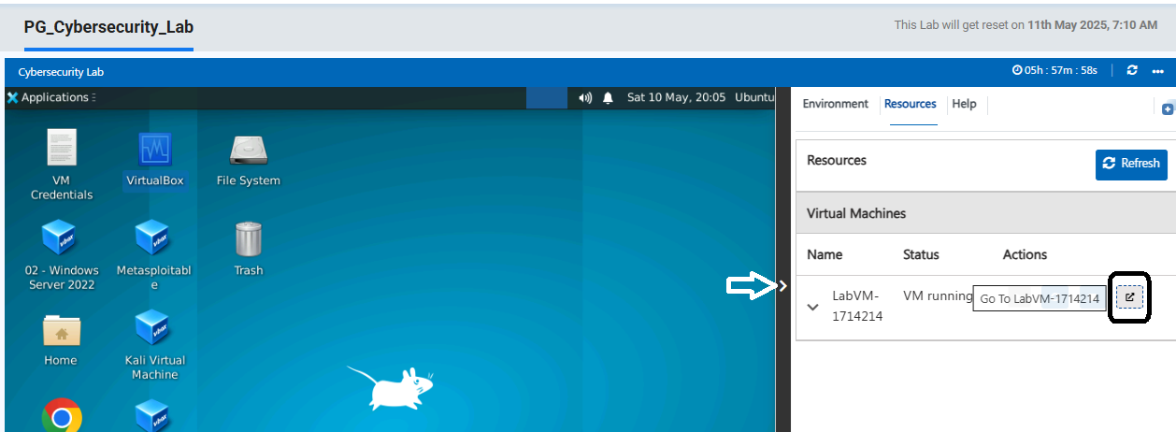
🔍 Alternative Tips:
- Ensure stable internet (minimum 8 Mbps recommended).
- Prefer Ethernet connection over Wi-Fi when possible.

🧠 Latency Issues:
When you launch a lab for the first time, VMs may experience latency due to default memory allocations. To improve performance, click on “Base Memory” to adjust the memory as per the recommendation below:
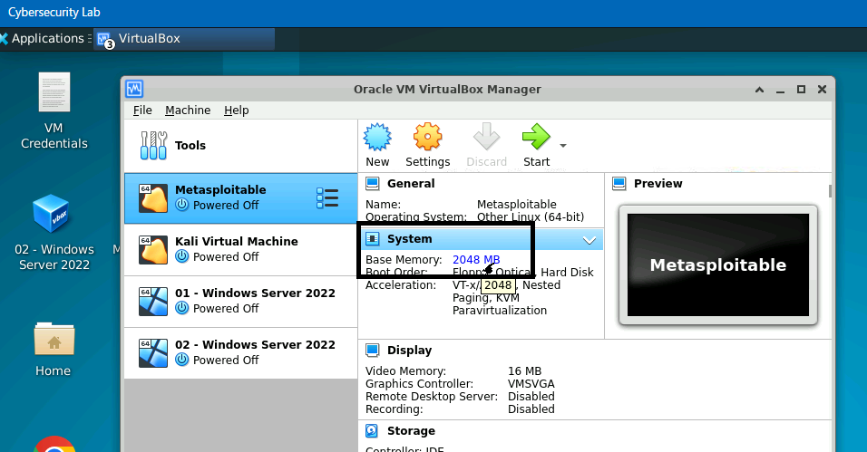
Recommended Memory Settings:
Virtual Machine | Recommended Base Memory
Metasploitable | 1024 MB (1 GB)
Kali Linux | 2048 MB (2 GB)
01 - Windows Server 2022 | 4096 MB (4 GB)
02 - Windows Server 2022 | 4096 MB (4 GB)
💡 Memory settings can be adjusted before starting the VM via VirtualBox > Settings > System > Base Memory.

📦 Cisco Packet Tracer:
To launch Cisco Packet Tracer, follow these steps:
- Open Oracle VirtualBox.
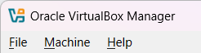
- Start the Windows Server 2022 VM.
- Locate and launch the Cisco Packet Tracer application from the desktop or start menu in the VM. (PFA)
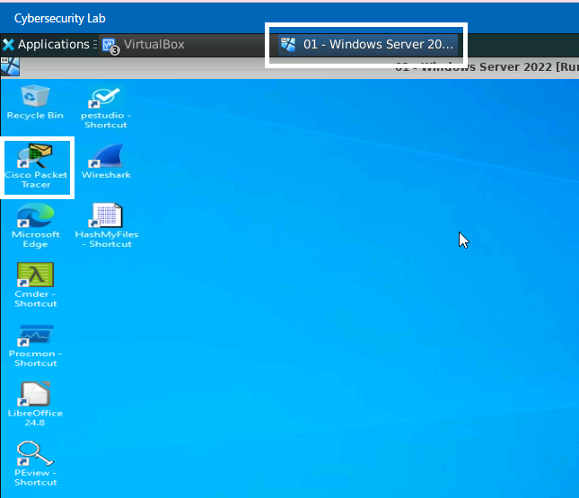

B. Projects Overview
1. Lesson-End Projects (LEPs):
These are provided after most lessons to help you apply what you’ve learned.
- Submission is not required.
- They are meant solely for self-practice and to test your understanding of the concepts.
- Please note that LEPs are available for most, but not all, lessons.

2. Course-End Projects (CEPs):
These are assigned after the completion of courses.
- Submission is required via the "Submit" icon in the Assessment section of the course.
- To meet the program completion criteria, you need to submit two CEPs from two different courses.
- Evaluation typically takes 3–5 business days from the date of submission.
3. Capstone Project:
The Capstone is a type of Course-End Project and serves as a comprehensive final assessment.
- While you are allowed to submit any two CEPs from different courses to fulfill the requirement, we strongly recommend completing the Capstone project.
- It is designed to help you gauge your readiness and consolidate your learning across the program.

