What is a Flowchart?

A flowchart is a graphical representations of steps involved in planning & execution of any project. It was originated from computer science as a tool for representing algorithms and programming logic. They help us visualize complex processes, or make explicit the structure of problems and tasks.

## Flowchart Symbols

Different flowchart shapes have different conventional meanings. The meanings of some of the more common shapes are as follows:

### **Terminator**

The terminator symbol represents the starting or ending point of the system.

Flowchart symbol: Terminator

**Process**

A box indicates some particular operation.

Flowchart symbol: Process

### **Document**

This represents a printout, such as a document or a report.

Flowchart symbol: Document

### **Decision**

A diamond represents a decision or branching point. Lines coming out from the diamond indicates different possible situations, leading to different sub-processes.



### **Data**

It represents information entering or leaving the system. An input might be an order from a customer. Output can be a product to be delivered.

Flowchart symbol: Data

### **On-Page Reference**

This symbol would contain a letter inside. It indicates that the flow continues on a matching symbol containing the same letter somewhere else on the same page.

Flowchart symbol: On page reference

### **Off-Page Reference**

This symbol would contain a letter inside. It indicates that the flow continues on a matching symbol containing the same letter somewhere else on a different page.

Flowchart symbol: Off page reference

### **Delay or Bottleneck**

Identifies a delay or a bottleneck.

Flowchart symbol: Delay

### **Flow**

Lines represent the flow of the sequence and direction of a process.

Flowchart symbol: Flow

**Benefits of using a Flowchart**

* It helps to clarify complex processes.
* It identifies steps that do not add value to the internal or external customer, including delays; needless storage and transportation; unnecessary work, duplication, and added expense; breakdowns in communication.
* It helps team members gain a shared understanding of the process and use this knowledge to collect data, identify problems, focus discussions, and identify resources.
* It serves as a basis for designing new processes.

Short notes created here has been Extracted from :

<https://www.visual-paradigm.com/tutorials/flowchart-tutorial/>

**Quick Examples**

### **Flowchart Example – Simple Algorithms**

A flowchart can also be used in visualizing algorithms, regardless of its complexity. Here is an example that shows how flowchart can be used in showing a simple summation process.

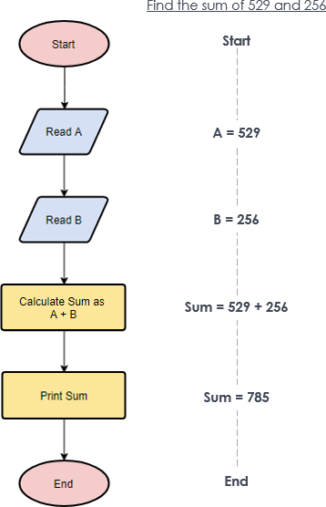

### **Flowchart Example – Calculate Profit and Loss**

The flowchart example below shows how profit and loss can be calculated.

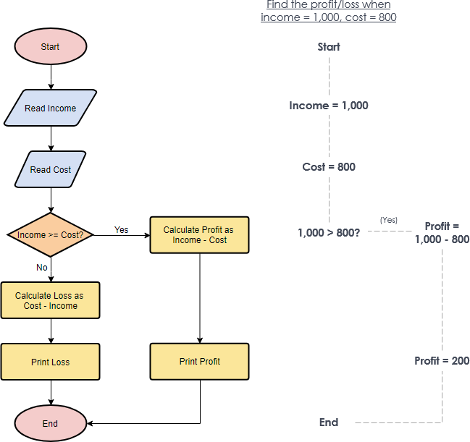

### **Flowchart Example – Medical Service**

This is a hospital flowchart example that shows how clinical cases shall be processed. This flowchart uses decision shapes intensively in representing alternative flows.

