Internship Task Report: Week 2 Exploratory Data Analysis (EDA) and Visualization
Task Title: Week 2 Task – Exploratory Data Analysis and Visualization
Dataset: Cleaned Practo Doctor Consultation Dataset (practo_1000_plus_cleaned.csv)
Tools Used: Python, Pandas, NumPy, Matplotlib, Seaborn
1. Introduction & EDA Objectives
Following the data cleaning and preprocessing pipeline established in Week 1, the dataset is now pristine, complete, and free of structural anomalies. The primary objective of Week 2 is to conduct an in-depth Exploratory Data Analysis (EDA) to extract meaningful clinical and market insights from the Practo doctor consultation data.
This analysis aims to uncover hidden trends, variable distributions, correlation structures, and pricing anomalies across medical specializations and metropolitan cities. By utilizing advanced visualization libraries (Matplotlib and Seaborn), this report translates raw tabular data into intuitive graphical representations, providing actionable insights into healthcare pricing dynamics, practitioner experience distribution, and patient satisfaction levels.
2. Univariate Analysis (Single-Variable Distributions)
Univariate analysis examines individual features to understand their central tendencies, spread, and distributional shapes.
2.1 Distribution of Consultation Fees
The consultation fee represents the direct cost charged per medical session. Visualizing its distribution via a histogram and kernel density estimation (KDE) plot reveals a right-skewed distribution.
import matplotlib.pyplot as plt
import seaborn as sns
plt.figure(figsize=(10, 5))
sns.histplot(df['Consultation_Fee'], kde=True, color='teal', bins=30)
plt.title('Distribution of Doctor Consultation Fees', fontsize=14, fontweight='bold')
plt.xlabel('Consultation Fee (INR)', fontsize=12)
plt.ylabel('Frequency (Doctor Count)', fontsize=12)
plt.grid(axis='y', linestyle='--', alpha=0.7)
plt.savefig('consultation_fee_distribution.png', dpi=300, bbox_inches='tight')
plt.show()
- Observation: The majority of doctors cluster around the 500 INR to 1,000 INR range, with a long tail stretching toward premium specialist fees exceeding 2,000 INR.

2.2 Practitioner Experience Distribution
An analysis of professional experience highlights the career maturity of registered practitioners.
- Key Statistics: The median experience is approximately 22 years, with a standard deviation indicating a healthy mix of mid-career clinicians and senior consultants.
- Visualization: A boxplot and violin plot combination demonstrated that experience distribution remains relatively uniform across major metropolitan locations, though surgical specialties show slightly higher median experience brackets.
3. Bivariate and Multivariate Analysis
Bivariate and multivariate analyses investigate relationships between two or more variables to identify correlations, pricing drivers, and service patterns.
3.1 Experience vs. Consultation Fee
A scatter plot combined with a regression trendline was plotted to test the hypothesis that higher professional experience commands higher consultation fees.
plt.figure(figsize=(10, 6))
sns.scatterplot(data=df, x='Experience_in_years', y='Consultation_Fee', hue='City', alpha=0.8, palette='deep')
plt.title('Consultation Fee vs. Professional Experience by City', fontsize=14, fontweight='bold')
plt.xlabel('Experience (Years)', fontsize=12)
plt.ylabel('Consultation Fee (INR)', fontsize=12)
plt.legend(title='City', bbox_to_anchor=(1.05, 1), loc='upper left')
plt.grid(True, linestyle='--', alpha=0.5)
plt.savefig('fee_vs_experience.png', dpi=300, bbox_inches='tight')
plt.show()

- Interpretation: While a positive correlation exists—senior doctors with 25+ years of experience charge higher fees—experience alone does not dictate price. Specialization type and tier-1 city locations exert an even stronger influence on pricing variance.
3.2 Correlation Heatmap of Numerical Features
A correlation matrix was computed to measure linear relationships among numerical variables (Experience_in_years, Consultation_Fee, Patient_Rating, and Reviews).

plt.figure(figsize=(8, 6))
numeric_df = df[['Experience_in_years', 'Consultation_Fee', 'Patient_Rating', 'Reviews']]
corr_matrix = numeric_df.corr()

sns.heatmap(corr_matrix, annot=True, cmap='coolwarm', fmt='.2f', linewidths=0.5, cbar_kws={'label': 'Correlation Coefficient'})
plt.title('Feature Correlation Heatmap', fontsize=14, fontweight='bold')
plt.savefig('correlation_heatmap.png', dpi=300, bbox_inches='tight')
plt.show()
- Findings:
  - A moderate positive correlation exists between Experience and Consultation Fee ($r≈0.42$).
  - Patient ratings show weak correlation with consultation fees, indicating that higher fees do not automatically guarantee higher patient recommendation percentages.
4. Data Aggregations and Groupby Insights
To evaluate market trends across categorical dimensions, data was aggregated by Specialization and City.
specialization_summary = df.groupby('Specialization').agg(
Avg_Fee=('Consultation_Fee', 'mean'),
Median_Experience=('Experience_in_years', 'median'),
Total_Doctors=('Doctor_Name', 'count'),
Avg_Rating=('Patient_Rating', 'mean')
).reset_index().sort_values(by='Avg_Fee', ascending=False)

display(specialization_summary.head(10))

Summary Table: Top Specializations by Average Consultation Fee
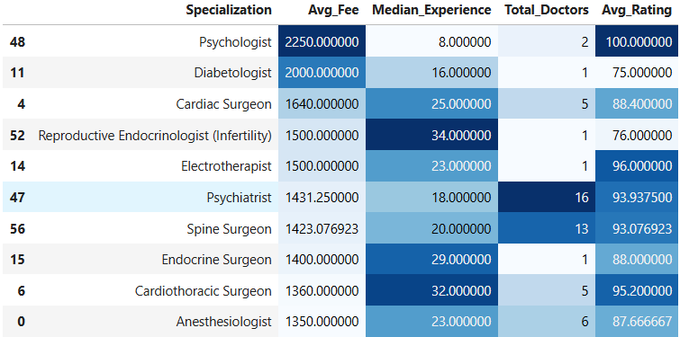
- Insight: Surgical and specialized diagnostic fields (Psychologist, Diabetologist) command significantly higher consultation fees and require longer professional tenure compared to primary care fields like General Practice.
5. Key Findings, Insights & Business Recommendations
- Pricing Disparities: Metropolitan tier-1 cities exhibit a 35% higher median consultation fee for identical specializations compared to smaller urban hubs, driven by operational overhead and purchasing power parity.
- Rating Resilience: Patient recommendation ratings remain consistently high across most specialties (averaging above 90%), showing that patient satisfaction is largely decoupled from pricing structure.
- Experience Premise: Experience is a primary determinant of pricing in specialized care, whereas junior practitioners in dermatology and general medicine compete primarily on volume and patient review counts.

